Dungeon Scramble

Rules Manual

<Narrative-baseds game intro with some plot and a hook>

Introduction
DUNGEON SCRAMBLE is a cooperative or solo dungeon-crawler in which intrepid Adventurers perform daring feats - with outcomes decided by the rolls of dice within a 4x4 Dice Tray. In this dice-drafting deck-builder, players will gear up their Adventurers with increasingly powerful Loot Dice, while putting their tactics, knowledge, and guts to the test puzzling-out the best Actions to take in tough situations.

Producers: The Friedmans
Editors: The Friedmans
Art: The Friedmans and Nick
Production: Brimstone the kitty
Trademark 2024 OR SOMETHING

The DUNGEON SCRAMBLE Core Set is compatible with all DUNGEON SCRAMBLE Origin Expansions and all DUNGEON SCRAMBLE Delve Expansions. Players may freely interchange Loot Dice and Encounter Cards between expansions, or combine them into one large set. Additional rulesets for incorporating multiple expansions will be explained later in the manual.

Box Components

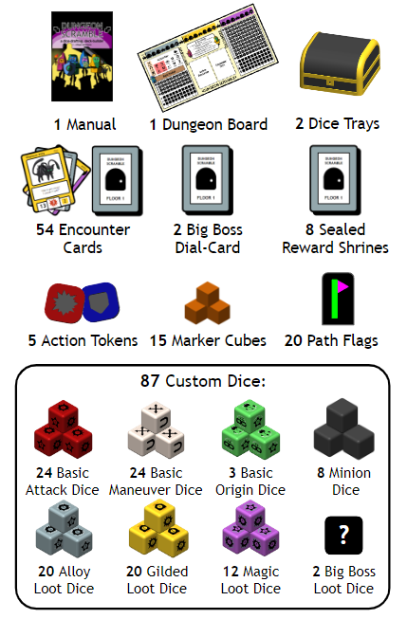

Game Overview/Goals

You are Adventurers, intent on reaching the bottom of a storied dungeon, and willing to use any and all tools at your disposal to make it to the next floor! SCRAMBLE your trusty Loot Dice, and use the resulting die faces to take on any threats you may find; for the faces of these dice represent Actions making use of your bespoke collection of trinkets, tools, wits and weapons. Determine the best path of Actions available to defeat Foes, disarm Traps, and get better Loot Dice.

To survive in a dungeon, Adventurers will need as much equipment as they can carry! So throughout the course of the game you will collect and swap out Loot Dice gained from pilfering the dungeon’s seemingly endless rooms. Weapons, armor, artifacts, potions, poisons, and more lay waiting for a capable and courageous wielder on their way into legend. But choose your loadout wiseley - the taverns sound with mocking songs of novices who brought daggers to a crossbow fight.

Game Dice

The dice are at the core of DUNGEON SCRAMBLE, representing Adventurers’ innate skills, as well as all the loot they gather throughout their travels. The faces of these dice represent possible outcomes of using said loot: a looted sword may miss an enemy, hit an enemy, or even combo with subsequent hit, while a looted spell may cast spectacularly, fizzle out, or even backfire on the user, all based on the result of the roll of the Loot Dice. Further, the dice are rolled (or SCRAMBLE’d!) within a 4x4 Dice Tray, where not only the face showing on the dice matters, but also its position related to other dice. Before taking a deeper look at how the dice and tray work further in the manual, new Adventurers should become familiar with their layout below.

NOTE: The following sections focus on the dice, themselves. The symbols shown on the dice faces represent Actions, and their meaning will be explained in the Gameplay Section.

Dice Tray

During gameplay, all dice are rolled - or SCRAMBLE’d - in the 4x4 Dice Tray. Adventurers use and store 16 dice of choice in their Tray, with the rest kept in the Back Pocket for later.

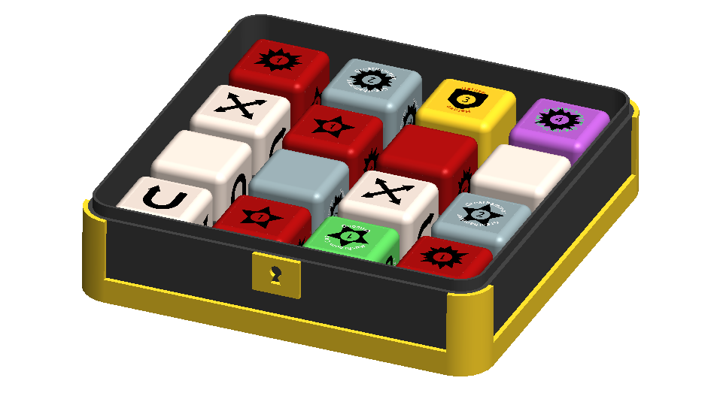

When prompted to SCRAMBLE, place the lid securely on the Dice Tray and shake it around to randomize the dice facing and location.

Note: try a vigorous shake followed by a few seconds of panning to get the best SCRAMBLE. If you open the Dice Tray and there are dice out of place, simply reroll them on the table and place them into any empty slots. Honesty is a virtue in Adventurers, but I’m only a tome, not your dad.

Die Layout

- Die Type: The color of the die corresponds to its type. These types are explained below.
- Upgrade Level: For Basic Dice, the amount of upgrades is indicated by a border outline. Level 1 Basic Dice have no outline, level 2 have dashed outline, and level 3 have solid outlines.
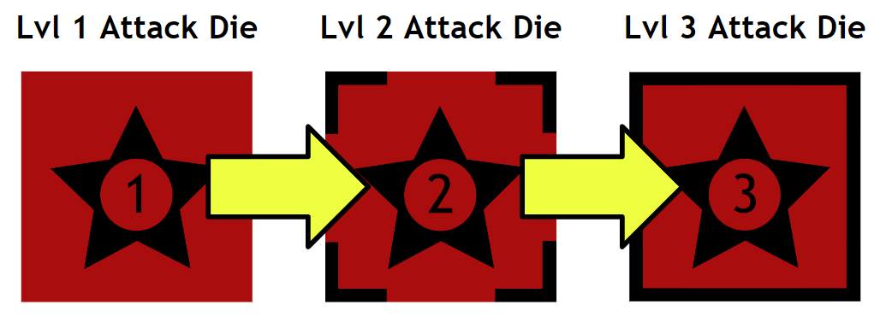
- Item Name: For Loot Dice, the unique name of the piece of loot is included.
- Action Symbol: The sides of the dice are either blank, or contain a symbol which represents Actions the Adventurer can take.
- Action Value: Some Actions have a value representing the magnitude of the Action.
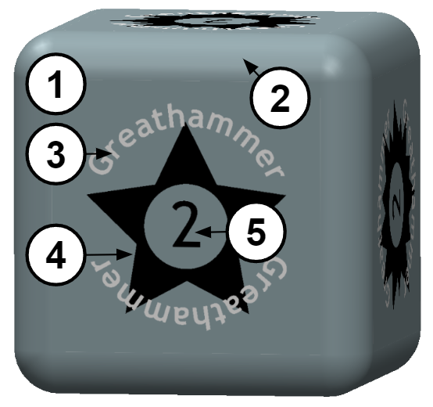

Basic Dice

The dice every Adventurer starts with are called Basic Dice, and these can be broken into the following categories: Attack, Maneuver, and Origin.

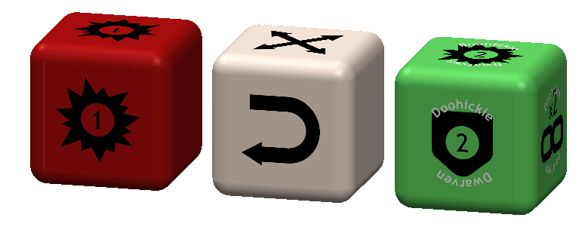Attack Dice

Red Basic Dice represent whatever your fresh Adventurer brings to the dungeon to do damage. They have a chance of rolling the crucial HIT and COMBO Actions, but have an equal chance of whiffing completely. These can be upgraded in power, or traded out for other Loot Die.

Maneuver Dice

White Basic Dice represent whatever your fresh Adventurer brings to the dungeon to get around and stay safe. They have a chance of rolling the LEAP, DODGE, and PIVOT Actions, all of thich allow the Adventurer to manipulate the 4x4 Dice Tray in advantageous ways. These can be upgraded in power, or traded out for other Loot Die.

Origin Dice

Dwarves, Gnomes, Halflings, and other would-be heroes all have natural proficiencies derived from their unique cultures and experiences! Green Origin Dice contain a thematic set of Actions representing each of these Origins’ skill sets.

Loot Dice

The dice Adventurers take from the dungeon are called Loot Dice, and these will generally replace the Basic Dice over the course of play. These can be broken into the following categories:
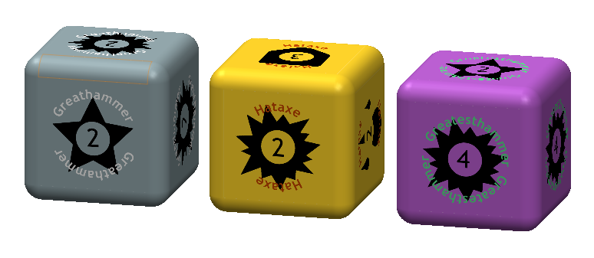

Alloy Dice

Gray Alloy Dice represent hard-forged weapons, trusty climbing tools, armor, and any other number of common, though nonetheless useful, pieces of loot. These are often found on the Dungeon’s First Floor.

Gilded Dice

Yellow Gilded Dice represent greathelms forged only by skilled hermits, rare poisons made with unpronounceable reagents, and one-of-a-kind experimental prototypes - truly high-quality pieces of loot. These are often found on the Dungeon’s Second Floor.

Magic Dice

Purple Magic Dice represent the weapons of legend, storied artifacts, and documents only spoken of by excommunicated clerical workers. These are the most powerful dice known to Adventurers, and the most terrible to behold! They can supposedly be found deep within the Dungeon’s Final Floor.

Game Board

The Dungeon Board is used to keep track of the Adventurers, and Encounters they face, and their progress through the dungeon. It can be broken into 3 sections:
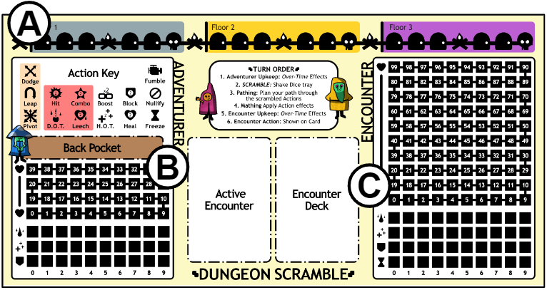

A. The Dungeon Track

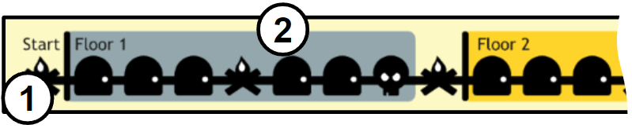
- Location Tracker: The top of the Board has the tracker for an Adventurers’ progress through a dungeon. Events on this track are either: Camps, indicated by campfire icons , Encounters, indicated by door icons , or Bosses, indicated by skull icons.
- Floor Indicator: The color-coded blocks on the Location Tracker show which Dungeon floor is currently being explored, with the first floor shown below.

B. The Adventurer Tracker

- Action Key: Includes a reference list of Action Symbols.
- Back Pocket: The extra Dice which are not in the Dice Tray are stored here.
- Health Tracker: Marker Cubes are used to track the Adventurer’s health here. The higher cube is the maximum health and the lower (or equal) is current health.
- Status Tracker: Marker Cubes are used to track the Adventurer’s Status effects here. Whenever D.O.T., H.O.T., or BLOCK are applied, move the marker cube in the respective row to the right. Status effects clear automatically after combat.
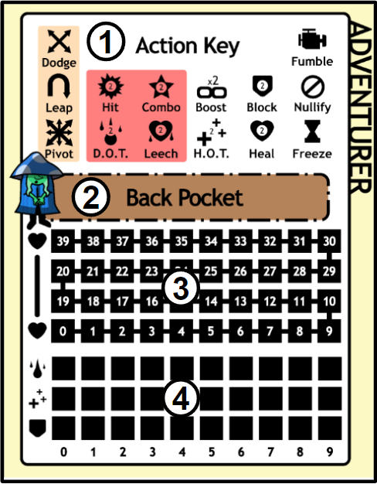

C. The Encounter Tracker

- Active Encounter: Whenever the top card of the Encounter Deck is drawn, it is placed here.
- Encounter Deck: The Deck for the current floor goes here.
- Health Tracker: Marker cubes are used to track the Encoutner’s health here. The higher cube is the maximum health and the lower (or equal) is current health. If necessary, an additional Marker cube can be used to represent health above the board’s maximum value.
- Status Tracker: Marker cubes are used to track the Encounter Status effects here. Whenever D.O.T., H.O.T., or BLOCK are applied, move the marker cube in the respective row to the right.
- Turn Counter: Similar to the Status Tracker, this is used to measure the Turn Number for Encounters with the symbol in the Quest Description.
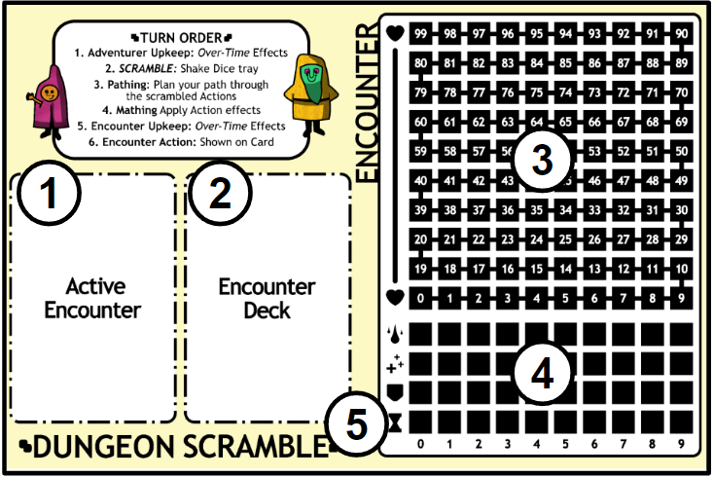

Setup

The first step is to create the Dungeon in which the game takes place. Dungeon setup may differ depending on optional rulesets explained later, but to create a standard randomized dungeon:

Encounter Card Pool

Gather the Encounter Cards that you want to fill the dungeon. Then, using the card backs, sort the cards into the piles: Floor 1, Boss 1, Floor 2, Boss 2, Floor 3. Shuffle each pile and place them above the game board.

Loot Dice Pool

Gather the Loot Dice that you want to fill the dungeon’s loot tables. Separate them into their respective colors and place them into the Alloy, Gilded, and Magic Loot Sacks. Give them a good shake to shuffle them, and place them above the game board.

Setting the Table

Put the Dungeon Board on the table and place the Floor 1 deck onto the “Encounter Deck” spot. Place the remaining decks above the board for later. Place the 3 loot bags above the board as well. Place marker cubes on the “0” slot each of the Status Trackers. Place max- and current- health markers on the Adventurers Health Tracker. Solo Adventurers start with 20 Health, with 10 Health added for each additional co-op adventurer.
Place a marker cube on the campfire marked “Start” and to represent the arrival of your Adventurers.

Adventurer Creation

Start creating your Adventurers by choosing their Class and Origin.

Adventurer Classes

Adventurer Class determines which Dice Tray to use during play. Each Class has a unique ability, usable in the highlighted section of that class’s Dice Tray, as shown below:

- A Guard can change any Action or Blank in the highlighted section into a BLOCK, once per turn.
- An Armsmaster can change any Action or Blank in the highlighted section into a HIT, once per turn.
- A Dungeoneer can treat the highlighted sections as though they are connected, and “loop around” the Dice Tray while making a Path of Actions.
- An Arcanist can continue the Path of Actions diagonally across the highlighted section, as if they were also DODGE Actions.
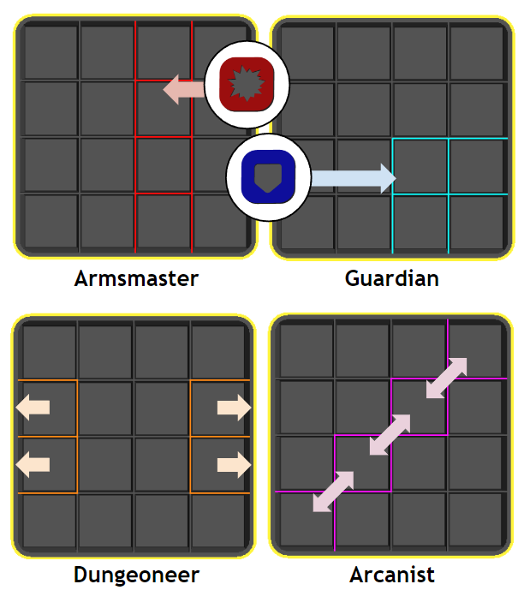

Adventurer Origins

An Adventurer’s Origin determines the first die they will receive. Once you decide on an Origin, find the corresponding Origin Dice and add it to your Dice Tray.
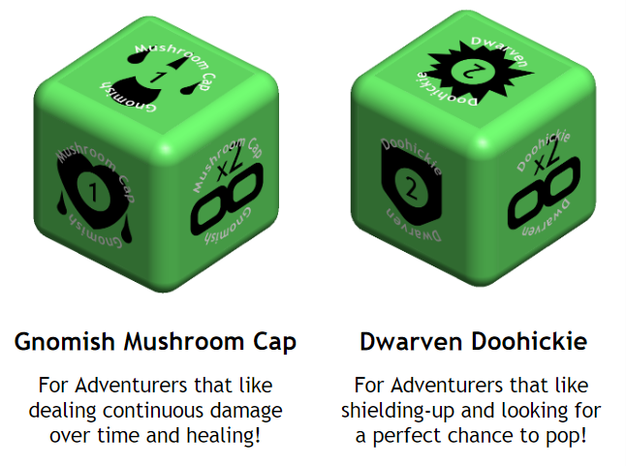

Starter Die

After deciding on your Adventurer Classes and Origins, it is time to fill the rest of the Dice Trays. Find the level 1 Attack Dice and level 1 Maneuver Dice in their respective bags and add 7 of each into the Dice Trays. Finally, choose either 1 additional Attack or Maneuver Dice to add to the Dice Trays. There should now be 16 dice inside.

For example: A Gnome Arcanist, would start with the loadout shown in the first image below. A Dwarf Dungeoneer, would start with the loadout shown in the second image below.

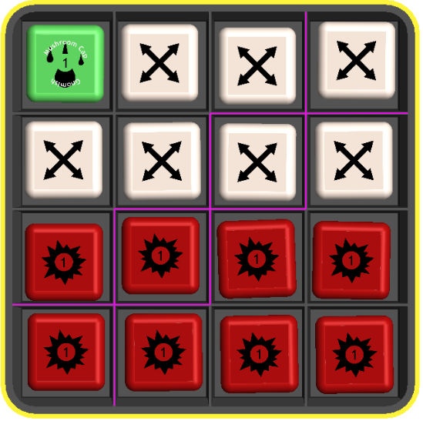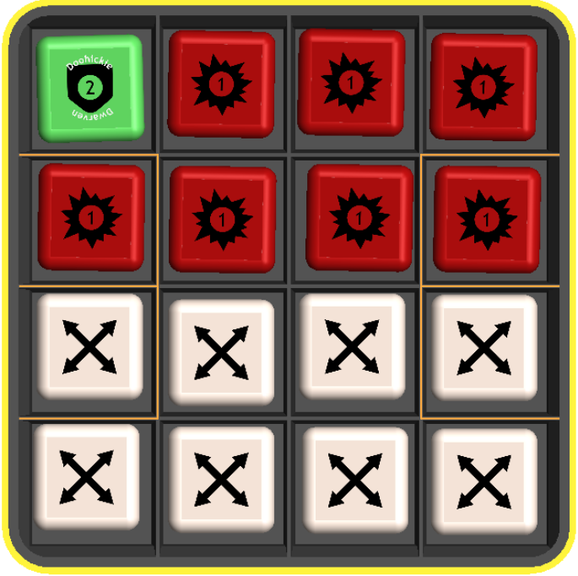

Gameplay

Though it is unknown what exactly lies beyond the next dungeon door, the Adventurers have an idea of the best route through each floor, represented by the route at the top of the Dungeon Board. The route is made up of the following events:

- Camping (Start)
- Encounter x3
- Camping
- Encounter x2
- Floor Boss
- Move to the next floor and repeat!

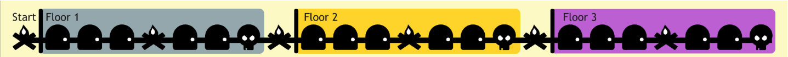

Encounters make up the majority of the crawlable dungeon, representing the contents of its many rooms. As such, Encounters will be explained first, with Camping and Bosses explained after.

Encounters

The various obstacles you will face in the dungeon are represented by cards in the Encounter Decks. For each door the Adventurers reach on the Location Tracker, encounters are drawn and placed face-up on the Active Encounter section of the Dungeon Board. The number of Encounters drawn is equal to the number of Adventurers, and the Encounter Health is the sum of the individual Encounter Health values combined. Bigger groups attract more attention!

There is 1 Encounter deck for each floor of the Dungeon.

Encounter Cards

- Encounter Name
- Encounter Type: Encounters are either a Foe, Trap, or Shrine.
- Special Rules: Some encounters have starting conditions (i.e. beginning battle with some amount of Shield) or react to certain Adventurer Actions. Details for these cases will be shown in the Special Rules section, if applicable.
- Quests: If checkboxes are present on the card, Quests are available. The first part of a quest shows how much damage completing it will deal to the Encounter. The second part shows the conditions which need to be met. In the case of Shrines, only a boon is shown. Each Foe or Trap that has Quests also tracks a Quest Health value alongside its Health -- this is the maximum total damage that Encounter can lose from Quest bonuses across the whole fight, no matter how many Quests are completed. Once an Encounter has lost its full Quest Health to bonus damage, completing further Quests still counts but grants no additional damage.
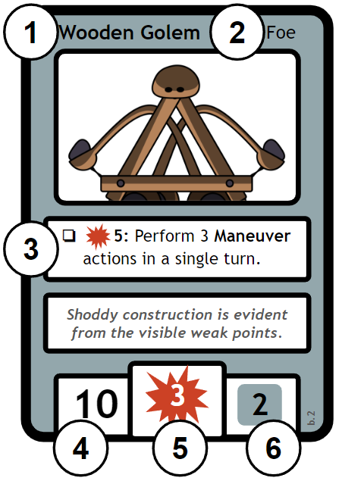
- Starting Encounter Health: Whenever an Encounter is drawn, match the Encounter Health and maximum health trackers on the Dungeon Board to the Starting health on the card.
- Encounter Action(s): Each turn, during the Encounter Action phase, the listed Actions are taken by the Encounter and applied to the Adventurers. (see: Action Symbols, below)
- Loot Reward Options: If the Adventurer defeats an Encounter, the number and color of this value indicate how many, and of what type, of Loot Dice to draw. From this pool, the Adventurers choose one each. (see: Encounter Defeated, below)

Remember: Upon drawing an Encounter Card, place counters on the Encounter Board to indicate the health and maximum health of the Encounter.

Foes

The most common type of Encounter, Foes are the denizens of the dungeon who are less than ecstatic about the Adventurers’ foray into their territory, and will spring to defend their treasure!

Some Foes have one or more Quests shown on their card in the form of a checklist. These quests reward the Adventurers with bonus damage (often significant) for accomplishing a specific task. These can vary from performing a number of specific Actions in a single turn to simply surviving a set number of turns. Each Quest can only be completed once per Encounter, use marker cubes to keep track.

Traps

The Trap type of Encounter represents an obstacle exceedingly difficult to overcome by dealing damage alone. Completing Quests is the best way to survive these Encounters, and the Adventurers may need to complete multiple in order to escape or disable the trap.

Shrines

Occasionally the Adventurers will come across a Shrine, which may bestow a valuable boon! These have no Health, Actions, or Loot Choices, but instead allow the Adventurers to gain the permanent upgrade described on the card. If a Shrine is drawn at the same time as another Encounter (such as in games with 2 or more Adventurers), that Foe, Trap, or Boss, must be defeated before the effect of the Shrine is gained. The Adventurers then move to the next room as when defeating an Encounter.

Combat Order

Whenever the Adventurers come across a Foe or Trap, Combat begins. Combat is organized into rounds made up of the following steps:

- Adventurer Upkeep
- SCRAMBLE
- Pathing
- Mathing
- Encounter Upkeep
- Encounter Action

Steps 1-4 are the Adventurers Turn and Steps 5-6 are the Encounter Turn.
At any point, if the Encounter or Adventurers Health reaches 0, it is defeated and combat ends. See the After Combat Section.

1. Adventurer Upkeep

If any of the Adventurers Status Trackers are higher than 0, this is when their status effects are resolved and applied to the Adventurers Health Tracker. Note: In the first round, there is usually nothing to upkeep.

2. SCRAMBLE

Now comes the Adventurers turn. Each Adventurer closes the lid of their Dice Tray and gives it a vigorous shake, followed by a few seconds of panning to get the best SCRAMBLE. Then they reopen the Dice Tray.

3. Pathing

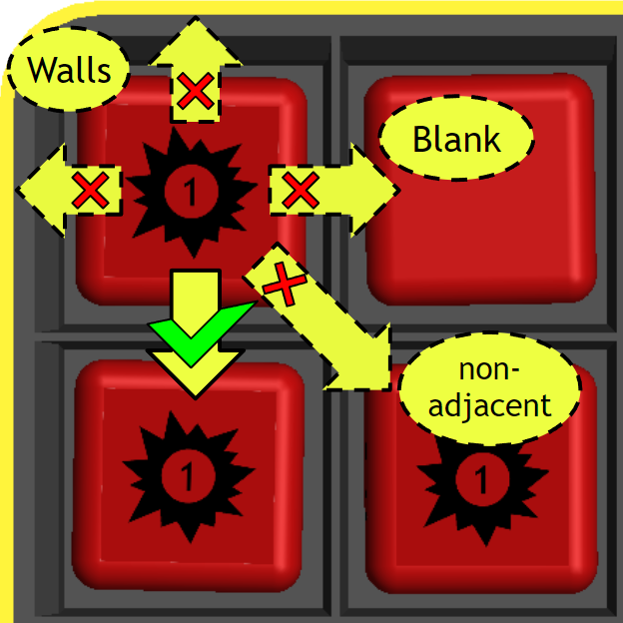
The Faces of the SCRAMBLE’d Dice will either be blank, or have an Action Symbol showing. It is up to the Adventurers to work with what the fates have given them and choose a Path of Action (or simply, Path) through the SCRAMBLE’d Actions, activating them in order to gain their effects in combat. The Path can start on any Action in the Dice Tray, and must connect continuously to other Actions until no more can be reached.
A few rules apply to all Actions unless stated otherwise:
- All Actions (except Maneuver Actions) allow for the Path to continue ONLY into an adjacent Action exactly one cube over.
- Blank spaces cannot be used as part of a Path.
- Walls of the Dice Tray cannot be used as part of a Path.
- A Cube’s Action can not be used more than once in the same Path. (i.e. no repeats!)

Adventurer Action Symbols

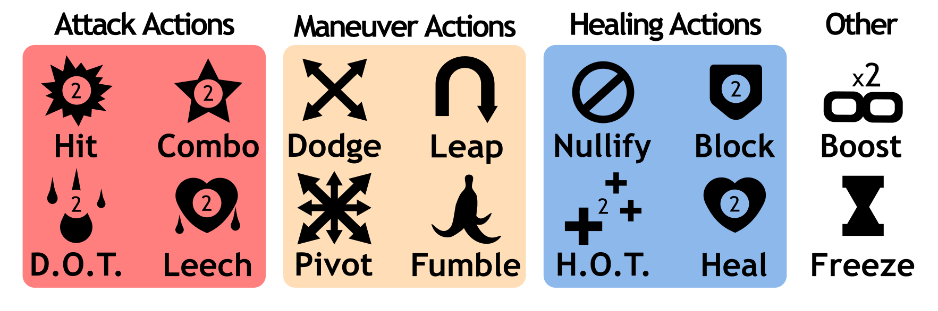

Note: Some Actions mention other subsets of Actions - these categories are indicated by the groups above. Attack Actions are highlighted in red, Maneuver Actions are highlighted in cream, and Healing Actions are highlighted in blue.

Attack Actions:

- HIT: Deal 1 damage per Action Value.

- COMBO: Deal 1 damageper Action Value, PLUS damage equal to the number of each adjacent Attack Actions per Action Value.

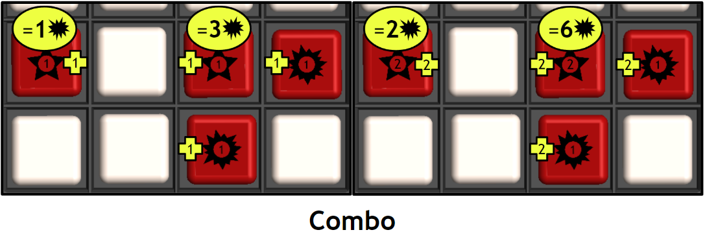
In the first example above, a lone COMBO is worth its Action Value, 1. In the second example, the COMBO is touching two HITS, thus is worth 3 (1+1+1). In the third example, another lone COMBO is worth its Action Value, this time 2. In the final example, the COMBO touching two HITs is worth 6 (2+2+2)

Note: If determining the value of a COMBO is proving tricky, try by starting with your finger on the Action Value of the COMBO, then add that value again for each adjacent attack action you count with your finger.

- D.O.T.(Damage over Time): Increase the Encounter D.O.T. by 1 per Action Value. During each Encounter Upkeep, deal damage equal the Encounter D.O.T. Tracker. If the Encounter D.O.T. tracker is maxed out at 9, every additional D.O.T. applied deals 1 damage instead.

- LEECH: Increase the Encounter D.O.T. and the Adventurers H.O.T. by 1 per Action Value. During each Encounter Upkeep, deal damage equal the Encounter D.O.T. Tracker. During each Adventurers Upkeep, increase Adventurers Health by the current Adventurers H.O.T. (up to Maximum Health). If the Encounter D.O.T. tracker is maxed out at 9, every additional D.O.T. applied deals 1 damage instead.

Maneuver Actions:

- DODGE: Allows for the Path to continue ONLY into a Diagonal Action, one cube over.

- LEAP: Allows for the Path to continue ONLY into an Adjacent Action, exactly two cubes over. The Action that is “skipped-over” is not counted, and may still receive the Path this round.

- PIVOT: Allows the Path to continue to any adjacent or diagonal Action, one cube over.

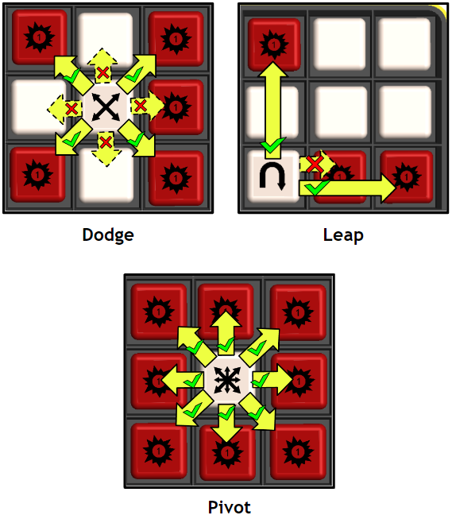

- FUMBLE: Increase the Adventurers D.O.T. by 1 per Action Value. Whoops! On the plus side, the path can still continue adjacently.

Healing Actions:

- BLOCK: Increase the Adventurers Block by 1 per Action Value. Whenever the Adventurers receive damage, reduce that damage by the current Adventurer Block. For each damage prevented, lower Adventurers Block by 1.

- HEAL: Increase the Adventurers Health by a 1 per Action Value (up to their Maximum Health).

- H.O.T.(Heal over Time): Increase the Adventurers H.O.T. by 1 per Action Value. During each Adventurers Upkeep, increase Adventurers Health by the current Adventurers H.O.T. (up to Maximum Health). If the Adventurers H.O.T. tracker is maxed out at 9, every additional H.O.T. applied increases the Adventurers Health by 1 instead (up to their Maximum Health).

- NULLIFY: Remove all minions, OR all D.O.T.s from the Adventurers OR all H.O.T.s from the Encounter.

Other Actions:

- BOOST: Multiply the effect of the next adjacent Attack Action or Support Action by the Action Value. Only Actions that deal damage or healing benefit from Boost (Hit, Combo, D.O.T., Leech, Heal, H.O.T.) -- Block does not, even though it is a Support Action. The effect dissipates across non-Attack Actions and must be immediately used unless the Path continues through another BOOST. In this case, the effects multiplied.
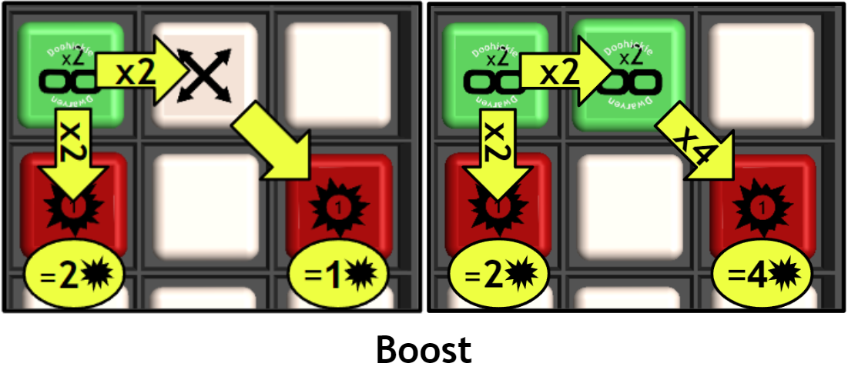
- FREEZE: Place a Freeze Token on one active Encounter. This encounter then skips the next Encounter Action Step. (Encounter Upkeep still occurs)

Note: To keep track of particularly tricky Paths, make use of the Path Flags to mark out your path. Simply place them in the Dice Tray slot next to a chosen die.

4. Mathing

Once the Adventurers have settled on their Paths, the next step is to apply the effects! All Path Actions are totalled up, and occur simultaneously at the end of this step. The results are tracked on the Adventurers and Encounter Trackers.

If the Adventurers manage to defeat an encounter by dealing damage equal to 10 greater than necessary, an Overkill Reward is also gained. This Overkill Reward allows the adventurer to add +1 to the Encounter Loot Reward value.

Example SCRAMBLE

The COMBO in the bottom-right of the Dice Tray is chosen as the starting point. The Path continues up through a chain of Attack Actions, and then uses a LEAP and a DODGE to reach an additional HIT. From this point, there are no more legal moves available, so the next step is to total up the damage.
All Actions rolled have an Action Value of 1. The starting Combo has a is adjacent to 1 other Attack Action, so it deals 2, and the next COMBO is adjacent to 2 Attack Actions, so it deals 3. There are also 3 HITs, which deal 3combined. In total, this Path dealt 8 damage.

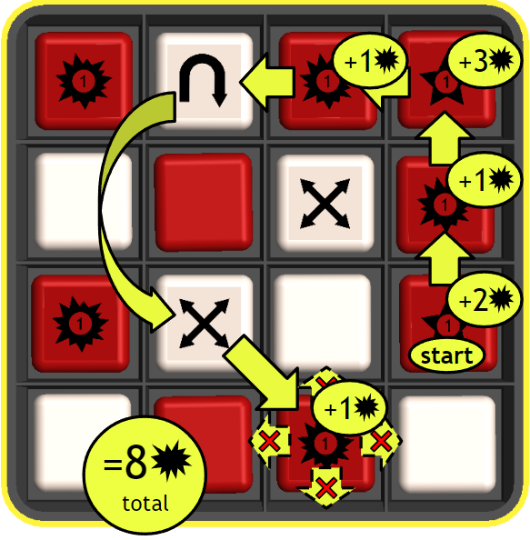

5. Encounter Upkeep

If any of the Encounter Status Trackers are higher than 0, this is when their status effects are resolved and applied to the Encounter Health Tracker.

6. Encounter Action

Now comes the Encounter turn. The Encounter Action(s) shown on the card(s) are applied.

- HIT: Decrease the Adventurers Health by the number shown in the Encounter Action.
- D.O.T.: Increase the Adventurers D.O.T. by the number shown in the Encounter Action.
- BLOCK: Increase the Encounter Block by the number shown in the Encounter Action.
- HEAL: Increase the Encounter Health by the number shown in the Encounter Action.
- MINION: Force the Adventurers to temporarily replace a Dice in their Dice Trays with a blank Minion Die per the number shown in the Encounter Action. This Die always counts as a blank. Minions can be removed with the NULLIFY Action, or by applying HITs to them (they have 1 health)

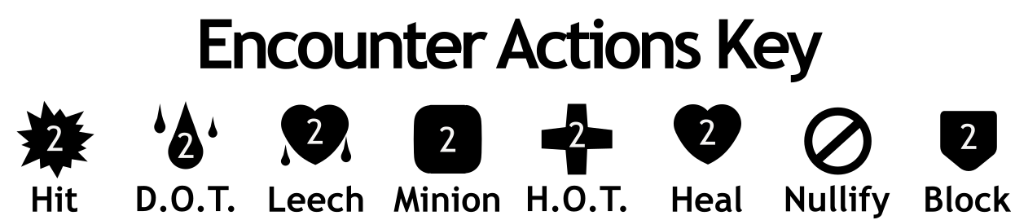

After the Encounter Action is taken, a new Round begins with Step 1.

After Combat

After the dust of combat has settled, there are two possible outcomes:

Encounter Defeated

If the Encounter Health Tracker reaches 0 Health, the Adventurers are victorious and get to draw the number of Loot Dice indicated on the Encounter Card. They pick one to take as a reward, and place the others back into the loot bag. The chosen Loot Die is then used to replace a dice in the Dice Tray. The leftover Die is placed into the Back Pocket for later. All Statuses are reset to 0 (H.O.T, D.O.T., BLOCK, turn number). The Adventurers then move the Location Tracker to the next event, continuing the game.

Note: For co-op and larger groups, draw dice based on the best Encounter Loot Reward out of the defeated encounters, then each Adventurer picks one as a reward.

Adventurers Defeated

If the Adventurers Health Tracker reaches 0 Health, they may have to get desperate. If there are any dice in anyone’s Back Pockets, roll one at a time on the table.
If the die rolls any Action, 5 Health is restored to the Adventurers, and the die is removed from play (placed back in its bag). The round then continues as normal.

If the die comes up Blank, nothing happens and that die is removed from play (placed back in its bag).

If there is nothing left in the Back Pocket, the Adventurers are forced to ditch their loot and retreat hastily back to town in temporary defeat. Fortunately, they have the cunning to snag 1 of their collected Loot Die to take with them! This Loot Die can be added to the Dice Tray during the next Adventurer Creation to provide an advantage against the Dungeon!

Camping

In between some Encounters and after Bosses, the Adventurers find some time for respite and reorganization. For each  reached on the Location Tracker, the Adventurers can choose any or all of the following options:

- Organize Die: Freely exchange Dice between the Dice Tray and the Back Pocket.
- Upgrade Basic Die: 3 Basic Die of the same type may be converted into a single Basic Die of one level higher. For example, three lvl 1 Attack Dice can be upgraded to one lvl 2 die, and eventually, three lvl 2 Attack Dice can be upgraded to one lvl 3 die.
  - Adventurers may only do 2 upgrades per turn - 1 Attack Die and 1 Maneuver Die.
  - Loot Dice may be used as lvl 1 “wild” dice, counting as either a lvl 1 Attack or lvl 1 Maneuver die for the purposes of upgrading.
- Rest: At the end of camping, choose one Adventurer to SCRAMBLE their finalized Dice Tray and count the number of Actions shown. The Adventurers gain Health equal to half that number (rounded up).

Boss Encounters

Before the Adventurers can move on from one floor to the next, they need to get through a Boss Encounter guarding the way. These extra-powerful adversaries are represented by cards in the Boss Encounter Decks. For each reached on the Location Tracker, a Boss card is drawn and placed face-up on the Active Encounter section of the Dungeon Board. For each Adventurer beyond the first, reinforce the Boss with an additional Encounter from the current floor.

Bosses behave like other Encounters, though are generally much tougher than anything else found on their floor. Instead of attacking with the same Encounter Action each turn, Bosses cycle 1 at a time through the Actions shown on the Boss Encounter Card.

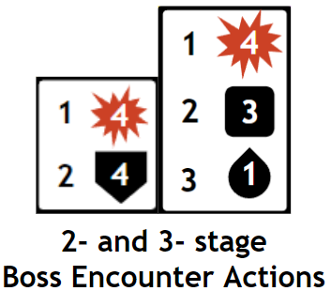

There are 2 Boss Decks, one each for floors 1 and 2 of the Dungeon. The first time each Boss is defeated, find their sealed reward card and unseal it. The Shrine contained inside can be shuffled into the corresponding floor Encounter Deck, providing boons in subsequent runs.

Big Boss Encounter

The Big Boss of a Dungeon is a singular threat, often infamous throughout the surrounding lands for their cruelty and dominion. Upon reaching the final at the end of Floor 3, find the Big Boss Dial-Card and place it face-up on the Active Encounter section of the Dungeon Board. Like the other Encounter Cards, it indicates the

Image of Dial-Card

Explanation of moving dials for damage and attacks. Attacks change as damage is taken? Like phases?

Game End and Saving

Once the Adventurers defeat the Big Boss and gain its Big Boss Loot Die, that die may be added to the pool of Origin dice available for Adventure Creation. This represents an Origin themed after respective Big Bosses.

At any time, a game may be “Saved” by simply marking the location of the Adventurers and Storing their Dice inside of the Dice Trays. Sometimes you need a real long rest!

Additional Rules

Story Mode

You may choose to progress through the dungeon in Story Mode. This allows for certain themes or narratives to play out in the Encounters and Bosses, or for more control over difficulty. To accomplish this, instead of randomly shuffling the Encounter Decks during setup, use one of the following Card lists to create a static lineup.

Dwarf story
Gnome story
Hardest
easiest

Endless Mode

Want to dig deeper? Want to see how deep a full Dice Tray of Magic and Boss Dice can take you?

Sweaty Rules

Seeking an even steeper challenge? When creating an Adventurer, pick an Origin Die and only 7 Basic Die.

Comfy Rules

Don’t want to deal with the whole table setup and just want to make a bunch of noise on the couch? Cutting edge gnomish research has brought us the Cozy Ruleset! Create your Adventurer as in a normal game, but leave the cards and mats for the uncomfy. You now begin your turn by Scrambling your Dice Tray and seeing how much damage you are capable of dealing in a turn. If that damage exceeds the Loot Dice values shown below, then add a random of that Loot Die to your Dice Tray, putting the replaced dice back in their bags. See how high of a score you can get before you pass out from being in a slightly leaning position!

Damage Scores to Loot Table
5+ --- Alloy Dice
8+ --- Gilded Dice
12+ --- Magic Dice
20+ --- Boss Dice

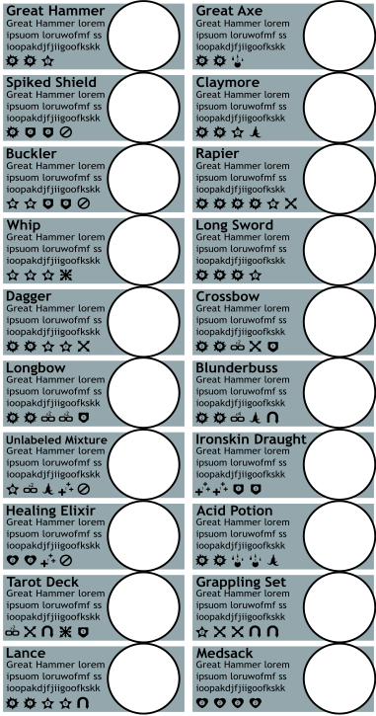

Loot Almanac
Lorem ipsum mf’ers

Image of Loot names, small icon, and flavor text

Index

Adventurer -
Dice Tray-
Basic Dice -
Loot Dice -
Action -
Action Magnitude -
SCRAMBLE -
Path of Actions -
Camp -
Boss -
Big Boss -
Encounter -
Foe -
Trap -
Shrine -
First Floor-
Second Floor-
Final Floor-
Attack Action -
Maneuver Action -
Origin -
Class -
Adventurer Health Tracker -
Adventurer Status Tracker -
Encounter Health Tracker -
Encounter Status Tracker -
Encounter Deck -
Adjacent -

Reference Sheet

Fill at end with Icons, turn order, etc

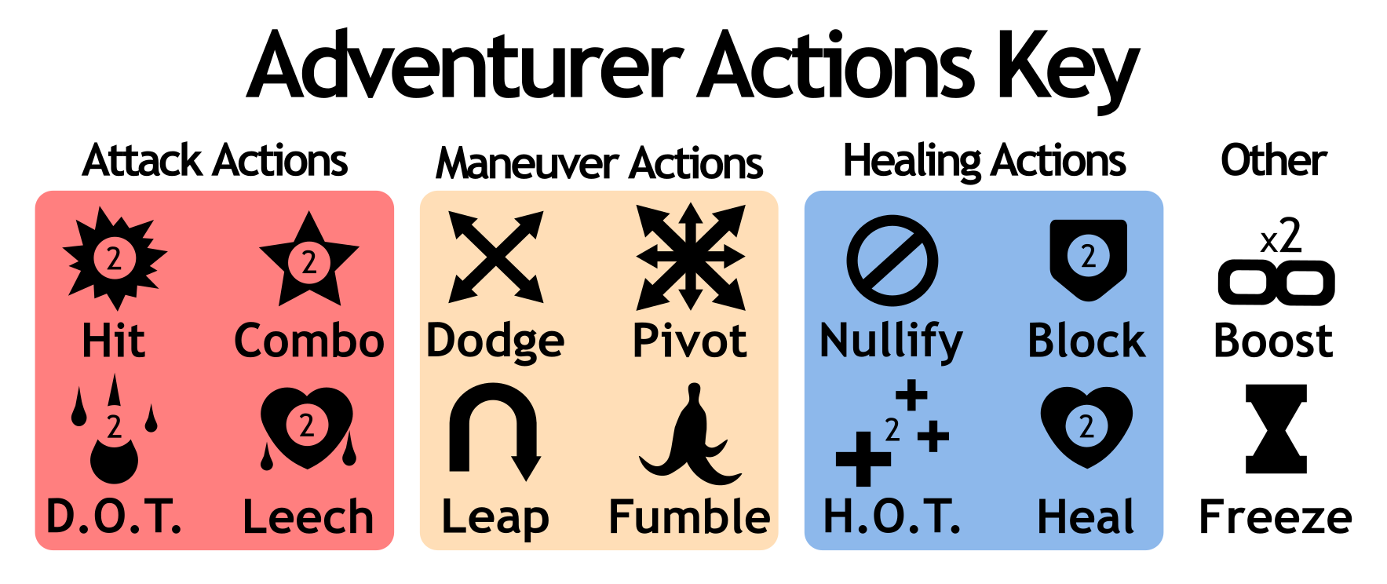
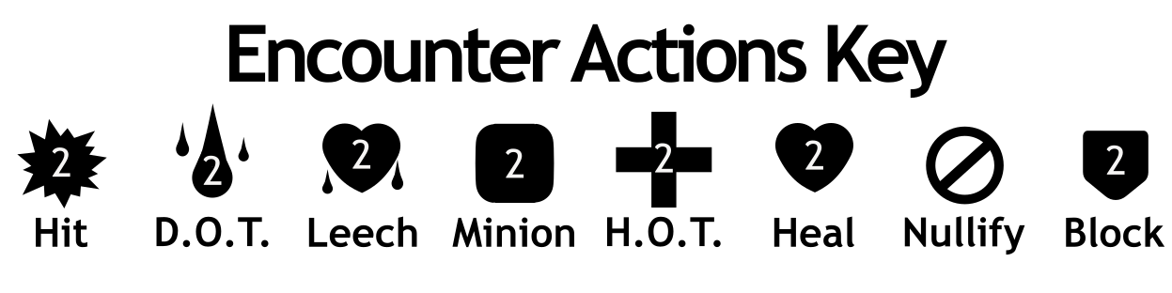

Example SCRAMBLE

The COMBO in the bottom-right of the Dice Tray is chosen as the starting point. The Path continues up through a chain of Attack Actions, and then uses a LEAP and a DODGE to reach an additional HIT. From this point, there are no more legal moves available, so the next step is to total up the damage.

