Dungeon Scramble Rulebook
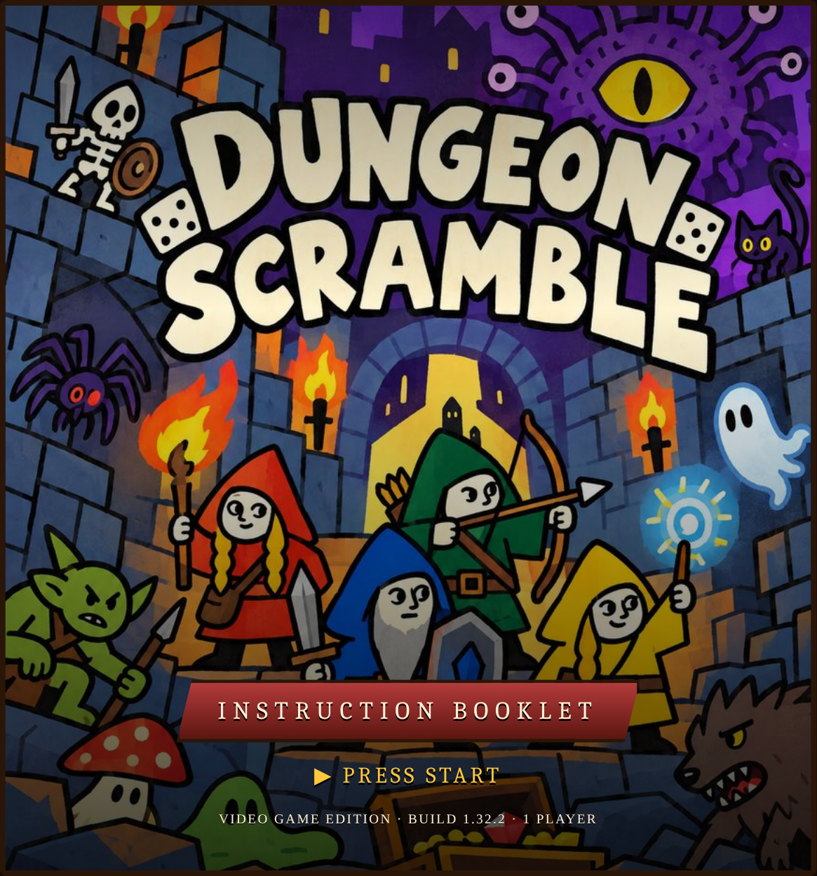

Table of — Contents
- Goal & Run at a Glance1
- Starting a Run2
- The Dice3
- Taking a Turn4
- Actions & Statuses5
- Encounters6
- After a Fight7
- Camp8
- Relics9
- Defeat10
- Progression & Records11
- Quick Reference12
- Dice ReferenceA

Chapter 1 — Goal & Run at a Glance
You are one Adventurer. Fight through three dungeon floors and defeat the Big Boss at the bottom.
Each turn your 16 dice are scrambled into a 4×4 Tray. Tap out a Path through the faces to attack, defend and heal. Every fight is a small puzzle; every victory is a new die or relic to build with.

The Route
Every floor is the same eight stops, shown on the Route bar at the top of the screen. Long-press any stop to see what it is.
Camp · Room ×3 · Camp · Room ×2 · Boss
A room is an Enemy, a Trap or a Shrine, and you only learn which when you open the door. The first room of a run is always an Enemy. Between two Camps (or a Camp and the Boss) you meet at most one Trap and one Shrine.
Floor | Loot | Enemy Health | Trap Health | Boss
1 | Alloy | 7 – 15 | 25 | Rogue Golemancer, Heating Elemental or Grosteque Grafter
2 | Gilded | 14 – 26 | 30 | The Necrorancher, Bellicose Biomancer or Ceramic Golem
3 | Magic | 14 – 38 | 40 | Big Boss: Extruzeon or Myceleus
HOW YOU WIN. Defeat the Big Boss. The run ends in defeat only when your Health hits 0 and you have no Back Pocket dice left to roll. See Chapter 10.

Chapter 2 — Starting a Run
On the character screen pick an Origin and a Class, optionally name your Adventurer (the name is cosmetic) and press [Enter the Dungeon]. You start with 20 Health, an empty Back Pocket, and a Tray of 16 dice: 8 Attack Die I, 7 Maneuver Die I and your Origin die.

Choose your Origin
Your Origin sets your signature die.
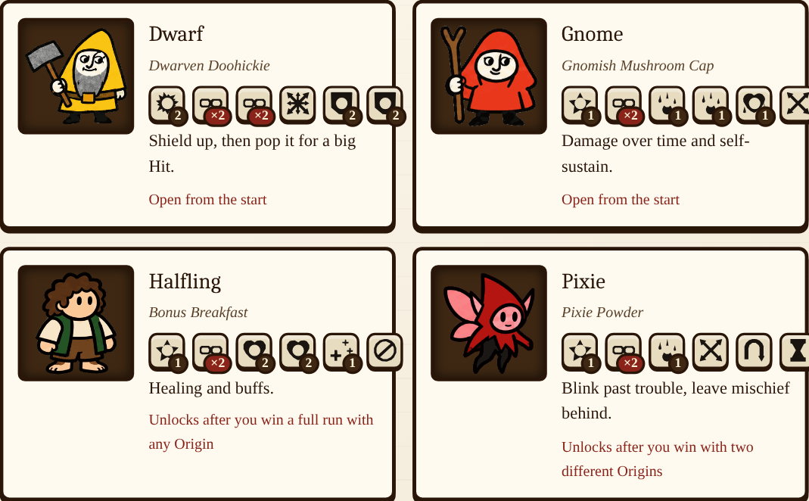

Choose your Class
Your Class gives you a zone on the Tray, highlighted in the Class color, and one ability that works inside it.
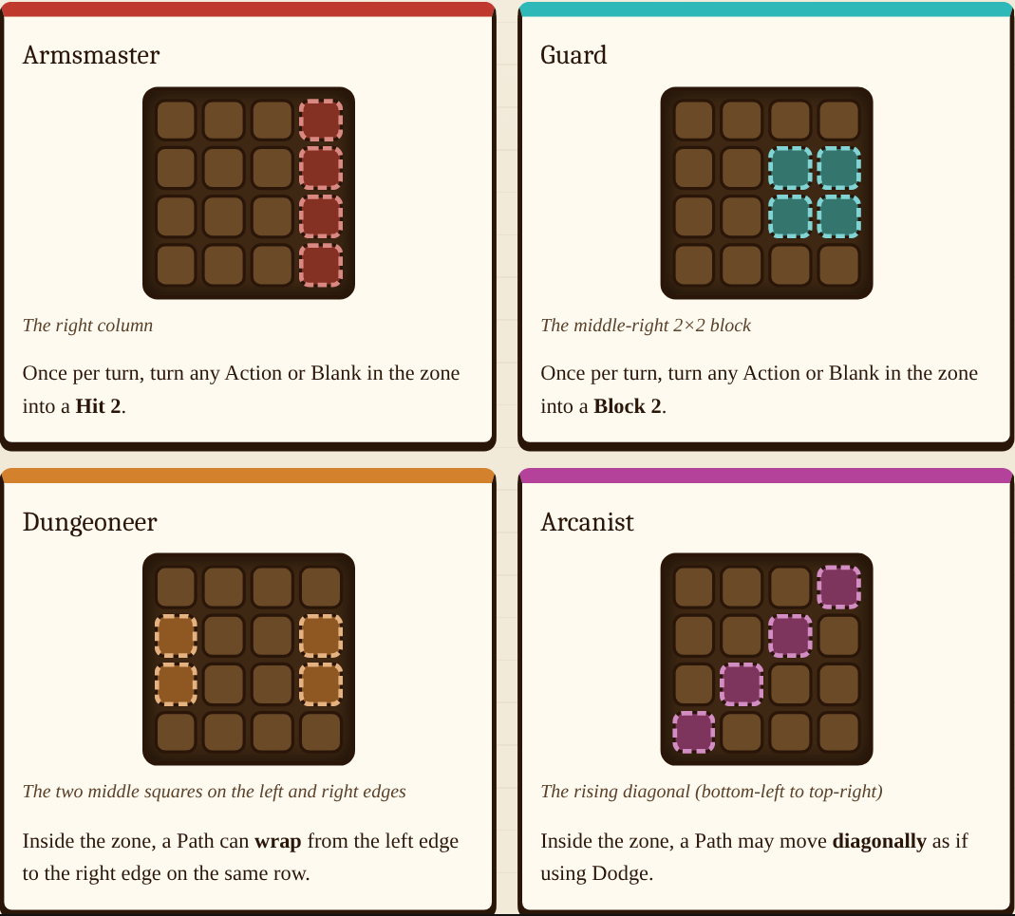
USING A CLASS SKILL. For Armsmaster and Guard, press [Skill], then tap a die in your zone. The conversion lasts for that turn only.

Starting Boon
Once unlocked, you can swap one of your Maneuver Die I for a Loot die you have discovered. A die carried over from a defeat replaces your extra Attack Die I. See Chapter 11.

Chapter 3 — The Dice
Your power lives in your dice. Sixteen sit in the Tray and are scrambled every turn; any others wait in the Back Pocket. Each die has six faces, each either blank or an Action with a value. Long-press any die to read what its face does.
Die | What it is | Faces
Attack Die I | Basic damage die | 
Attack Die II | Basic damage die | 
Attack Die III | Basic damage die | 
Maneuver Die I | Basic movement die | 
Maneuver Die II | Basic movement die (adds a Pivot) | 
Maneuver Die III | Basic movement die (two Pivots) | 
Origin die | One per Adventurer | See Chapter 2
Alloy Loot dice | Common loot, Floor 1 | 20 dice
Gilded Loot dice | Rare loot, Floor 2 | 20 dice
Magic Loot dice | The strongest, Floor 3 | 12 dice
Basic dice show their level (I, II, III). Loot dice show the name of the item. Every Loot die is in the Dice Reference at the back.

The Back Pocket
The Back Pocket holds every die that is not in your Tray. Dice land there when a new Loot die replaces them, and you can swap them back at Camp. They are also your safety net: when your Health hits 0, the game rolls a random Back Pocket die for you. Open it any time with [Pocket].

Chapter 4 — Taking a Turn
A fight is a series of rounds (the Round counter sits above the Tray). Combat ends the instant either side reaches 0 Health, even mid-round.
- Scramble. Every die takes a random face. This happens when a room opens and at the end of every round.
- Build a Path. Tap a die to start, then tap neighbors to extend. Tap the last die again to step back one. [Clear] removes the whole Path. A running damage total and any Lethal or Overkill hint update as you build.
- Go. Your Path resolves one die at a time, in the order you tapped. [Skip] fast-forwards the animation without changing the result.
- The reply. Enemy takes its D.O.T.; enemy heals from its H.O.T., then acts (unless frozen); then you take your own D.O.T. and receive your H.O.T.
- New round. Fresh Scramble. Back to step 2.

Example Path
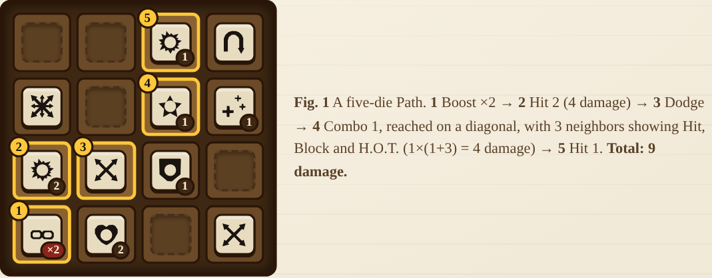

Path Rules
- A Path may start on any die showing an Action. Blanks can never be part of a Path.
- A die can be used only once per Path.
- After most dice the next die must be directly up, down, left or right. Maneuvers change this:
- Dodge → next die is diagonal Leap → exactly two squares away in a straight line (jumps the square between) Pivot → any of the eight neighbors
- Your Class zone can add moves (Chapter 2).
- You may press [Go] with a Path of just one die. If every die is blank, Go lets you pass the turn.
- Dice covered by a Minion count as blanks.

Tokens
Shrines hand out one-use tokens, used from the [Item] button during a fight (not mid-resolution):
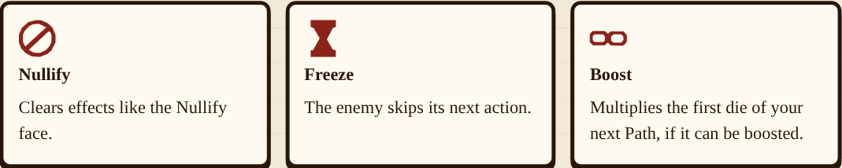

Chapter 5 — Actions & Statuses

Action Faces
Face | Name | Effect
 | Hit N | Deal N damage.
 | Combo N | Deal N × (1 + neighbors) damage. A neighbor is a die directly up, down, left or right of the Combo (in your Path or not) currently showing a Hit, Combo, Block, H.O.T. or D.O.T.
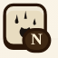 | D.O.T. N | Add N to the enemy's D.O.T.
 | Leech N | Add N to the enemy's D.O.T. and N to your own H.O.T.
 | Heal N | Heal N Health right now, up to your maximum.
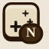 | H.O.T. N | Add N to your H.O.T.
 | Block N | Add N to your Block.
 | Boost ×N | Multiply the next Hit, Combo, D.O.T., Leech, Heal, H.O.T. or Block in your Path by N. Consecutive Boosts multiply (×2 then ×3 is ×6). Any other face in between wastes it.
 | Dodge | Path may continue to a diagonal die. No other effect.
 | Leap | Path may continue exactly two squares away in a straight line. Clears a Minion in the square it jumps over.
 | Pivot | Path may continue to any of the eight neighbors. No other effect.
 | Fumble N | Add N to your own D.O.T. (never multiplied by Boost). The Path continues normally.
 | Freeze | The enemy skips its next action. It still takes D.O.T. and heals from H.O.T.
 | Nullify | Clears all Minions. If none, clears your D.O.T. If you have none, clears the enemy's H.O.T.
Dodge, Leap and Pivot are Maneuvers. They do nothing alone but count toward many quests.

Statuses
Status | How it works
Block | Absorbs incoming damage point for point and is used up as it does. It lasts for the current fight only.
D.O.T. | At round end the holder takes damage equal to its D.O.T., then it drops by 1 (3 deals 3, then 2, then 1). Your own D.O.T. ignores Block.
H.O.T. | At round end the holder heals equal to its H.O.T., then it drops by 1. Never above maximum Health.
Shield (enemy) | Some enemies gain Shield, which soaks up the damage you deal (Hits, Combos and quest bonuses) before their Health is touched. D.O.T. ignores Shield.
Minion | Covers a random die in your Tray so it counts as a blank. Each Hit that resolves removes one Minion, as does a Leap over it, or Nullify (all of them).
RESETS. Every status resets when a new room opens: your Block, D.O.T. and H.O.T., and all of the enemy's statuses. Only relics that grant Block at the start of a fight (Vanguard Banner, Forgeplate) give you any. An armed Boost shows as a gold chip on your status row; long-press any status chip to read it.

Chapter 6 — Encounters
Every door opens onto one Encounter. The doorway shows its name, Health bar, what it does each turn, and any quests.

Enemies & Traps
Enemies are the dungeon's ordinary defenders. Traps have more Health (25, 30 and 40 by floor) and are meant to be beaten with quests rather than raw damage. Each turn an Enemy or Trap performs every action on its card in one go: it hits you, gains Shield, heals, channels H.O.T., adds to your D.O.T., or summons Minions.

Quests
Most Enemies and every Trap list quests. Completing one deals its bonus damage at once (or grants its listed effect). Quests are checked once your Path finishes, so "3 maneuvers" means three Maneuver faces in one Path. Each quest counts once per fight. An Encounter's Quest Health caps the total bonus damage its quests can deal.
Quests ask for: a number of Maneuvers, Dodges, Leaps, Pivots, Heals or Blocks in one Path; blank dice left unused; a Path of a certain length (or a short one); a damage total in one turn; or surviving until a certain turn.

Shrines
A Shrine is a room without a fight. Take its boon and walk on.
Floor | Shrine | Boon
1 | Sacred Bellows | Upgrade Player Maximum Health by 5.
1 | Expediting Spores | Upgrade a lvl 1 Maneuver Die to a lvl 2 Maneuver Die.
1 | Ecclectrical Outlet | Trade in loot for one of three Alloy dice options.
1 | Half-Empty Fountain | Heal 10 OR Upgrade Player Max Health by 5.
1 | Scroll Dispenser: CLEAR | Gain a one-use Nullify token (x3).
2 | Enchanted Anvil | Upgrade a lvl 1 Attack Die to a lvl 2 Attack Die.
2 | Alchemists Stone | Upgrade Player Maximum Health by 10.
2 | Department Spore | Choose one of three Relics.
2 | Half-Full Fountain | Heal 15 OR Upgrade Player Maximum Health by 10.
2 | Scroll Dispenser: BIG | Gain a one-use x4 Boost token (x2).
3 | Scrying Spheroid | Replace a loot die with a random Magic die.
3 | Heron's Fountain | Upgrade Player Maximum Health by 15.
3 | Storied Emporium | Choose one of three Relics.
3 | Scroll Dispenser: STOP | Gain a one-use Freeze token.
If you already own every Relic, a Relic Shrine heals 10 instead.

Bosses
Bosses guard the end of each floor. A Boss does one thing per turn, cycling in this order through only the actions it has: hit, summon Minions, gain Shield, channel H.O.T., heal, add D.O.T. A Boss fight also offers three Loot choices.
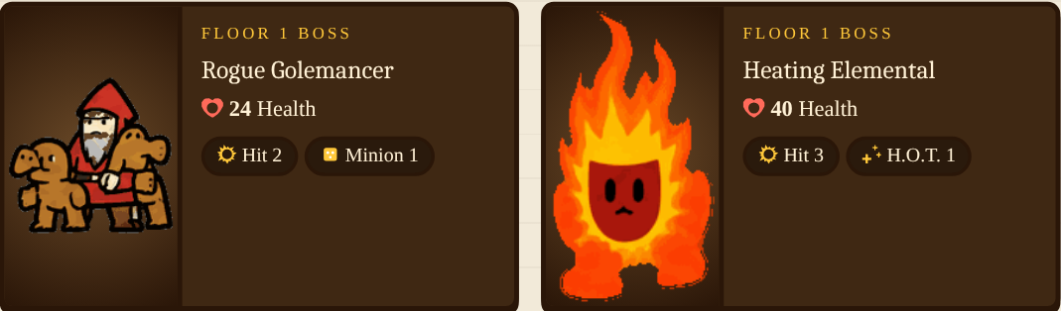
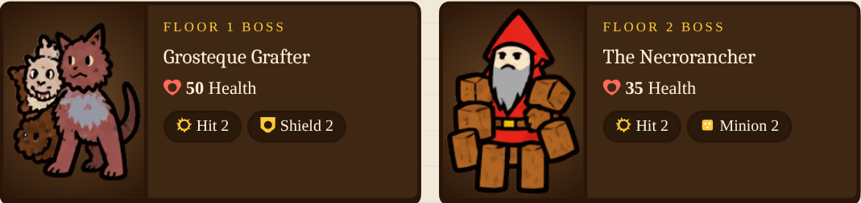
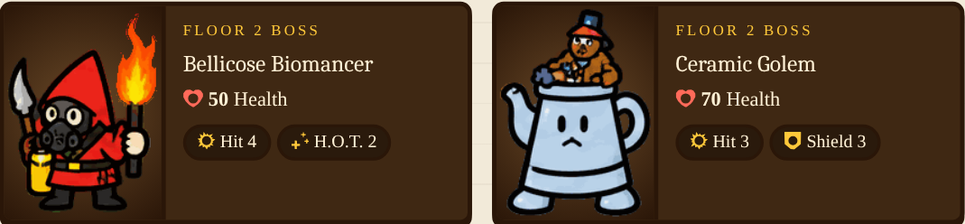
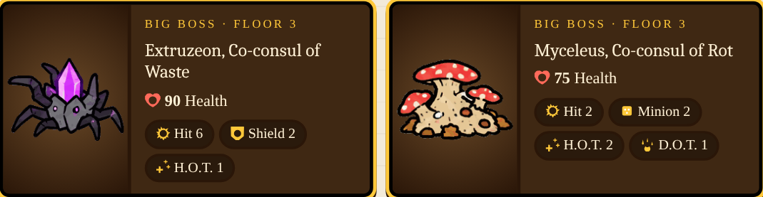

Chapter 7 — After a Fight
When an Encounter reaches 0 Health it falls and a loot chest appears. The chest holds one pip for each die inside; tap it to open, then pick one die.
Source | Dice to choose from
Enemy or Trap | 2
Boss or Big Boss | 3
Overkill | +1
Lucky Coin relic | +1
Dice come from your floor's tier (Alloy, Gilded, Magic). You will not be offered a die you already own this run until the whole tier has been seen. Dice you've never seen carry a NEW tag.
OVERKILL!. If the killing blow carries 10 or more damage past what was needed (6 with the Hungry Blade relic), you score an Overkill: a callout banner, a bigger chest, and one extra die to choose from. While building a Path the game warns you in advance with a Lethal or Overkill hint.
Taking the die. After choosing, pick one Tray die to replace. It goes to your Back Pocket, not the bin, so you can swap it back at Camp. Unchosen dice return to the pool.
NO FREE HEALING. After loot, your Health is not restored. The route moves on to the next room or Camp.

Chapter 8 — Camp
CAMP. Camp is your only chance to reorganize. Every floor has two: one at the start and one after the third room.
- Organize. Swap any Tray die with any Back Pocket die, as often as you like: tap one die in the Tray and one in the Pocket.
- Upgrade. Combine 3 matching Basic dice (same type and level, Tray or Pocket) into one a level higher, up to III. One Attack and one Maneuver upgrade per Camp. If dice leave the Tray you need enough spare Pocket dice to refill. Loot dice can't be upgrade material.
- Stay a While & Rest. Once per Camp the Tray is scrambled and you heal half the non-blank faces it shows, rounded up (Campfire Kettle adds 3). Resting also gives you a fresh scramble for the next room.
Press [Break Camp & Continue] when you are done.

Chapter 9 — Relics
Relics are permanent passive perks for the rest of a run. They take no Tray space and can't be lost or swapped. You can hold any number, never the same one twice. They show as badges above the doorway; tap to read, and watch them pulse when they fire.

Shrine Relics
Found at Relic Shrines (Department Spore and Storied Emporium). You are shown 3 you don't hold and keep 1.
Relic | Effect
Whetstone | Your first Hit each turn deals +2 damage.
Iron Rations | Heal 2 after every victory.
Padded Gambeson | Every enemy attack deals 1 less damage.
Lucky Coin | Loot rewards offer +1 die to choose from.
Campfire Kettle | Resting at Camp heals 3 extra.
Vanguard Banner | Start every fight with 3 Block.
Bottomless Flask | +8 maximum Health, immediately.
Echo Chime | A Path of 5 or more dice deals +3 damage.
Venom Vial | Every D.O.T. face you play adds +1 D.O.T.
Hungry Blade | Overkill triggers at 6 extra damage instead of 10.
Tincture Kit | Every Heal face you play heals +1.

Origin Relics
Never offered at Shrines. Winning a full run with an Origin earns that Origin's relic, and every later run as that Origin begins with it.
Relic | Effect
Forgeplate (Dwarf) | Start every fight with 5 Block.
Spore Satchel (Gnome) | Leech faces also add +2 D.O.T. and heal +1 more.
Picnic Basket (Halfling) | Heal faces heal +2 and H.O.T. faces add +1 H.O.T.
Glimmer Dust (Pixie) | Each Dodge, Leap or Pivot in your Path adds +1 damage to its last damaging die.
The Relic Codex (gear menu) lists every relic; ones you haven't found appear as locked mystery slots.

Chapter 10 — Defeat
When your Health reaches 0 the game checks your Back Pocket before ending the run.
- If the Pocket has dice, one is chosen at random and rolled.
- If it lands on any Action, you are restored to 5 Health and the fight goes on. The die is spent either way.
- If it lands on a blank, that die is lost and the game rolls another.
- When the Pocket is empty, the run ends.
CARRY A DIE FORWARD. On the Defeated screen you choose one die from the highest tier of Loot dice in your Tray to carry into your next run, where it takes the place of your extra Attack Die I.

Chapter 11 — Progression & Records
The game remembers every run on your device. None of this changes how a turn is played; it decides what a new Adventurer can start with, and celebrates what happened on the way.

Unlocks
- Origins. Dwarf and Gnome from the start. Halfling unlocks after you win with any Origin. Pixie unlocks once you've won with two different Origins.
- Origin Relics. Your first win with an Origin earns its relic. The victory screen announces it; the character screen shows it as a locked slot until then.
- Starting Boons. Swap your first Maneuver Die I for a Loot die you've discovered. Alloy after your first win, Gilded after reaching Floor 3, Magic after winning with every Origin. Tap the star on a die to favorite it.
- Carried die. The die you carry after a defeat is used in your next run only.

Records
- Achievements are lifetime milestones (win a run, win with every Origin or Class, land 10 Overkills, defeat 100 Encounters). They never change gameplay.
- Run Highlights. The end-of-run screen shows your biggest single turn, biggest Overkill, longest Path and Close Calls. A gold NEW BEST appears when one of the first three beats an earlier run.
- Close Calls. A turn that leaves a foe with 3 Health or less, or a kill 1 to 3 damage short of an Overkill, is called out on screen ("Just 2 HP left!"). Information only.
- Run History keeps your last 20 runs. The Dice Compendium lists every die you've discovered; the Relic Codex every relic.

Settings & Play Data
The gear menu holds sound, motion and vibration options, the Key (a glossary of icons), and Reset Progress, which erases all unlocks and records. Export Play Data packages your recent runs as a file for playtest feedback; nothing is uploaded automatically.

Chapter 12 — Quick Reference
Topic | Rule
Start | 20 Health · 16 dice · empty Pocket
Floor | Camp · 3 rooms · Camp · 2 rooms · Boss
Loot | 2 dice (3 for Bosses) · +1 Overkill · +1 Lucky Coin
Overkill | 10+ past lethal (6 with Hungry Blade)
Rest | ½ of non-blank faces, rounded up
Upgrade | 3 matching Basics → 1 a level higher
Revive | Pocket die rolls Action → 5 Health
Statuses | All reset when a new room opens
D.O.T. / H.O.T. | Trigger at round end, then drop by 1
Boost | Multiplies the next value face only

From the Tabletop
Dungeon Scramble began as a physical dice game. The video game keeps the rules but takes over the chores: it scrambles the dice, tracks every counter and cube, and shuffles the encounters. The tabletop's multi-Adventurer co-op (extra Health and summed Encounter Health per player) is not part of the video game; this is a solo experience.

Appendix — Dice Reference
Every Loot die in the game, with all six faces. Faces are tinted by tier.

Alloy Floor 1 Loot Dice (20)
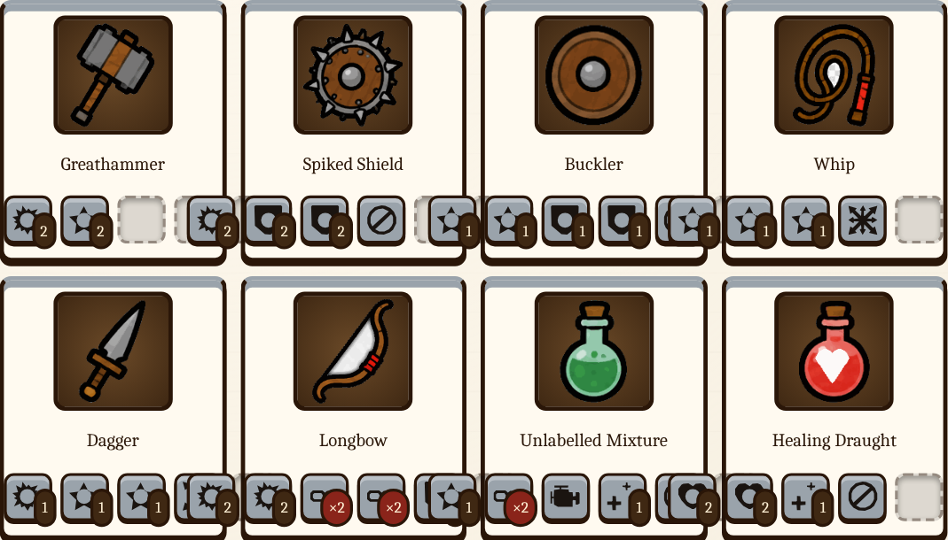
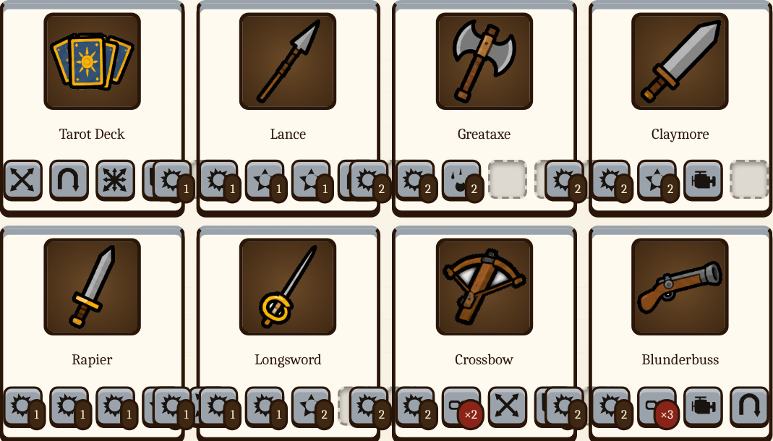
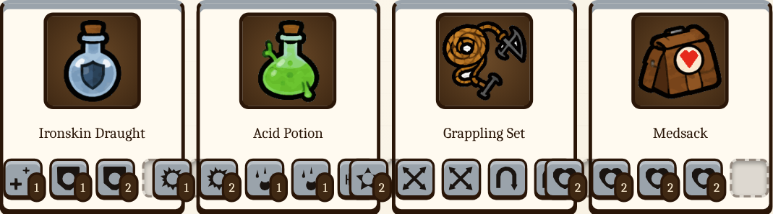

Gilded Floor 2 Loot Dice (20)
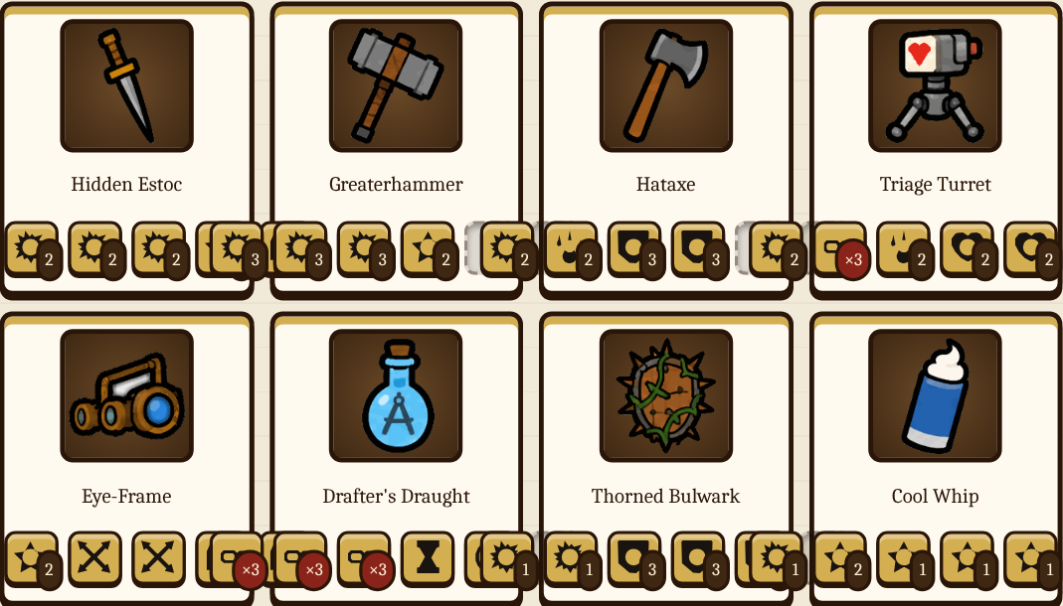
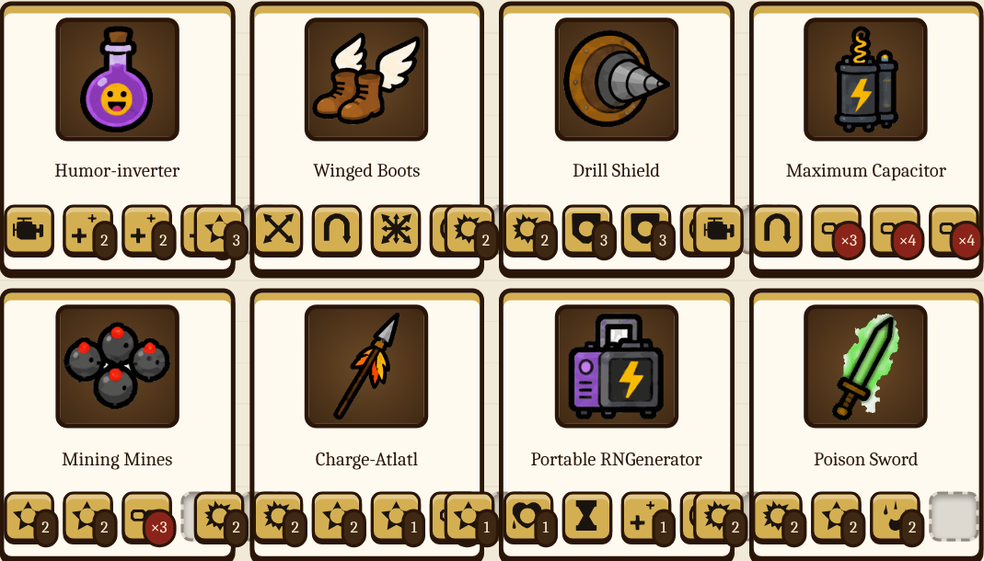
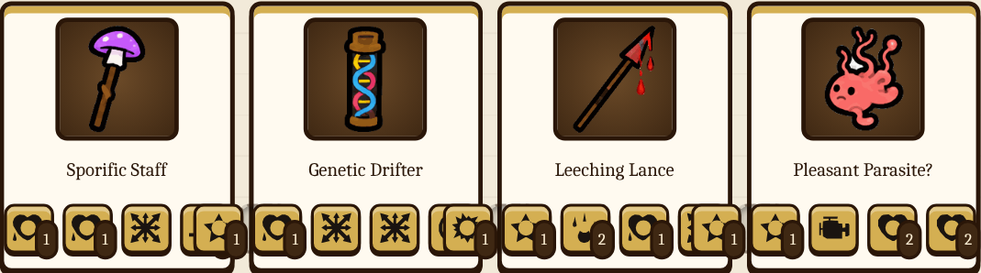

Magic Floor 3 Loot Dice (12)
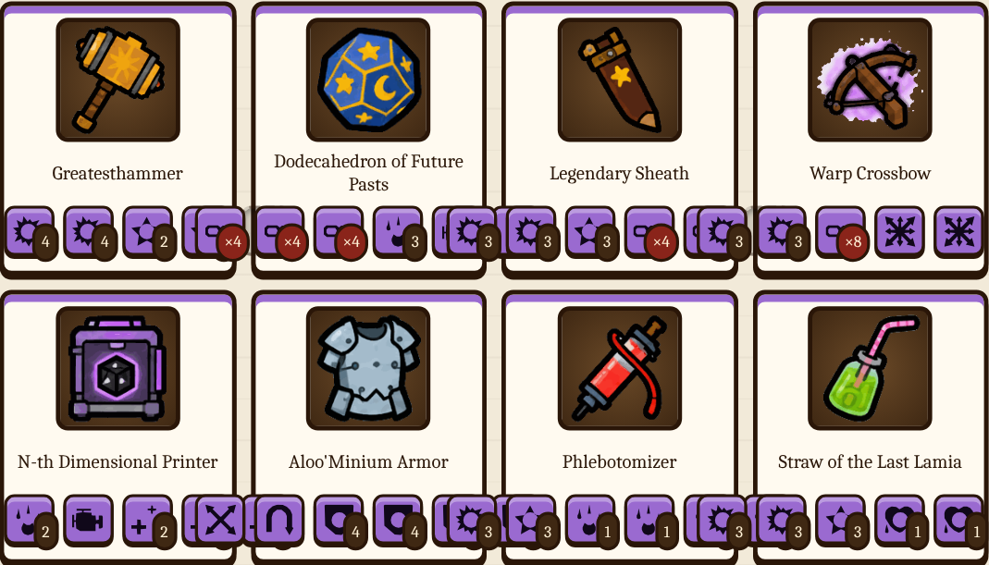
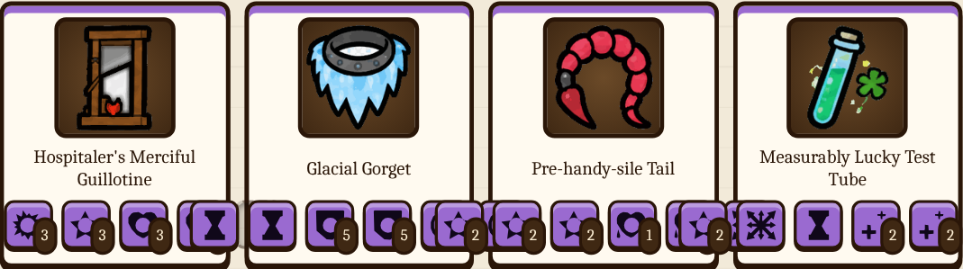
© Dungeon Scramble · Keep this booklet in a safe place. Dice not included.

