Choose the Right Hardware

Proposal Template

# Scenario 1: Manufacturing

Client Requirements and Potential Hardware Solution

Look through the scenario and find any relevant client requirements. Then, suggest a potential hardware type and explain how this hardware would satisfy each of the requirements.

|  |
| --- |
| **Which hardware might be most appropriate for this scenario?**  **(CPU / IGPU / VPU / FPGA)** |
| *Field Programmable Gate Array* |

|  |  |
| --- | --- |
| **Requirement Observed**  **(Include at least two.)** | **How does the chosen hardware meet this requirement?** |
| *Example requirement:*  The client requires a tiny device to be connected to their CPU—and their budget is only about $100 for each device. | *Example explanation:*  VPU or NCS2 is only about 27.40 mm in size and would fit in the price range. |
| *The client requires image processing be 5 times per seconds from the current vision cameras with 30-35 FPS recording speed and available 24/7* | *FPGA are designed for 100% ontime performance 24/7/365.* |
| *Client require the system that can be repurposed later to address a second issue* | *FPGA can be reprogrammed to adapt to new evolving and custom network* |
| *Client requires it to last for 5-10 years for 2nd issue* | *Guarenteed for long lifespan of 10 years* |

## Queue Monitoring Requirements

|  |  |
| --- | --- |
| **Maximum number of people in the queue** | *2* |
| **Model precision chosen (FP32, FP16, or Int8)** | *CPU - FP32, GPU-FP32, VPU-FP16, FPGA-FP16* |

## Test Results

After you've tested your application on all four hardware types (CPU, IGPU, VPU, and FPGA), copy the matplotlib output showing the comparison into the spaces below. You should have three graphs (for model load time, inference time, and FPS).

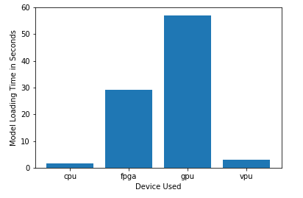

***Model Load Time***

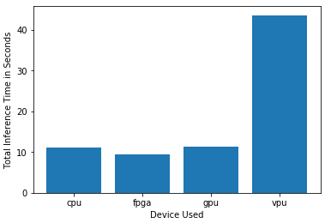

***Inference Time***

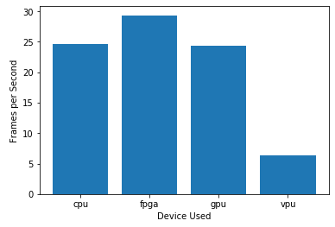

***FPS***

## Final Hardware Recommendation

Now synthesize your points from above and provide a brief write-up describing why the chosen hardware is the best choice for this scenario. Be sure to discuss the client's requirements, the test results, and how these relate to one another (e.g., perhaps one of the devices performed better than the rest, but does not meet one of the client's requirements).

|  |
| --- |
| **Write-up: Final Hardware Recommendation** |
| *From the client’s requirements and tests conducted, it was identified that FPGA is the suitable hardware. Tests revealed that VPU was the fastest in processing frames per second (FPS) which was 5 FPS. However, it was still fitting for FPGA since it met most of the client’s requirements. FPGA image FPS processing was below the 30-35 FPS required by the current camera recording time. Tests revealed FPGA is the fastest in inferencing below 10 seconds. Hence, it met the the client’s requirement to have processing tasks to be completed five times per second. So, FPGA will surely help in increasing the speed of client’s production requirements. Since FPGA can be reprogrammed to adapt for new, evolving custom networks, and it lasts longer, it is sure fitting for the client’s needs to repurpose the system to address the second issue in the future.* |

# 

# Scenario 2: Retail

Client Requirements and Potential Hardware Solution

Look through the scenario and find any relevant client requirements. Then, suggest a potential hardware type and explain how this hardware would satisfy each of the requirements.

|  |
| --- |
| **Which hardware might be most appropriate for this scenario?**  **(CPU / IGPU / VPU / FPGA)** |
| *Integrated Graphics Processing Unit (IGPU)* |

|  |  |
| --- | --- |
| **Requirement Observed**  **(Include at least two.)** | **How does the chosen hardware meet this requirement?** |
| *Example requirement:*  The client requires a tiny device to be connected to their CPU—and their budget is only about $100 for each device. | *Example explanation:*  VPU or NCS2 is only about 27.40 mm in size and would fit in the price range. |
| *Client already have modern computers with intel i7 processors with minimal computational power usage* | *IGPU is intergrated in i7 core processors and can be used as an accelarator for inferencing.* |
| *Client does not have much money to invest in additional hardware,* | *The use of IGPU will not incure any additional hardware cost.* |
| *Client would like to save as much as possible on his electric bill.* | *Unused sections of IGPU can be shutdown for less power consumption.* |

## Queue Monitoring Requirements

|  |  |
| --- | --- |
| **Maximum number of people in the queue** | *5* |
| **Model precision chosen (FP32, FP16, or Int8)** | *CPU-FP32, IGPU-FP32, VPU-FP16, FPGA-FP16* |

## Test Results

After you've tested your application on all four hardware types (CPU, IGPU, VPU, and FPGA), copy the matplotlib output showing the comparison into the spaces below. You should have three graphs (for model load time, inference time, and FPS).

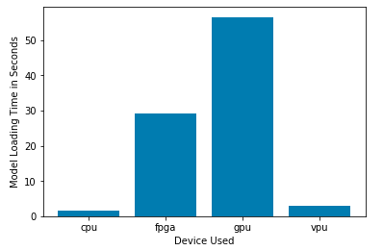

***Model Load Time***

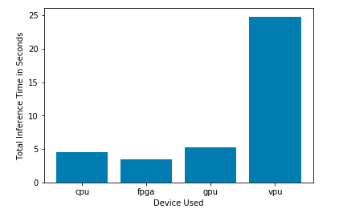

***Inference Time***

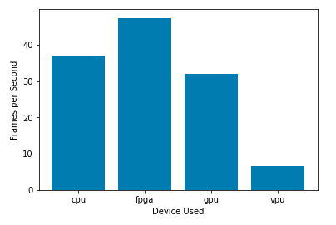

***FPS***

## Final Hardware Recommendation

Now synthesize your points from above and provide a brief write-up describing why the chosen hardware is the best choice for this scenario. Be sure to discuss the client's requirements, the test results, and how these relate to one another (e.g., perhaps one of the devices performed better than the rest, but does not meet one of the client's requirements).

|  |
| --- |
| **Write-up: Final Hardware Recommendation** |
| *The final recomended hardware for this scenario is IGPU. Depending on the client’s financial status, two most identified hardware that cost much less were the IGPU and VPU. Comparing model load time and frames per second speed based on the test results, VPU had advantage over IGPU. However, IGPU inference time is around three times much faster then VPU. Thus, IGPU still had advantage in processing the frames and performing inferencing on the images. And since IGPU is integrated with the existing CPU of the current hardware the client have, IGPU is the most recomended hardware for this retail client.* |

# 

# Scenario 3: Transportation

Client Requirements and Potential Hardware Solution

Look through the scenario and find any relevant client requirements. Then, suggest a potential hardware type and explain how this hardware would satisfy each of the requirements.

|  |
| --- |
| **Which hardware might be most appropriate for this scenario?**  **(CPU / IGPU / VPU / FPGA)** |
| *VPU* |

|  |  |
| --- | --- |
| **Requirement Observed**  **(Include at least two.)** | **How does the chosen hardware meet this requirement?** |
| *Example requirement:*  The client requires a tiny device to be connected to their CPU—and their budget is only about $100 for each device. | *Example explanation:*  VPU or NCS2 is only about 27.40 mm in size and would fit in the price range. |
| *Client have current PCs with CPU used for processing CCTV footage and no significant additional power is available for inferencing* | *VPUs are low power devices that can be used to accelerate performance of pre-existing systems.* |
| *Client’s budget allows for maximum $300 per machine* | *VPUs are low cost devices and be easily added to each machines to accelerate performance.* |
|  |  |

## Queue Monitoring Requirements

|  |  |
| --- | --- |
| **Maximum number of people in the queue** | *5* |
| **Model precision chosen (FP32, FP16, or Int8)** | *CPU-FP32, IGPU-FP32, VPU-FP16, FPGA-FP16* |

## Test Results

After you've tested your application on all four hardware types (CPU, IGPU, VPU, and FPGA), copy the matplotlib output showing the comparison into the spaces below. You should have three graphs (for model load time, inference time, and FPS).

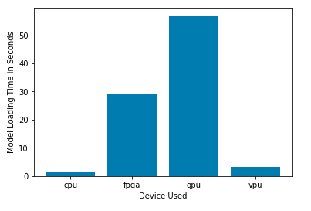

***Model Load Time***

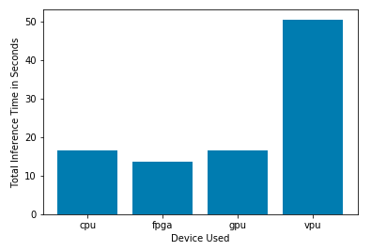

***Inference Time***

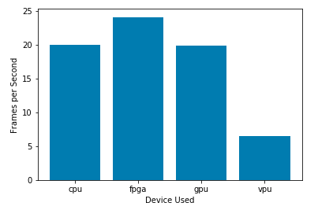

***FPS***

## Final Hardware Recommendation

Now synthesize your points from above and provide a brief write-up describing why the chosen hardware is the best choice for this scenario. Be sure to discuss the client's requirements, the test results, and how these relate to one another (e.g., perhaps one of the devices performed better than the rest, but does not meet one of the client's requirements).

|  |
| --- |
| **Write-up: Final Hardware Recommendation** |
| *Acording to the clients requirements, two significant hardware to be chosen was either the CPU or VPU. CPU’s could be used since each security booths had existing all-in-one PCs. However, eventhough CPU model load time and inference time is much faster than VPU, it performs three times much slower in processing frames per second (FPS) than VPU. Hence, CPU would not be a good fit for this scenario since it will be overloaded with processing images from the videos cameras for both security and inferencing. Hence, VPU is the recommended hardware as it process frames per second much faster than the other hardwares. And also VPUs, had a lower power consumption, and is within the budget range of the client.* |