**TOPIC: INTEGERS**

**What is an integer?**

**Integers are the whole numbers and their opposites.**

**Two integers are opposites if they are the same distance from 0 in either the positive or negative direction on a number line.**

**This means, positive integers are all the whole numbers greater than zero: 1, 2, 3, 4, 5,…..**

**Negative integers are all the opposites of these whole numbers: -1, -2, -3, -4, -5,……..**

**Negative numbers are less than zero.**

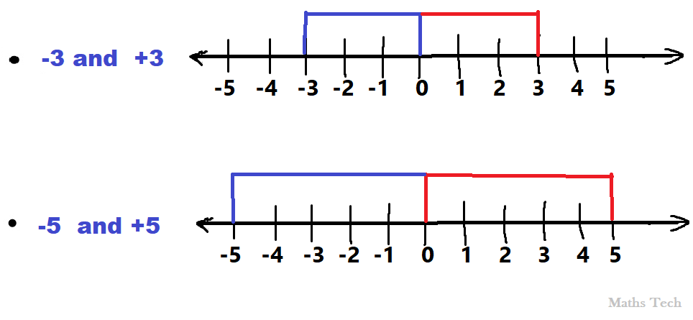**Here are some examples of opposites**

**Click the video link for more information about Integers**

**Video tutorial :** [**https://www.youtube.com/watch?v=_BgblvF90UE**](https://www.youtube.com/watch?v=_BgblvF90UE)