**TOPIC: MIXED OPERATIONS**

There is an order to follow to help you solve a question with multiple operations (add, subtract, multiply and divided). It is known as **'BEDMAS.'**

**BEDMAS** is an acronym that stands for:

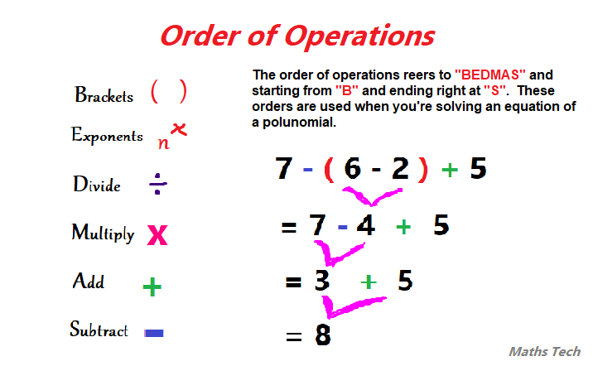

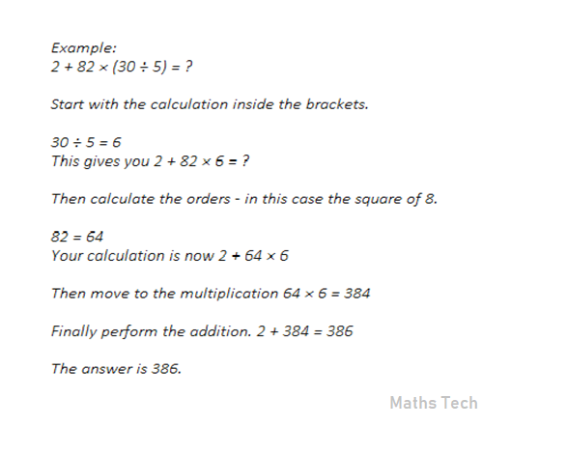

**Click the video for more information about order of operations.**

**Video tutorial to use:** [**https://www.youtube.com/watch?v=dAgfnK528RA**](https://www.youtube.com/watch?v=dAgfnK528RA)