

# Team:

## Samurai Jack

1. Виктор Бахтев – westi3m

2. Васил Василев – vkv.1986

3. Митко Митев – Mitko_Mitev

4. Ивайло Иванов – Jarolim

5. Светлан Янев – svetlan

# Project – EShop:

### Online Shop (E-Shop) – selling Music, Movies, Books and Games

# Class Diagram:

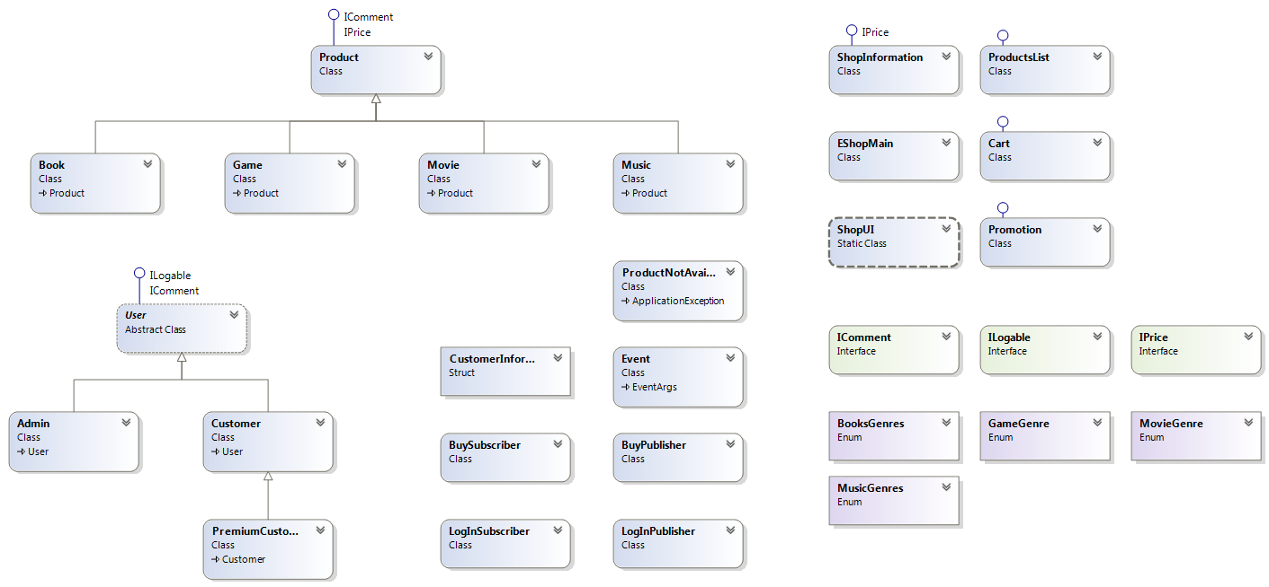

# Project purpose – what problem do we solve:

### Project EShop is an object-oriented application designed for managing an online shop for selling music, movies, books and games.

It is implemented by using of four **interfaces** – **IComment**, **ILoggable** and **IPrice**, designed for the application, and **IEnumerable** from System.Collection library.

We use four **enumerations** – **BooksGenres**, **GameGenre**, **MovieGenre** and **MusicGenres**.

Class **Product** is fundamental for the project. Its instances present particular products from the shop. It is inherited by classes **Music**, **Movie**, **Book** and **Game**. They methods functions ToString() and Equals() and operators “==” and “!=” and implement IComment and IPrice interfaces.

Class **ProductList** is also basic for the project, because objects of this class can hold a collection of different products. Products can be accessed by index, can be searched, added and removed from the ProductList. It also override the method ToString().

Objects of class **Cart** present a customer cart in the shop and implement IComment and IPrice interfaces. Objects of class **Promotion** present products in the shop, which have promotion price, and implement IComment interface. Both classes use objects of class ProductList.

We use one **structure** – **CustomerInformation**, to store all important data for the customers of the shop. It also uses ProductList.

We also implement **exception class** **ProductNotAvailableException** to alert when a product is missing or there is not enough quantity of it.

Another fundamental class for the project is **abstract class** **User**, which implement IComment and ILoggable interfaces. It is inherited by classes Admin and Customer.

Objects of class **Admin** are profiles of shop administrators. They can add new products to the shop, change products’ prices, make promotion and make premium customers.

Objects of class **Customer** are profiles of shop customers. Class Customer uses Cart and CustomerInformation and overrides ToString(). Customers can add products to the cart remove or buy them. Class **PremiumCustomer** inherits class Customer and has special method GetPromotion().

The project implements **Singleton design pattern** by class **ShopInformation**. This class holds whole information about the shop – all available products, all sold products, current promotions, all registered administrators and customers (or premium customers). It can have only one instance. It implements IPrice interface and uses ProductList and Promotion.

We implement a console user interface by **static class** **ShopUI**. It holds several static methods, from which only one is public – LogInMenu(). According to choices of the user program starts the other menus from the class and perform actions following his commands.

The project also implements two **events** – LogIn and Buy event. It is done using classes **Event**, **LogInPublisher**, **LogInSubscriber**, **BuyPublisher** and **BuySubscriber**. First event asks the user to log-in in order to start the program, and the second one informs the customer (or premium customer) when a purchase is done.

Class **EShopMain** contains the **Main() method** of the program.

All of them are part of **namespace** **EShop**.

The URL of our TFS repository: [**http://samuraijack.codeplex.com/SourceControl/list/changesets?ProjectName=samuraijack**](http://samuraijack.codeplex.com/SourceControl/list/changesets?ProjectName=samuraijack)

[**http://samuraijack.codeplex.com/SourceControl/changeset/view/24906**](http://samuraijack.codeplex.com/SourceControl/changeset/view/24906)

[**http://samuraijack.codeplex.com/**](http://samuraijack.codeplex.com/)