*Exploring* *Blockchain Ecosystems*

Github repo: <https://github.com/Jaromeat/BlockchainEcosystems.git>

Joe Cucuzza [cucuzzaj@wit.edu](mailto:cucuzzaj@wit.edu)

Jamie Kerr  
kerrj@wit.edu

***Abstract*** - With various ecosystems in the field of blockchain, such as Ethereum, Bitcoin, Ripple, Litecoin, etc. it can be challenging to understand the advantages and disadvantages of each system. Our project focuses on research on the ecosystems of Bitcoin, Ethereum, Libra by Facebook, Cardano, and Tezos. The plan is to discover these advantages and disadvantages of each ecosystem. We will define “good” smart contract systems vs “bad” smart contract systems. After, we plan on developing a similar program on each ecosystem that exemplifies the benefits and drawbacks of using the system.

***Keywords:*** *Blockchain, Blockchain ecosystems, Decentralization, Smart Contracts, Ethereum, Bitcoin, Cardano, Libre, Tezos*

# Introduction

Blockchain technology was invented for digital currency. It allows two or more users to securely transfer money to one another over servers. One of the most important aspects of blockchain is that there isn’t an online bank or banks in charge of money. Money can be transferred from anywhere at any time. All that is required is an internet connection. This concept is referred to as decentralization. Freedom from a centralized provider spurred the birth of Bitcoin, a digital currency reliant entirely on the merits of blockchain. However, Bitcoin is not alone. Currencies like Ethereum managed to stay ahead of the competition with the introduction of smart contracts, a framework for developing apps that run entirely on the blockchain, run by the blockchain miners at a cost. The introduction of smart contracts has led many cryptocurrencies to blossom into blockchain ecosystems, complex networks of interwoven contracts and decentralized applications (Dapps). The smart contract has become an important tool in expanding the use of cryptocurrencies, but not all ecosystems are created equal. Which ecosystem should a developer choose when designing a Dapp? We plan to define the benefits and downfalls of blockchain ecosystems of widely varying structure to inform development decisions and predict the future of blockchain ecosystems.

# Problems

One of the most important immerences of cryptocurrency is the smart contract, a means to write decentralized applications. These applications offload processing to block miners at a cost. When a developer decides which ecosystem to develop a smart contract in, many concerns arise.

* **Features:** How easy is development in the ecosystem’s framework? What does the ecosystem do better than its competition? What does it do worse? For example, what ecosystems have faster transaction speeds? Which are slower due to needed time for verification. Is there helpful debugging/testing tools provided by a helpful, trustworthy IDE?
* **Popularity**: how popular is the ecosystem? If an ecosystem is not utilized, an Dapp on the ecosystem will not be used.
* **Future**: What is the future of the smart contract ecosystem? Will the ecosystem stay updated and relevant? Will a new ecosystem come out that has better features? How easy is it to maintain a Dapp or migrate to a different ecosystem?

Each of these questions will be answered for these current or up and coming blockchain ecosystems: Bitcoin, Ethereum, Libra, Cardano, Tezos. We look to leave the reader with a comprehensive understanding of the benefits and drawbacks of current and up and coming smart contract ecosystems so that they may make educated decisions when designing a decentralized application.

# Contributions & Plan

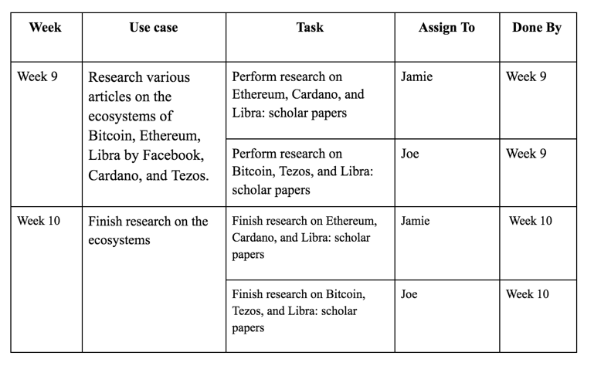

##### 

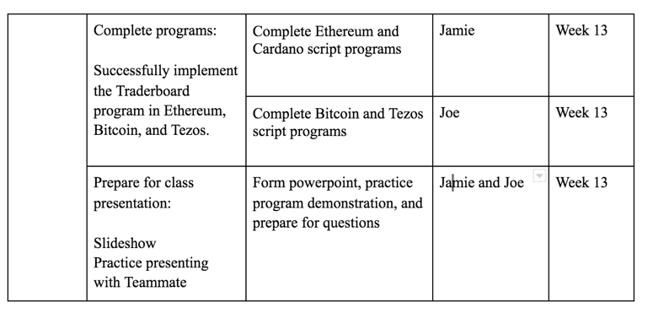

# References

* Bitcoin
  + Bitcoin Script White Paper <https://papers.ssrn.com/sol3/papers.cfm?abstract_id=3160279>
  + [Datestamping the Bitcoin and Ethereum bubbles](https://www.sciencedirect.com/science/article/abs/pii/S1544612317307419)
  + [An Empirical Analysis of Smart Contracts: Platforms, Applications, and Design Patterns](https://link.springer.com/chapter/10.1007/978-3-319-70278-0_31)
* Ethereum
  + Solidity Documentation <https://solidity.readthedocs.io/en/v0.7.4/>
  + [Datestamping the Bitcoin and Ethereum bubbles](https://www.sciencedirect.com/science/article/abs/pii/S1544612317307419)
  + [An Empirical Analysis of Smart Contracts: Platforms, Applications, and Design Patterns](https://link.springer.com/chapter/10.1007/978-3-319-70278-0_31)
* Libra
  + Libra Documentation: [Welcome · Libra](https://developers.libra.org/docs/welcome-to-libra)
  + [Facebook's Project Libra: Will Libra Sputter Out or Spur Central Banks to Introduce Their Own Unique Cryptocurrency Projects? by John Taskinsoy](https://papers.ssrn.com/sol3/papers.cfm?abstract_id=3423453)
* Cardano
  + Cardano Documentation: <https://docs.cardano.org/en/latest/>
  + [Use of the Proof-of-Stake Algorithm for Distributed Consensus in Blockchain Protocol for Cryptocurrency](https://opencommons.uconn.edu/srhonors_theses/580/)
  + [Why Cardano ADA Deserves your Attention – Cardano Cryptocurrency Strategy](https://tradingstrategyguides.com/cardano-cryptocurrency-strategy/)
* Tezos
  + Tezos Documentation: <https://tezos.gitlab.io/>
  + Tezos White Paper: <http://everipedia-storage.s3.amazonaws.com/NewlinkFiles/16739988/8d4d1f1b-8/white_paper.pdf>
  + [[1909.08458] Introduction to the Tezos Blockchain](https://arxiv.org/abs/1909.08458)

**IEEE conference templates contain guidance text for composing and formatting conference papers. Please ensure that all template text is removed from your conference paper prior to submission to the conference. Failure to remove template text from your paper may result in your paper not being published**