Bitcoin: The first major cryptocurrency, Bitcoin is the #1 largest cryptocurrency and most popular cryptocurrency. It focus is on creating a fully digital currency that will be used for anonymously transferring money between two users. This has no association with banks or the government, however as the popularity of cryptocurrency grows, banks and the government may try to take control and add regulations to Bitcoin and other cryptocurrency.

Bitcoin has low costs for transactions than other cryptocurrencies and executes the transactions quickly. Every Bitcoin transaction takes about 10 to 30 minutes to complete. Compared to a standard bank that could take days for a fund to settle, the quickness of Bitcoin could protect the merchants from chargeback frauds. Another way Bitcoin can protect the user from chargeback fraud is by allowing a fund to be reversible only if the seller agrees with the senders refund request.

As popularity of bitcoin grows more and more, it has formed the exact problems that standard cash currencies have. With popularity, bitcoin has become vulnerable to attacks of hacking causing some bitcoin users falling victim to theft of their money. As bitcoin has become more known, it has been noticed that crimes like money laundering have been hiding within the currency. With Bitcoin having a peer-to-peer system where transactions are anonymous and do not require supervision or have any government regulations, money laundering occurs frequently with some Bitcoin users.

Without government regulation, problems from legal tender occur for Bitcoin’s future, potentially jeopardizing its chances to replace standard currencies like the US dollar. With the absence of legal tender, each individual company can decide whether or not they accept Bitcoin as a currency. Another issue with Bitcoins future is for the companies that do decide to adopt Bitcoin as a currency, they would need to adjust their prices frequently. This is due to Bitcoin’s feature of having a very high volatile price. Companies would need to change their prices frequently because if they don’t they could lose business as soon as Bitcoin’s price changes. Without this action, they could see a decrease in returns from underpriced goods or a loss of competition due to overpriced goods.

These concerns in Bitcoin’s future may encourage more and more users to change into miners of the currency instead of actual users, especially if Bitcoin’s prices continues to increase overtime. However, an advantage that Bitcoin has over other cryptocurrencies to one day replace the US dollar is what it has already accomplished. The fact that Bitcoin is already the #1 largest cryptocurrency in the world invites new user to use Bitcoin rather than a small cryptocurrency like Tezos that wishes to grow as big as Bitcoin.

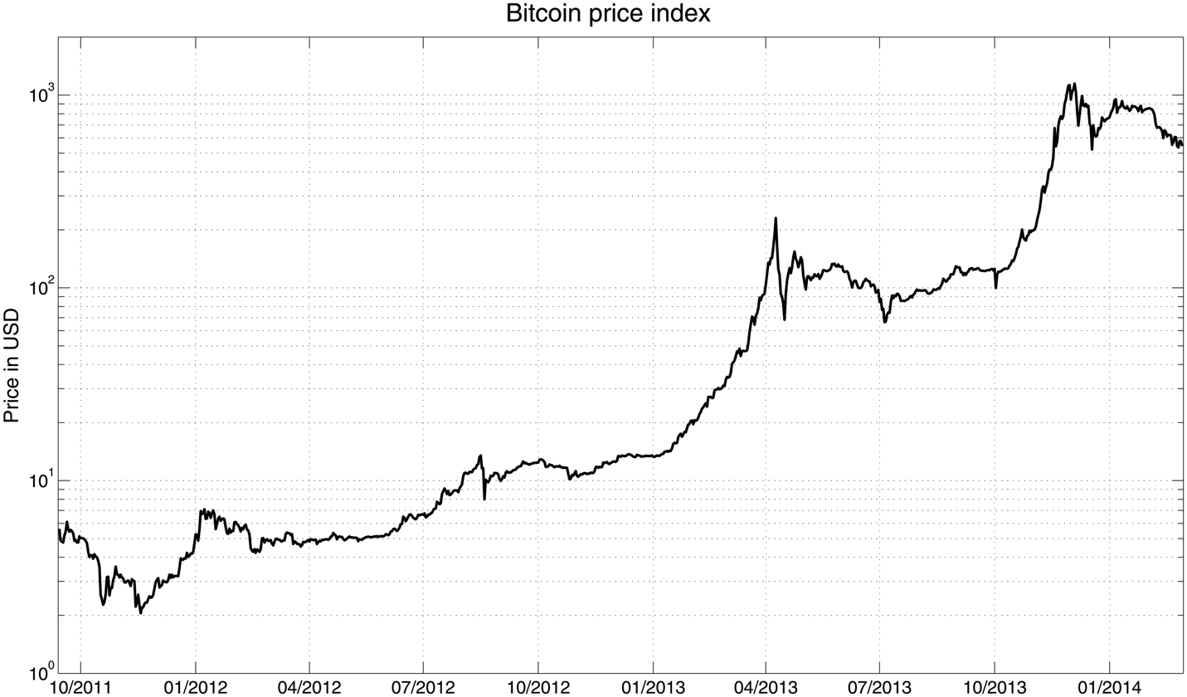

Figure 1: Chart showing the Volatile growth of Bitcoin’s Price throughout a 30 month period (2011 – 2014). Although volatile with ups and downs in the short term, the price grows steadily overtime. If this pattern continues in the future, people who would like to use Bitcoin for long term purposes would be confident to adopt the cryptocurrency.

Advantages:

* Personal data protection
* Lower Transaction Fees
* Speed of transfers protects the merchants from chargeback fraud.
* Immune to inflation

Disadvantages:

* Lack of solid anonymity
* Bitcoin prone to scams
* Trust: some people may be reluctant to adopt a virtual wallet due to uncertainty of Bitcoin’s future.

<https://journals.plos.org/plosone/article?id=10.1371/journal.pone.0123923#sec002>

<http://www.globeco.ro/wp-content/uploads/vol/GEO_Vol_5_No_2.pdf#page=63>

Ethereum: Ethereum, first implemented in 2015, is the 2nd largest cryptocurrency on the market. It largely gained popularity due to its smart contracts and its wide usability. The goal of Ethereum is to develop dapps rather than be a currency. Ethereum is well established and supported by the Enterprise Ethereum Alliance. The future of Ethereum shows expansions into proof of stake and shard chains, a concept similar to sidechaining.

Advantages:

* Wide usability
* Popular
* EVM(Ethereum Virtual Machine)
* Well implemented smart contracts
* Open source
* Bright future

Disadvantages:

* Slow transactions and block mining
* Not scalable in current form
* Several hard forks have splintered the community
* Does not yet officially support sidechaining

Cardano: Cardano is a crypto that has been running for 5 years and advertises itself as a 3rd generation cryptocurrency. Created by Ethereum co-founder, Charles Hoskinson, Cardano is a proof of stake cryptocurrency and is currently the 10th biggest cryptocurrency by market cap. Proof of stake means miners or pools with more currency are rewarded with more currency. Therefore, there is minimal work needed to be done for a block to be mined, so transactions can occur much faster. A problem with proof of stake is pools of miners are encouraged to get bigger. This leads to centralized systems as inevitably efforts move to a single super pool. Cardano implements many strategies to encourage dispersal of pools to ensure decentralization is upheld. One method is to create a limit to rewards given to pools of a certain stake size. This strategy encourages larger stakeholders to separate into their own pools to ensure their reward is maximized. Cardano utilizes a sidechain to enable interoperability within the blockchain platform. Data can be stored in side chains to allow the transferral of assets between parallel blockchains with different rules, mechanisms, or languages.

Advantages:

* Fast: thousands of transactions per second
* Sidechains: allow interoperability
* Miners do not have to “work” for a reward
* Open source
* Potentially scalable

Disadvantages:

* Proof of Stake has more risk
* Many features are yet to be implemented
* Future of currency is still uncertain
* Not as popular

Libra: Libra is an interesting case as it has not been implemented yet. The goal of Libra is to create a stable crypto by backing it with govt bonds. It was set to be released Q1 2020, but government bodies shot the idea down. This led to nearly every major backer, Paypal, eBay, Mastercard, Stripe, Visa, and Mercado Pago, to bail in early October 2019. The project is still in development, but has been significantly scaled-down.

Advantages:

* Stable: big advantage
* Easy to understand
* Features meant to mitigate crypto learning curve

Disadvantages:

* Centralized
* Likely will not be open source
* Not yet Implemented, likely won’t be for a long time
* Very ambitious, currently with little support

Tezos:

The main idea of Tezos is to allow companies to make accounting books based on its chain. Tezos is based on the OCaml Language. Tezos has its own advanced blockchain with a unique feature of an on-chain governance model that allows stakeholders to reach an agreement on proposed protocol amendments. It also auto-regulates its transactions. Other features of Tezos includes self-amendment, proof of stake, and delegation. With self-amendment, Tezos is able to update itself without having to fork or split the blockchain into two different chains. Proof of stake and delegation are used to help the blockchain as a whole reach consensus on the state of the blockchain.

More on Features of Tezos:

**Self-Amending Blockchain** – protocol that approves blocks and that modifies its own algorithm.

**Proof-of-Stake** – takes into consideration of the number of tokens (the stake), a user has to push a block. Pushing a block in Tezos means to bake a block. These users are bakers. Although Tezos is relatively newer than established currencies like Bitcoin, its consensus protocol of Proof-of-Stake is more advanced than those cryptocurrencies. For example, unlike Bitcoin, Tezos handles potential malicious behaviors from bakers. The threats to the ecosystem include double baking and double endorsement. Double baking pushes two different blocks at the same time. Double endorsement is when two different blocks are placed at the same level. The protocol is designed to give out a penalty whenever one of these two acts of cheating occurs. Proof-of-Stake is designed as the baker placing an entry of 256 tokens. The system holds these tokens, now inaccessible to the baker and anyone else. During the two weeks, if the baker is caught cheating, the 256 tokens and any rewards made will be disregarded from the baker.

**Formal Verification and the use of OCaml Language** – Tezos is programmed to strictly eradicate any runtime errors or attacks. For this reason, Tezos’ base is mainly coded in the programming language of OCaml. The language’s features of static type system and memory management system are used to minimize null pointer exceptions and buffer overflows.

*Tezos seems to be more advanced than cryptocurrencies like Bitcoin when it comes to preventing attacks and preventing programming errors. The Tezos ecosystem actually has an entire public network used for testing, called **Zeronet.**

Other two public tezos networks:

Mainnet – runs with real tezos tokens that have been baked or allocated

Alphanet – uses free tokens, reference network for developers.

Advantages:

* fast transactions
* cheap fees
* Tezos ICO (Initial Coin Offering) was one of the biggest ever performed, indicating that there are several strong believers/supporters backing up Tezos.

Disadvantages:

* Might scare programmers/users away due to an uncertain future
* There is also uncertainty about Tezos algorithm, and the future plans of the founders. Therefore Tezos is harder to trust than more established cryptocurrencies like Bitcoin and Ethereum.

<https://arxiv.org/pdf/1909.08458.pdf>