**Water Proof Device**

This week, we have spent some time playing in the wondrous world of Arduino. We have created a contraption that can measure the temperature and the pH value of the water in your swimming pool.

When the pH value is too high, the accompanied monitoring interface will warn you and tell you how much chlorine you must add to the pool in order to improve the water quality. In this guide, we’ll learn you how you can make the same project on your own.

## Step 0: Gathering the right components

For this project we used the following materials:

1. BreadBoard - Half Size
2. Node MCU 1.0V (Arduino Uno + ESP8266 WiFi module)
3. DS18B20 1-Wire Temperature Sensor – Waterproof
4. Analog pH Meter Kit
5. 4.7K Ohm Resistor
6. USB micro-B Cable
7. Jumper Wires Pack

## Step 1: Setting up the hardware

Setting up the temperature sensor and the pH sensor is quite simple. First plug in the Arduino on the breadboard.

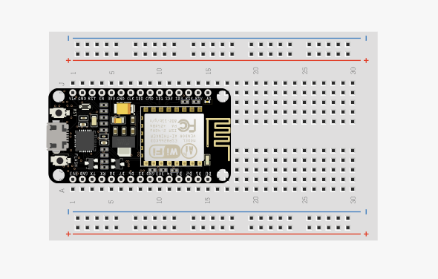

Next, connect the sensors to the breadboard. We used a 4.7kΩ resistor for the temperature sensor.

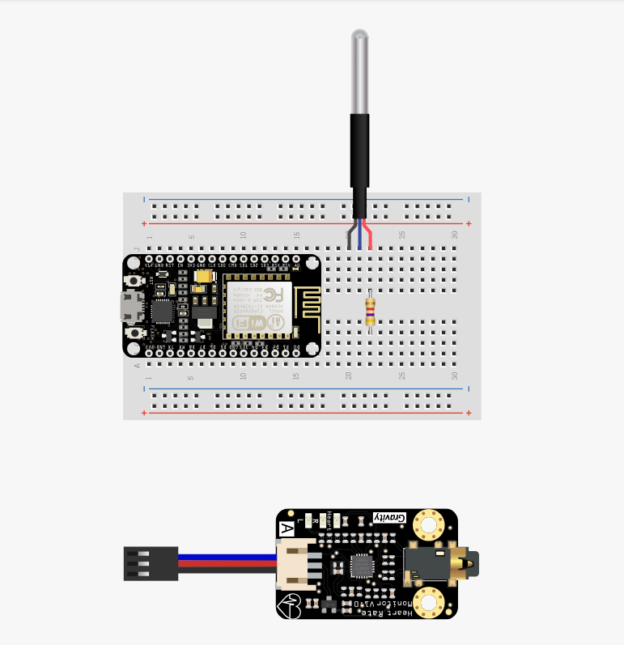

Once this is done, start connecting the sensors to the Arduino using jumper cables, as shown below.

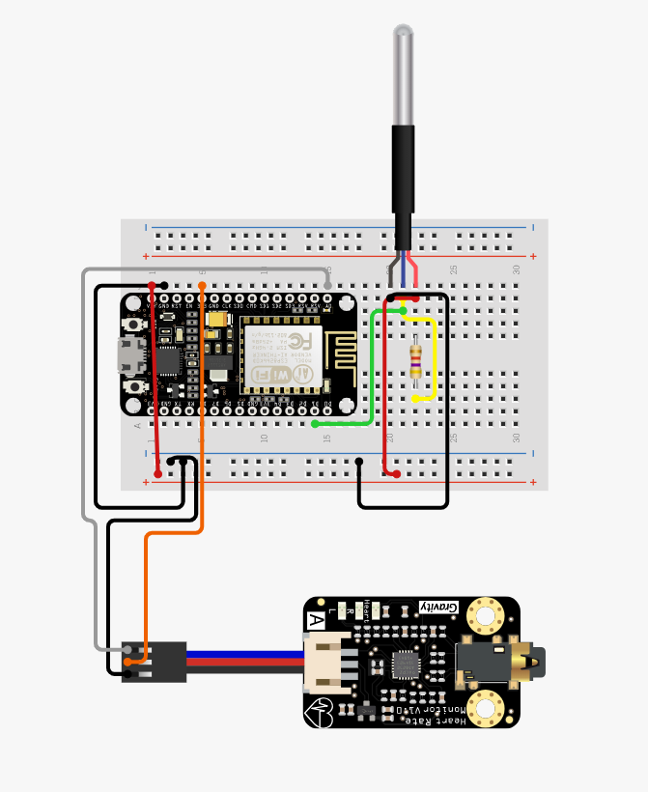

Finally, you can connect your Arduino board to the computer using a USB cable.

**Make sure that your power supply is connected and working properly!**

## Step 2: Setting up the Software

This is what you need to do in order to make the application run on the Arduino:

1. Download the .zip from Github: <https://github.com/JaronTrossaert/project2_wpd>
2. Extract all the files to a new folder. Call it "Waterproof_Wifi" (case insensitive) in order to make the file within (the sketch) recognizable within the Arduino IDE.
3. Open Waterproof_Wifi.ino in the Waterproof_Wifi folder using the Arduino IDE.
4. Make sure the board is connected to your computer via USB.
5. In the Arduino IDE: don't forget to select the correct Port and Board in the IDE’s Tools menu.
6. If you don’t already have them, include the following Libraries through Sketch > Include Library:
   1. ESP8266WiFi
   2. OneWire
   3. ArduinoJson (! preferably version 5.XX, using v6.XX or higher certain code will become outdated and won’t compile)
   4. PubSubClient

Some of these libraries will need to be downloaded and added as a .zip (Sketch > Include Library > Add .ZIP Library…). You can find versions of library (c) here:

<https://github.com/bblanchon/ArduinoJson/releases/tag/v5.0.7>

and library (d) here:

<https://github.com/knolleary/pubsubclient/releases/tag/v2.3>

1. Change the credentials in the code of Waterproof_Wifi.ino according to your own personal data:
   1. 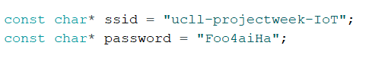
   2. 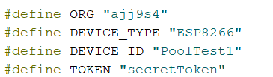
2. Upload Waterproof_Wifi.ino to your board.
3. You can check the payload that is being sent over WiFi through the Serial Monitor in the IDE’s Tools menu (Ctrl+Shift+M or a button in the GUI).