**Website Design Task 2:**

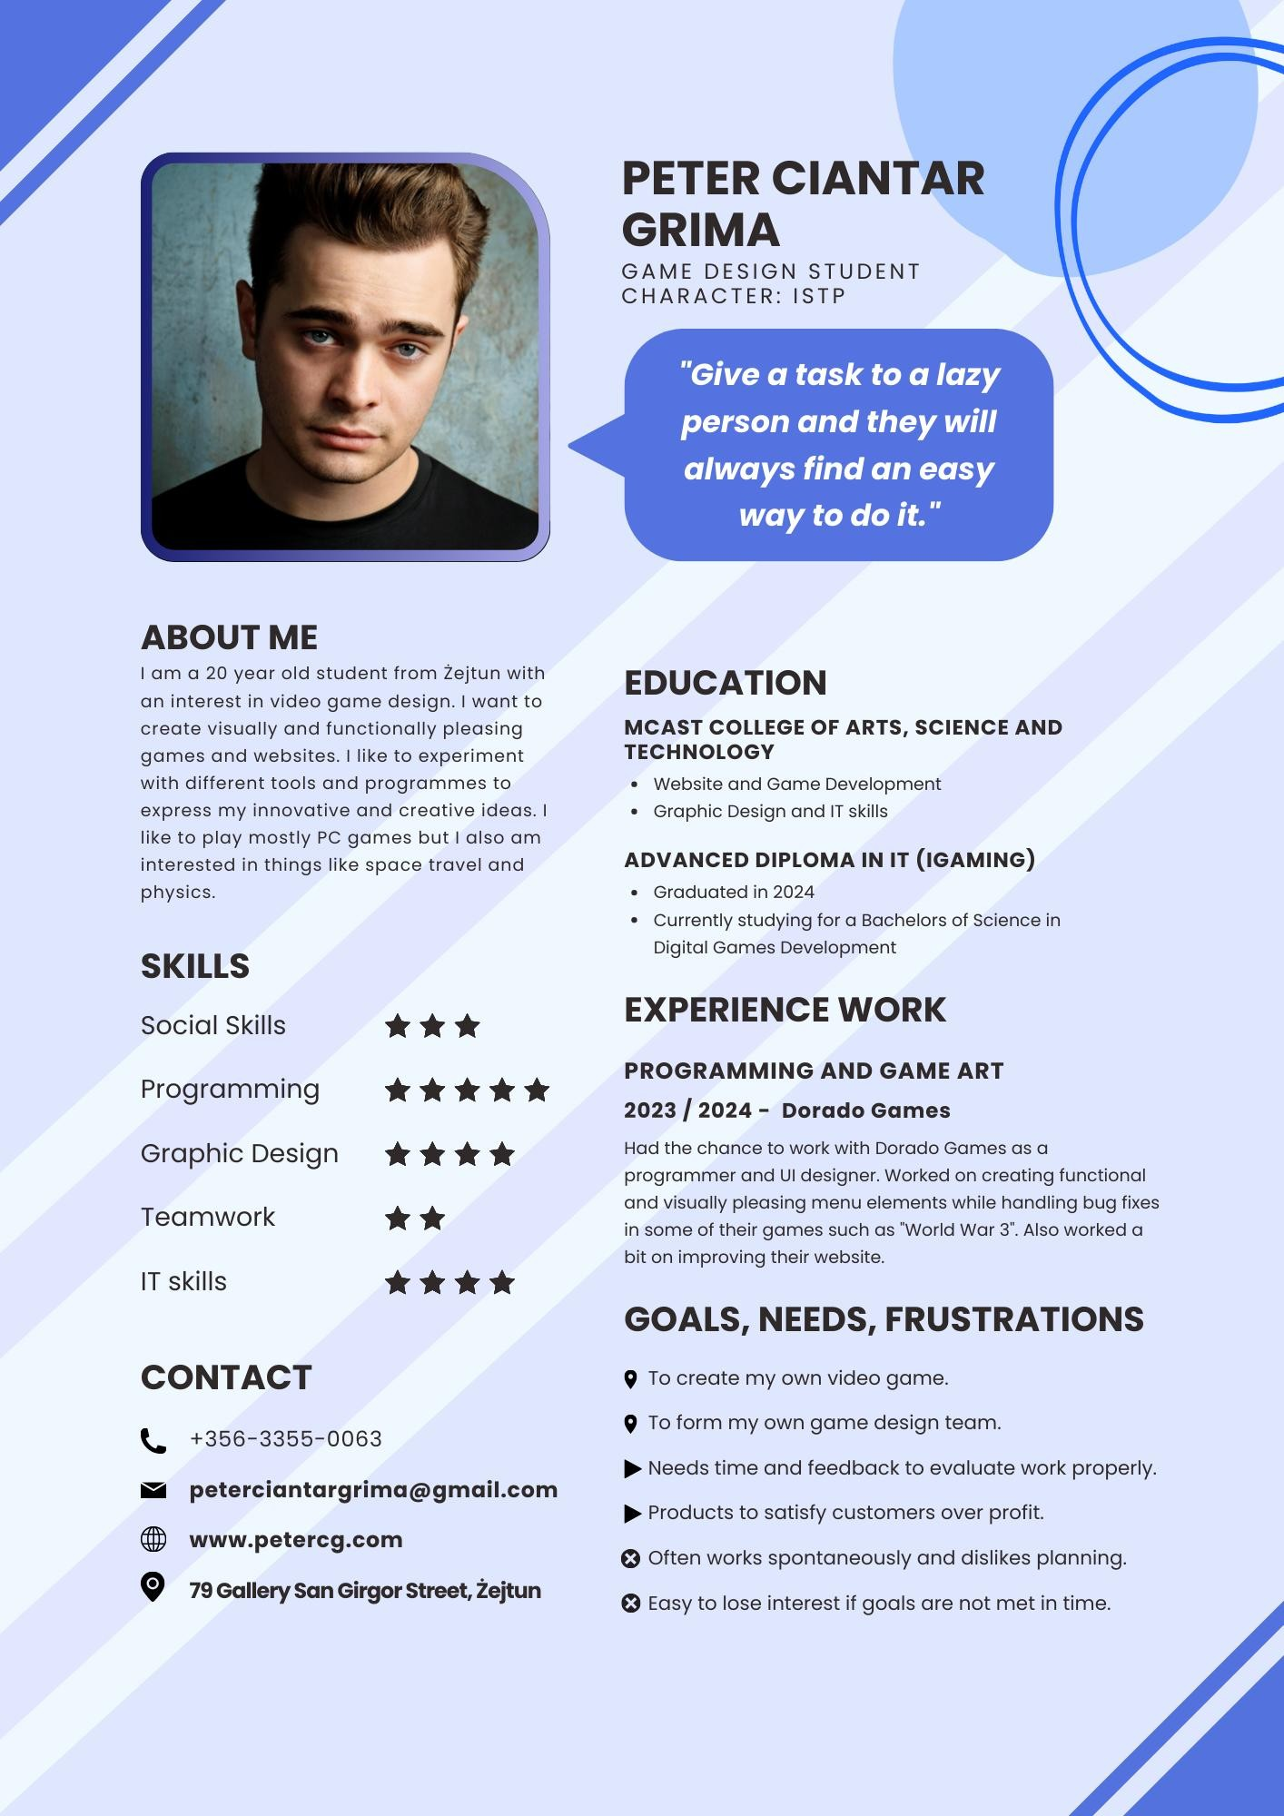

Link to Survey:

[https://forms.office.com/Pages/ResponsePage.aspx?id=tutbJeivRU2s ydx93JR5_oVHNigAGtFDh9bon5DkOWBUMlpUVVVFQTQySjVLTE41R 1lTQUxLUE5UUC4u](https://forms.office.com/Pages/ResponsePage.aspx?id=tutbJeivRU2sydx93JR5_oVHNigAGtFDh9bon5DkOWBUMlpUVVVFQTQySjVLTE41R1lTQUxLUE5UUC4u)

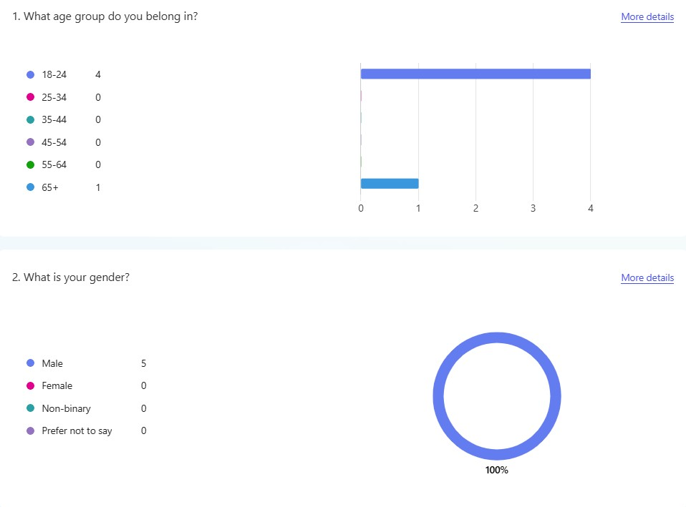The majority of the participants were around 18 till 24 years old which is what made me decide the age of my user persona and all the participants were male which is why the persona is also male. 3 out of the 5 participants claimed to be students while one of the remaining 2 were employed full-time.

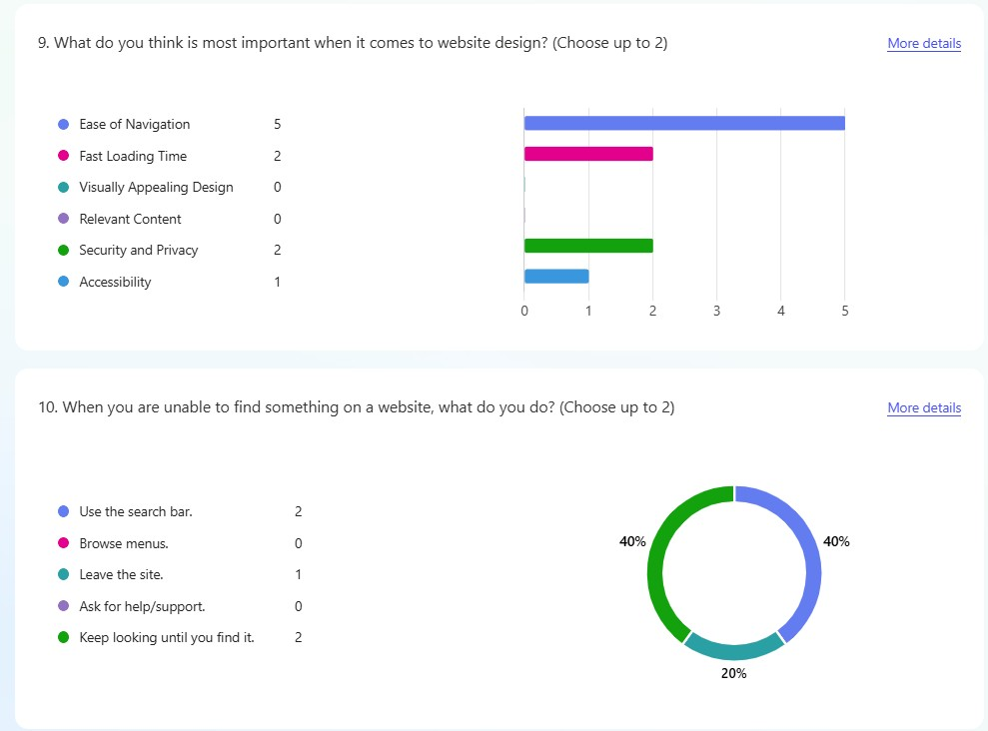This made me go through the decision to make the user persona a student with some work experience and that has a lot of creative computer skills since many of the participants also claimed to use the internet for more than 4 hours a day, some claiming to use it all day. I gave the student an interest in good graphic design since many participants said they value easy navigation and quick loading times when

visiting websites.

**Design Plan**

**Lo-fi Prototype**

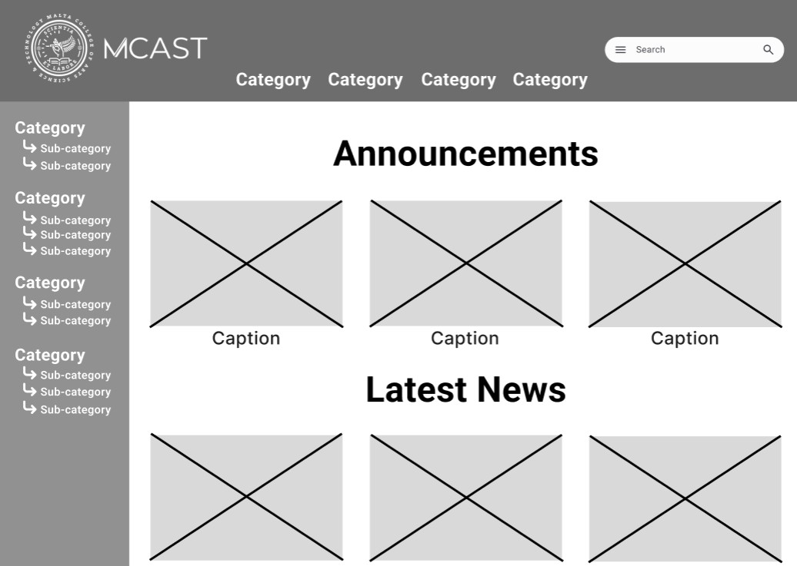

**Home Page**

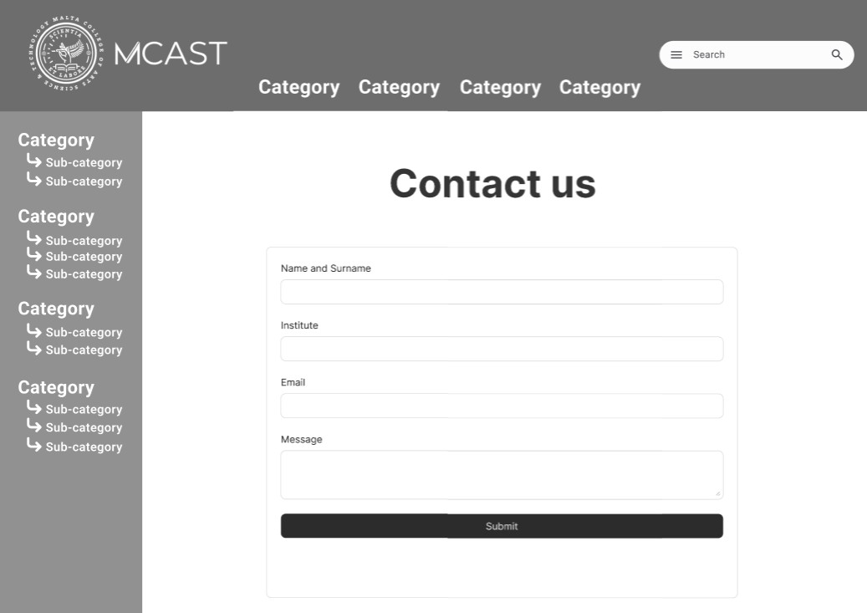

**Contact Page**

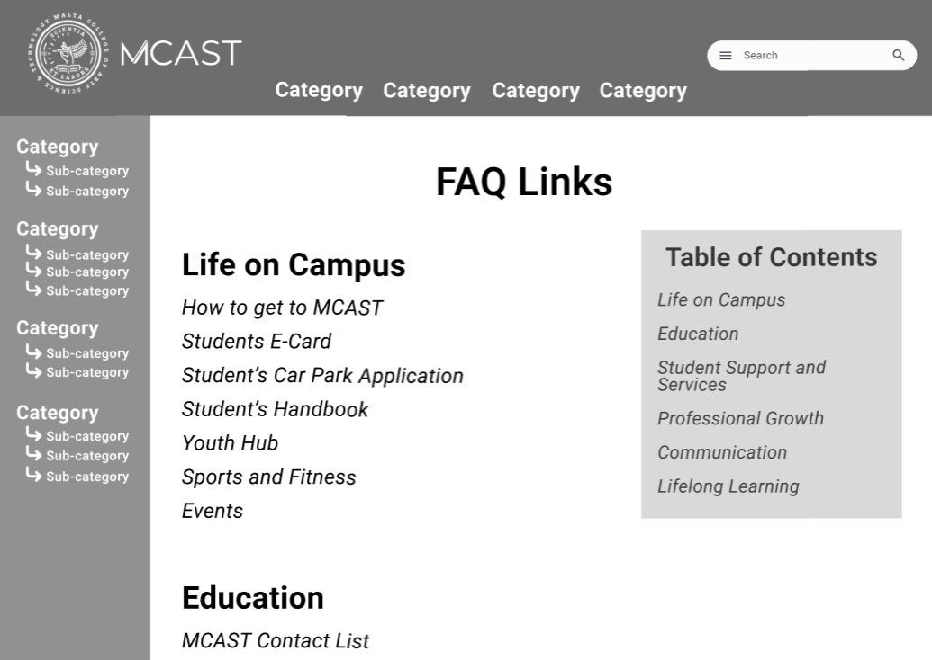

**FAQ Page**

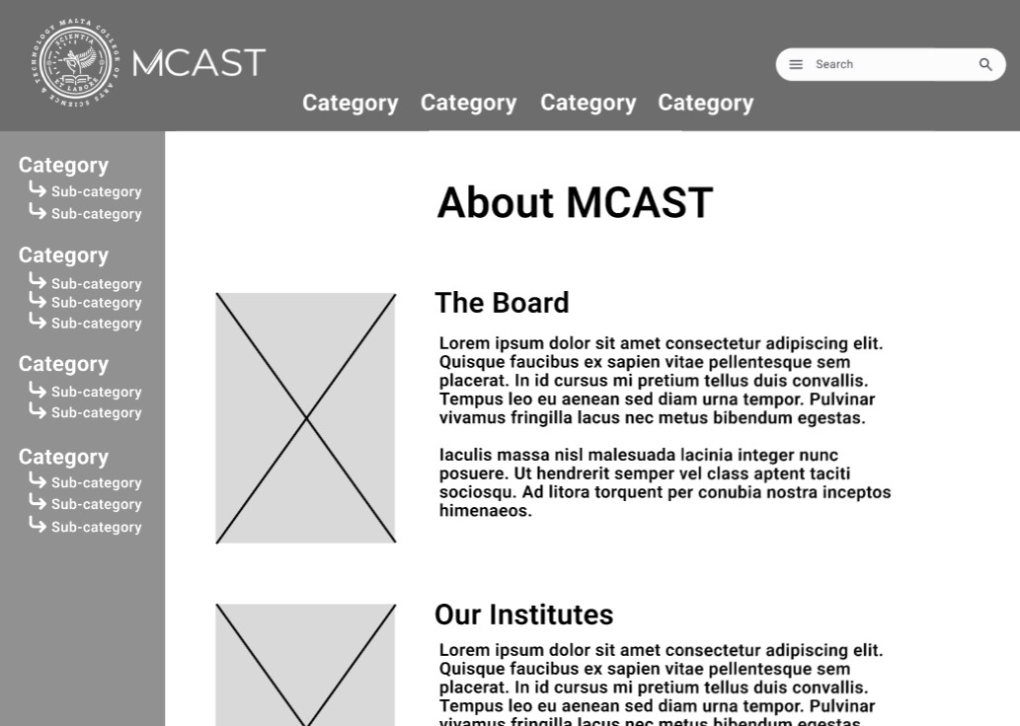

**About Page**

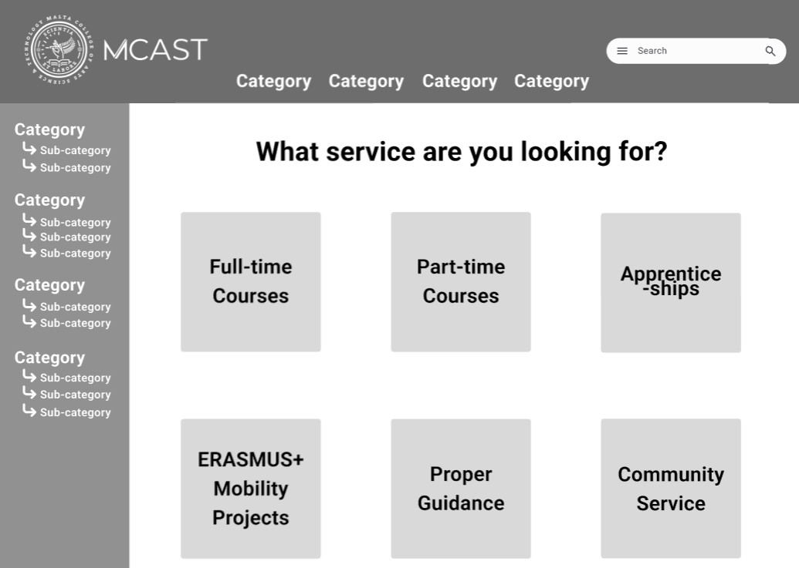

**Services Page**

# Style Guide

(See next page)

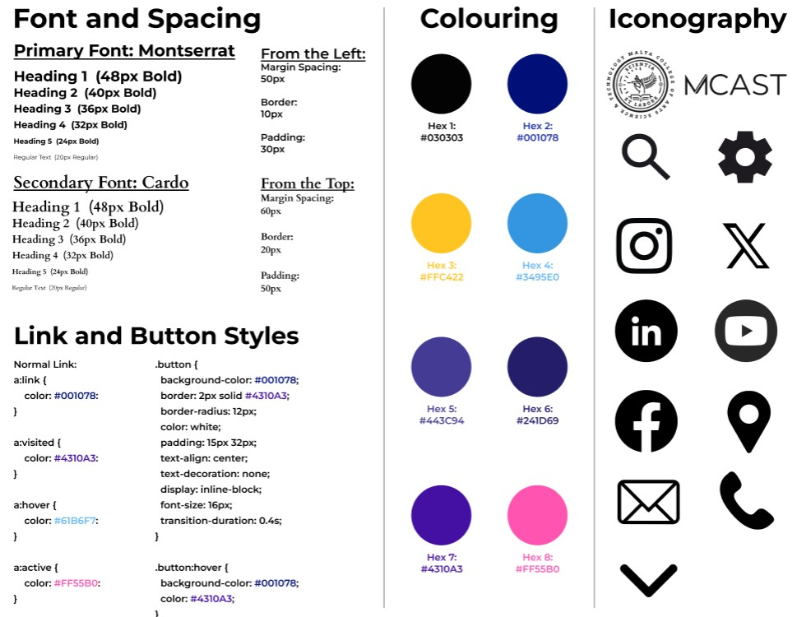

# Hi-Fi Prototype

(See next page)

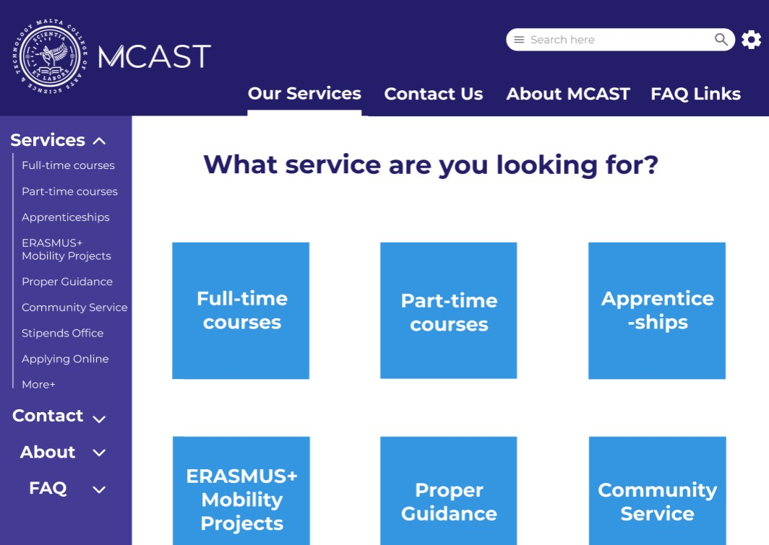

## Hi-fi prototype of service page