**Web Design Task 4: Evaluation**

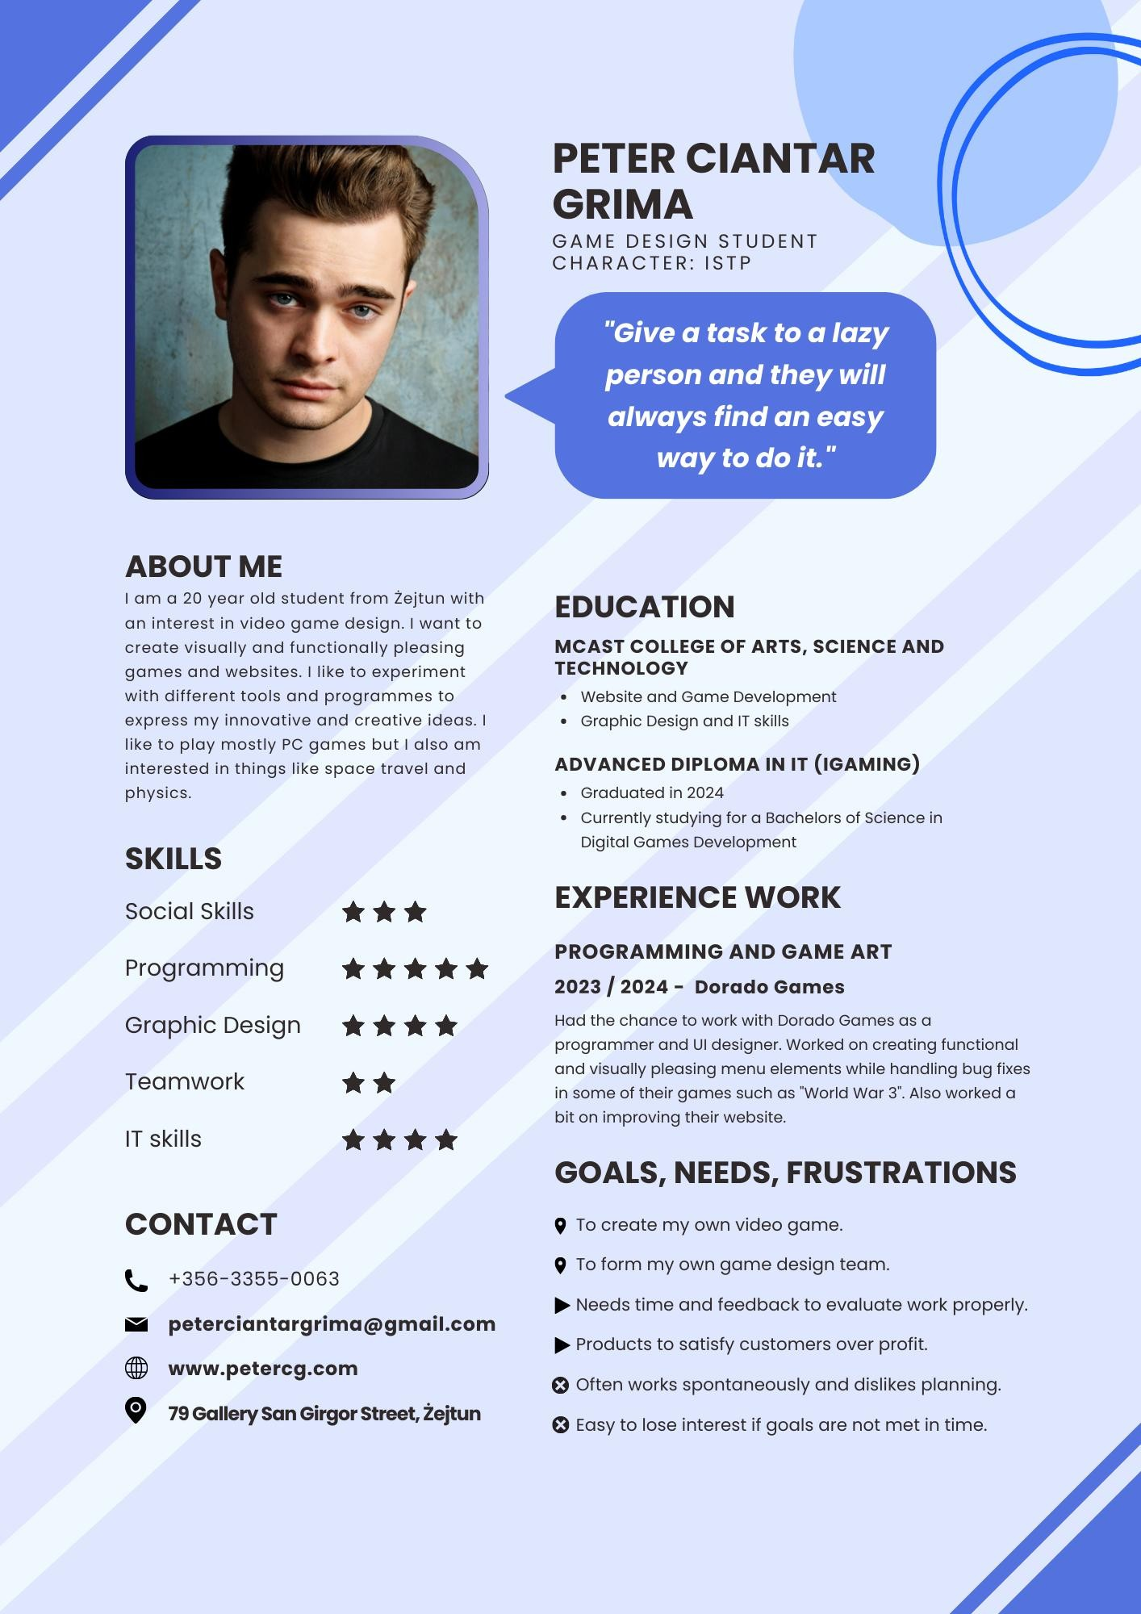

**User Persona for reference**

One of the strengths of my redesign is that when accessing different pages of the website, one does not have to click specifically on a drop-down menu option to access the page they want to. Users can instead press any of the categories in the top or left navbar and the website will bring you to said page that shows you all results that have to do with the page you accessed. For example, accessing the services page shows you all the services available while on the official MCAST website it only brings you back to the home page, forcing you to choose an option via the drop-down menu instead. This is because my user-persona liked functionally pleasing design rather than the whole drop-down system the MCAST website has currently.

One of the website’s weaknesses is that it was not very original. A major part of the website’s graphic design was heavily borrowed from the official MCAST website such as the use of blue, certain layouts and most of the text. The user persona wanted to create their own game, but this can also apply to creating a website. There was the idea that the website should use red as opposed to blue, but it would end up looking to much like the Maltese University website, so I went the route of using what made the MCAST website different from other Maltese school websites.

‘*’It’s very vague on its purpose and when I want to search for something I actually need, as for example about courses, I find it difficult on the website and need to find some sort of 3rd party.*’’ ‘’ *It is difficult to find the right course.*’’ These two quotes both comment on the awful navigation of the official MCAST website which is why I made sure to fix that issue and make it as obvious as possible to find courses and other pages as even I had a difficult time navigating the website when trying to make my version of it.

One person commented on its ‘’*ugly design*’’ so I wanted to make the website look more pleasing while retaining its functional appeal. The key is not to overdo any design elements as to not bombard users with extra information.