VetBara
VETcert Digital Exam
Candidate Guide
What to expect and how to prepare

Welcome
Your VETcert exam is run on VetBara, a tablet-based exam system. This short guide walks through what you'll see on the day, so none of it is a surprise — there is nothing to install beforehand and nothing to practise on your own device.
You'll receive a personal QR code and link from your exam centre. That link is yours alone — it identifies you to the system, so do not share it with other candidates.

1. How to prepare in advance
There is nothing to install and no account to create — the system itself needs no preparation. What's worth doing ahead of time is making sure you know how the exam session will flow, so the day itself holds no surprises:
- Read through this guide once, start to finish. Every screen it describes matches exactly what you'll see on the exam tablet.
- Confirm with your exam centre in advance which level you are sitting — Practicing or Consulting — since the Consulting level includes an extra client-report step this guide covers in Section 3.3.
- If you've never used a stylus/pen on a tablet before, it's worth trying one beforehand on any device — the drawing tool used for sketches in this exam (Section 3.3) only responds to actual pen input, not a finger.
- Prepare for the exam content itself (the VETcert syllabus and practical skills) through your usual training route — this guide only covers how to use the VetBara system, not the arboriculture knowledge being tested.

Tip: The most useful preparation is simply knowing the sequence in advance: confirm identity, then written test, then (Consulting only) field data and report. Nothing about the system itself needs rehearsing beyond that.

2. Before you arrive
- You do not need to install anything or create an account. The exam centre will hand you a tablet, or ask you to scan a personal QR code with your own device.
- Know your candidate ID and level (Practicing or Consulting) — the centre will confirm this when they hand you your access link.
- Your personal QR code / link will be given to you by the exam centre on the day — it is not something you receive or set up beforehand.

3. During the exam
This section walks through everything you will actually do on the tablet, in the order it happens.

3.1 Logging in and confirming your identity
Open your personal link (or scan your QR code). You'll land on a page like this:
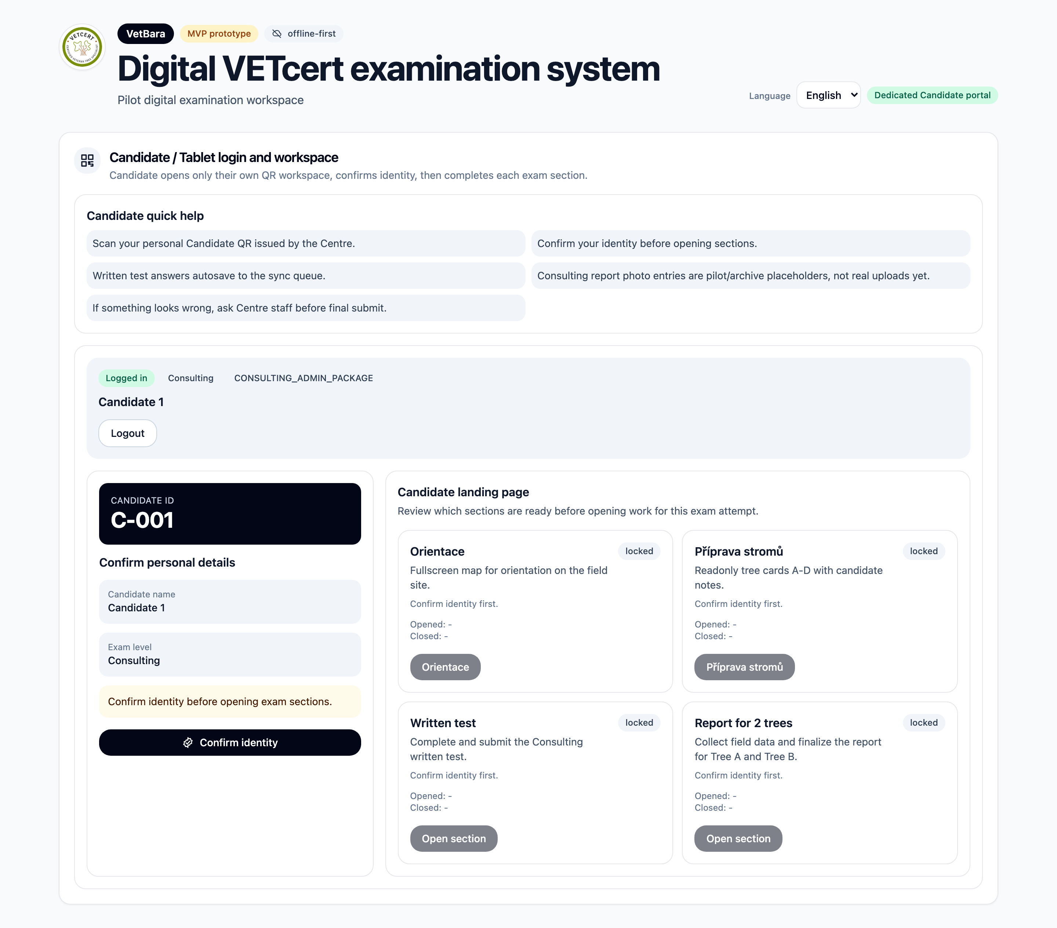
Your starting screen — nothing else unlocks until identity is confirmed.
Press Confirm identity once the centre has checked you are who your access link says you are. This is a one-time gate: until it's done, none of the exam sections can be opened.
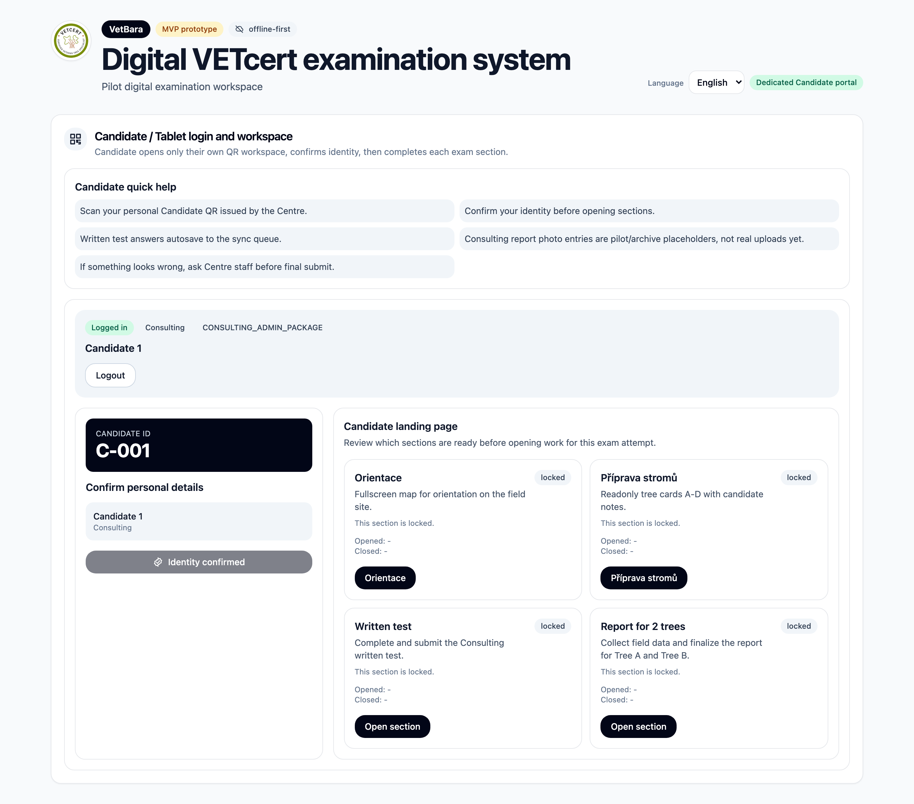
After confirming identity, your exam sections appear as cards.
You'll see a card for each part of your exam. Practicing candidates typically see the written test only through this device (the outdoor part is scored by an examiner on their own tablet, not yours). Consulting candidates additionally see a Report section for the client report.

3.2 The written test
Open the written test card when you're ready to begin — once you start, work at your own pace through the questions.
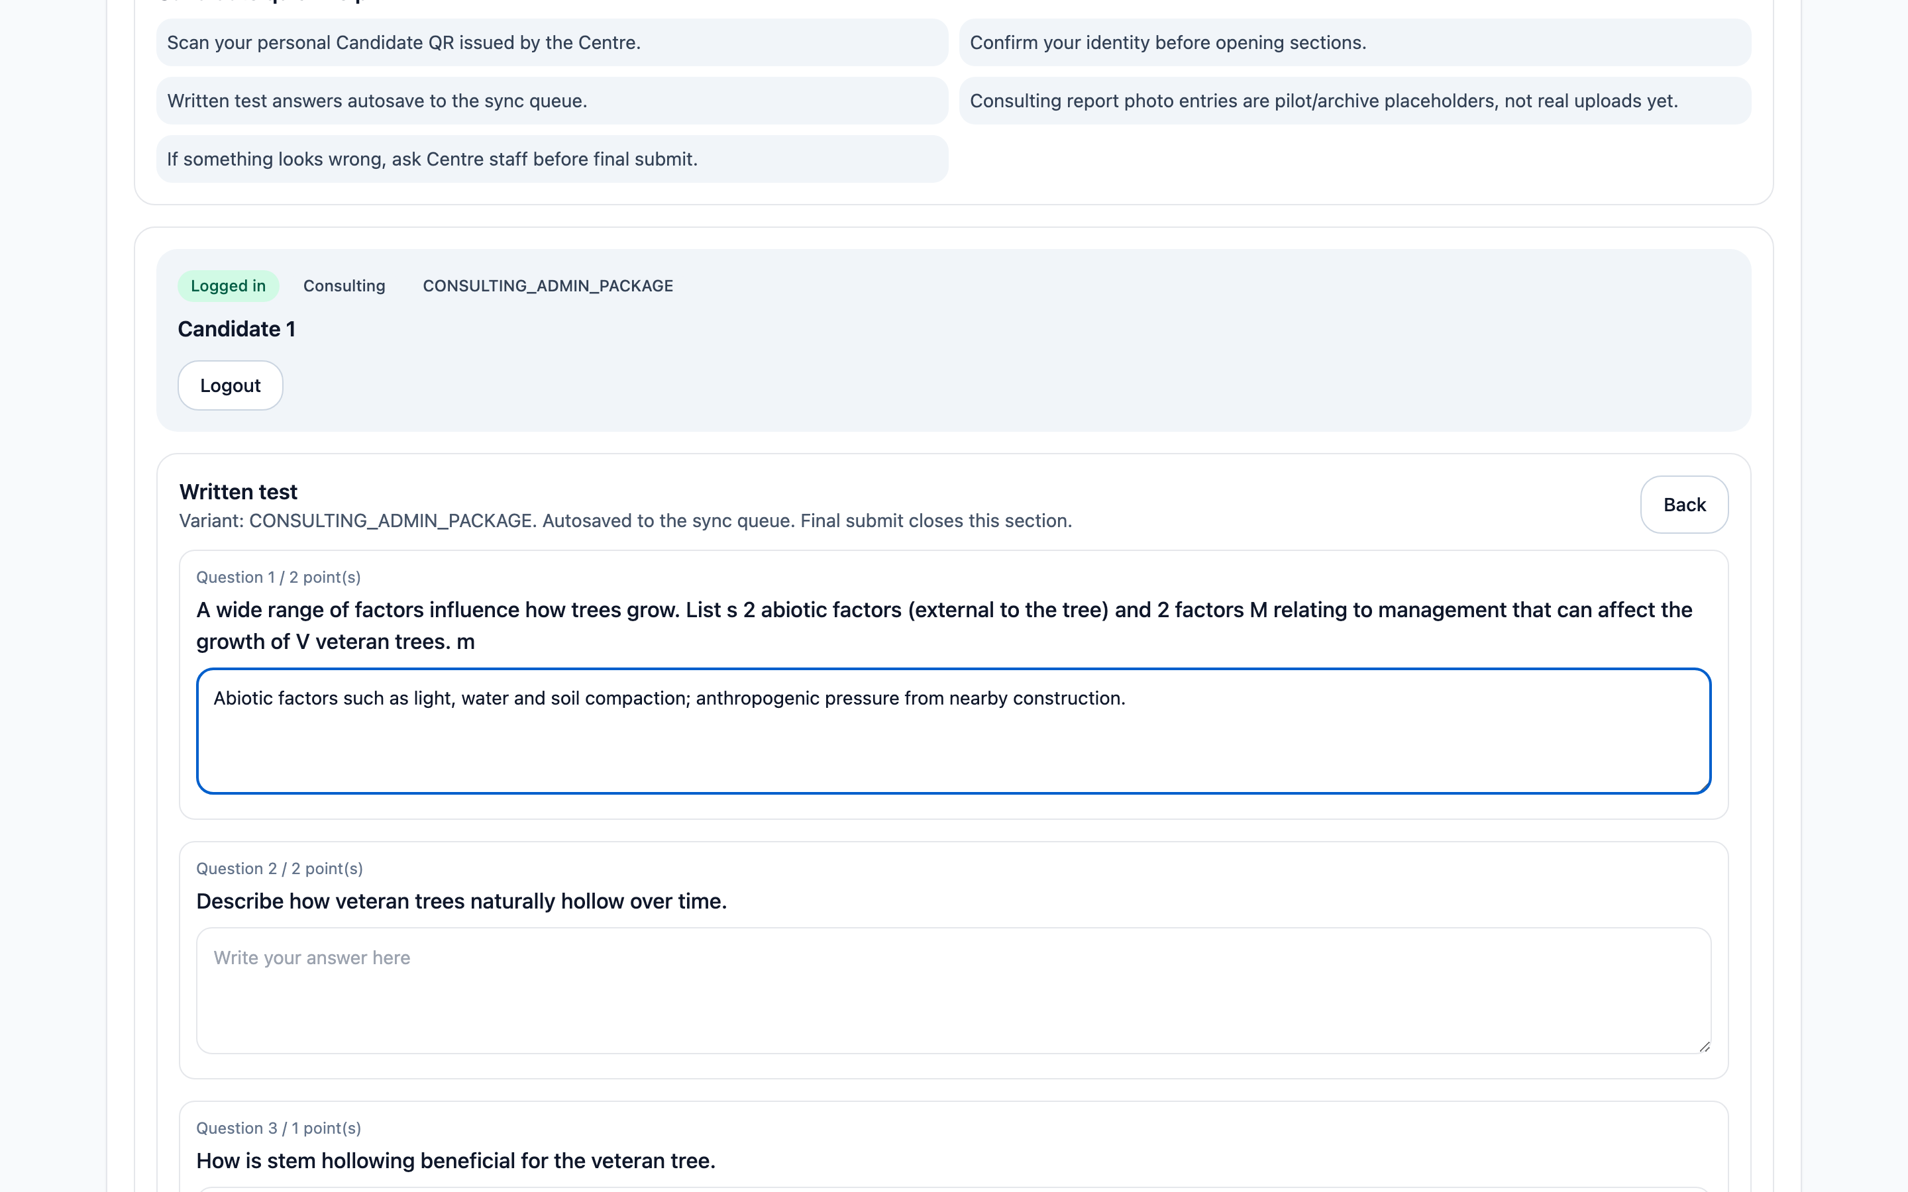
One question at a time; your answer saves automatically as you type.
- Your answers save automatically as you go — there is no separate "save" step to remember.
- You can move between questions freely before final submission.
- Submitting the test closes the section. This is meant to be final.
Important: Once you submit, re-opening the written test requires a proctor to type an approval password on the device. You cannot casually reopen it yourself, so make sure you're genuinely done before you submit.

3.3 Consulting report: field data (Consulting level only)
If you are taking the Consulting-level exam, you will also prepare a short client report based on two trees inspected during the exam. The first step is field data collection — a place to gather your notes and photos on-site before you write up the report itself.
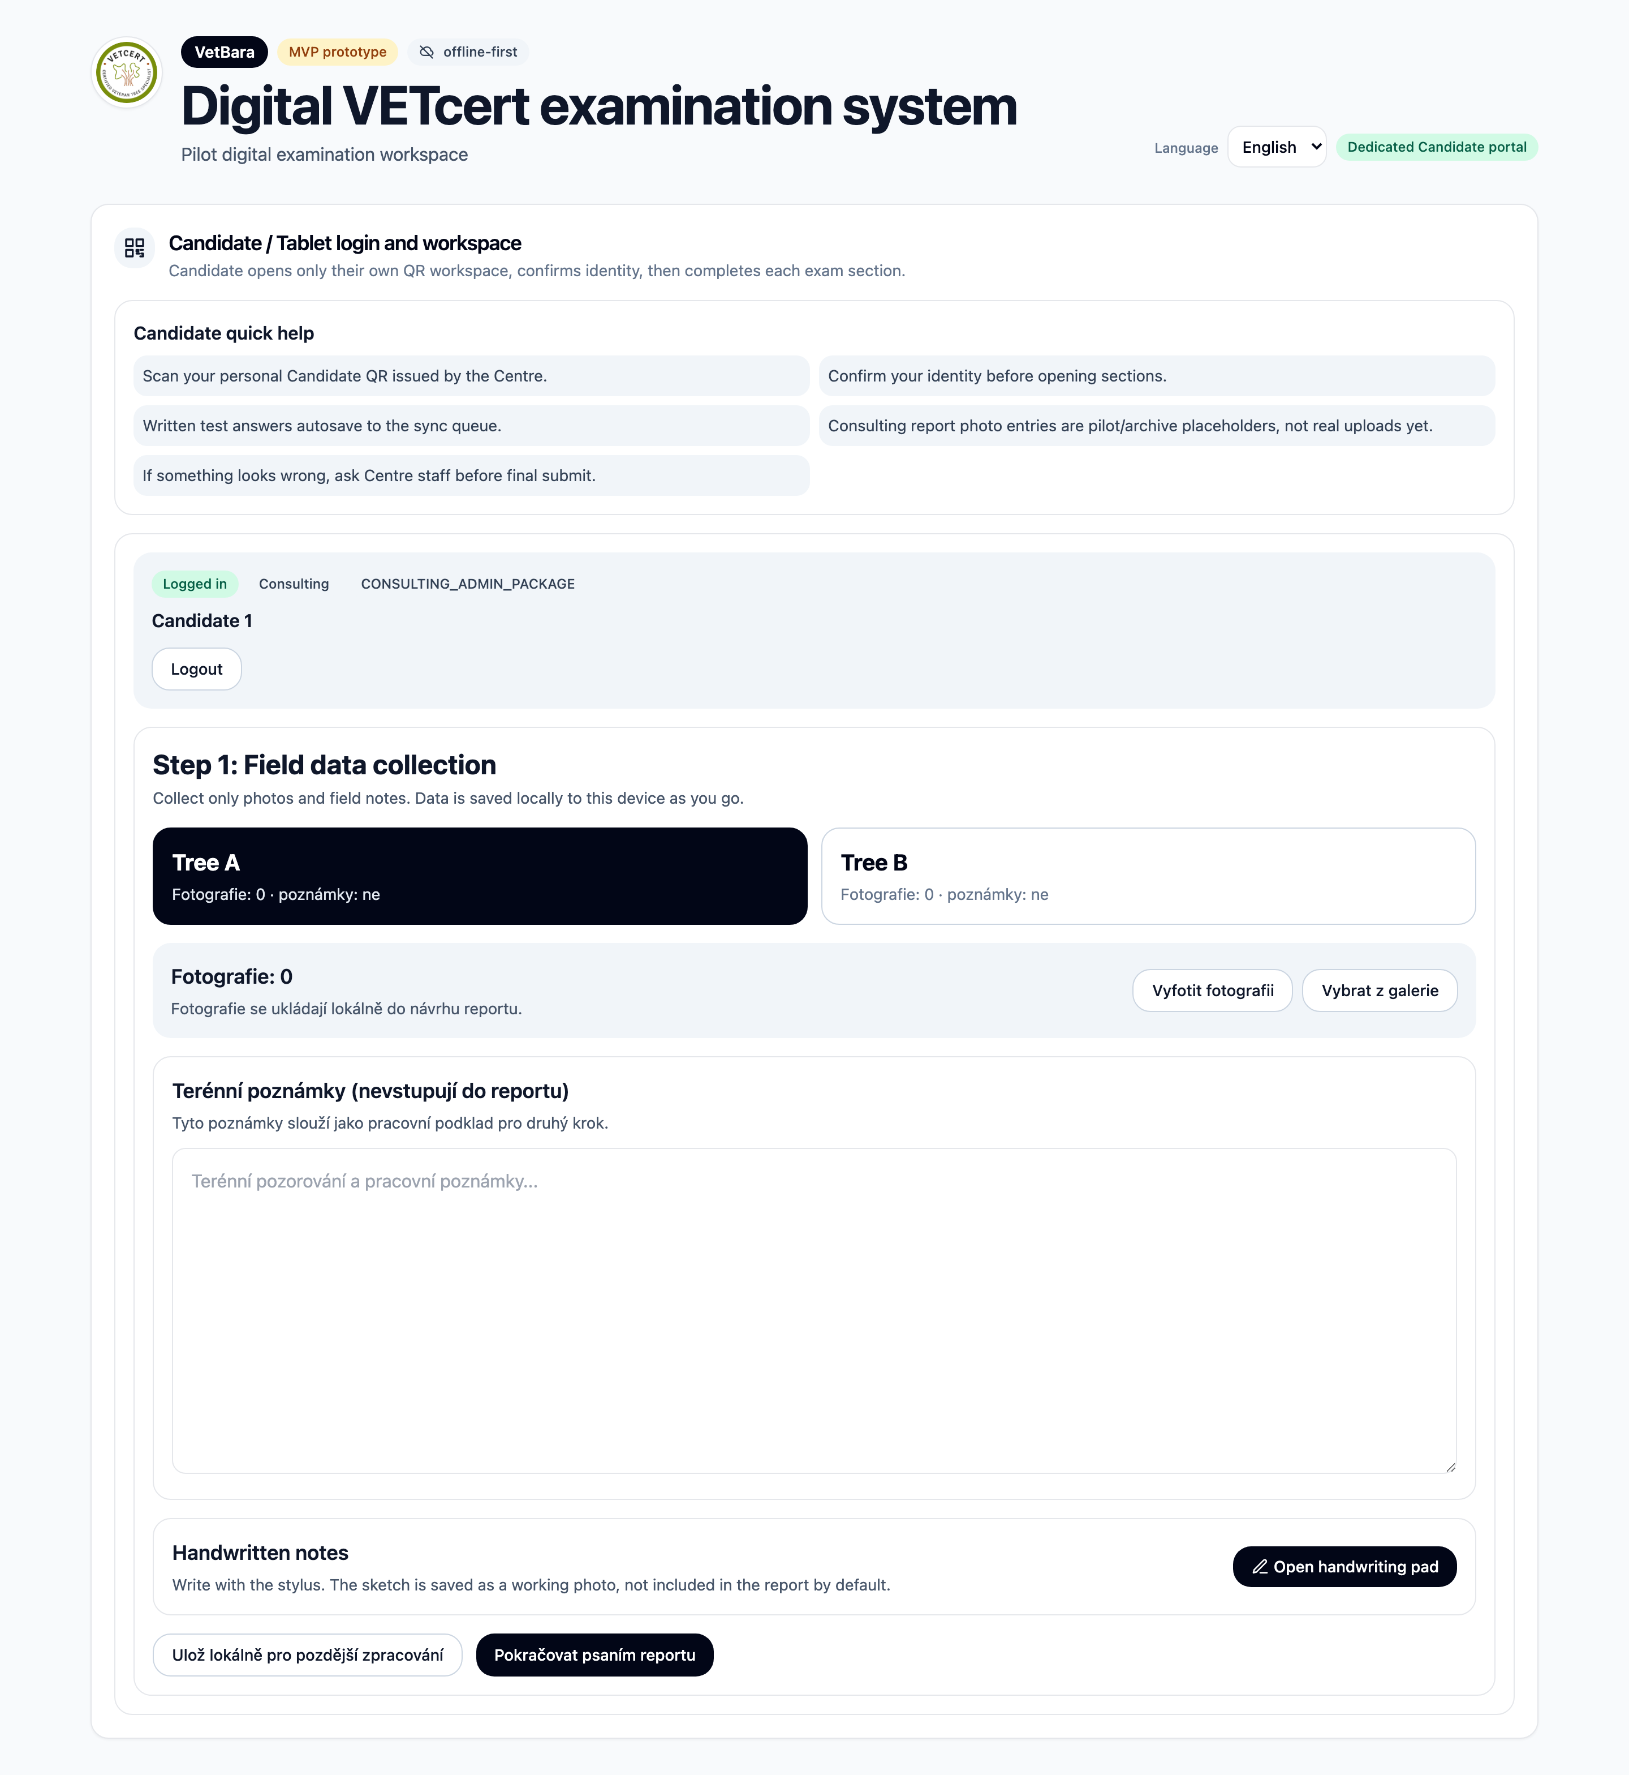
Field data collection for Tree A and Tree B.
- Take photos of each tree as needed.
- Field notes here are your own working notes — they are not automatically copied into your final report text, so anything you want in the finished report needs to be written into the report itself.

Using the handwriting pad
Next to the field notes, you can open a stylus drawing pad for a quick sketch — for example, a rough diagram of the tree or a defect.
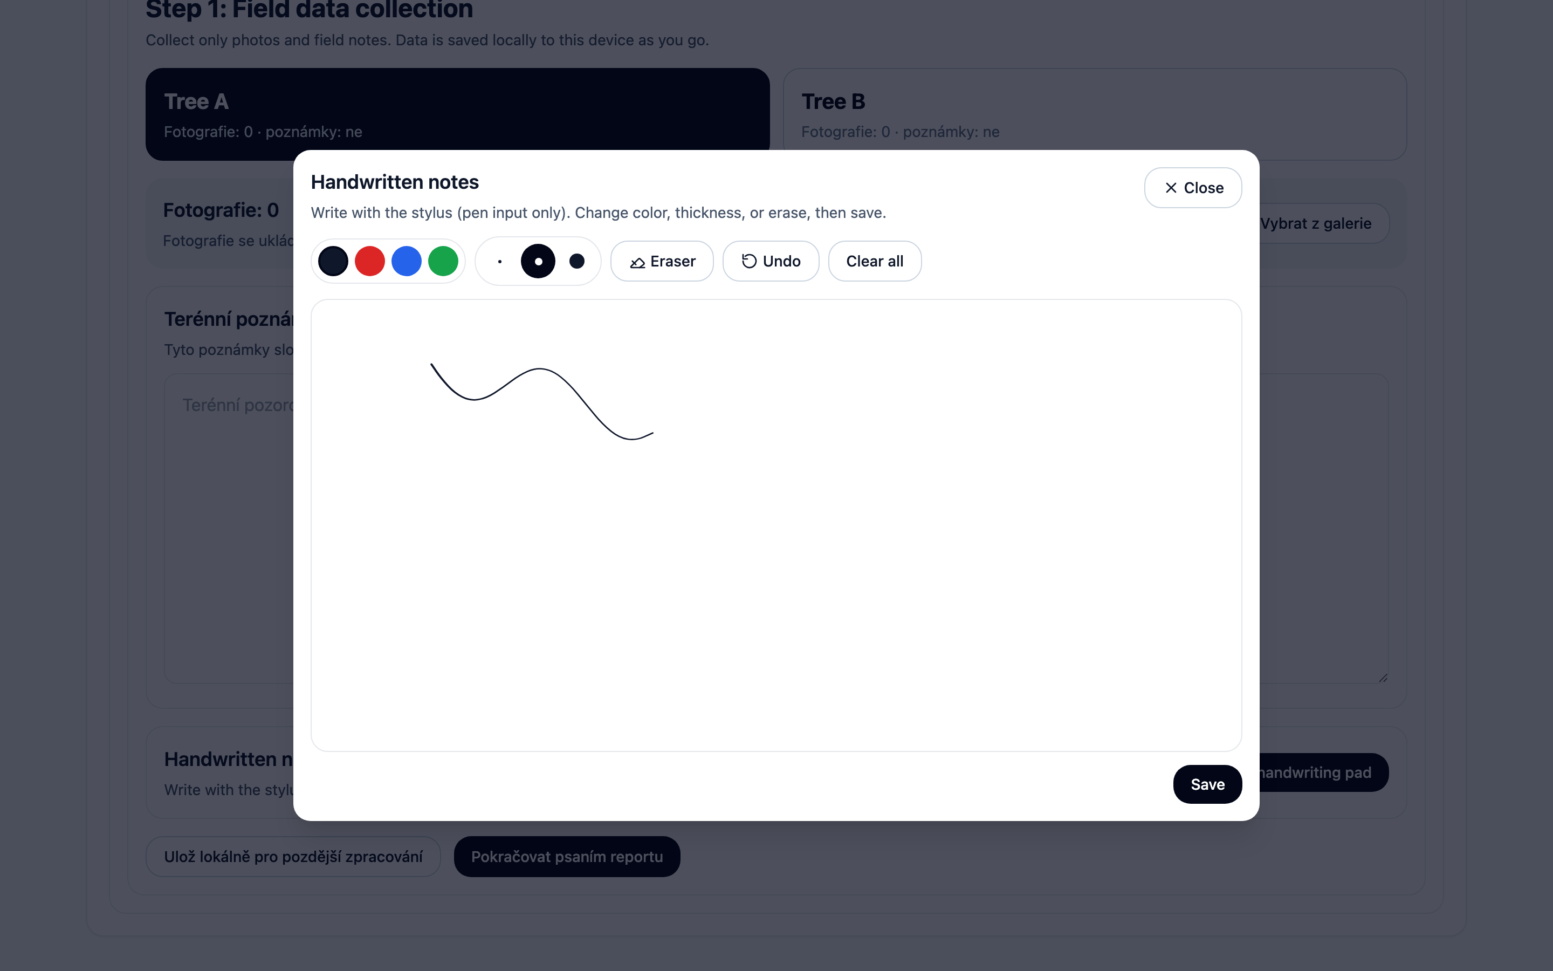
The handwriting pad: pick a colour and thickness, draw, erase a stroke, undo, or clear everything.
- Choose one of four colours and one of three line thicknesses before you draw.
- Eraser removes a whole stroke at a time — it is not a fine pixel eraser.
- Undo removes your last stroke; Clear all wipes the sketch and starts over.
- Save turns your sketch into a photo attached to your field notes.
Tip: The pad only responds to an actual stylus/pen touch, not a finger. Resting your hand on the screen while you write on paper next to it will not add stray marks.

4. On the day — quick checklist
- Get your personal QR code / link from the exam centre — don't lose it, and don't share it.
- Open the link, then press Confirm identity.
- Work through the written test at your own pace; it autosaves as you type.
- Only submit the written test when you are completely finished.
- Consulting candidates: collect field photos/notes for both trees, then move on to writing the report itself.
- If anything looks wrong on screen, or you get stuck, ask the exam centre staff — do not try to force your way past a locked section.
Important: The exam runs without needing an internet connection at the venue, so a brief Wi-Fi drop is not a problem — your answers are saved locally as you go either way. If a whole section looks broken or won't open, that's the moment to flag a member of staff rather than trying to reload repeatedly.

