**Resurrect** (Visual Studio extension, supports: Visual Studio 2012, 2013)



After extension installation, it is accessible from standard toolbar (**View -> Toolbars -> Standard)**, and under **Ctrl+R, Ctrl + 0** [zero] shortcut:

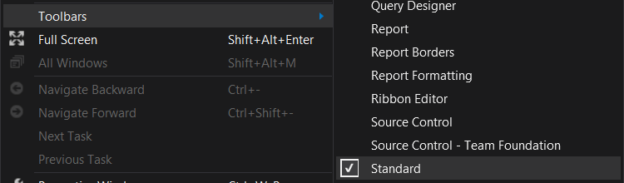

First Visual Studio run after plugin installation, will show it as disabled. It’s because there is no information stored yet about processes being debugged previously:

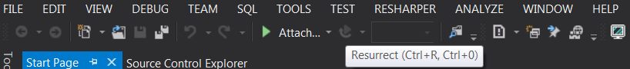

If you attach to some processes (**Debug -> Attach to Process…)**, and next stop the debug session, the plugin will became enabled. It remembers the history of processes names, to which we were attached previously (including multiple processes debugged at single session):

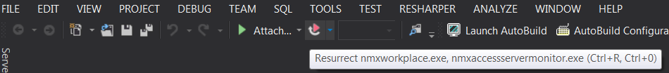

Processes to be re-attached are related to specific solutions, to which they had been previously attached. If there are multiple VS instances opened in parallel, plugins across all them are always aware of recently attached processes, no matter which instance was used as the last. All necessary data is stored in registry.