ADDIS Summary of Mediators GTExV8

Audrey Fu Lab

Jarred Kvamme

3/28/2021

Total number of Cis and Trans genes identified as Mediators under MRPC-ADDIS

|  |  |  |
| --- | --- | --- |
|  | Total.Num.Genes | Percent.Of.Total |
| Cis Only | 1356 | 0.2652582 |
| Trans Only | 3674 | 0.7187011 |
| Both Cis & Trans | 82 | 0.0160407 |

Total number of Unqiue Cis and Trans genes identified as Mediators under MRPC-ADDIS

|  |  |  |
| --- | --- | --- |
|  | Total.Unique.Genes | Percent.Of.Total |
| Cis Only Unique | 730 | 0.1994536 |
| Trans Only Unique | 2848 | 0.7781421 |
| Both Cis & Trans | 82 | 0.0224044 |

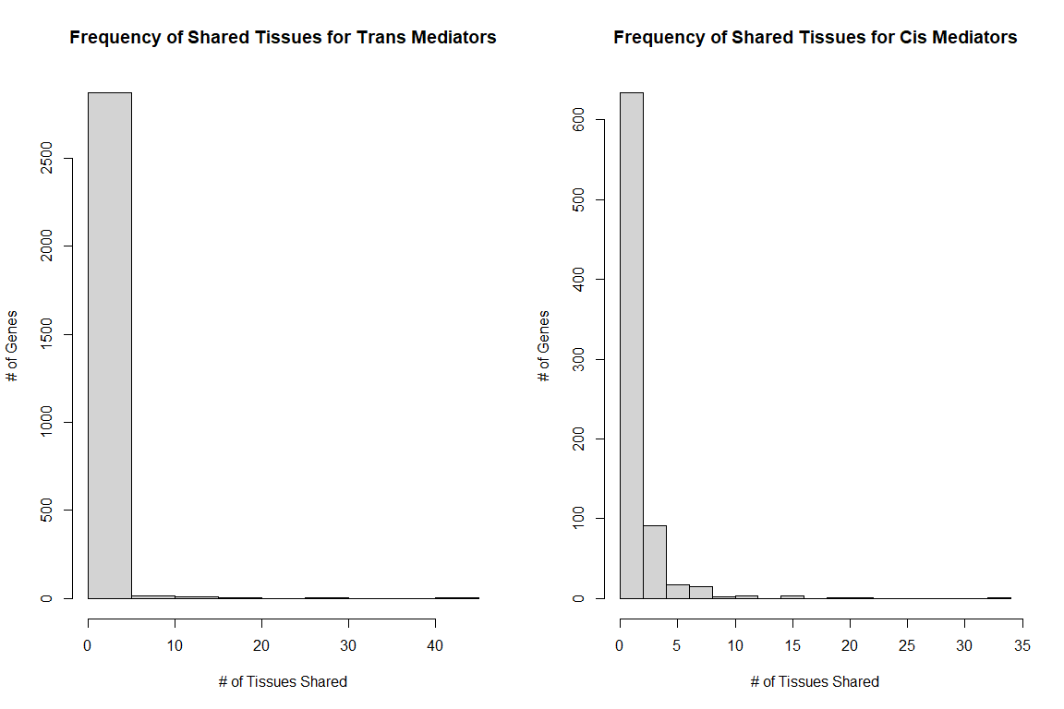

ADDIS Trans Mediator Tissue Counts

|  |  |
| --- | --- |
| Num.of.Genes | Num.of.Shared |
| 2656 | 1 |
| 160 | 2 |
| 34 | 3 |
| 13 | 4 |
| 8 | 5 |
| 3 | 6 |
| 1 | 7 |
| 4 | 8 |
| 2 | 9 |
| 3 | 10 |
| 3 | 11 |
| 2 | 13 |
| 1 | 14 |
| 1 | 15 |
| 1 | 16 |
| 1 | 17 |
| 2 | 20 |
| 1 | 26 |
| 1 | 30 |
| 1 | 44 |

ADDIS Cis Mediator Tissue Counts

|  |  |
| --- | --- |
| Num.of.Genes | Num.of.Shared |
| 514 | 1 |
| 120 | 2 |
| 60 | 3 |
| 31 | 4 |
| 10 | 5 |
| 7 | 6 |
| 7 | 7 |
| 8 | 8 |
| 2 | 10 |
| 2 | 11 |
| 1 | 12 |
| 2 | 15 |
| 1 | 16 |
| 1 | 20 |
| 1 | 21 |
| 1 | 34 |

ADDIS Unique Cis Mediator Gene Types

|  |  |
| --- | --- |
|  | Percentage |
| IG_V_gene | 0.00685 |
| IG_V_pseudogene | 0.00274 |
| lncRNA | 0.26301 |
| miRNA | 0.00137 |
| polymorphic_pseudogene | 0.00274 |
| processed_pseudogene | 0.04658 |
| protein_coding | 0.50274 |
| TEC | 0.01918 |
| TR_V_gene | 0.00137 |
| TR_V_pseudogene | 0.00137 |
| transcribed_processed_pseudogene | 0.02055 |
| transcribed_unitary_pseudogene | 0.00685 |
| transcribed_unprocessed_pseudogene | 0.07260 |
| translated_unprocessed_pseudogene | 0.00137 |
| unprocessed_pseudogene | 0.03973 |
| NA’s | 0.01096 |

ADDIS Unique Trans Mediator Gene Types

|  |  |
| --- | --- |
|  | Percentage |
| IG_C_gene | 0.00105 |
| IG_D_gene | 0.00316 |
| IG_J_gene | 0.00070 |
| IG_V_gene | 0.00667 |
| IG_V_pseudogene | 0.00632 |
| lncRNA | 0.20154 |
| miRNA | 0.06812 |
| misc_RNA | 0.05969 |
| Mt_tRNA | 0.00140 |
| polymorphic_pseudogene | 0.00035 |
| processed_pseudogene | 0.18645 |
| protein_coding | 0.24122 |
| pseudogene | 0.00035 |
| ribozyme | 0.00035 |
| rRNA | 0.00211 |
| rRNA_pseudogene | 0.01369 |
| scaRNA | 0.00035 |
| snoRNA | 0.02669 |
| snRNA | 0.06250 |
| TEC | 0.00808 |
| TR_C_gene | 0.00035 |
| TR_J_gene | 0.00421 |
| TR_J_pseudogene | 0.00070 |
| TR_V_gene | 0.00176 |
| TR_V_pseudogene | 0.00105 |
| transcribed_processed_pseudogene | 0.00772 |
| transcribed_unitary_pseudogene | 0.00105 |
| transcribed_unprocessed_pseudogene | 0.02247 |
| unitary_pseudogene | 0.00105 |
| unprocessed_pseudogene | 0.06742 |
| NA’s | 0.00140 |

ADDIS gene types for genes found as both Cis and Trans Mediators

|  |  |
| --- | --- |
| Gene.Type | Percent |
| IG_V_gene | 0.01220 |
| lncRNA | 0.17073 |
| processed_pseudogene | 0.10976 |
| protein_coding | 0.43902 |
| transcribed_processed_pseudogene | 0.01220 |
| transcribed_unitary_pseudogene | 0.01220 |
| transcribed_unprocessed_pseudogene | 0.13415 |
| unprocessed_pseudogene | 0.10976 |

ADDIS Unique cis mediator gene types after grouping all gene types into 4 categories: pseudogene, protein_coding, lncRNA, and Others

|  |  |  |
| --- | --- | --- |
| Type | Count | Proportion |
| pseudogene | 142 | 0.1945205 |
| protein_coding | 367 | 0.5027397 |
| lncRNA | 192 | 0.2630137 |
| others | 29 | 0.0397260 |

ADDIS Unique trans mediator gene types after grouping all gene types into 4 categories: pseudogene, protein_coding, lncRNA, and Others

|  |  |  |
| --- | --- | --- |
| Type | Count | Proportion |
| pseudogene | 879 | 0.3086376 |
| protein_coding | 687 | 0.2412219 |
| lncRNA | 574 | 0.2015449 |
| others | 708 | 0.2485955 |

Gene types in the entire genome after grouping all gene types into 4 categories: pseudogene, protein_coding, lncRNA, and Others

|  |  |  |
| --- | --- | --- |
| Type | Count | Proportion |
| pseudogene | 17093 | 0.2546254 |
| protein_coding | 22792 | 0.3395203 |
| lncRNA | 17951 | 0.2674065 |
| others | 9294 | 0.1384478 |

To analyze the mediator genes classified under MRPC-ADDIS, we partitioned the Cis and Trans mediator genes into subsets by their gene types (2 levels: Pseudogene or Non-pseudogene). We then employed hypothesis testing to determine if there was dependence among a mediator gene’s position (2 levels: Cis or Trans) and its gene type. We conducted a Chi-Squared test of Independence with the null and alternative hypotheses:

$$H_{0}:\text{Gene type is independent of mediator position}$$

$$H_{A}:\text{Gene type is not independent of mediator position}$$

The resulting $2×2$ contingency table is given in . The test yielded a $χ_{(1)}^{2}=43.77, p=1.489e^{−09}$ and we therefore rejected the null hypothesis of no dependence. From the resulting rejection is due to an approximately $10\%$ difference in the number of pseudogenes between Cis and Trans gene positions. However, under the current test conditions, we are unable to determine if the trans position is $10\%$ enriched with pseudogenes or is the cis position is $10\%$ depleted.

2X2 contingency table comparing the cell counts of mediator position and gene_type:pseudogene

|  |  |  |  |  |  |
| --- | --- | --- | --- | --- | --- |
|  | cis | %cis | trans | %trans | Col.Total |
| non-pseudo | 588 | 0.8055 | 1969 | 0.6914 | 2557 |
| pseudo | 142 | 0.1945 | 879 | 0.3086 | 1021 |
| row.total | 730 | 1.0000 | 2848 | 1.0000 | 3578 |

Chi-Squared Test of Independence Summary: gene.type = pseudogene

|  |  |
| --- | --- |
|  | Value |
| Chi-Squared | 36.54885 |
| P | 0.00000 |
| df | 1.00000 |

To further investigate the possibility of trans mediator pseudogene enrichment, we employed a Chi-Squared Goodness of Fit test to determine if enrichment was similar to the proportion of pseudogenes present in the whole genome. In this case, the vector of probabilities ${\bf p}$ is taken to be the observed proportion of pseudo and non-pseudogene types among trans mediator genes, and ${\bf p_0}$ is the expected proportions given by the proportion of pseudo/non-pseudogene types in the entire genome. This leads to the null and alternative hypotheses:

$$ H_0: {\bf p} = {\bf p_0} $$

$$ H_A: {\bf p} \neq {\bf p_0} $$

The test resulted in a $χ_{(1)}^{2}=43.77, p=3.68e^{−11}$ and we therefore rejected the null hypothesis of equality of observed and expected proportions. indicates that the rejection is due to a roughly $5.4\%$ increase of pseudogene gene type among trans mediators relative to the entire genome.

It is important to note that, because the test statistic in both tests is asymptotically $χ^{2}$, the large sample sizes translate into high power and therefore a small difference is translated into a null hypothesis rejection.

##   
## Chi-squared test for given probabilities  
##   
## data: summary(trans.types)  
## X-squared = 43.777, df = 1, p-value = 3.68e-11

Chi-Square GOF observed vs. expected proportions of trans gene types ADDIS: gene.type=Pseudogene

|  |  |  |  |  |
| --- | --- | --- | --- | --- |
|  | non-pseudo | %non-pseudo | pseudogene | %pseudogene |
| Observed | 1969 | 0.6914 | 879 | 0.3086 |
| Genome | 50037 | 0.7454 | 17093 | 0.2546 |

Similar to the above tests, we also explored the dependence among gene position and gene type with types consisting of protein coding or non-protein coding. Again, we conducted a Chi-square test of independence (). The test yielded a $χ_{(1)}^{2}=189.98, p≈0$ and we rejected the null hypothesis of no dependence. The rejection is due to an approximately $1:2$ ratio of protein coding to non-protein coding gene types among the cis mediators and an approximately $1:5$ ratio of protein coding to non-protein coding gene types among the trans mediators.

2X2 contingency table comparing the cell counts of mediator position and gene_type:protein coding

|  |  |  |  |  |  |
| --- | --- | --- | --- | --- | --- |
|  | cis | %cis | trans | %trans | Col.Total |
| non-protein_coding | 363 | 0.4973 | 2161 | 0.8055 | 2524 |
| protein_coding | 367 | 0.5027 | 687 | 0.1945 | 1054 |
| row.total | 730 | 1.0000 | 2848 | 1.0000 | 3578 |

Chi-Squared Test of Independence Summary: gene.type = protein coding

|  |  |
| --- | --- |
|  | Value |
| Chi-Squared | 189.9823 |
| P | 0.0000 |
| df | 1.0000 |

We further explored protein coding gene type enrichment among cis mediators by conducting a Chi-Square GOF test to compare the relative proportion of protein-coding genes among cis mediators to the observed proportion of protein coding genes in the entire genome. The test resulted in a $χ_{(1)}^{2}=122.72, p≈0$. we therefore rejected the null hypothesis of equality of observed and expected proportions. indicates that the rejection is due to an approximately $16$ difference in the proportion of protein coding gene type among cis mediators relative to the entire genome.

##   
## Chi-squared test for given probabilities  
##   
## data: summary(trans.types)  
## X-squared = 122.72, df = 1, p-value < 2.2e-16

Chi-Square GOF observed vs. Expected proportions of cis gene types ADDIS: Type=Protein Coding

|  |  |  |  |  |
| --- | --- | --- | --- | --- |
|  | non-protein_coding | %non-protein_coding | protein_coding | %protein_coding |
| Observed | 363 | 0.4973 | 367 | 0.5027 |
| Genome | 44338 | 0.6605 | 22792 | 0.3395 |

Finally, we explored the dependence among gene position and gene type with type consisting of lncRNA or non-lncRNA using a Chi-square test of independence (). The test yielded a $χ_{(1)}^{2}=12.68, p≈0.00037$, and we rejected the null hypothesis of no dependence. The rejection is due to an approximately $1:4$ ratio of non-lncRNA to lncRNA gene types among the cis mediators and an approximately $1:5$ ratio of non-lncRNA to lncRNA gene types among the trans mediators.

2X2 contingency table comparing the cell counts of mediator position and gene_type:lncRNA

|  |  |  |  |  |  |
| --- | --- | --- | --- | --- | --- |
|  | cis | %cis | trans | %trans | Col.Total |
| non-lncRNA | 192 | 0.263 | 574 | 0.2015 | 766 |
| lncRNA | 538 | 0.737 | 2274 | 0.7985 | 2812 |
| row.total | 730 | 1.000 | 2848 | 1.0000 | 3578 |

Chi-Squared Test of Independence Summary: gene.type = lncRNA

|  |  |
| --- | --- |
|  | Value |
| Chi-Squared | 12.6859428 |
| P | 0.0003684 |
| df | 1.0000000 |

To Explore lncRNA gene type enrichment among trans mediators we conducted a Chi-Square GOF test to compare the relative proportion of lncRNA genes among trans mediators to the observed proportion of lncRNA genes in the entire genome. The test resulted in a $χ_{(1)}^{2}=63.06, p≈0$. we therefore rejected the null hypothesis of equality of observed and expected proportions. indicates that the rejection is due to an approximately $5.5\%$ difference in the proportion of lncRNA gene type among trans mediators relative to the entire genome.

##   
## Chi-squared test for given probabilities  
##   
## data: summary(trans.types)  
## X-squared = 63.062, df = 1, p-value = 2.003e-15

Chi-Square GOF observed vs. Expected proportions of gene types ADDIS: Type=lncRNA

|  |  |  |  |  |
| --- | --- | --- | --- | --- |
|  | non-lncRNA | %non-lncRNA | lncRNA | %lncRNA |
| Observed | 574 | 0.2015 | 2274 | 0.7985 |
| Genome | 17951 | 0.2674 | 49179 | 0.7326 |