**Steps to run project:**

1. Run the .sql script that is included in the submission to create your local database, after the script is run you should have 3 tables (products, enquiries, users) in a database named ‘Project’.
2. Navigate to the lib folder in the project directory
3. Open the Database.cs file
4. Change the code snippet shown below starting at line 17, set the server name to your local SQL Server name, change the user Id and password to your own data as well.

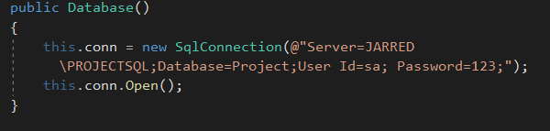

1. Navigate to the login.aspx file, click start without debugging to launch the app
2. You will have to create your own test data, to test all functionalities of the app you will need to create a buyer account from the register page and a seller account.
3. When logged in as a seller you can create some products that will show up for your buyer account via the home page
4. From this point on you can use the app switching between buyer and seller accounts to test the functionality of all requirements listed in the project requirements document on slate.