Stock Evaluation of NetEase
By Jarren Rowe Himawan (124040023), Mei Enran (125030053)


Investment Summary
Calculations through future cash flow valuations using projections from 2025E to 2030E yield a future NPV of 586.70 billion RMB, which amounts to a fair price of 181.43 RMB per share. Comparisons place current NetEase stock prices slightly under the fair price, at 179.00 HKD with a conversion rate of 1 HKD = 0.873 RMB, equivalent to 156.27 RMB per share.

Valuation of Fair Price Above Current Market Price
Recommendation
Using free cash flow valuations based on data from several analysts’ projections of revenue, we found that the calculated fair value is 16.1% above the current market price, which means the stock price is currently undervalued.

Fair Price
181.43 RMB
Buy
30-04-2026 Market Price
156.27 RMB

Strong Financials, with Further Growth Expected
In 2025, NetEase achieved RMB 112.6 billion in revenue – a 7% increase compared to its 2024 revenue – and a net profit attributable to shareholders of RMB 33.8 billion as well as an operating cash flow of RMB 50.7 billion. The company has repurchased $2 billion USD in shares and continues to pay dividends, indicating healthy revenue-generating capabilities. With the launch of popular new games such as Where Winds Meet with millions of global users, combined with ongoing AI-driven cost reduction and efficiency gains, this strong financial trajectory is expected to further strengthen.

Business Description
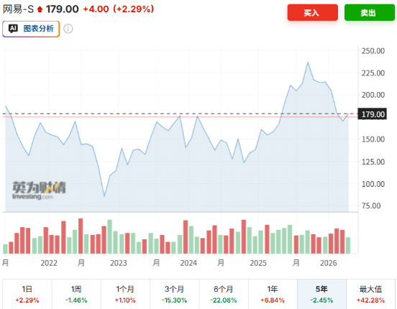
NetEase is one of the largest gaming companies in China by revenue, founded by William Ding and established in 1997 as an internet service provider. It has since evolved into a gaming-focused company, consistently developing and launching new games such as Identity V. Its portfolio mainly consists of mobile, PC, and console platforms. The company has been enlisted on the Nasdaq Stock Market since 2000 (ticker symbol: NTES).
Fig 1: NetEase’s Historical Stock Price Chart (in HKD)

Business Operations & Revenue Structure
Although NetEase’s primary market remains China, the company has expanded internationally through launching several games and listed itself on the Hong Kong Stock Exchange in 2020. Beyond games, NetEase also owns Youdao, an AI-based learning platform featuring smart devices, as well as NetEase Cloud Music – one of China’s largest music platforms. These non-gaming businesses diversify NetEase’s portfolio, but its gaming segments have continued to fuel most of its revenue and operating profits.
Industry Overview
- Demand for games
Modern lifestyles often include gaming habits, which has become an increasingly common form of entertainment. The demand for games has been clear as the gaming industry has become increasingly popular over the years, its global market revenue showing consistent annual growth rates over the past decade. Furthermore, the global gaming revenue is expected to grow at a CAGR of approximately 6% from 2026 to 2030.
- Game Development
With continuous improvements in AI capabilities and development, the game industry is expected to thrive in the future. AI-based development tools may improve game research and development efficiency by assisting in coding, testing, and live operations, which allow faster content updates for games. With these prospects, global gaming revenue is expected to reach $353 billion USD by 2030.
- R&D Capabilities Determine Rankings
Although NetEase and others have built deep expertise in proprietary engines, such as NeoX, and long-term game operations, they still need breakthroughs in narrative design and original IP globalization to increase player engagement. Future competition will depend on creative capacity, with R&D intensity determining industry rankings.

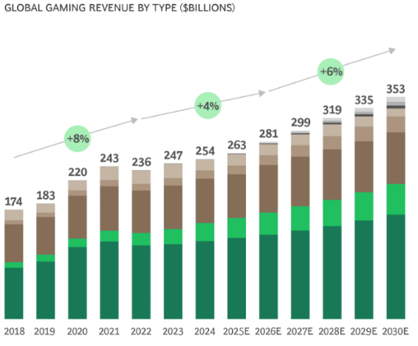
Competitive Positioning
NetEase is China’s second-largest company in the gaming industry by revenue, competing against other gaming company giants like Tencent and miHoYo. While the game industry continues to thrive, NetEase has seized opportunities to release new games, introducing popular games such as Where Winds Meet, which have supported its revenue growth.
Source: BCG Publications
Fig 2: NetEase’s Historical and Projected Revenue (by analysts)
Core Focus on Gaming Services
NetEase focuses mostly on games, which makes up around 82% of its annual revenue in 2025 (Fig 3). This business strategy allows NetEase to allocate more resources towards developing its game services and content, giving it an edge in player engagement, which is important for its competitiveness in the gaming market.
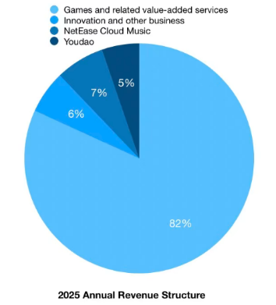
Diversification Beyond Gaming
NetEase also owns Youdao and NetEase Cloud Music, which together generated 12% of NetEase’s total revenue in 2025. Although these companies are smaller in scale compared to NetEase’s gaming business, they help diversify NetEase’s portfolio and reduce its dependence on just gaming services.

Fig 3: NetEase’s 2025 Annual Revenue
Financial Analysis
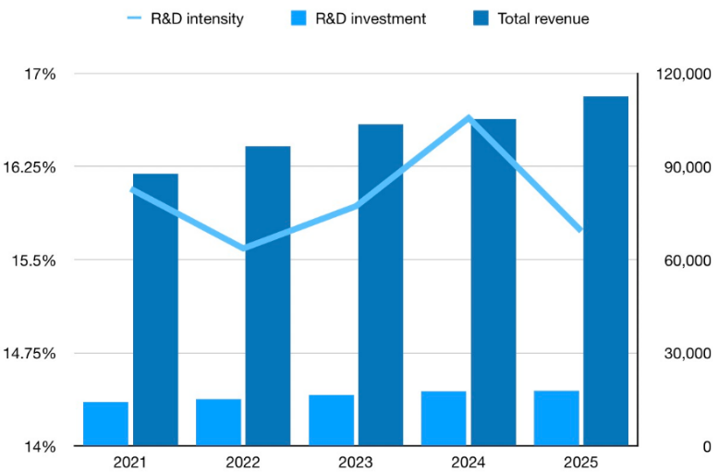
1. Stable R&D
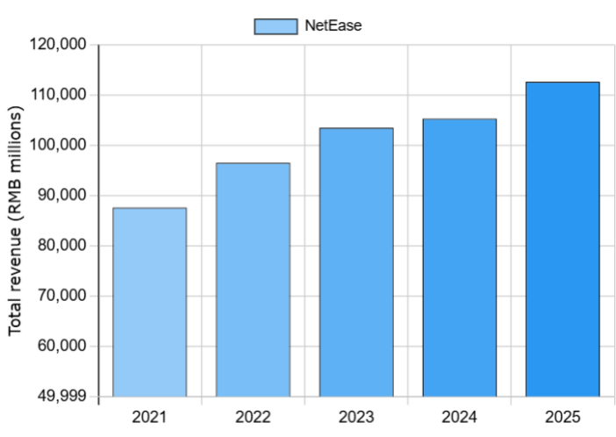
NetEase’s R&D costs have been generally constant to steadily increasing the past few years. This could be attributed to NetEase’s R&D in-house team, meaning that competitors cannot just copy their games. Furthermore, around 82% of NetEase’s gross profits is from games (Fig 3) which shows that NetEase, in addition to being the second largest gaming company in China by revenue, will continue to be a strong competitor in the gaming industry.
Fig 4: R&D costs and intensity
2. Steady Revenue Growth
NetEase’s revenue has been increasing steadily over the past five years. This may be due to its consistent new game launches, some of which have quickly gained popularity. Furthermore, NetEase owns NetEase Cloud Music and Youdao, which are both respectively successful companies. Combined with the fact that R&D intensity has decreased in 2025 (Fig 4), it likely means that NetEase has improved its efficiency with resources while bringing in more cash.
Fig 5: NetEase total annual revenue
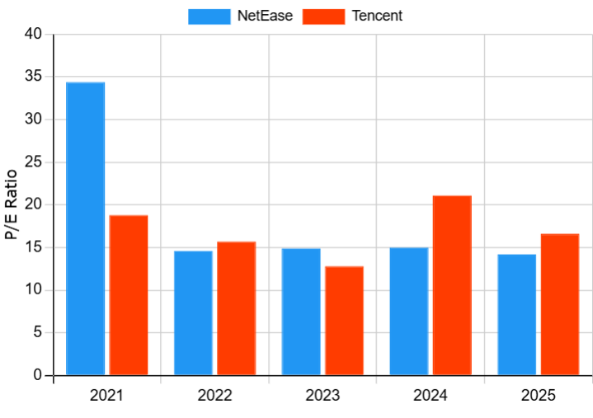
3. P/E ratio
NetEase’s P/E ratios have been similar to Tencent’s – its main competitor and China’s largest gaming company by revenue – for the past five years (Fig 6). This is significant since this means that NetEase, as a more gaming-focused company, is valued similarly to Tencent – which has a more diversified portfolio and owns popular apps like WeChat – which proves that NetEase is a very strong competitor in the gaming industry.
Fig 6: Tencent & NetEase’s Historical P/E Ratios

Valuation
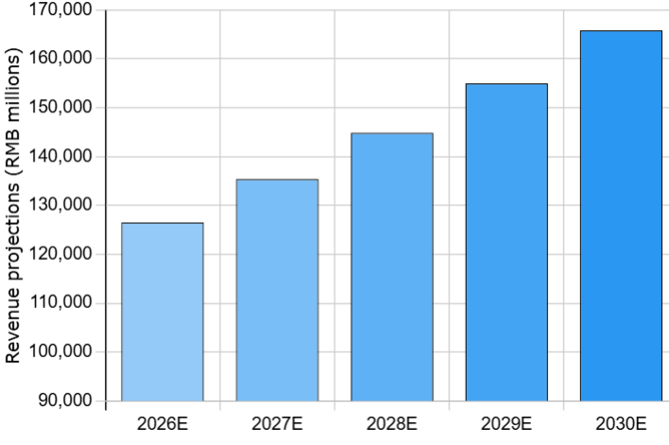
Expected Future Revenue
The global gaming market’s revenue is expected to grow at a 6.6% CAGR for its PC segment and 4.4% for its console segment from 2026 to 2028. Based on current and previous data, we project that NetEase’s annual revenue growth will be between 6-7%. This assumption accounts for its strong competitive position in the market.
Fig 7: NetEase’s Revenue Projections
Costs of Goods Sold (COGS)
Costs of goods sold is estimated to be around 35-36% of revenue. This estimation is derived from historical data from around 2021-2025. As such, it is reasonable to continue using this data as a future baseline considering the gaming market’s consistent annual growth rate.
Depreciation
We project future depreciations to be equal to 2.0% of total revenue. This assumes that: 1) future depreciation projection to revenue ratio will remain the same as 2025’s, and 2) this holds for all future cash flows.
Research and Development (R&D)
Using NetEase’s 2021-2025 R&D expenses’ annual growth rate average as a baseline, we expect the R&D to be approximately 15.7% of revenue.
Selling, General and Administrative (SGA)
The average of NetEase’s 2021-2025 SGA expenses is 16.7% of its revenue. We assume this average to be used as a fixed percentage to calculate future projections of SGA in our valuation model for all forecasted periods.
Capital Expenditures (CapEx)
Historical capital expenditures to revenue ratios yields an average of approximately 2.0-2.1%. Given the stability of this ratio throughout past data from 2021-2025, we project future capital expenditures to maintain a similar ratio and thus utilize this trend to compute future capital expenditure projections.
Net Working Capital (NWC)
NWC has consistently remained positive from 2021 to 2025, indicating that NetEase holds enough current assets to cover short-term obligations. For our valuation model, using this historical data as a baseline, we expect moderately positive annual NWC changes in the future.
Weighted Average Cost of Capital (WACC)
To calculate the WACC, we use the following formula:
$$WACC=\frac{E}{D+E} \left(r_{E}\right)+\frac{D}{D+E} \left(r_{D}\right) (1-t)$$
where:
- $r_{E}$is the cost of equity, calculated using the CAPM formula. The computations yield $r_{E}$ = 8.13%.
- Beta is taken from data in Yahoo Finance, at 0.82 monthly based on the last 5 years’ data.
- The equity risk premium is chosen from China’s market at 6.5%, as NetEase’s primary market is China, where the typical range is 6-8%.
- The risk free rate is chosen from local risk-free rate, at 2.8%.
- $r_{D}$ is the pre-tax cost of debt, calculated by approximating NetEase’s yield-to-maturity at 5.0% from historical trends.
- The corporate tax rate, t, is calculated by historical average of tax rate data from 2021-2025, yielding 16.4%.
- Market value of equity (E) and market value of debt (D) is calculated using values from the 2025 annual report, where E = 451.7 billion RMB and D = 21.0 billion RMB.
Applying this formula yields a WACC of 7.96%.
Free Cash Flow (FCF)
Referring to Appendix A-4, we expect the FCF have a growth rate of 1%, using the Gordon growth model as our valuation method since NetEase is a mature firm.
Using the calculated WACC as the discount rate, as well as assuming a perpetual growth rate of 1%, we used a Gordon growth model to calculate all future cash flows at 2032, with a PV of
$$\frac{43087\left(1.01\right)}{0.0796-0.01}=625 256.7529 million RMB$$

We then discount this back to 2025 (as Year 0), since the last annual report is from 2025. As such, the total NPV would equal
$\frac{29,565}{{1.0796}^{0}}+\frac{29,065}{{1.0796}^{1}}+\frac{32,002}{{1.0796}^{2}}+\frac{35,079}{{1.0796}^{3}}+\frac{38,428}{{1.0796}^{4}}+\frac{42,030}{{1.0796}^{5}}+\frac{42,660}{{1.0796}^{6}}+\frac{43,087}{{1.0796}^{7}}+\frac{625,256.7529}{{1.0796}^{7}}$
which is equal to 586694.8119 million RMB. Divide that by the total number of shares outstanding (3,233.7 million shares) to get a fair price of
$$\frac{586,694.8119}{3,233.7}=181.431429 RMB/share$$
Sensitivity Analysis
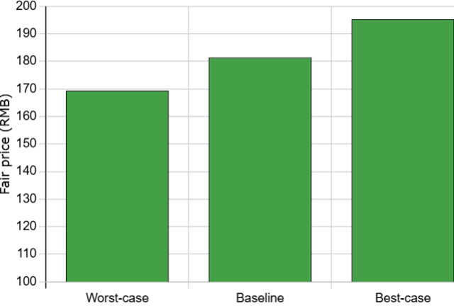
For the sensitivity analysis, we adjusted the WACC by +- 0.5%. This method is commonly used as it allows us to simulate the fair price in realistic ranges. Analyzing NPV changes in this uncertainty range can help us better understand the firm’s sensitivity to change. The worst-case scenario in this analysis happens when the WACC is 0.5% above the baseline, which yields a fair price 6.6% below the baseline, and the best-case scenario occurs when the WACC is 0.5% below the baseline, which yields a fair price 7.7% above the baseline, as fair price is inversely proportional to the WACC (Fig 8).

Fig 8: Sensitivity Analysis of NetEase Using WACC Changes

Investment Risks
Market Risk – Competitive Environment (C)
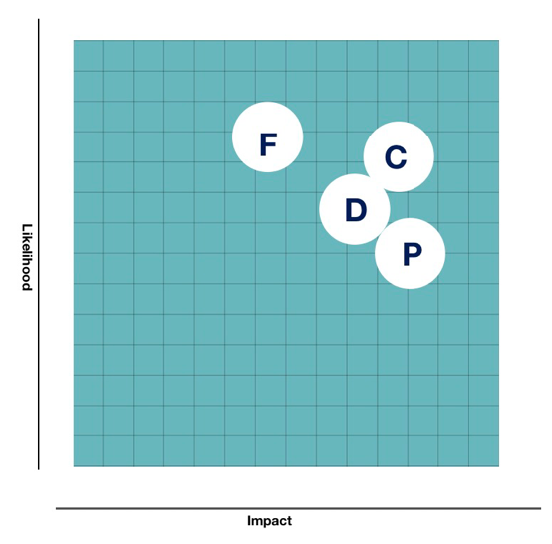
China’s game market is highly concentrated. However, Tencent and NetEase are China’s first and second largest gaming firms, together accounting for over 70% of the market. NetEase builds its defence through sustained high R&D spending (17.7 billion RMB/year) and global game launches.
Market Risk – Foreign Exchange Risk (F)
Overseas revenue now accounts for about 20% of NetEase’s total revenue. However, this also means that NetEase is exposed to risk of losses from foreign currency exchanges. In 2025, RMB appreciated around 6.9% against USD, leading to a total foreign exchange loss of 776 million RMB. To reduce this risk, NetEase uses FX forward contracts and natural hedging to minimize short-term volatility.
Fig 9: Risk Matrix
Policy Risk – Regulatory Uncertainty (P)
Game license approvals have normalized with over 100 games licensed per month, but regulations such as the Cyber Data Security Administration Regulation and the Cybersecurity Law continue to tighten, raising compliance costs and cross-border data transfer requirements. NetEase reduces policy risk by diversifying its game pipeline, strengthening compliance systems, and maintaining a deferred revenue buffer (20.5 billion RMB, +5% QoQ).
Operational Risk – Dependence on Legacy Games (D)
Game revenue accounts for approximately 82% of total revenue. Popular games form the revenue foundation, and declines in these legacy games would directly pressure earnings. NetEase reduces this risk by launching new games such as Where Winds Meet, expanding its licensed game portfolio, and sustaining R&D investment above 17.7 billion RMB annually.

Appendices
Appendix A-1: Historical expense data (in RMB millions)
 | 2021 | 2022 | 2023 | 2024 | 2025
Depreciation | 3,276 | 2,858 | 3,055 | 2,418 | 2,247
SGA | 16,478 | 18,099 | 18,869 | 18,698 | 18,848
R&D | 14,076 | 15,039 | 16,485 | 17,525 | 17,719

Appendix A-2: Revenue history (in RMB millions)
 | 2021 | 2022 | 2023 | 2024 | 2025
Revenue | 87,606 | 96,496 | 103,468 | 105,295 | 112,626

Appendix A-3: SWOT Analysis
Strengths  - Strong market position in China’s gaming industry.  - Diversified non-gaming businesses.  - Rich game pipeline.  - Robust financial health. | Weaknesses  - Heavy reliance on legacy games.  - Weak international presence compared to its domestic presence.  - Non-gaming segments under pressure.
Opportunities  - Game license quota system as a moat.  - Global “Research & Development and operations” integration.  - Accelerating profitability of NetEase Cloud Music. | Threats  - Intensifying competition.  - Volatility in overseas expansion.  - Potential tightening of game approvals, data security, or overseas investment rules.

Appendix A-4: Cash flow projections (in RMB Millions)
 | 2025A | 2026E | 2027E | 2028E | 2029E | 2030E | 2031E | 2032E | Continue value
Revenue | 112,625 | 126,530 | 135,387 | 144,864 | 155,004 | 165,854
- Cost Of Goods Sold | 40,224 | 45,445 | 48,165 | 51,064 | 54,127 | 57,374
- Depreciation | 2,247 | 2,524 | 2,701 | 2,890 | 3,093 | 3,309
- SGA | 18,848 | 21,510 | 22,716 | 23,989 | 25,324 | 26,782
- R&D | 17,719 | 20,245 | 21,431 | 22,676 | 24,000 | 25,396
EBIT | 35,834 | 36,530 | 40,125 | 44,035 | 48,304 | 52,956
Taxes | 5,416 | 7,306 | 8,025 | 8,807 | 9,661 | 10,591
Unlevered Net Income | 30,418 | 29,445 | 32,299 | 35,396 | 38,768 | 42,394
+ Depreciation | 2,247 | 2,800 | 2,950 | 3,100 | 3,250 | 3,400
- ΔNWC | 1,048 | 254 | 162 | 173 | 185 | 198
- CapEx | 2,052 | 2,650 | 2,836 | 3,034 | 3,298 | 3,474
Free Cash Flow | 29,565 | 29,065 | 32,002 | 35,079 | 38,428 | 42,030 | 42,660 | 43,087 | 625,257
WACC (r) | 7.96% | 7.96% | 7.96% | 7.96% | 7.96% | 7.96% | 7.96% | 7.96% | 7.96%
PV of FCF | 29,565 |  |  | 27,878 |  | 28,658 | 26,943 | 25,206 | 365,779
  26,922
  27,457
  28,288
Total NPV | 586,695

Appendix A-5: Sensitivity Analysis Best Case (WACC -0.5%)
[in RMB millions]
 | 2025A | 2026E | 2027E | 2028E | 2029E | 2030E | 2031E | 2032E | Continue value
Revenue | 112,625 | 126,530 | 135,387 | 144,864 | 155,004 | 165,854
- Cost Of Goods Sold | 40,224 | 45,445 | 48,165 | 51,064 | 54,127 | 57,374
- Depreciation | 2,247 | 2,524 | 2,701 | 2,890 | 3,093 | 3,309
- SGA | 18,848 | 21,510 | 22,716 | 23,989 | 25,324 | 26,782
- R&D | 17,719 | 20,245 | 21,431 | 22,676 | 24,000 | 25,396
EBIT | 35,834 | 36,530 | 40,125 | 44,035 | 48,304 | 52,956
Taxes | 5,416 | 7,306 | 8,025 | 8,807 | 9,661 | 10,591
Unlevered Net Income | 30,418 | 29,445 | 32,299 | 35,396 | 38,768 | 42,394
+ Depreciation | 2,247 | 2,800 | 2,950 | 3,100 | 3,250 | 3,400
- ΔNWC | 1,048 | 254 | 162 | 173 | 185 | 198
- CapEx | 2,052 | 2,650 | 2,836 | 3,034 | 3,298 | 3,474
Free Cash Flow | 29,565 | 29,065 | 32,002 | 35,079 | 38,428 | 42,030 | 42,660 | 43,087 | 673,651
WACC (r) | 7.46% | 7.46% | 7.46% | 7.46% | 7.46% | 7.46% | 7.46% | 7.46% | 7.46%
PV of FCF | 29,565 | 27,047 |  | 28,269 |  | 29,331 | 27,704 | 26,039 | 407,106
  27,713
  28,818
Total NPV | 631,592

Appendix A-6: Sensitivity Analysis Worst Case (WACC +0.5%)
[in RMB millions]
 | 2025A | 2026E | 2027E | 2028E | 2029E | 2030E | 2031E | 2032E | Continue value
Revenue | 112,625 | 126,530 | 135,387 | 144,864 | 155,004 | 165,854
- Cost Of Goods Sold | 40,224 | 45,445 | 48,165 | 51,064 | 54,127 | 57,374
- Depreciation | 2,247 | 2,524 | 2,701 | 2,890 | 3,093 | 3,309
- SGA | 18,848 | 21,510 | 22,716 | 23,989 | 25,324 | 26,782
- R&D | 17,719 | 20,245 | 21,431 | 22,676 | 24,000 | 25,396
EBIT | 35,834 | 36,530 | 40,125 | 44,035 | 48,304 | 52,956
Taxes | 5,416 | 7,306 | 8,025 | 8,807 | 9,661 | 10,591
Unlevered Net Income | 30,418 | 29,445 | 32,299 | 35,396 | 38,768 | 42,394
+ Depreciation | 2,247 | 2,800 | 2,950 | 3,100 | 3,250 | 3,400
- ΔNWC | 1,048 | 254 | 162 | 173 | 185 | 198
- CapEx | 2,052 | 2,650 | 2,836 | 3,034 | 3,298 | 3,474
Free Cash Flow | 29,565 | 29,065 | 32,002 | 35,079 | 38,428 | 42,030 | 42,660 | 43,087 | 583,349
WACC (r) | 8.46% | 8.46% | 8.46% | 8.46% | 8.46% | 8.46% | 8.46% | 8.46% | 8.46%
PV of FCF | 29,565 | 26,798 |  | 27,494 |  | 28,003 | 26,206 | 24,404 | 330,401
  27,204
  27,770
Total NPV | 547,845

