List of Pages

Stephen Terrio

B00755443

The three web pages I will be evaluating are the three that relate to the tasks which were performed under the User persona document.

They are….

1. The government departement page - <https://beta.novascotia.ca/government>

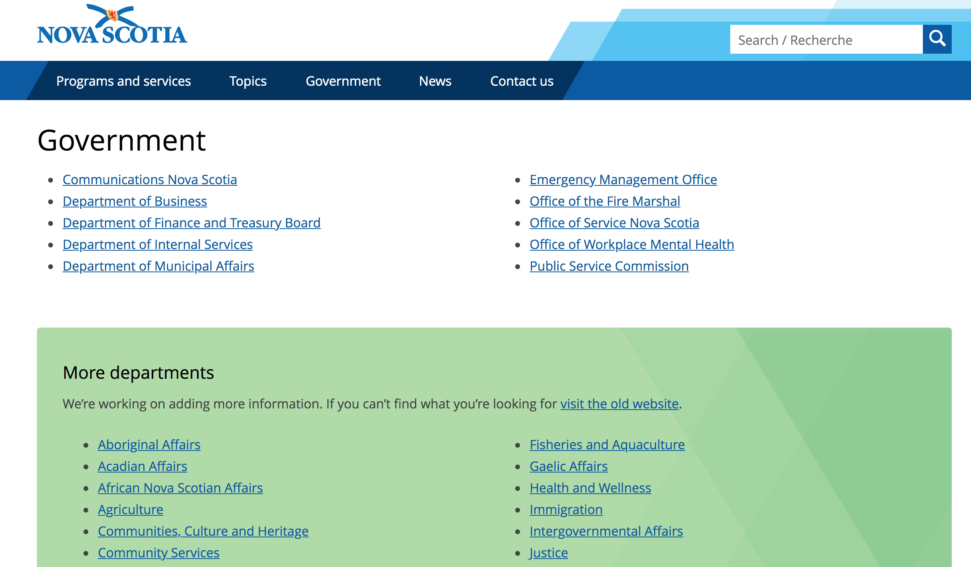

1. News topics page, search and selection - <https://novascotia.ca/news/>

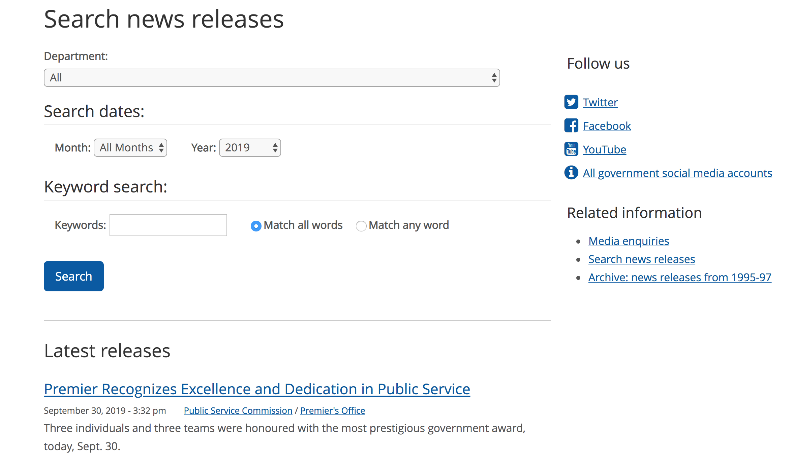

1. Education, training & skills - <https://beta.novascotia.ca/topic/education-training-and-skills>

