Student ID: 31862616

Student Name: Garret Yong Shern Min

Unit Code: FIT3171

Applied Class No: 06

Comments for your marker:

(a)

|  |  |  |  |  |  |  |
| --- | --- | --- | --- | --- | --- | --- |
| **TIME** | **TRANS** | **ACTION** | **A** | **B** | **C** | **D** |
| **0** | **T1** | **UPDATE A** | X(T1) |  |  |  |
| **1** | **T1** | **UPDATE B** |  | X(T1) |  |  |
| **2** | **T2** | **READ C** |  |  | S(T2) |  |
| **3** | **T2** | **READ D** |  |  |  | S(T2) |
| **4** | **T3** | **UPDATE A** | T3 wait T1 |  |  |  |
| **5** | **T2** | **UPDATE C** |  |  | X(T2) |  |
| **6** | **T1** | **ROLLBACK** | X(T3) |  |  |  |
| **7** | **T3** | **UPDATE C** |  |  | T3 wait T2 |  |
| **8** | **T2** | **UPDATE B** |  | X(T2) |  |  |
| **9** | **T2** | **UPDATE A** | T2 wait T3 |  |  |  |

* Does a deadlock exist in this transaction sequence?
* Explain why you came to this conclusion.

At time **4,** transaction **T3** waits on **T1** to complete in order to use the resource **A** as **T1** has an exclusive lock on the resource. However, a little down the line (2 time slots later), **T1** uses a rollback and this frees up resource **A** allowing **T3** to proceed and get an exclusive lock on resource **A**.

At time **7**, transaction **T3** waits on **T2** to complete in order to use the resource **C** as **T2** has an exclusive lock on the resource.

Meanwhile, at time **9**, transaction **T2** waits on **T3** to complete in order to use the resource **A** as **T3** has an exclusive lock on the resource (after attaining it after **T1** rollback).

Based on this we notice that there is a loop whereby **T3** is waiting on **T2** to complete but **T2** requires **T3** to complete so that it can access resource. Since there is a loop between the transactions, it can be concluded that there is a deadlock present.

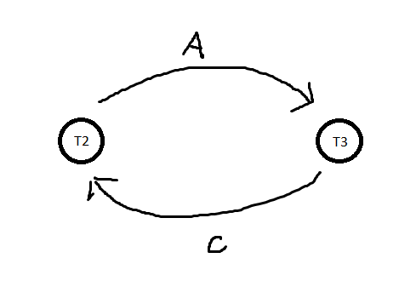

Hence, there **is** a deadlock present.

(b)

|  |  |  |  |  |  |  |  |  |  |
| --- | --- | --- | --- | --- | --- | --- | --- | --- | --- |
| **TRL ID** | **TRX NUM** | **PREV PTR** | **NEXT PTR** | **OPERATION** | **TABLE** | **ROW ID** | **ATTRIBUTE** | **BEFORE VALUE** | **AFTER VALUE** |
| 101 | 601 | Null | 102 | Start | ****Start Transaction |  |  |  |  |
| 102 | 601 | 101 | 103 | UPDATE | PRODUCT | ABC | PROD_QOH | 1205 | 1206 |
| 103 | 601 | 102 | 104 | UPDATE | PART | A | PART_QOH | 567 | 566 |
| 104 | 601 | 103 | 110 | UPDATE | PART | B | PART_QOH | 98 | 97 |
| 110 | 601 | 104 | 121 | UPDATE | PART | C | PART_QOH | 549 | 548 |
| 121 | 601 | 110 | null | COMMIT | ****End of Transaction |  |  |  |  |

…. add extra rows as needed