Jarrett Nobles

IST220

10/4/2021

Test 1 Part B

21. A. SELECT PubID,Name

FROM [JLBookstore].[dbo].[Publisher]

C. SELECT PubID,Name

FROM [JLBookstore].[dbo].[Publisher]

ORDER BY Name ASC

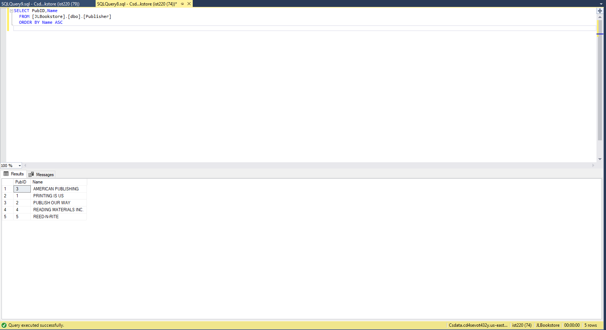

22. SELECT Order#, Item#, ISBN, Quantity, PaidEach,

Quantity\*PaidEach AS 'Item Total'

FROM [JLBookstore].[dbo].[ORDERITEMS]

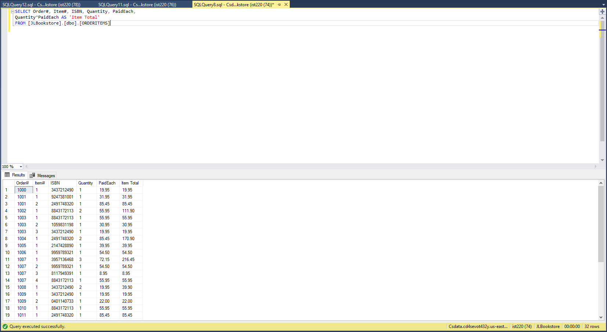

23. SELECT Lname, Fname

FROM [JLBookstore].[dbo].[Author]

WHERE Fname LIKE '%AN%'

ORDER BY Lname ASC

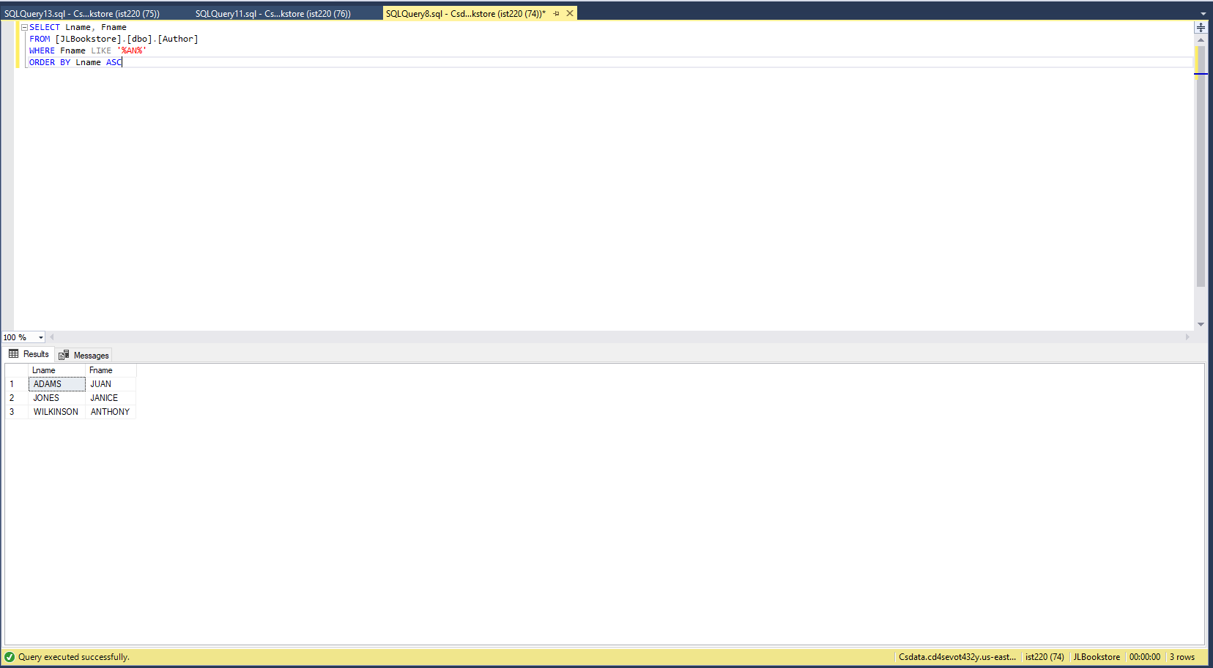

24. SELECT ISBN, Title, Name, Contact

FROM [JLBookstore].[dbo].[Books]

CROSS JOIN [JLBookstore].[dbo].[Publisher]

ORDER BY Title ASC

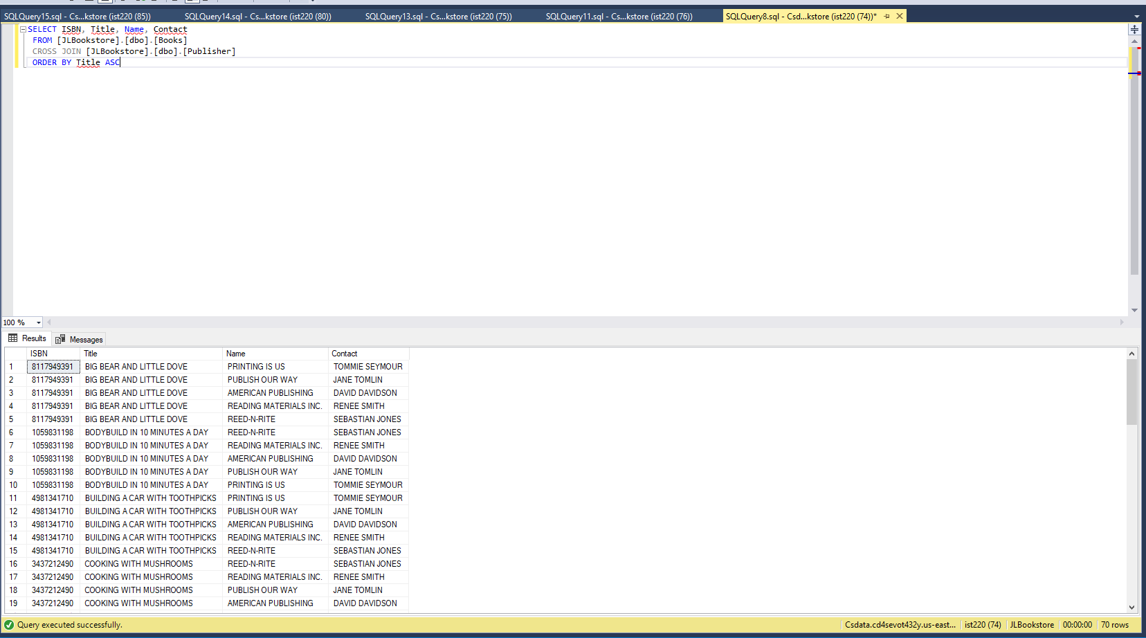

25. SELECT Fname, Lname

FROM [JLBookstore].[dbo].[Author] CROSS JOIN [JLBookstore].[dbo].[Customers]

WHERE FirstName = 'Becca' AND LastName = 'Nelson'

