Cache-Blocked Iterative vs Strassen Matrix Multiplication
An empirical comparison. Advanced Algorithms, Programming Assignment 2
Jarrod Carmont
November 2026

Abstract
The study empirically compares a cache-blocked matrix multiplication kernel against Strassen’s algorithm, demonstrating that Strassen achieves a 1.98× speedup at $n=4096$ by cutting multiplication work in half. While a theoretical cost model accurately predicted many outcomes, the experimental results revealed unexpected hardware interactions and algorithmic behaviors.

1. The problem and the algorithms

1.1 Problem statement
Given dense square matrices $A,B∈R^{n×n}$, stored as IEEE-754 doubles in row-major order with any row stride ≥ n, compute
$$C=AB, c_{ij}=\sum_{k=1}^{n}{a_{ik}} b_{kj},$$
into an output that shares no memory with either input. The matrices are square because Strassen’s algorithm partitions square blocks. Correctness means bit-for-bit agreement with a reference on inputs whose partial sums are exact integers, and staying within floating-point error bounds otherwise. That error is itself one of the quantities compared (§2.7).
Every classical algorithm performs the same ~2n³ floating-point operations (flops) and differs only in their order. Strassen’s algorithm does something different in kind: fewer multiplications, paid for with extra additions and memory. The two algorithms represent these two ideas. One reorganises the same arithmetic to suit the memory hierarchy; the other changes the arithmetic itself.

1.2 Algorithm A: cache-blocked iterative multiplication
Key idea. The triple loop can run in any order and over any partition of the index space. The arithmetic stays the same, but the order decides how often each element must be fetched from slow memory. A plain i-j-k loop walks down a column of B for every output element. In row-major storage every step lands on a new cache line, so for large n the loop runs at memory speed. Blocking splits the iteration space into T × T × T tiles:
for ii, kk, jj in steps of T: # tile of C/A rows, shared dimension, C/B columns
for i in ii .. ii+T-1:
for k in kk .. kk+T-1:
a = A[i][k]
for j in jj .. jj+T-1: # contiguous in C and B -> vectorised
C[i][j] += a * B[k][j]
A tile step reuses a T × T block of B for each of T rows of C. Each element of B fetched from a slow level is therefore used about T times instead of once. Inside the tile the order is i-k-j. The innermost loop multiplies one scalar of A by a contiguous row segment of B and adds it into a row segment of C (an “axpy”), which the compiler vectorises: with AVX2, four doubles per instruction.
Complexity. Θ(n³) time, exactly 2n³ flops, O(1) extra memory. T changes only the constant factor, so it is treated as an experimental variable (E1), not a fixed constant.
Implementation. src/algo_blocked/ is about 60 lines of C++17. The inner loop takes __restrict pointer parameters, so it vectorises without a runtime aliasing check (confirmed from the compiler’s vectorisation report). It deliberately has no hand-written intrinsics and no BLAS-style register micro-kernel. Both algorithms get equal implementation effort, and Strassen’s leaves call exactly this kernel.

1.3 Algorithm B: Strassen’s algorithm
Key idea. Split each matrix into four (n/2) × (n/2) quadrants. The direct block product needs eight quadrant products, which recurses to Θ(n³) and gains nothing. Strassen (1969) showed seven suffice:
Product | Combination
$M_{1}=(A_{11}+A_{22})(B_{11}+B_{22})$ | $C_{11}=M_{1}+M_{4}−M_{5}+M_{7}$
$M_{2}=(A_{21}+A_{22}) B_{11}$ | $C_{12}=M_{3}+M_{5}$
$M_{3}=A_{11} (B_{12}−B_{22})$ | $C_{21}=M_{2}+M_{4}$
$M_{4}=A_{22} (B_{21}−B_{11})$ | $C_{22}=M_{1}−M_{2}+M_{3}+M_{6}$
$M_{5}=(A_{11}+A_{12}) B_{22}$
$M_{6}=(A_{21}−A_{11})(B_{11}+B_{12})$
$M_{7}=(A_{12}−A_{22})(B_{21}+B_{22})$
The cross terms cancel: for example, $M_{1}+M_{4}−M_{5}+M_{7}$ expands to exactly $A_{11}B_{11}+A_{12}B_{21}$. The derivation never uses commutativity, so the scheme applies recursively to the quadrants. Forming operands and combining products takes 18 quadrant additions, each of (n/2)² flops.
Complexity. $T(n)=7T(n/2)+18(n/2)^{2}=Θ(n^{{\text{log}}_{2}7})≈Θ(n^{2.807})$. The price is Θ(n²) extra memory, additions with very low arithmetic intensity, and weaker numerical stability (§2.7).
What makes it practical. Three choices, each a runtime parameter that the experiments measure:
- Cutoff. Below size c the recursion stops and calls Algorithm A’s kernel; recursing to 1 × 1 would be dominated by additions and call overhead. With d levels there are 7ᵈ leaves, so the multiplication work is (7/8)ᵈ of classical. At n = 4096 with c = 128 (d = 5) that is 51.3%, plus 1.1% in additions.
- Padding. Every level needs an even size, so n is zero-padded to some m ≥ n. Zero padding is exact. There are three rules:
  - nextpow2: the next power of two (1025 → 2048).
  - minimal: m = s · 2ᵈ, with d the fewest halvings that bring s = ⌈n/2ᵈ⌉ to at most c (1025 → 1040 at c = 128).
  - aligned: added after experiment E4 (§5.2). It rounds the leaf size s up to a multiple of 4 or 8.
- Memory schedule. Each node needs three (n/2)² temporaries. Three of the seven products are written straight into output quadrants, so each node needs only one quadrant copy. The workspace totals under n² doubles, about one extra matrix. A Plan allocates it, and any padded copies, before execution; the recursion never allocates.
Implementation. src/algo_strassen/ is about 220 lines. Quadrants are zero-copy views that keep the parent’s stride. strassen::predict() computes exact operation and memory counts in closed form. The tests check these against counters recorded during real executions, across more than 80 size, cutoff and padding combinations. So the cost model in §2 is a verified property of the code, not an assumption.

1.4 How they differ
A keeps the arithmetic fixed and attacks the memory cost: each element fetched from far away is used about T times. B attacks the arithmetic, cutting the exponent from 3 to 2.807. In exchange it adds operations that are almost pure memory traffic: each quadrant addition moves 24 bytes per flop and reuses nothing. It also allocates temporaries and pads awkward sizes. Because B’s leaves are A’s kernel, the only difference between the two is whether the top d levels are done Strassen’s way or classically. The project asks when trading a one-eighth cut in multiplication work per level for 18 memory-bound additions per node pays off on real hardware.

2. Theoretical comparison and predictions
Written and committed to the repository before any timing measurement was taken. The commit history shows this. Nothing in this section has been revised in light of results. Where the results disagree, §4 and §5 discuss why.

2.1 Target hardware
All timings will come from one machine: an AMD Ryzen 7 7800X3D (Zen 4) running Windows, compiled with MSVC /O2 /arch:AVX2 /fp:precise. Exact versions are recorded in §3. Every run is single-threaded. The cache sizes that matter for the reasoning below are a 32 KB L1 data cache and a 1 MB L2 per core, and a 96 MB shared L3. The L3 is unusually large: the chip stacks extra “3D V-Cache” on top of the usual 32 MB.

2.2 Asymptotic and exact operation counts
 | Algorithm A (blocked) | Algorithm B (Strassen, cutoff $c$, $d$ levels)
Time | $Θ(n^{3})$ | $Θ(n^{{\text{log}}_{2}7})≈Θ(n^{2.807})$
Multiply-kernel flops | $2n^{3}$ | $(7/8)^{d}⋅2n^{3}$
Addition flops | 0 | $\sum_{ℓ=0}^{d−1}{7^{ℓ}}⋅18 (n/2^{ℓ+1})^{2}$
Extra memory | none | $<n^{2}$ doubles workspace, plus $3m^{2}$ if padded to $m$
From the verified cost model (strassen::predict), these are the fractions of classical work that Strassen performs:
$n$ | cutoff | depth $d$ | kernel flops / $2n^{3}$ | addition flops / $2n^{3}$ | workspace
256 | 64 | 2 | 0.766 | 0.024 | 0.5 MB
1024 | 64 | 4 | 0.586 | 0.025 | 8 MB
1024 | 128 | 3 | 0.670 | 0.013 | 8 MB
4096 | 64 | 6 | 0.449 | 0.020 | 128 MB
4096 | 128 | 5 | 0.513 | 0.011 | 128 MB
In flop terms, the additions are never more than a few percent of the work. Strassen pays for them in a different currency: memory traffic.

2.3 Constant factors: a two-rate cost model
Counting flops treats every flop as equally expensive. They are not, so we model the run time as
$$t_{B}≈τ_{\text{mul}}⋅F_{\text{kernel}}+τ_{\text{add}}⋅F_{\text{add}}, t_{A}≈τ_{\text{mul}}⋅2n^{3},$$
where $τ_{\text{mul}}$ is the time per flop in the blocked kernel and $τ_{\text{add}}$ is the time per flop of a streaming quadrant addition. Their ratio $r=τ_{\text{add}}/τ_{\text{mul}}$ decides everything.
Estimating $τ_{\text{mul}}$. Each vector iteration of A’s inner loop loads 4 doubles of $B$ and 4 of $C$, multiplies, adds and stores 4 doubles back to $C$. That’s two loads and one store for 8 flops. Zen 4 can retire at most about one 256-bit store per cycle, so the kernel is bounded by roughly 8 flops per cycle, about 40 GFLOP/s at 5 GHz. It will not reach that bound: loop overhead, partial tiles and L2 traffic for the $C$ and $A$ rows all eat into it. Because the kernel has no register blocking, every flop pays for a load and a store. Prediction P1: Algorithm A sustains 10–20 GFLOP/s for $n≥256$, so $τ_{\text{mul}}≈0.05$–$0.1$ ns. (A tuned BLAS reaches several times this. That gap is the main reason we expect the crossover to land much earlier than published Strassen crossovers (e.g. Huss-Lederman et al., 1996), which were measured against tuned kernels.)
Estimating $τ_{\text{add}}$. A quadrant addition moves 24 bytes per flop. One core can stream on the order of 100 GB/s from L2 or L3 and roughly 40–60 GB/s from DDR5, which gives $τ_{\text{add}}≈0.25$ ns when the operands are cached and about 0.5 ns from DRAM. So $r≈3$–$10$.
Break-even for one level. One Strassen level at size $n$, with $h=n/2$, saves one quadrant product ($2h^{3}$ flops) and adds $18h^{2}$ addition flops plus one $h^{2}$ copy, worth about $2/3$ of an addition. Recursing pays off when
$$2h^{3} τ_{\text{mul}}>18.7 h^{2} τ_{\text{add}}⇔h>9.3 r.$$
With $r=3$–$10$ that gives $h≈28$–$93$, so recursion should be worth it once $n≳56$–$186$.
Prediction P2: the optimal cutoff $c^{*}$ is 64 or 128, at the centre of that range. The curve of time against cutoff will be flat near the optimum: within ±1 power of two of $c^{*}$, run time will vary by less than 10%. The model contains nothing that depends on $n$, so P3: $c^{*}$ does not change with $n$ across 512–4096, to within one power of two.
Prediction P4: with its best cutoff, Strassen beats blocked from about $n≈256$ upward. Below about 128 they are effectively the same algorithm, because at those sizes Strassen with $c^{*}≥128$ doesn’t recurse at all. Near the crossover the margin will be under 5%, so the measured crossover will be a fuzzy band rather than a sharp point.
Prediction P5: at $n=4096$, Strassen with the best cutoff is 1.5–1.8× faster than blocked. From the model: $1/(0.513+0.011r)$ gives 1.76× at $r=5$ and 1.60× at $r=10$. Allowing for some loss of kernel efficiency at the smaller leaf size pushes this towards the lower end.

2.4 Memory hierarchy: what should and shouldn’t matter
Tile size. Inside a tile, the $T×T$ block of $B$ is reused across $T$ rows, so it should fit in L1: $8T^{2}≤32$ KB gives $T≤64$. P6: the best tile size is between 32 and 64. $T≥256$ performs measurably worse because the B tile spills out of L1, and $T=1$ (unvectorisable) is several times slower than the best.
The 96 MB L3. We originally expected the large L3 to move the crossover, and said so in the project proposal. Working through the cost model changed our view. Algorithm A reads each element of $B$ from far memory only once per $T$ uses. At $T=64$ that’s about 16 flops per byte, so even DRAM bandwidth is barely touched, and A should be insensitive to L3 size. Algorithm B’s additions are bandwidth-bound, but only the top level’s working set (about $6×8(n/2)^{2}$ bytes: 96 MB at $n≈2900$) can overflow the L3, and the top level holds only $18(n/2)^{2}/2n^{3}=2.25/n$ of the work, about 0.05% at $n=4096$. P7: Algorithm A’s GFLOP/s stays within 10% of its peak all the way to $n=4096$, with no cliff at the point where the matrices outgrow L3 ($3×8n^{2}=96$ MB at $n≈2000$). If we artificially shrink the effective L3 (§3 describes a cache-pressure thread that streams through a large buffer on another core), Strassen’s speedup over blocked changes by less than 10%. This prediction is deliberately falsifiable. If the L3 matters more than this, the cost model is missing something.
Power-of-two strides. L1 is 8-way set-associative with 64 sets of 64-byte lines, so addresses 4 KB apart map to the same set. When $n$ is a multiple of 512, consecutive rows of a $B$ tile are $8n≥4$ KB apart, and the $T$ rows of a tile all compete for the same few sets. At $T=64$ that’s 64 lines for 8 ways, so the tile cannot actually stay in L1. P8: Algorithm A runs 10–40% slower per flop at $n=1024,2048,4096$ than at $n+8$, and padding the row stride (leading dimension) by one cache line removes the penalty. Strassen’s quadrant views and power-of-two-sized temporaries inherit the same strides, so it suffers similarly.

2.5 Padding
P9 (nextpow2): at $n=2^{k}+1$, Strassen does one more level of work than at $2^{k}$, so it takes about $7×$ longer than at $n=2^{k}$. At $n=1025$ that should make it about 4× slower than blocked, which is a complete loss. Blocked shows no step at all, because $(1+1/n)^{3}≈1$.
P10 (minimal): the padding overhead is a sawtooth in $n$. Its worst case, just past a size of the form $s⋅2^{d}$, is $(m/n)^{2.807}$ plus the $O(n^{2})$ copies, which is at most about 10% at $c=64$ (1025 pads to 1056: ${1.030}^{2.807}=1.087$). So with minimal padding, Strassen’s advantage over blocked should survive at every size, not just at powers of two.

2.6 Memory and allocation
P11: blocked needs no extra memory. Strassen needs about $n^{2}$ extra doubles of workspace (128 MB at $n=4096$), plus $3m^{2}$ for padded copies when $m≠n$. The cost of allocating that memory is mostly first-touch page faults: about 32,000 4 KB pages at $n=4096$, at a fraction of a microsecond each, so roughly 5–20 ms against a run time of several seconds. The difference between strassen::multiply (which allocates) and a reused Plan will be under 2% for $n≥1024$, but noticeable (over 5%) for $n≤256$.

2.7 Numerical accuracy
The classical algorithm satisfies a componentwise bound, $|C−\hat{C}|≤γ_{n}|A||B|$ with $γ_{n}=nu/(1−nu)$ and unit roundoff $u=2^{−53}$. Every entry is accurate relative to the sizes of the terms that make it up. Strassen satisfies only a normwise bound, due to Brent (1970) and proved in Higham (2002, §23.2.2), here in the max norm:
$$∥C−\hat{C}∥_{\text{max}}≤\left[{\left(n/c\right)}^{{\text{log}}_{2}12}\left(c^{2}+5c\right)−5n\right]u ∥A∥_{\text{max}}∥B∥_{\text{max}}+O(u^{2}),$$
with ${\text{log}}_{2}12≈3.585$. That error is relative to the largest entries of $A$ and $B$, not to the entries that actually contribute to a given $c_{ij}$. This happens because operands like $A_{11}+A_{22}$ mix entries of different magnitudes before multiplying.
- P12 (smallint): both algorithms are exact. This is already confirmed by the test suite, since it’s a correctness property rather than a measurement.
- P13 (uniform): with entries of similar magnitude the normwise bound isn’t hurt by mixing. Strassen’s Frobenius-relative error will be larger than blocked’s by a factor that grows with depth: about 3–10× at $d=3$ and about 10–100× at $d=5$–$7$. Both remain below ${10}^{−12}$.
- P14 (widerange, entries spanning $2^{±20}$): this is where the bound’s weakness shows. Measured componentwise, Strassen’s worst-case relative error will be at least ${10}^{3}×$ worse than blocked’s at $d≥3$, and some small entries of $C$ will have no correct digits at all. Measured by Frobenius norm, which is dominated by the large entries, the gap will look modest. This is why §3 reports both metrics.

2.8 Summary of predictions
# | Prediction | Confidence
P1 | Blocked sustains 10–20 GFLOP/s for $n≥256$ | Medium
P2 | Optimal Strassen cutoff $c^{*}$ is 64 or 128; flat (±10%) within one power of two | Medium
P3 | $c^{*}$ does not depend on $n$ (512–4096) | Medium
P4 | Strassen (best $c$) wins from about $n=256$; margin under 5% near the crossover | Medium
P5 | Strassen 1.5–1.8× faster than blocked at $n=4096$ | Medium
P6 | Best tile $T$ in 32–64; $T≥256$ worse; $T=1$ several times slower | High
P7 | No L3 cliff for blocked; shrinking effective L3 changes Strassen’s speedup by under 10% | Low (deliberately falsifiable)
P8 | Power-of-two $n$ costs blocked 10–40% per flop; fixed by stride padding; Strassen also affected | Medium
P9 | nextpow2: about 7× jump at $2^{k}+1$; Strassen about 4× slower than blocked at 1025 | High
P10 | minimal padding overhead under about 10%; Strassen’s advantage survives at all sizes | High
P11 | Allocation cost under 2% for $n≥1024$, over 5% for $n≤256$ | Low
P12 | smallint: both exact | Certain (tested)
P13 | uniform: Strassen error about 3–100× blocked depending on depth; both $<{10}^{−12}$ | Medium
P14 | widerange: componentwise error over ${10}^{3}×$ worse for Strassen; Frobenius gap modest | Medium

3. Experimental methodology

3.1 Platform
Every measurement was taken on one machine:
- CPU: AMD Ryzen 7 7800X3D (Zen 4; 32 KB L1d and 1 MB L2 per core, 96 MB shared L3).
- Memory and OS: 31 GB RAM; Windows build 10.0.26200; Ultimate Performance power plan; mains power.
- Toolchain: MSVC 19.51 (Visual Studio Community 18), CMake with Ninja, preset windows-release.
- Flags: /O2 /Ob2 /arch:AVX2 /fp:precise /permissive- /EHsc. These are identical for both algorithms. Strict floating point keeps the measured numerical error honest.
Both algorithms run single-threaded. The benchmark thread is pinned to one logical CPU at HIGH_PRIORITY_CLASS / THREAD_PRIORITY_HIGHEST. results/run_info.txt records all of this for every run, along with the git commit and a flag for uncommitted changes. The official run (E0–E8) was commit 73d07cf, 15:56–16:18 on 4 November 2026. The follow-ups E9 and E9b were separate runs, on commits 58ea095 and ffb7a43.

3.2 Inputs
Inputs come from a portable xoshiro256** generator (Blackman & Vigna, 2021), using only integer arithmetic and exact conversions; MSVC’s and GCC’s <random> distributions give different values from the same seed. A unit test checks hard-coded values on both compilers. Seeds depend only on n, so every experiment and every algorithm at a given size multiplies the same matrices. There are three input families:
- uniform U[−1, 1): used for all timings. The values have no denormals or special cases, so time reflects the algorithm alone.
- smallint, integers in [−8, 8]: every partial sum is exact in double precision, so both algorithms must match the reference bit for bit.
- widerange, ±m·2ᵉ with e ∈ [−20, 20]: built to expose Strassen’s normwise (rather than componentwise) error bound (§2.7).
Errors are measured against a double-double reference: about 106-bit accumulation, using exact FMA products and TwoSum (Knuth, 1997).

3.3 Experiments
Each experiment targets specific predictions from §2 (P1–P14):
ID | Varies | Tests
E0 | 30 repetitions at fixed parameters (n = 512, 1000) | variance; sets the repetition count
E1 | tile T ∈ {1, 8, …, 256, untiled}, n ∈ {256, 1000, 2000} | P1, P6; selects the tile
E2 | cutoff c ∈ {16, …, 512}, n ∈ {512, …, 4096} | P2, P3; selects the cutoff
E3 | 23 sizes, n = 64–4096 | P1, P4, P5
E4 | minimal vs nextpow2 at 2ᵏ − 1, 2ᵏ, 2ᵏ + 1 (k = 9–11), plus n = 1000–1100 in steps of 4 | P9, P10
E5 | packed vs row stride n + 8 vs size n + 8, at n = 512, 1024, 2048 | P8
E6 | antagonist occupying 0 / 1 / 32 / 64 / 80 MB of L3, n ∈ {1000, 2000, 3000} | P7
E7 | reused Plan vs allocating on every call, n = 128–4096 | P11
E8 | error, three input families, n = 128–1024, c ∈ {8, 32, 128} | P12–P14
E9, E9b | follow-ups to E4 and E9 (§5), each with predictions committed before it ran | —
Tuning parameters are measured, not chosen. E1 picks the tile and E2 the cutoff by a fixed rule. For each configuration, every candidate’s median is divided by the best median in that configuration; the winner has the smallest geometric mean of those ratios across configurations. Later experiments read the winners from results/tuned_params.txt: T = 128 and c = 128.
E6’s antagonist is a thread on a different physical core that reads one double per cache line of a private buffer, sharing only the L3. Its 1 MB control fits in its own L2, separating “a neighbouring core is busy” (which can lower the boost clock) from “part of L3 is occupied”.

3.4 Timing
The harness keeps the PA1 harness’s design rules. Its mm_bench executable runs a 163-check exact correctness gate before any timing, and refuses to run in a Debug build.
- Clock: std::chrono::steady_clock, which on Windows is QueryPerformanceCounter. Its resolution is 100 ns and each call costs 16.8 ns. Both are measured and reported; neither is subtracted.
- Sample length: each timed sample loops the call until it lasts at least 20 ms, so clock resolution is irrelevant. The number of inner calls is recorded.
- Warm-up: each algorithm gets one untimed warm-up call per configuration. It also sizes that inner loop.
- Nothing extra in the timed region. Inputs, outputs and Plans are created first; no allocation, I/O or formatting is timed, except E7’s labelled allocation rows.
- Repetitions: 7 per algorithm per configuration (30 in E0, 15 in E9b), and we report the median. E0 justifies 7: the coefficient of variation was 0.3–1.6%, and the 95% bootstrap interval on a 7-sample median was ±0.3–1.5%. Going to 15 samples narrows that to ±0.1–1.4%, which is not worth doubling the run time.
- Order: within each repetition, the algorithm order rotates. For E5 and E6, which compare different configurations, each repetition is one round over all configurations, rotated and reversed on alternate rounds, so the conditions being compared are measured seconds apart.
- Outputs consumed: every output is checksummed, and its relative difference from the first algorithm in its configuration is recorded. The largest difference in any timed configuration was 4.4×10⁻¹⁴.

3.5 Machine state, and what a shakedown run taught us
A first full run (archived in results/shakedown_2026-11-04/) was spoiled by a game started partway through: the same blocked multiplication fell from 26.0 to 21.8 GFLOP/s between E3 and E7. It also exposed a design flaw. E6 had measured every 0 MB configuration first and every 80 MB one last, so drift was indistinguishable from cache pressure. Two changes followed:
- Round-robin execution for E5 and E6.
- A drift monitor. Before every configuration, it times a fixed workload (blocked, n = 384, T = 64) and writes the reading to each row.
In the official and follow-up runs, 89% of the 288 readings were within ±5% of a warmed-up baseline (Figure 9). The lowest readings are the first configuration of each run (90–92%). Readings are also consistently low during sustained load, with medians of about 96% through E6’s two-core load and through E9. That pattern reflects the boost clock responding to temperature and to the number of active cores. It is not interference. Effects under about 5% between configurations are therefore treated as inconclusive. Effects within a configuration are protected by the rotated order.

3.6 Reproducing
Build with windows-release, run ctest, then run mm_bench.exe, mm_bench.exe --only E9 and mm_bench.exe --only E9b. Then run python scripts/analyse.py and python scripts/make_plots.py. Those two scripts regenerate every table in results/summary/ and every figure from the CSVs alone. Every number in §4–5 comes from those 3,661 rows across 11 CSV files.

4. Results and analysis
All times are medians of 7 repetitions with the tuned parameters (T = 128, c = 128), unless stated otherwise. “Effective GFLOP/s” is 2n³ divided by the time, which puts both algorithms on the same scale even though Strassen does fewer flops.

4.1 Scaling and crossover
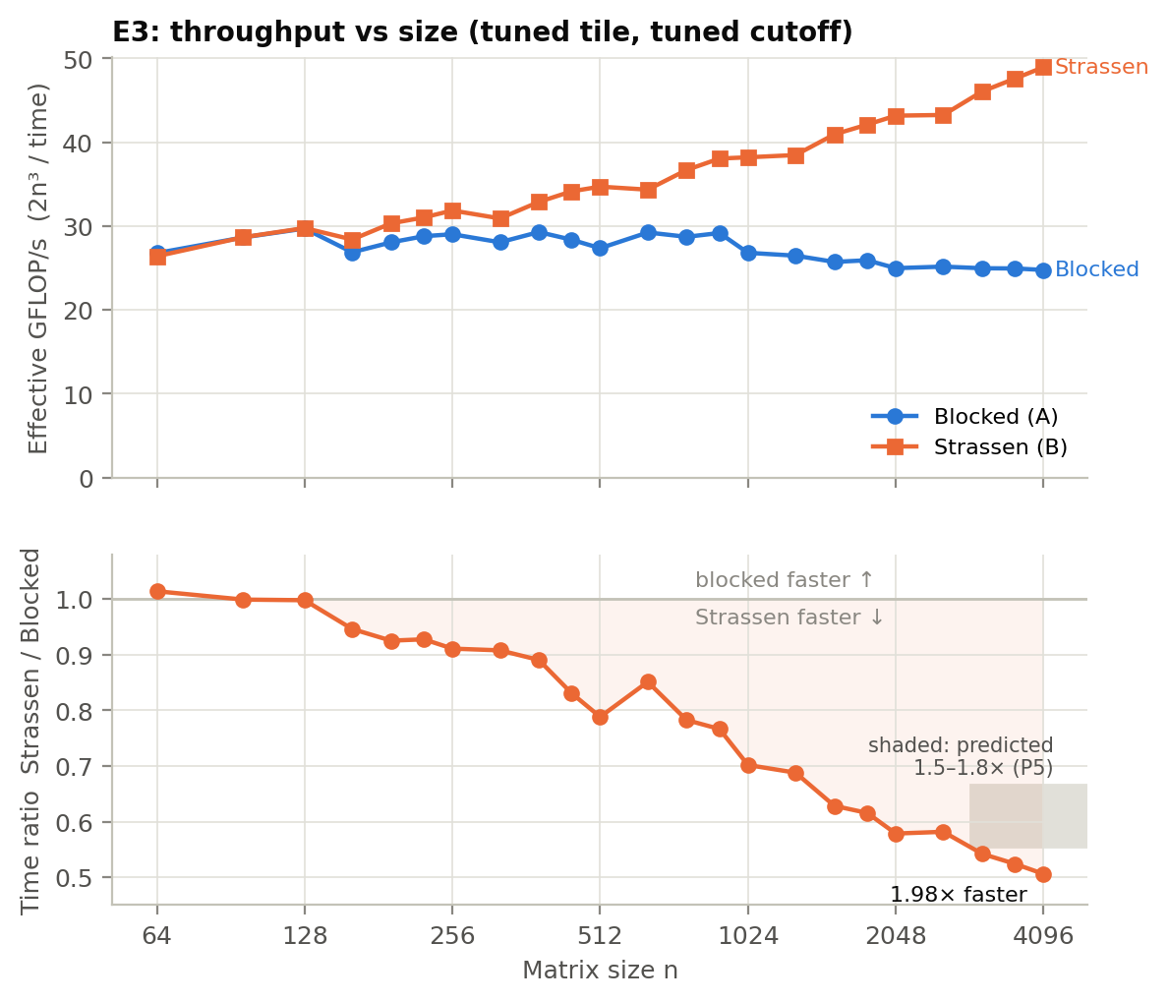
Figure 1. E3: effective throughput against n (top), and Strassen’s time as a fraction of blocked’s (bottom). The grey box is the speedup at n = 4096 predicted in P5.
Blocked:
- 26.8–29.7 GFLOP/s up to n = 1024, then a slow decline to 24.8 GFLOP/s at n = 4096.
- No step where the three matrices stop fitting in the 96 MB L3 (n ≈ 2000).
Strassen:
- Identical to blocked for n ≤ 128, where it doesn’t recurse (ratios 0.998–1.014).
- Wins from n = 160 on (0.946), and the margin widens steadily: 0.911 at 256, 0.702 at 1024, 0.579 at 2048.
- At 4096 it takes 0.506 of blocked’s time, a 1.98× speedup, at 48.9 effective GFLOP/s.
Why the margin widens with n. Each recursion level replaces 8 quadrant products with 7. At n = 4096 there are 5 levels, so the leaves perform (7/8)⁵ = 51.3% of the classical multiplication work. The 18 additions per node add only 1.1% more flops.
Where the time goes (Figure 10). Modelling the leaves at the kernel’s measured rate for their size, what remains is additions, copies and overhead. That remainder grows from 6–7% of Strassen’s time at one level to 15–18% at four or five. It implies about 0.27 ns per added element, 6.7× a kernel flop, inside §2.3’s 3–10× estimate. So the additions carry 1–2% of the flops but about 15% of the time. The ratio holds at 5.0–6.8 from n = 192 to 4096, because only the top level’s quadrants outgrow L3, and that level holds just 2.25/n of the work.
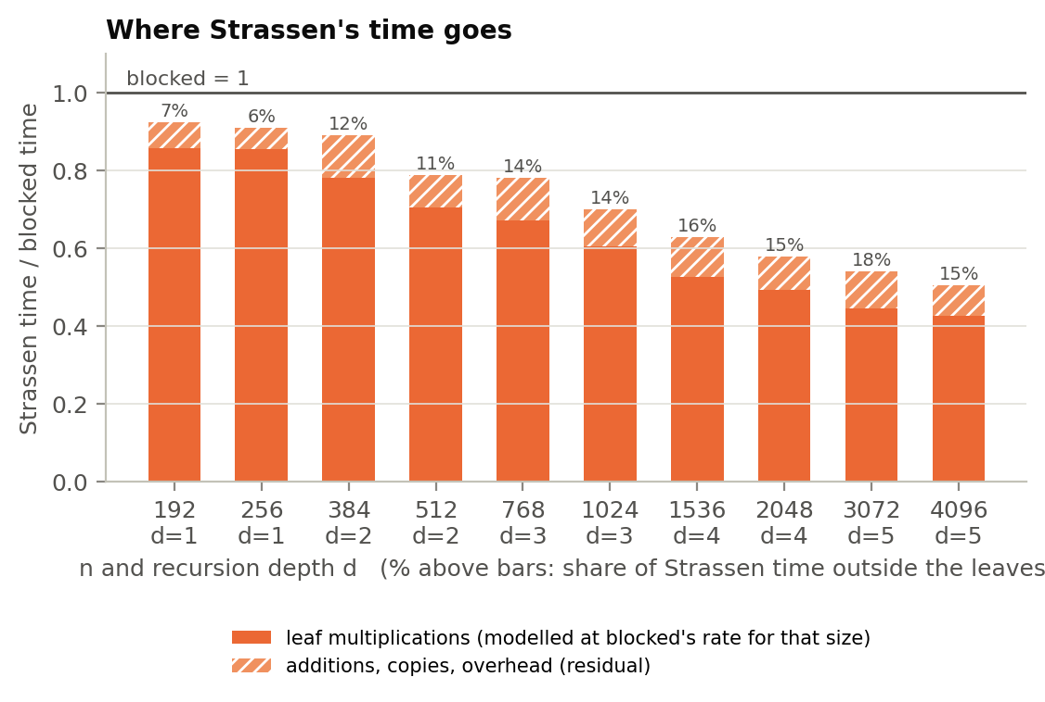
Figure 10. Strassen’s time as a fraction of blocked’s, split into leaf multiplications (modelled) and the residual. Labels: the residual’s share of Strassen’s time.
Why Strassen beat P5’s prediction (1.5–1.8×). It wins twice. It does 49% fewer multiplication flops, and its remaining flops run faster per flop than blocked’s do at full size. A 128 × 128 leaf multiplies at 29.7 GFLOP/s; blocked at n = 4096 manages 24.8. So the leaves alone take 0.513 / (29.7 / 24.8) ≈ 0.43 of blocked’s time, and the additions bring that to 0.51. §2 assumed one kernel rate for both algorithms. The recursion’s real side benefit is that it keeps every multiplication cache-sized, which is the same thing blocking tries to do.

4.2 Tuning: tile and cutoff
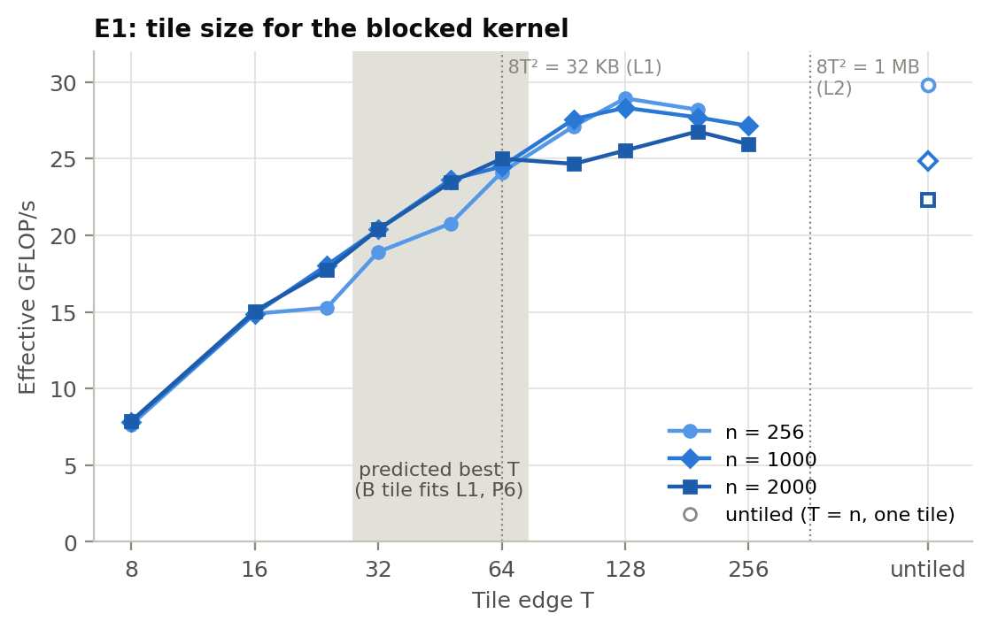
Figure 3. E1: blocked throughput against tile edge T. Hollow markers: untiled (T = n).
Tile. Throughput rises from 7.6–7.9 GFLOP/s at T = 8 to 24.1–25.0 at T = 64, and peaks at T = 128 (28.3–28.9; T = 192 at n = 2000). T = 1 cannot vectorise and manages 0.74. Untiled wins only at n = 256 (29.8), falling to 22.3 at n = 2000 as B streams from L3. T = 128 and 192 are within 1–3% of each other; the shakedown run chose 192. §5.1 explains why the optimum is far above P6’s L1-sized T = 64.
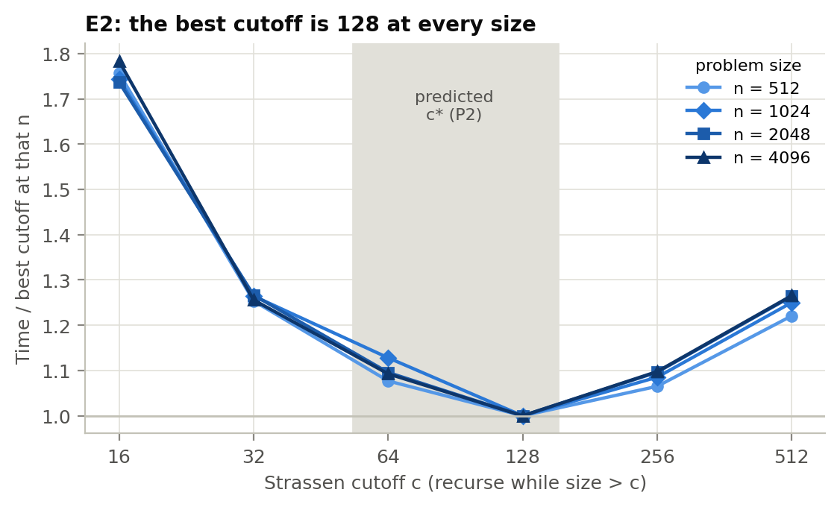
Figure 2. E2: Strassen’s time against cutoff, relative to the best cutoff at each n.
Cutoff. c = 128 is best at all four sizes (P2, P3). The curve is steep on both sides:
- c = 64 is 7.7–12.8% slower, and c = 256 is 6.5–9.8% slower, which is not quite the ±10% flatness P2 predicted.
- c = 16 is 74–78% slower and c = 512 is 22–27% slower.
The §2.3 break-even rule says it pays to recurse at size n when n/2 > 9.3r. With the measured r ≈ 6.7, that’s n/2 > 62. Going from c = 128 to c = 64 means recursing at n = 128 into 64-sized halves, which is right at the break-even point. On top of that, the kernel is slower at 64 (26.8 GFLOP/s) than at 128 (29.7), so the extra level loses. The cost model predicts the optimum to within one power of two, from parameters measured independently of E2.

4.3 Padding
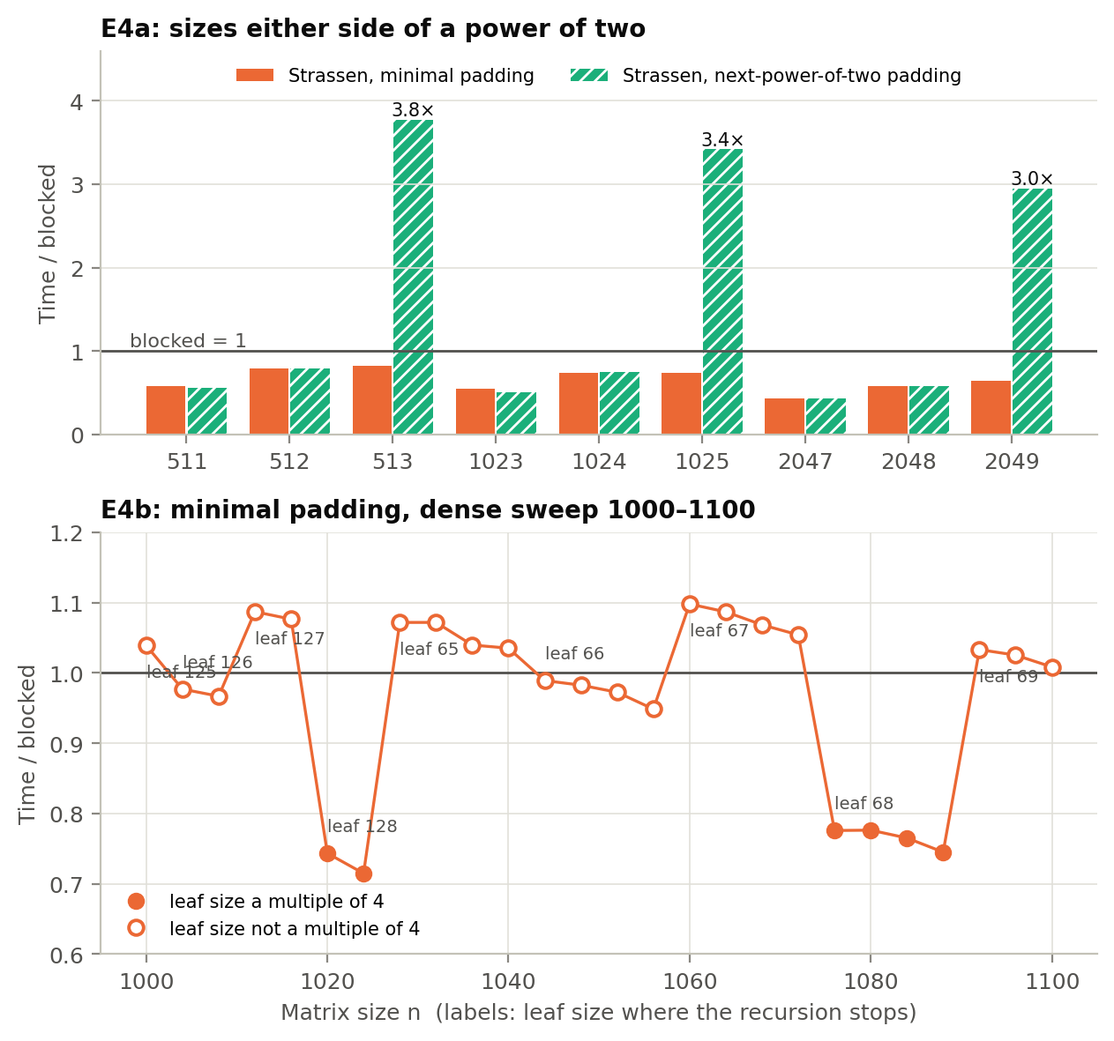
Figure 4. E4a: Strassen’s time relative to blocked either side of a power of two, for both padding rules. E4b: minimal padding across n = 1000–1100. Labels give the leaf size where the recursion stops.
nextpow2 behaves exactly as predicted (P9). One size past a power of two, the padded problem doubles in each dimension and gains a recursion level. Time jumps 6.8×, 7.1× and 7.3× at n = 513, 1025 and 2049; the theoretical jump is 7. That makes Strassen 3.0–3.8× slower than blocked at those sizes.
minimal padding avoids that cliff: 0.64–0.82× blocked at 2ᵏ + 1. But in the dense sweep it was slower than blocked at 14 of 26 sizes (worst 1.10×). That refutes P10. The pattern follows the leaf size, not the amount of padding, and §5.2 tests why.

4.4 Memory hierarchy
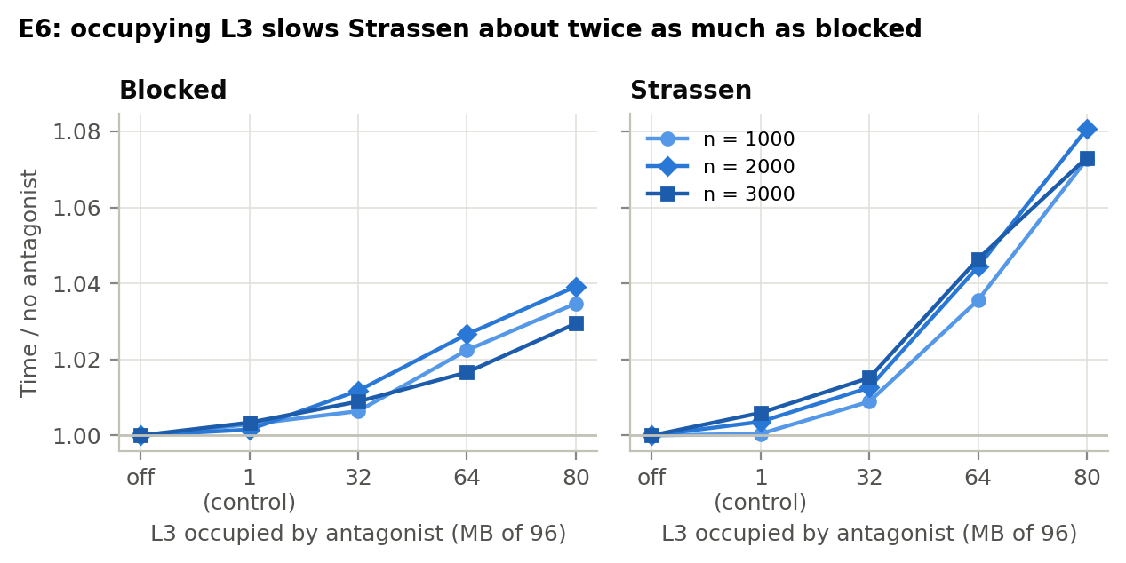
Figure 6. E6: time relative to no antagonist, as the antagonist occupies more of the shared L3.
L3 pressure (P7).
- The control works. A busy neighbouring core with only 1 MB, which stays in its own L2, changes times by at most 0.6%.
- Blocked slows by 2.9–3.9% with 80 MB of the 96 MB L3 taken.
- Strassen slows by 7.3–8.1%, about twice as much.
Blocked re-reads B from L3 only once per 128 uses (about 16 flops per byte), so even DRAM bandwidth barely limits it. Strassen’s additions are pure streaming at 24 bytes per flop, and they take about 15% of its time (Figure 10). If spilling their operands from L3 to DRAM raised the addition cost by about half, that alone would produce the 7–8%. The data is consistent with this, but we did not time the additions separately under pressure. Strassen’s speedup over blocked falls by at most 4.1%, so P7’s claim that L3 size barely matters holds.
The unusual 96 MB L3 is not what makes Strassen win. P7’s other half failed: blocked loses 15% from its peak between n = 256 and 4096, gradually, with no cliff where the matrices outgrow L3.
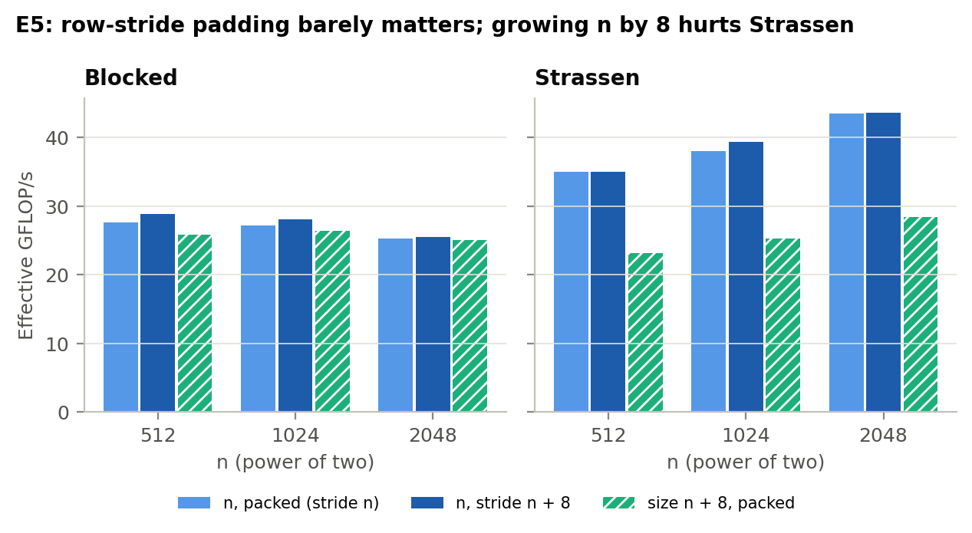
Figure 5. E5: power-of-two sizes stored packed, with the row stride padded by 8, and at size n + 8.
Power-of-two strides (P8): refuted. Padding the row stride by one cache line gains blocked 0.9–4.7% and Strassen 0.0–3.3%, against 10–40% predicted. Padding Strassen’s temporaries (temp_pad) moves it by at most 2%, below the bias found in §5.3. P8 assumed a B tile’s rows must sit together in L1, where they would collide in the same cache sets; the kernel never needs that (§5.1). Size n + 8 is much slower for Strassen (25.3 against 38.1 GFLOP/s at 1032), but that is §5.2’s leaf-alignment effect, not a stride effect.

4.5 Allocation
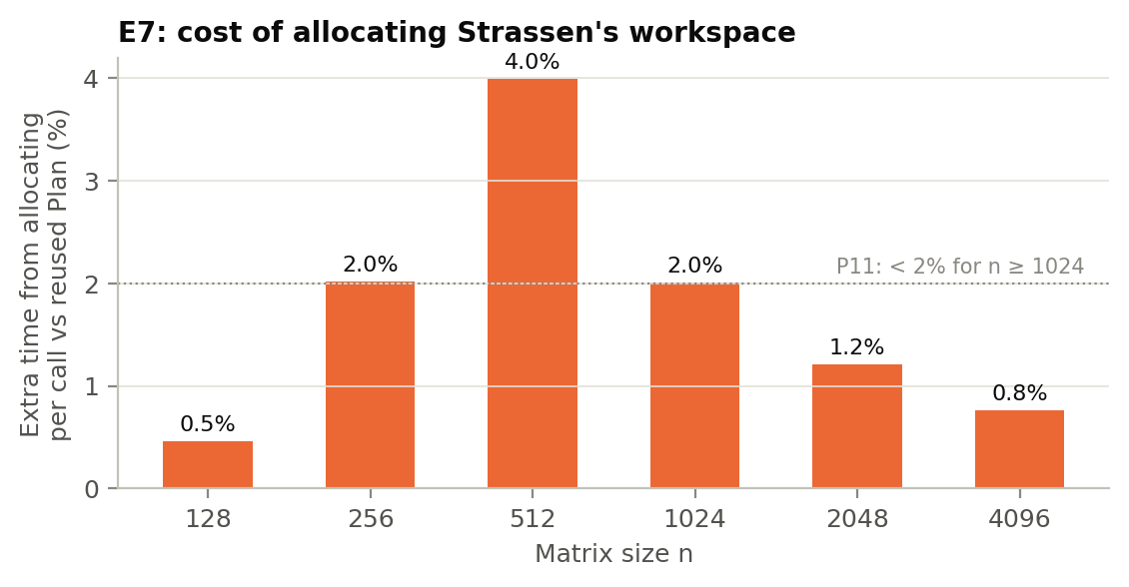
Figure 7. E7: extra time when Strassen allocates its workspace on every call, compared with reusing a Plan.
Allocating the workspace on every call costs 0.8–2.0% for n ≥ 1024, as P11 predicted, falling roughly as n⁻⁰·⁸ (n² of workspace against n²·⁸¹ of work). But it costs only 0.5–2.0% at n ≤ 256, not more than 5%, and peaks at 4.0% at n = 512. A plausible but untested explanation: small blocks are recycled by the allocator, while the 2 MB workspace at n = 512 is returned to the OS and re-mapped, with fresh page faults, on every call (§6).

4.6 Numerical accuracy
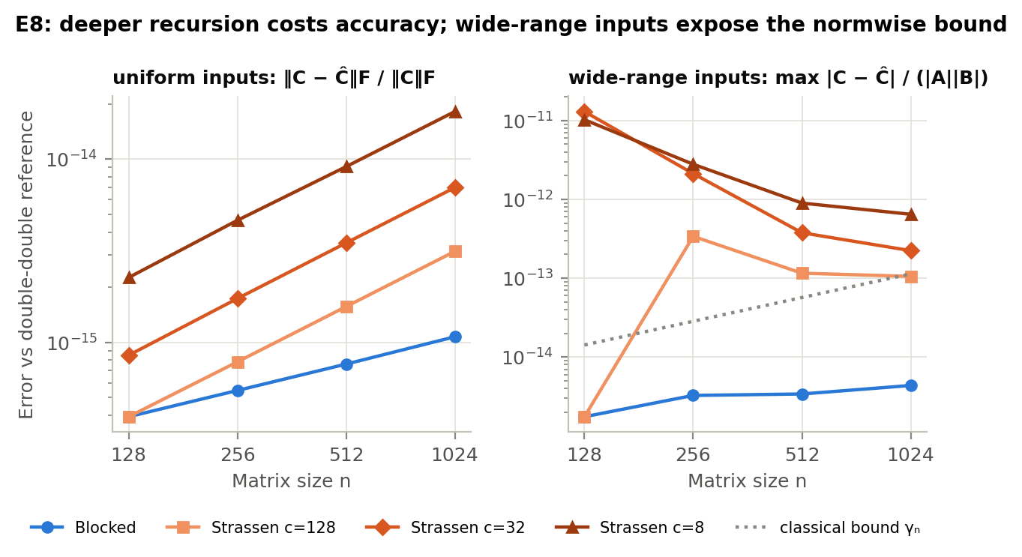
Figure 8. E8: error against the double-double reference, for uniform inputs (Frobenius, left) and wide-range inputs (componentwise, normalised by |A||B|, right).
Small integers: both algorithms are exact at every size and depth (P12).
Uniform inputs: Strassen’s error grows with recursion depth. Blocked’s Frobenius error is 3.9×10⁻¹⁶ to 1.1×10⁻¹⁵; Strassen with c = 8 (7 levels at n = 1024) reaches 1.8×10⁻¹⁴, 17× worse. Every value stays far below 10⁻¹² (P13).
Wide-range inputs separate the two kinds of bound:
- Blocked’s componentwise error, max |C − Ĉ| / (|A||B|), stays below the classical γₙ in every case (1.8–4.4×10⁻¹⁵).
- Strassen exceeds γₙ in 10 of its 11 recursive configurations: 1.0×10⁻¹³ to 1.3×10⁻¹¹, which is 24× to 7,400× worse than blocked. The one exception is n = 1024 with c = 128, at 0.93 γₙ.
- Its Frobenius error stays within 1–19× of blocked’s, and its normwise error is tiny.
Strassen meets the normwise guarantee it has and breaks the componentwise one it lacks, as §2.7 argued: small entries are swamped by sums such as A₁₁ + A₂₂ that mix magnitudes. P14 is only partly right: the gap exceeds 1,000× at n = 128 but shrinks to 24–148× by n = 1024. Strassen’s componentwise error falls with n here while blocked’s rises slowly. We did not establish why (§6).

4.7 Scorecard
 | Prediction | Outcome
P1 | blocked 10–20 GFLOP/s | refuted: 24.8–29.3
P2 | c* = 64–128, flat ±10% | c* = 128 confirmed; slightly steeper than predicted (neighbours up to 12.8% slower)
P3 | c* independent of n | confirmed
P4 | crossover about 256 | confirmed: Strassen at least 3% faster from n = 160
P5 | 1.5–1.8× at 4096 | exceeded: 1.98×
P6 | best T = 32–64 | refuted: T = 128 (§5.1)
P7 | no L3 cliff, speedup within 10% under pressure | cliff absent and speedup holds (≤4.1%), but blocked loses 15% gradually
P8 | power-of-two stride costs 10–40% | refuted: 0.9–4.7%
P9 | nextpow2 jumps about 7× | confirmed: 6.8–7.3×
P10 | minimal beats blocked everywhere | refuted: loses at 14 of 26 sizes (§5.2)
P11 | allocation under 2% at large n, over 5% at small n | half right
P12–P14 | accuracy | confirmed; P14’s 1,000× only at small n

5. What surprised us
Three predictions failed in ways that taught us something about the algorithms (P6, P10), or about our own measurements. Each explanation below was tested, not just proposed. Two of the tests (E9, E9b) were designed after the surprise appeared, and their predictions were committed to the repository before they ran (report/drafts/E9-preregistration.md, E9b-preregistration.md).

5.1 The best tile is twice the “L1-sized” one, because the kernel is overhead-bound, not cache-bound
§2.4 argued that the T × T tile of B is reused across T rows, so it should fit in L1 (8T² ≤ 32 KB, so T ≤ 64). The measured optimum is T = 128 (288 KB with T = 192 in the shakedown run), and T = 64 is up to 17% slower (Figure 3). The power-of-two stride result (P8) failed for what turned out to be the same reason.
The flaw was in what we assumed stays in L1. In the i-k-j kernel, one inner call is c[j] += a · b[j] over a row segment of length T. Its live data is one row of C and one row of B: 2 × T × 8 bytes, which is 2 KB at T = 128. The rest of the B tile is re-read row by row from L2 on every i. That access is sequential, which the hardware prefetcher handles well, and L2 bandwidth easily covers one 32-byte load per vector iteration. So the tile never needs to sit in L1, and neither cache sets nor power-of-two conflicts between its rows ever come into play.
What the tile size does control is how long each inner call runs. Each call pays a fixed cost (loop set-up, the vector remainder, the branch at exit) that is amortised over T/4 vector iterations. If that is the limit, throughput should follow $F(T)=F_{\text{max}} T/(T+T_{0})$. We tested that claim:
- The overhead model fits E1 for T = 8–128 with R² = 0.95 (n = 1000), 0.98 (n = 256) and 0.89 (n = 2000). The fitted overhead is T₀ ≈ 27–30 elements per call, about seven vector iterations’ worth.
- A cache explanation is inconsistent with the data. Tiled multiplication at n = 1000 runs within 5–9% of a single-tile multiplication of the same width, where all data is cache-resident (T = 64: 24.5 vs 26.8 GFLOP/s; T = 128: 28.3 vs 29.7; the latter from E3 at n = T). If cache misses were the limit, the large problem would be far slower than the in-cache one.
- The model’s one systematic miss is informative. At n = 2000 it overestimates T ≥ 96 by up to 15%. There, the strip of C rows that a tile row sweeps (T × n × 8 bytes, 2 MB at T = 128) no longer fits in L2. That second-order memory effect is why the optimum moves to T = 192 and flattens.
The lesson: we reasoned about where the data lives, when this kernel is limited by how much work each loop invocation gets. A BLAS-style register-blocked micro-kernel (Goto & van de Geijn, 2008) removes exactly this overhead (§6).

5.2 Minimal padding loses to plain blocked at half of all sizes, because of the leaf size it chooses
minimal padding minimises extra arithmetic (at most 3% around n = 1000), yet over n = 1000–1100 it was slower than blocked at 14 of 26 sizes (Figure 4b). Two neighbouring sizes show the effect: n = 1020 runs at 0.74× blocked, but n = 1028, which pads by only 12 rows, runs at 1.07×. Grouping by the leaf size where the recursion stops gives a sharp split. Leaves of 128 or 68 run at 0.71–0.78× blocked; leaves of 65, 67, 69, 125 or 127 run at 1.01–1.10×.
Hypothesis. One AVX2 register holds 4 doubles. A leaf of width 65 leaves a scalar remainder on every row. More importantly, the recursion temporaries then have row strides of 65, 130, 260… doubles. Those are not multiples of 4, so leaf rows start at addresses that are not 32-byte aligned, and many vector loads straddle two cache lines.
Test (E9, pre-registered). We added an aligned padding mode that rounds the leaf up to a multiple of 4 (or 8), and swept 35 sizes in 1000–1100 and 2000–2100 (Figure 11).
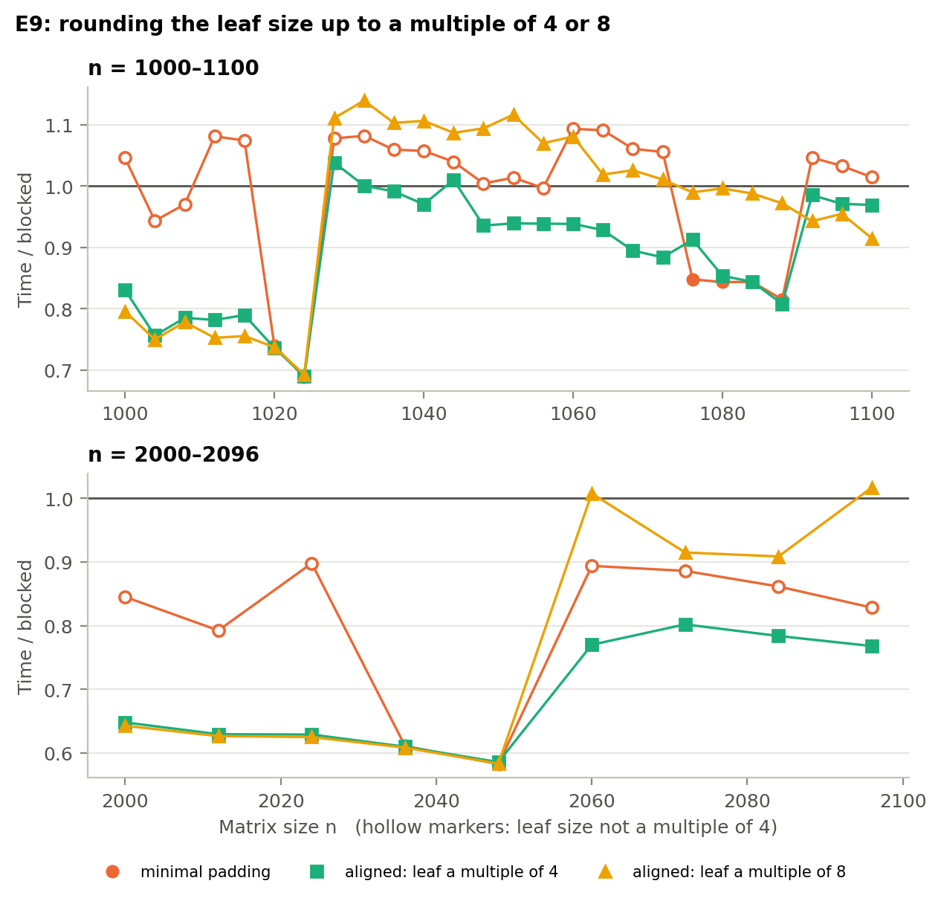
Figure 11. E9: Strassen’s time relative to blocked for minimal padding and for leaves rounded up to multiples of 4 and 8. Hollow markers: leaf size not a multiple of 4.
- The core claim holds. Rounding to a multiple of 4 cut the number of sizes where Strassen loses from 17 of 35 to 3 of 35, even though it does up to 13% more arithmetic. For leaves 125–127, rounding up to 128 saved 20–30%: n = 2024 went from 0.90× to 0.63× blocked. Across all 35 sizes, minimal runs at a median 0.78× blocked when its leaf is a multiple of 4, and 1.03× when it isn’t.
- H1 (“beats blocked everywhere”) was partly refuted, and the residual has its own explanation, which we also checked. Every n from 1028 to 1088 pads to the same 1088. Aligned Strassen’s time is therefore flat across that range (77–85 ms), while blocked’s grows as n³ (82 → 95 ms). The three remaining losses (n = 1028, 1032, 1044) are padding work, not slow flops.
- H2 held. Alignment 8 buys nothing over 4. Wherever it pads further (for example 1152 instead of 1088) it is 7–32% slower. Vector-width alignment is what matters, not cache-line alignment.
So the padding rule that minimises flops is close to the worst one for the vector unit. Strassen’s practical cost depends on the shape of its leaves, which the asymptotic analysis, and our cost model, treat as free.

5.3 Our harness had a hidden 2–5% bias, and we could identify it
E9 produced a contradiction. At eight sizes in 1000–1100, aligned4 and aligned8 give identical computations (same leaf, same padded size, same code path), yet aligned8 was consistently 1–6% faster, with a third of the spread. Where no padded copies are made (n = 1020, 1024, 2036, 2048), the two agreed within 0.4%. Either our order rotation was to blame, since it fixes each variant’s predecessor (aligned8 always ran straight after aligned4), or each Plan’s separately allocated buffers landed somewhere luckier in memory.
E9b (pre-registered) ran two identical aligned4 variants, allocated first and second, in both execution orders, with 15 repetitions. Times were compared within each repetition (Figure 12).
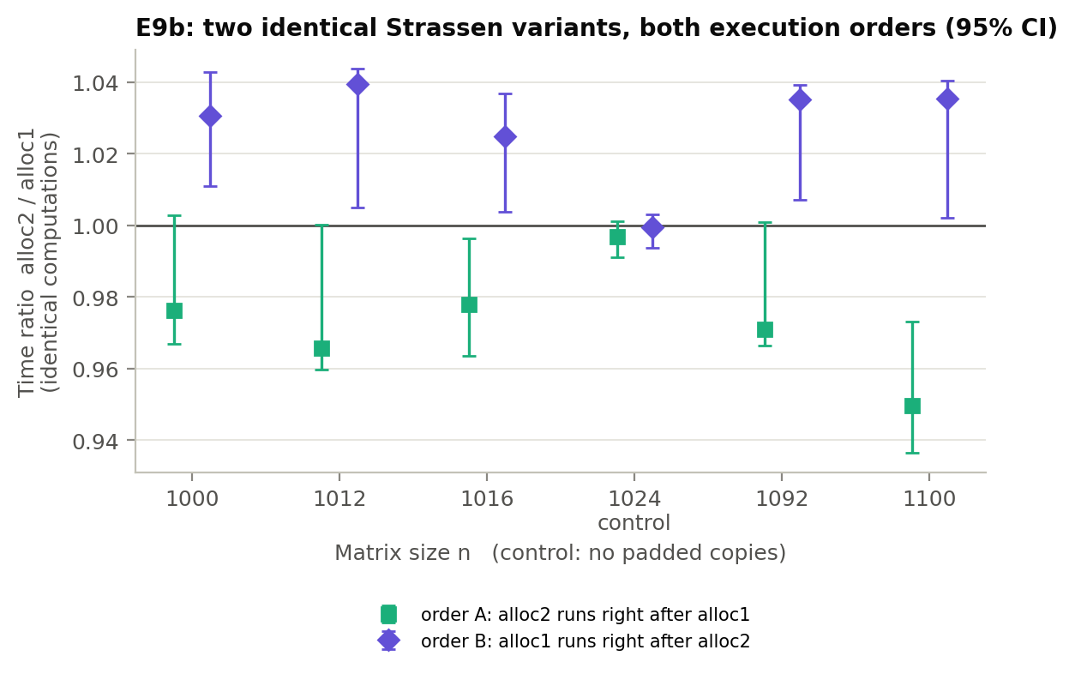
Figure 12. E9b: time ratio of two identical Strassen variants with 95% bootstrap intervals, in both execution orders. n = 1024 is the control, with no padded copies.
- At all five sizes with padded copies, whichever copy ran second was faster, in both orders. That’s 2.2–5.0% when the second-allocated copy ran second, and 2.5–3.9% when the first-allocated one did. The variant running right after minimal also had two to six times the spread.
- Placement is ruled out. The same allocation was never faster in both orders.
- The control behaved as predicted: 0.997 and 0.999, with both intervals containing 1.
It is a carry-over effect. A Strassen variant runs faster after a near-identical computation than after one with a different padded layout. Prefetcher, TLB or branch-predictor state are the likely carriers; we did not isolate which. So within a configuration, Strassen variants differing by less than about 5% are not distinguishable. That covers E9’s aligned8 vs aligned4 and E5’s temp_pad. The headline results are unaffected: E3 and E6 alternate two variants symmetrically, and the effects in E1, E2, E4 and E9 are 7% or larger.

5.4 A smaller surprise: Strassen wins twice
Besides cutting flops, Strassen’s recursion turns one large multiplication into many cache-resident 128 × 128 ones, which run at 29.7 GFLOP/s against blocked’s 24.8 at n = 4096. That is why the speedup beat P5 (§4.1). In effect it is the cache-oblivious blocking (Frigo et al., 1999) that Algorithm A implements by hand.

6. What we’d do next
- Register-blocked micro-kernel. §5.1 shows the blocked kernel is limited by fixed costs per row, not by memory. A BLAS-style micro-kernel that keeps a small block of C (for example 4 × 8) in registers would raise $F_{\text{max}}$ and remove T₀. Both algorithms would speed up, but blocked would gain on every flop while Strassen gains only on its leaves. So we expect the crossover to move to larger n. How far is the central open question of Theme 3: our crossover (about 160) sits well below published ones precisely because our kernel is modest.
- Separate the two alignment effects. E9 fixed the vector remainder and the 32-byte row alignment together. Padding the temporaries’ strides to multiples of 4 while keeping odd leaf widths would show which of the two matters.
- Remove the carry-over bias, then find its cause. Randomise or Latin-square the order of variants instead of rotating it, or insert a neutral flush workload between variants. Then use hardware counters (AMD uProf) on E9b to see which state carries over: prefetcher, TLB or branch predictor.
- Winograd’s variant and hybrid depth. Winograd’s form of Strassen (Winograd, 1971) needs 15 additions instead of 18, attacking the 15% residual in Figure 10. A per-level choice of whether to recurse, rather than one global cutoff, could also exploit the fact that the kernel rate depends on leaf shape (§5.2).
- Multi-threading. Strassen’s seven independent products parallelise naturally, and with eight cores sharing one L3, E6’s cache pressure becomes the normal condition.
- Open questions from the data. Why does allocation cost peak at n = 512 (§4.5)? Why does Strassen’s componentwise error fall with n on wide-range inputs (§4.6)?

References
Blackman, D., & Vigna, S. (2021). Scrambled linear pseudorandom number generators. ACM Transactions on Mathematical Software, 47(4), Article 36.
Brent, R. P. (1970). Algorithms for matrix multiplication (Technical Report TR-CS-70-157). Computer Science Department, Stanford University.
Frigo, M., Leiserson, C. E., Prokop, H., & Ramachandran, S. (1999). Cache-oblivious algorithms. In Proceedings of the 40th IEEE Symposium on Foundations of Computer Science (pp. 285–297).
Goto, K., & van de Geijn, R. A. (2008). Anatomy of high-performance matrix multiplication. ACM Transactions on Mathematical Software, 34(3), Article 12.
Higham, N. J. (2002). Accuracy and stability of numerical algorithms (2nd ed.). SIAM. (Fast matrix multiplication: chapter 23; the error analysis of Strassen’s method: §23.2.2.)
Huss-Lederman, S., Jacobson, E. M., Johnson, J. R., Tsao, A., & Turnbull, T. (1996). Implementation of Strassen’s algorithm for matrix multiplication. In Proceedings of the 1996 ACM/IEEE Conference on Supercomputing.
Knuth, D. E. (1997). The art of computer programming, Volume 2: Seminumerical algorithms (3rd ed.). Addison-Wesley.
Strassen, V. (1969). Gaussian elimination is not optimal. Numerische Mathematik, 13(4), 354–356.
Winograd, S. (1971). On multiplication of 2 × 2 matrices. Linear Algebra and its Applications, 4(4), 381–388.
Code and data. Repository: https://github.com/Jarrod-Ca/Assignment-2-strassen-vs-blocked. Official benchmark run at commit 73d07cf; follow-ups E9 at 58ea095 and E9b at ffb7a43. Pre-registered predictions: report/drafts/02-theory-and-predictions.md, E9-preregistration.md and E9b-preregistration.md, each committed before the corresponding run.

