 | TECHNICAL REPORT | 

Title: IR Photometry of the JWST Calibration Field |  | Doc #:  Date:  Rev: | JWST-STScI-001378, SM-12  18 April 2008
Authors: Jay Anderson | Phone: 410-338-4982 | Release Date:

Abstract
In 2005, a 5'×5' field in JWST’s continuous-viewing zone was selected to serve as an astrometric reference field that will facilitate solving for the distortion in JWST’s instruments, both during commissioning and afterwards. In April and July of 2006, HST’s Advanced Camera for Surveys (ACS) observed this field for 7 orbits, yielding a catalog with 100,000 stars that have relative positions good to about 1 mas (Diaz et al 2008, in preparation). This catalog can now be used to calibrate the distortion within any instrument any time that instrument observes the field. From the standpoint of JWST, there are two ways this catalog can be improved: (1) supplement the V_{F606W}-band photometry of the ACS observations with infrared colors, to get a better idea of how best to observe this field with JWST, and (2) extend the catalog to a larger field-of-view, to allow cross-calibration of the location and orientation of JWST’s different detectors. We therefore took supplemental observations of the calibration field from the ground to get J, H, and K_{s} fluxes, and also to extend the field to 20' × 20'. This report summarizes the photometric addition to the catalog. A subsequent report will discuss the astrometric extension.

Introduction
Many of the observing modes of JWST will depend critically on the accuracy of the distortion solution. For example, dithering will be important to compensate for undersampling, and we will need to know the distortion in both the FGS-Guider and the individual instruments in order to execute instrument-specific dithers accurately. We will also need to know the solution extremely well to be able to move stars precisely onto the coronagraphic spots, long slits and IFUs. NIRSpec’s MSA will be particularly dependent on our distortion solutions: since positions in NIRCam images will be used to identify sources and design NIRSpec observations, we will need to deal with the distortion in both instruments. The formal requirement is to know the distortion to 5 mas within any given instrument, but we hope to do much better.
There are two ways to calibrate the distortion in an instrument. Either we can observe an astrometric standard field and extract the distortion solution by comparing the observed positions of stars against the known distortion-free positions, or we can do a self-calibration, which involves imaging the same field at different orientations and offsets so that we can tease out the single distortion solution that allows all the observations to be transformed into each other using only conformal transformations (translations, rotations, and scale changes).
The distortion solutions for HST’s instruments have been obtained via self-calibration, since there were no fields that had been observed from the ground with the astrometric accuracy (1 mas) and star density (hundreds per chip) necessary to construct an adequate solution for HST’s cameras. Because JWST will have significant constraints on its field of regard and orientation at any given time, it will not be feasible to calibrate its distortion via a self-calibration approach during commissioning. Furthermore, adjustments of the primary-mirror segments over time may end up changing the distortion over the long term, so it will be necessary to evaluate the distortion multiple times during the mission. In any case, it will be good to have an astrometric standard field that JWST can point to at any time that will allow for a direct solution of the distortion.
Although other observatories were unable to help HST calibrate its distortion by constructing a useful reference field for it, it turns out that the resolution, field-of-view, and sensitivity of HST are comparable to those of JWST, and HST can therefore be used to construct an accurate astrometric standard field for JWST. Such a field should ideally be located in JWST's Continuous Viewing Zone (CVZ, which is within 5 degrees of the ecliptic poles) and should have a density and brightness distribution of stars that would match JWST's sampling and sensitivity.
Rhoads (2005) discusses many of the factors that went into choosing the best field for JWST and concluded that a field near the center of the Large Magellanic Cloud (LMC) would be ideal since: (1) it is in the CVZ, (2) the density is high, but the stars are still well separated for the 0.032" pixels of NIRCam, (3) the density is also uniform, so the distortion will be equally well measured everywhere on the detector, and (4) the LMC stars are far enough away that they should not have large internal proper motions. The specific field location was selected by R. Diaz-Miller, and is described in Diaz-Miller (2007). The calibration field was observed by HST’s Advanced Camera for Surveys (ACS) in 2006 through the F606W filter, and the extracted catalog will be presented in Diaz-Miller et al. (2008, in preparation).
Of course, the positions of stars should not depend on which filter was used to observe them, but it would be good to have an idea of how bright the stars will be in the infrared filters that JWST will be using. Therefore, we have supplemented this visible-band catalog with some ground-based observations taken during commissioning of the HAWK-I camera on the Very Large Telescope (VLT) in Chile. The ground-based data give us fluxes out to 2 microns, and allow us to extend the catalog to a larger field of view (20′×20′), which will enable us to accurately locate JWST’s instruments relative to the FGS-Guider. The present report presents the infrared fluxes for the stars in the 5′×5′ ACS-based catalog; another report will deal with the entire field covered by the ground-based observations.
This Technical Report is organized as follows. First, we review the catalog that was constructed with HST. We will then introduce the ground-based data that were taken with HAWK-I at the VLT. We zero-point the IR data using the Two-Micron All-Sky Survey (2MASS) catalog, and incorporate the HAWK-I and the 2MASS photometry into the ACS catalog. We also construct stacked images of the ground-based data to facilitate visualization. This catalog will eventually will be placed on a public website, so that instrument teams and the general astronomical community can make use of it. Finally, we discuss several ways that this resource will be used to calibrate JWST.

The ACS field
The chosen field in the LMC is centered on α_{J2000} = 05:21:57, δ_{J2000} = −69:29:51. The field was mosaicked with the WFC in April and July 2006 (program CAL/OTA 10753), at two different orientations so that the linear terms of the distortion could be properly solved for and removed. The total field covered is 5'×5'. In support of this calibration effort, GO-11021 also observed a field in the open cluster M35, which had been previously calibrated by HST’s FGS, so that the absolute scale of the WFC (and hence of the calibration field) could be established (see van der Marel et al 2007).
The construction of the standard field from the WFC observations will be covered in another document (Diaz et al 2008), so we will give only a brief overview here. We took the ACS observations in F606W, the filter for which the best distortion solution is available. We mosaicked the field to cover an area of 5′×5′. This field is large enough to contain any of the individual JWST instruments, but it is not large enough to contain more than one instrument at a time.
Two catalogs have been constructed from the WFC images. The first catalog concentrated on the stars that could be measured well. It contains 218,663 stars that are bright (V_{F606W} < 25) and isolated (no brighter neighbor within 5 pixels). Most stars in this catalog have positions measured to better than 1 mas, and almost all the stars have positions good to 5 mas. The second catalog contains 545,222 stars and is the product of multiple automated finding passes (see Anderson et al 2008 for a description of the finding program). It includes nearly every star that could reasonably be found by a careful human, and goes down to about V_{F606W} = 27 with a wide variation in measurement quality, related to the particular local environment of each star (the flatness of the background, the proximity of its neighbors).
The first list is useful for determining what can be done when focusing on the best stars; the second list is useful for determining how much crowding-related issues might impact a particular study of the field. The density of the field is quite uniform; there are about 6 stars per square arcsecond down to V_{F606W}=27, so the stars are typically separated by a little less than a half an arcsecond, or about 15 NIRCam short-wavelength-channel pixels.
Figure 1 shows the luminosity function (LF) for the two catalogs, which are nearly identical for stars with V_{F606W}<22, since those stars are almost all isolated. Saturation in the deep WFC exposures sets in for stars at about V_{F606W}=19, which is the level of the red clump of the Horizontal Branch, seen as a peak in the LF. We used short exposures to measure accurate V_{F606W} fluxes for the stars that were saturated in the deep exposures. From this diagram alone, it is hard to say where saturation in JWST’s NIRCam will set in, since from the ACS data we have only visible fluxes. Furthermore, we cannot say which stars are blue or red, making it even harder to predict JWST fluxes. Clearly, some infrared photometry would be useful to help us gauge what to expect, both signal-to-noise-wise and crowding-wise, when we observe this field with JWST. That is the aim of this document and the accompanying catalog.
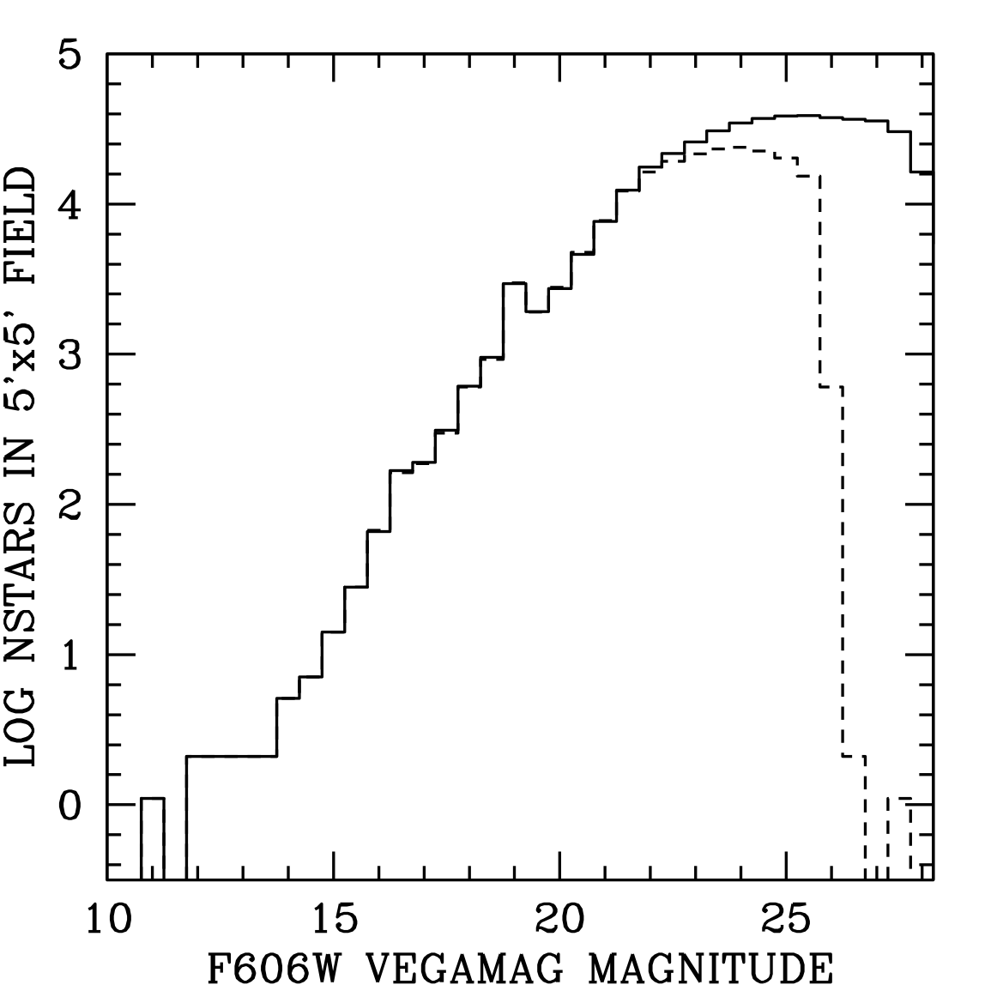
Figure 1: Luminosity function of stars in the field. The dark line shows all the stars; the dotted line shows those in the bright, isolated catalog.

The Infrared Observations
This section describes the infrared observations that we took to supplement the ACS-based catalog. Although the infrared observations covered a larger field than that of our ACS-based catalog, this report covers only the results for the area of overlap. In a subsequent report, we will use these ground-based observations to increase the field size for which astrometry and photometry is available to 20′×20′.

The HAWK-I camera
The HAWK-I (High Acuity Wide-field K-band Imager) is an infrared camera that has recently undergone commissioning at the VLT at Paranal in Chile. It consists of a 2×2 array of 2048×2048 Rockwell H2RG chips that cover a field of 7.5′×7.5′ with a pixel scale of 0.1″/pixel and a gap of about 0.5′ between chips. The detector is sensitive over the range of 0.9 to 2.5 microns, and is the same model as will be used for the NIR imagers on JWST. The 8m VLT telescope uses “active optics” to correct for the tip-tilt variations of the wavefront in order to improve the seeing. The active-corrected seeing is typically 0.3″ to 0.5″ in the infrared.
During commissioning, HAWK-I observed the JWST calibration field so that its own distortion could be solved for using the catalog that we have constructed for JWST. The observations HAWK-I made through J, H, and K_{s} can in turn be used to provide infrared photometry for the brighter stars in the field, so that we will have an idea how bright they will be when we observe them with JWST.
In each of the J, H, and K_{s} bands, the calibration field was observed in a 5×5 array of pointings, such that each point in the calibration field would be covered by between 5 and 25 exposures through each filter. Each exposure consists of a 100-s integration, and the up-the-ramp slopes are recorded in the units of counts per 10 seconds.

Reductions
A list of sources was extracted from each image by a custom-made software program. The program first constructed a PSF using the bright, isolated stars and then used that PSF to measure positions and fluxes for all the sources, bright and faint, that satisfied some simple finding criteria (at least 5000 counts above sky in the inner 3×3 pixels, and a shape that is consistent with the PSF).
The distortion in the HAWK-I camera is not very large (about one pixel from the center to the edge of the chip), and it was removed by comparing observed positions against the distortion-free ACS reference frame. This provided a nice proof-of-concept that the astrometric field can serve as we designed it. In the present report, we will use the distortion solution to match up stars, but we will not need it for anything else.
We matched up stars in the source list from each HAWK-I exposure with those in the ACS master star list. The ACS-based master list goes much deeper than the ground-based source lists. We found that V_{F606W}=20 is the faintest star we could find in the HAWK-I set, so we did not try to match up fainter catalog stars with the HAWK-I lists. We used the cross-identified stars to define a transformation from the frame of each exposure into the master frame, and collated the source lists from the 25 observations for each filter in the master frame. We identified a star wherever 5 or more of the HAWK-I images detected something within 50 mas (one pixel in the master frame, half a pixel in the HAWK-I exposures).
We thus made a list of the solid detections in each IR band, and derived an estimate of its error from the agreement among the individual observations. At this stage, the photometry still is in instrumental magnitudes, –2.5 log₁₀(N_{CTS}), where N_{CTS} corresponds to the number of counts in a 10-s integration.
Figure 2 shows the plot of internal error against instrumental magnitude for the K_{s}-band astrometry and photometry. The pixel size is 50 mas, so the bright stars are measured with a precision of about 5 mas in each coordinate in each exposure. Since each star can be found in multiple exposures, the ultimate precision for the purely ground-based portion of the extended catalog will be better than this. Photometrically, the internal error is about 0.02 magnitudes for the brightest four magnitudes below saturation (which occurs at an instrumental magnitude of –15.5). The J- and H-band measurement quality is similar.
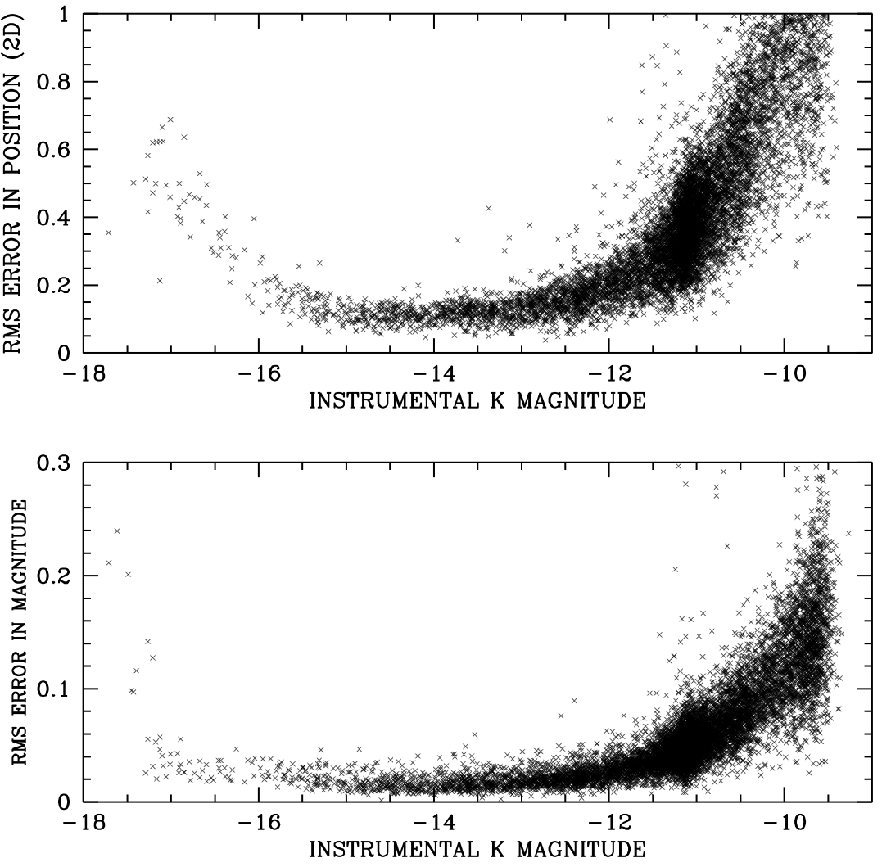
Figure 2: Position and flux errors as a function of instrumental magnitude for the K-band HAWK-I images. Position errors are in WFC pixels, which are 50 mas on a side.

Stacks
Now that we have a distortion solution for the HAWK-I chips, we can generate for each filter a deep image stack in the ACS reference frame. This will remove the plentiful artifacts in the HAWK-I images, and will facilitate visualization of the field in different bands.
Using a stacking procedure similar to DRIZZLE with pixfrac = 0, we combined the 25 HAWK-I exposures together into a single frame that was astrometrically matched to the 5'x5', 8000x8000-pixel ACS reference frame. Figure 3 shows a comparison between the four stacks: V_{F606W}, H, J, and K_{s} for the center of the calibration field. These images have also been supplied with a WCS header, so it will be easy to match up stars with standard catalogs.

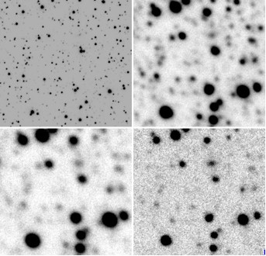
Figure 3: The center of the calibration field shown in V_{F606W} (upper left), J (upper right), H (lower left), and K_{s} (lower right). The field shown is or 6″×6″, or 300×300 ACS/WFC pixels.

Photometric Calibration
We calibrated the HAWK-I photometry by cross-identifying the bright stars in that catalog with the 2MASS catalog. Figure 4 shows the comparison and the zero-point we determined for each filter.

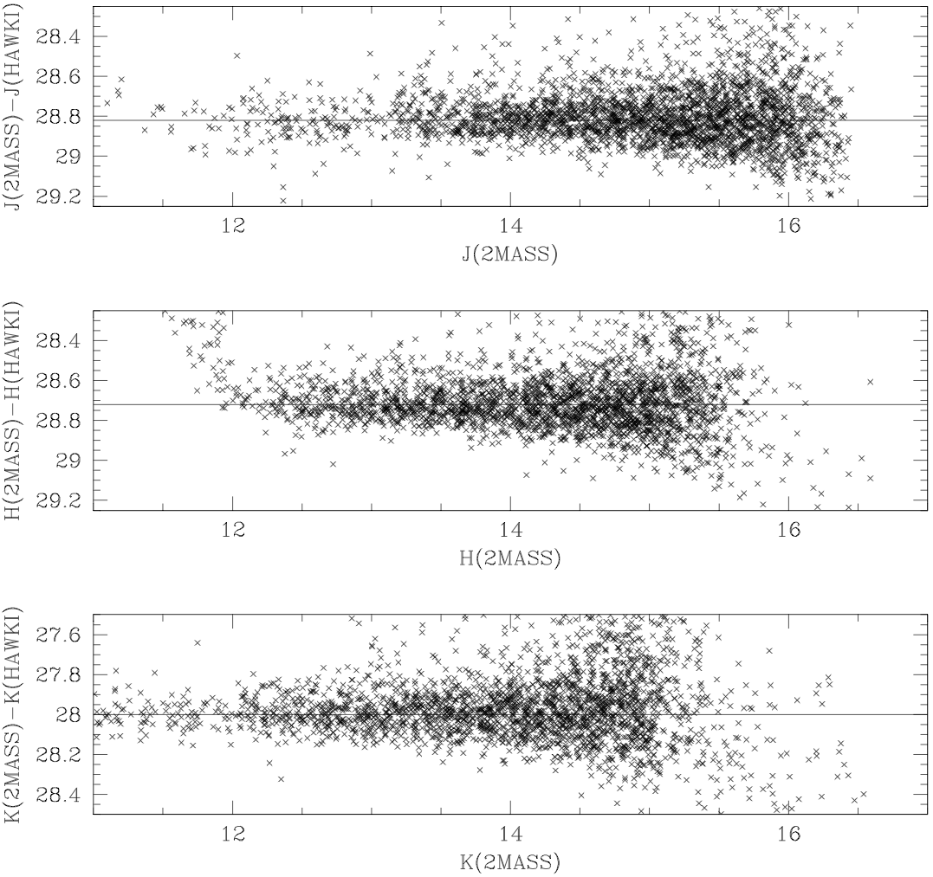
Figure 4: Comparison of the photometry from the 2MASS Catalog with the HAWK-I photometry in order to construct zero-points for the HAWK-I data. The departure from linearity of the H photometry brighter than H=12 is due to the fact that the pipeline software was accidentally not set to capture pixels that saturated during ramp-up.

The Star Catalog
We now have 7 star lists: the ACS reference catalog, the HAWK-I source lists for J, H, and K_{s}, and the official 2MASS catalog for J, H, and K_{s} (Skrutskie et al. 2006). All have been transformed into the 8000×8000-pixel ACS reference frame.
Since the ACS catalog was constructed from higher-resolution images and it goes much fainter than the others, it should contain any star that is found in any of the other lists. As we mentioned before, only the stars brighter than V_{F606W} = 20 have any chance of being detected in the ground-based catalogs, so we confined our cross-identification to the 9400 stars with V_{F606W} < 20 in the “isolated” ACS catalog. To match stars in the HAWK-I catalogs with the ACS stars, we used a matching radius of 0.5 WFC pixel (25 mas). We had to use a larger matching radius (2.5 WFC pixel) for the 2MASS data, since the 2MASS positions are not as accurate. Since stars in the “isolated” ACS catalog were selected on the basis of having no brighter neighbors within 5 WFC pixels and the typical separation of the bright V_{F606W}<20 stars is 60 pixels, the chance of mis-identification is small for HAWK-I. The cross-identifications we provide with the 2MASS catalog may suffer somewhat from misidentification or blending.
This composite catalog now contains 218,663 stars with F606W photometry in the VEGAMAG system for all stars. We also have J, H, and K_{s} photometry for the ∼6000 stars found in the HAWK-I images, and J, H, and K_{s} for the ∼500 stars found in the 2MASS catalog.

Some color-magnitude diagrams
Figure 5 below shows a color-magnitude diagram (CMD) for the stars found in the 2MASS and HAWK-I data. 2MASS goes down to about K_{s}=15, just deep enough to see the upper few magnitudes of the RGB. HAWK-I goes about 3 magnitudes deeper, to just below the red clump of the Horizontal Branch at K_{s}=17. The shortest NIRCam full-chip exposure (20s) should saturate at about K=15, so the HAWK-I photometry already gives us a good idea of how many high-signal-to-noise stars JWST will have to work with.
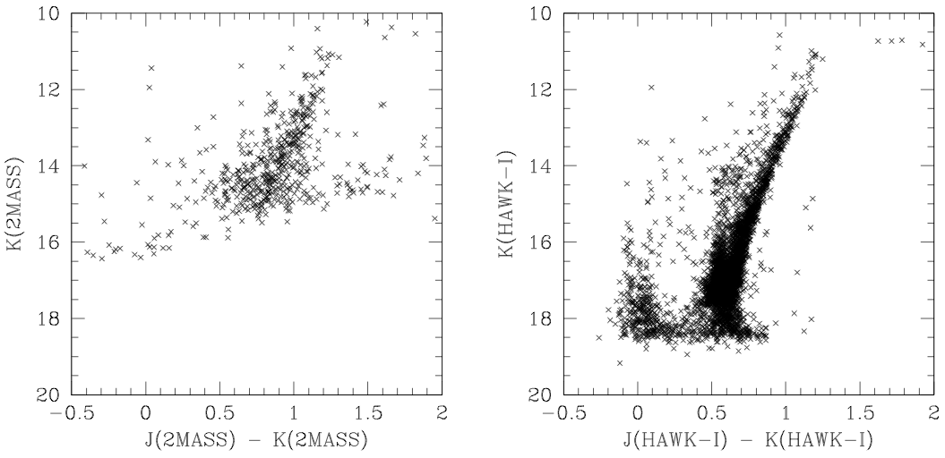
Figure 5: Color-magnitude diagrams for the J−K_{s} photometry from the stars found in the 2MASS catalog (left) and the HAWK-I source lists (right).
Figure 6 below shows a CMD with a larger color baseline (V_{F606W}−K_{s}) to give us a broader idea of how different the field will look in the IR as compared to the visible. There are two clear populations: the blue stars, comprised of foreground stars and young LMC stars, and the red LMC giant-branch stars. It is worth noting that the brightest blue and red stars are about the same brightness in the visible. But in the K_{s} band, the bright red stars are about 100 times brighter than the bright blue stars. Thus, the field will look quite different for JWST in K than it does for ACS in the visible: the red stars will be much more prominent.

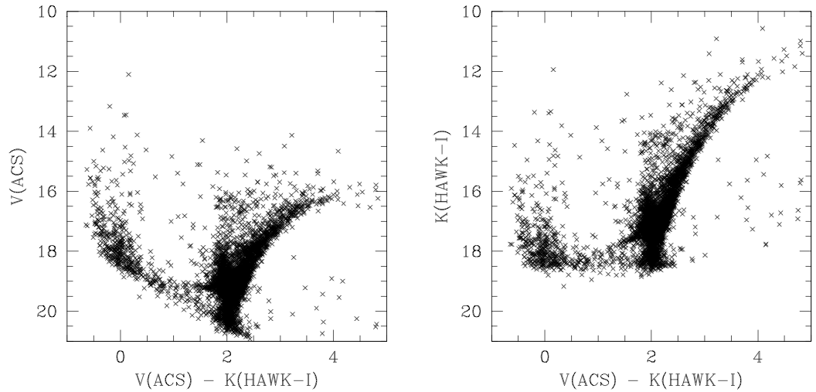
Figure 6: CMDs in V_{F606W}−K_{s} color. On the left, V_{F606W} (from ACS) is on the vertical axis, and on the right HAWK-I K_{s} is on the vertical axis. It is worth noting that F606W is quite a bit redder than Johnson V.

A census of the 5′×5′ field
In Table 1 below we provide a simple census of the numbers of bright stars in the field as a function of V_{F606W}, J, H, and K_{s} magnitude. Saturation in the NIRCam detector should occur at around K = 15 for full-chip read mode (depending somewhat where the gain is ultimately set), so there should be about 580 stars that are saturated in the 5′×5′ field. (This number comes from taking half the stars in the K_{s}=15 bin, and all those in the brighter bins.) This translates to about 23 stars in the 1.1′×1.1′ field of one of NIRCam’s 2048×2048-pixel short-wavelength detectors.

Table 1: Number of stars in each of the bright magnitude bins within the 5x5 ACS field. The bin at mag 15 contains the stars between 15.5 and 14.5.

mag | V_{F606W} | J | H | K_{s}
11 | 1 | 0 | 0 | 10
12 | 2 | 6 | 2 | 25
13 | 6 | 24 | 68 | 82
14 | 10 | 82 | 202 | 219
15 | 37 | 275 | 454 | 491
17 | 482 | 1314 | 2708 | 3170

Some extrapolation
The HAWK-I data give us IR fluxes for the bright stars, but it would be useful to have estimates for the IR fluxes for all the stars. We saw in Figure 6 that the brightest stars span a V_{F606W}−K_{s} color range of over 5 magnitudes. As we go fainter, the blue and red sequences would be expected to meet at the main-sequence turnoff and continue largely together below that. Thus, it should be easier to predict the K_{s}-band photometry from the V_{F606W} photometry for the fainter stars than it is for the brighter stars.
Thus, in an effort to provide some estimate for the infrared brightnesses of stars below the HAWK-I detection limit, we fit an isochrone to the observed giant-branch sequence, and used it to predict the colors for the fainter stars. Bertelli et al (1994) provide isochrones for a wide range of metallicities and ages, and their updated website provides them for the ACS VEGAMAG system. We took an isochrone for Z=0.004 and 10 Gyrs and found that a reddening of E(B−V)=0.075 and a distance modulus of 18.35 did a decent job fitting the upper sequences simultaneously in V_{F606W}, J and K_{s}. These values are within the range found by Nikolaev et al (2004) in their study of deep 2MASS images of the LMC region.
Figure 7 shows the isochrone fit to the V_{F606W}, J, and K_{s} photometry. The isochrone does not fit perfectly; indeed, no single isochrone can represent the complicated star-formation history of the LMC (see Skillman & Gallart 2002 and other references in that volume). The parameters we found are at the extreme end of what we know to be appropriate for the LMC (more reddening and a farther distance); but a more careful treatment would involve color equations and filter-transmission-curve analyses, which is beyond the scope of this project. Despite the limitations, the isochrone predictions should be sufficient to give us a rough idea of the infrared fluxes for the fainter stars, until we are able to observe actual fluxes for them, perhaps with Wide-Field Camera 3 (WFC3).
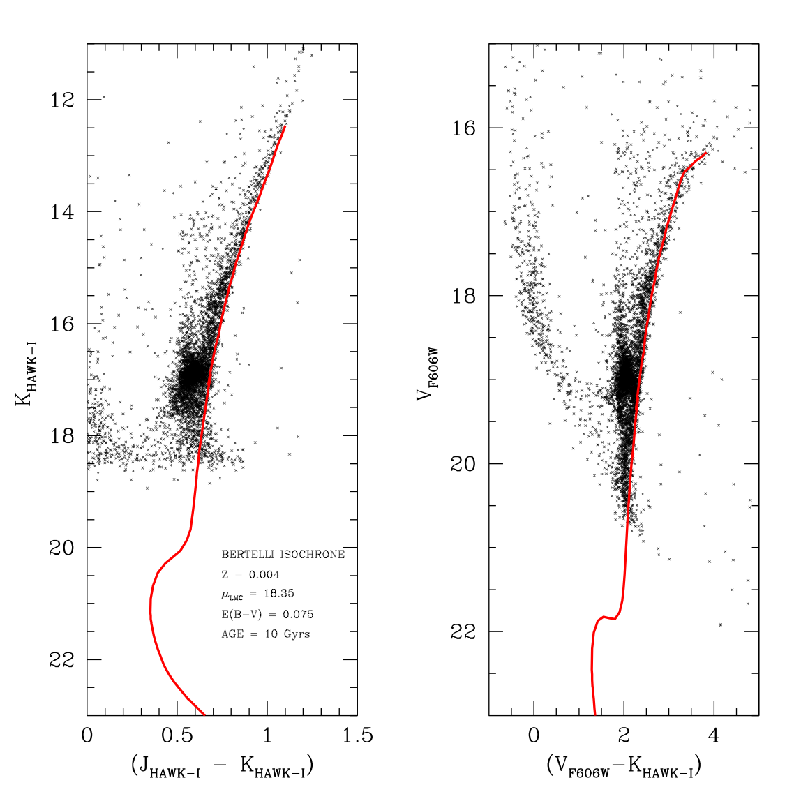
Figure 7: Fit of the Bertelli et al (1994) isochrones to the observed sequences.
Using the above isochrone, we were able to estimate J, H, and K_{s} fluxes from each star’s F606W flux. This isochrone-predicted flux will be included in the final catalog, along with the observed fluxes.

The available files
We provide the catalog in a single text file, named MASTER.ISO.XYVJHKRD. It can currently be found at /grp/jwst/wit/calib_field, but we will soon make it available to the public at http://www.stsci.edu/jwst/instruments/calibration.
The file has 218,663 lines, one line for each star in the “isolated” ACS catalog. There are 17 columns. The first three columns are the x and y position in the ACS reference frame, and the F606W photometry. The reference frame has the ACS pixel scale (roughly 50 mas/pixel) and is the same frame as was used for the stacked images. The third column has the VEGAMAG F606W photometry.
Columns 4 through 6 contain the HAWK-I J, H, and K_{s} photometry, zero-pointed to agree with 2MASS. Entries of “30.000” mean that the star was not found. Columns 7 through 9 give the 2MASS photometry for the brightest stars that could be identified in that catalog. In columns 10 through 12, we give the estimates of the J, H, and K_{s} flux for each star, based on the F606W flux and the Bertelli-isochrone models. Columns 13 through 15 combine the observations and the models, giving the observed infrared photometry where available, but the estimates from the isochrone when no observations were available.
The last two columns (16 and 17) give the R.A. and Dec. (in degrees), which we calibrated by matching the bright ACS stars with stars in the 2MASS catalog to solve for the translational zero-point and the orientation. According to Skrutskie et al (2006), the astrometric errors in the 2MASS catalog are about 50 mas per star (random) and 15 mas (systematic). With hundreds of stars, the accuracy of our absolute calibration should just be the 2MASS systematic accuracy (15 mas). In Diaz et al (2008, in preparation) we plan to use the ACS calibration constructed in van der Marel et al. (2007) to more accurately determine the scale and orientation of the reference frame.
In addition to the multi-color catalog above, we also provide a more comprehensive list of stars found in the ACS images. This file is called MASTER.ALL.XYV, and it contains over 540,000 stars. This list includes all the “isolated” stars above, but it also contains stars that are too faint or too close to nearby neighbors to be measured to high accuracy. The more comprehensive list will be useful for making simulations of the field that investigate crowding-related issues.
Finally, we provide stacked images of the field in V_{F606W}, J, H, and K_{s}. These images are 8000×8000 pixels and are in the same frame as the above catalogs. The images are provided with WCS headers, so that they can be easily compared with other images and other star lists.

Uses for the field
This astrometric reference field and photometric catalog should serve as a valuable resource for planning the calibration of JWST. In addition to providing an instantaneous distortion solution any time the field is visited, this optimally dense field will allow many other important calibrations:
- By imaging this field at several offsets, it should be possible to compare the fluxes of stars as a function of location in the field, which will allow us to detect any vignetting or low-frequency flat-fielding errors that may be present.
- We can characterize the variation of the PSF with location in the field, thanks to the large number of stars with high signal to noise.
- Periodic visits to this field can tell us if the distortion, the PSF, or the instrument sensitivity is changing over time. Changes in the telescope distortion might give us information about the primary-mirror segments that the standard wavefront-sensing and control observations are less sensitive to.
- By observing many bright stars with well-known relative positions through NIRSpec’s MSA, we should be able to construct accurate constraints for the instrument model, which can be used to calibrate the spectral-reduction pipeline.
- The many stars in this field can provide important diagnostics when experimenting with placing stars on the coronagraphs, the IFUs, or the slits. Each instrument should determine which of its other calibration goals can be met with this well characterized resource.

Future Plans
There are several plans underway to improve this catalog. The first improvement will be to reduce some additional HAWK-I data that were taken in January and February 2008. These data cover a 20′×20′ field. This will give us an astrometric reference field that goes about 3 magnitudes deeper than 2 MASS and has a precision of better than 5 mas for most stars. This will easily be sufficient to calibrate the locations of all of the instruments relative to the focal-plane frame (defined by one of the FGS-Guider detectors). In addition, we should have Y and K_{s} photometry for each of those stars, so we should be able to estimate their brightnesses in most of JWST’s NIR filters. Also, it should be possible to identify candidate guide-stars over this larger field, so that the calibration field can be observed at any orientation, and thus at any time of year.
We also intend to merge into this catalog the photometry from the SAGE survey of the LMC project (Meixner et al 2006), giving us wavelength coverage all the way out beyond 25μ so that MIRI will also be able to estimate reliable fluxes for the field in its detectors.
Finally, it is likely that WFC3 will use the JWST calibration field for its own distortion calibration; if this is the case it will provide us with infrared colors for stars well down the main sequence.
Acknowledgements: I thank Luigi Bedin and Markus Kissler-Patig for taking the infrared observations that have made this catalog enhancement possible, and also thank Rossy Diaz for the careful planning of the ACS observations.

References
Anderson, J. et al. 2008, AJ, 135, 2055
Bertelli, G., Bressan, A., Chiosi, C., Fagotto, F., & Nasi, E. 1994, Theoretical isochrones from models with new radiative opacities, A&AS, 106, 275
Diaz-Miller, R. I. 2007, Photometric and Astrometric Calibration of the JWST Instrument Complement, ASP Conference Series, 364, 81
Diaz, R. I, Anderson, J., & Bohlin, R. 2008, in preparation for PASP.
Meixner, M. et al. 2006, Spitzer Survey of the Large Magellanic Cloud: I. Surveying the Agents of a Galaxy’s Evolution (SAGE). Overview and Initial Results, ApJ, 132, 2268
Nikolaev, S. et al. 2004, Geometry of the Large Magellanic Cloud Disk: Results from MACHO and the Two Micron Sky Survey, ApJ, 601, 260
Rhoads, J. E. 2005, HST Observations in Support of JWST Calibration, HST 2005 Calibration Workshop Proceedings, p. 360
Skrutskie, M. F. 2006, The Two Micron All Sky Survey (2MASS), AJ, 131, 1163
Skillman, E. D. & Gallart, C. 2002, First Results of the Coimbra Experiment, ASP Conference Series, 274, 535
van der Marel, R. P., Anderson, J., Cox, C., Kozhurina-Platais, V., Lallo, M., & Nelan, E. 2007, Calibration of ACS/WFC Absolute Scale and Rotation for Use in Creation of a JWST Astrometric Rerefence Field, ACS/ISR 07/07

