[Test3]

Window : (400, 400) # (Width, Height)

ArmBase : (200, 350) # (x-coordinate, y-coordinate)

ArmLinks : [

(180, 60, (10, 170)), # (length, initial angle, (min angle, max angle)

(180, 0, (-170, 170)),

]

Obstacles : [

(100, 100, 15),

(150, 120, 17),

(230, 200, 17),

(300, 50, 17),

(100, 250, 17)

]

Goals : [

(120, 50, 10) # (x-coordinate, y-coordinate, radius)

]

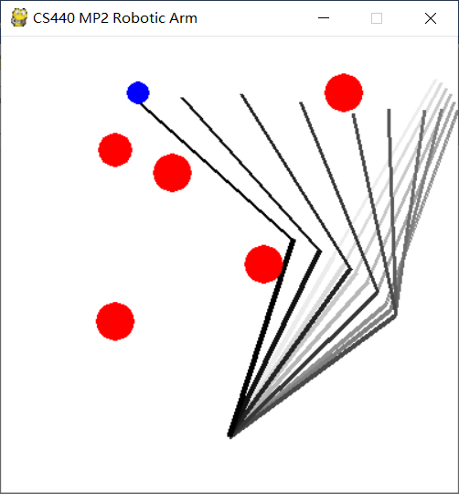

[Test3]

Window : (400, 400) # (Width, Height)

ArmBase : (200, 350) # (x-coordinate, y-coordinate)

ArmLinks : [

(180, 60, (0, 170)), # (length, initial angle, (min angle, max angle)

(150, 0, (-170, 170)),

]

Obstacles : [

(100, 100, 15),

(140, 120, 17),

(260, 150, 17),

(300, 50, 17),

(100, 250, 17)

]

Goals : [

(120, 50, 10) # (x-coordinate, y-coordinate, radius)

]

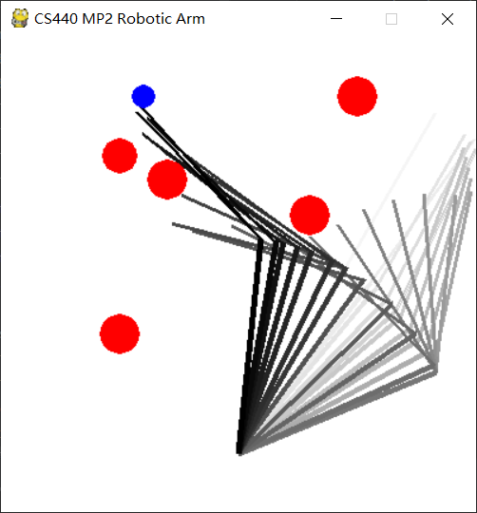

[Test3]

Window : (400, 400) # (Width, Height)

ArmBase : (200, 350) # (x-coordinate, y-coordinate)

ArmLinks : [

(180, 60, (0, 170)), # (length, initial angle, (min angle, max angle)

(100, 0, (-170, 170)),

(50, 0, (-170, 170)),

]

Obstacles : [

(100, 100, 15),

(140, 120, 17),

(260, 150, 17),

(300, 50, 17),

(100, 250, 17)

]

Goals : [

(120, 50, 10) # (x-coordinate, y-coordinate, radius)

]

