**STM32 CONFIGURACION GENERAL:**

**CONFIGURACION SYS LECTURA SERIAL**

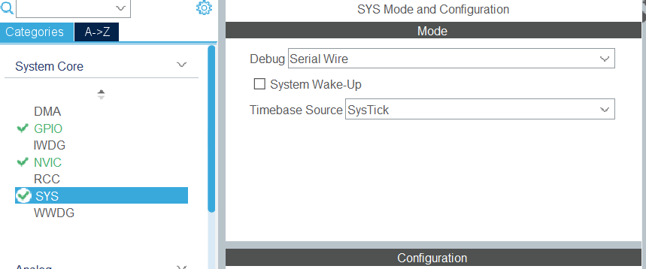

**CONFIGURACION CONNECTIVIDAD USART**

**CONFIGURACION TIM ENCODER**

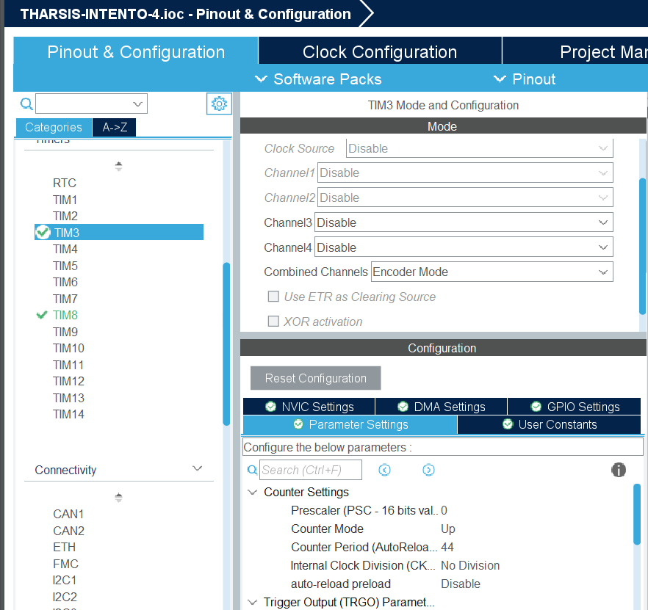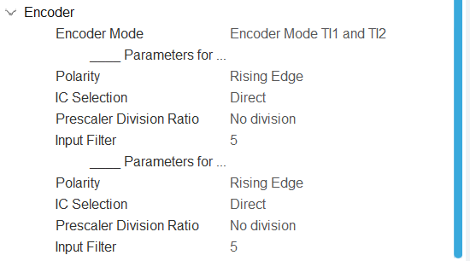

INPUT_FILTER: ES para encoder

**CONFIGURACION PINES PWM PARA MOTORES**

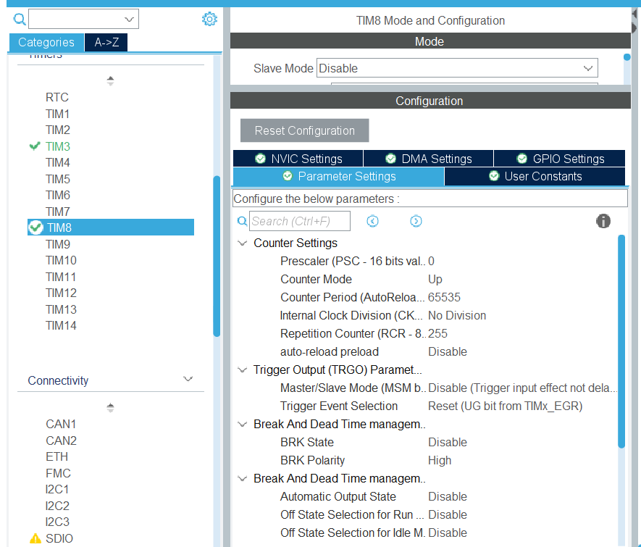

**CÓDIGO**

/* USER CODE BEGIN Header */

/**

******************************************************************************

* @file : main.c

* @brief : Main program body

******************************************************************************

* @attention

*

* Copyright (c) 2025 STMicroelectronics.

* All rights reserved.

*

* This software is licensed under terms that can be found in the LICENSE file

* in the root directory of this software component.

* If no LICENSE file comes with this software, it is provided AS-IS.

*

******************************************************************************

*/

/* USER CODE END Header */

/* Includes ------------------------------------------------------------------*/

**#include** "main.h"

/* Private includes ----------------------------------------------------------*/

/* USER CODE BEGIN Includes */

**#include** <stdio.h> // Para usar sprintf

**#include** <string.h> // Para usar memset

/* USER CODE END Includes */

/* Private typedef -----------------------------------------------------------*/

/* USER CODE BEGIN PTD */

/* USER CODE END PTD */

/* Private define ------------------------------------------------------------*/

/* USER CODE BEGIN PD */

/* USER CODE END PD */

/* Private macro -------------------------------------------------------------*/

/* USER CODE BEGIN PM */

/* USER CODE END PM */

/* Private variables ---------------------------------------------------------*/

**TIM_HandleTypeDef** htim3;

**TIM_HandleTypeDef** htim8;

**UART_HandleTypeDef** huart1;

/* USER CODE BEGIN PV */

**int32_t** full_rotations = 0; // Variable global para contar las vueltas completas

**uint32_t** previous_encoder_value = 0; // Valor anterior del encoder

**uint32_t** previous_time = 0; // Tiempo anterior en milisegundos

**float** speed_mps = 0; // Velocidad en m/s

**float** wheel_radius = 0.09; // Radio de la rueda en metros

**char** buffer[50]; // Buffer para almacenar la cadena de texto

/* USER CODE END PV */

/* Private function prototypes -----------------------------------------------*/

**void** **SystemClock_Config**(**void**);

**static** **void** **MX_GPIO_Init**(**void**);

**static** **void** **MX_TIM8_Init**(**void**);

**static** **void** **MX_TIM3_Init**(**void**);

**static** **void** **MX_USART1_UART_Init**(**void**);

/* USER CODE BEGIN PFP */

**int** **_write**(**int** file, **char** *ptr, **int** len) {

**HAL_UART_Transmit**(&huart1, (**uint8_t**\*)ptr, len, HAL_MAX_DELAY);

**return** len;

}

/* USER CODE END PFP */

/* Private user code ---------------------------------------------------------*/

/* USER CODE BEGIN 0 */

/* USER CODE END 0 */

/**

* @brief The application entry point.

* @retval int

*/

**int** **main**(**void**)

{

/* USER CODE BEGIN 1 */

/* USER CODE END 1 */

/* MCU Configuration--------------------------------------------------------*/

/* Reset of all peripherals, Initializes the Flash interface and the Systick. */

**HAL_Init**();

/* USER CODE BEGIN Init */

/* USER CODE END Init */

/* Configure the system clock */

**SystemClock_Config**();

/* USER CODE BEGIN SysInit */

/* USER CODE END SysInit */

/* Initialize all configured peripherals */

**MX_GPIO_Init**();

**MX_TIM8_Init**();

**MX_TIM3_Init**();

**MX_USART1_UART_Init**();

/* USER CODE BEGIN 2 */

**HAL_TIM_Encoder_Start**(&htim3, TIM_CHANNEL_ALL); // Inicia el encoder

**HAL_TIM_PWM_Start**(&htim8, TIM_CHANNEL_1);

TIM8->CCR1 =0;

/* USER CODE END 2 */

/* Infinite loop */

/* USER CODE BEGIN WHILE */

**HAL_TIM_PWM_Start**(&htim8,TIM_CHANNEL_1);

**while** (1)

{

**HAL_GPIO_WritePin**(GPIOD, GPIO_PIN_10, *GPIO_PIN_SET*);

// Variable para almacenar el valor de PWM ingresado

**uint16_t** pwm_value = 32767;

// Solicitar al usuario que ingrese el valor de PWM (0 a 65535)

// Aquí puedes usar una interfaz como UART, un teclado, o cualquier otro método de entrada.

// Por simplicidad, asumimos que el valor se ingresa manualmente en el código.

// Ejemplo: Cambia este valor manualmente para ajustar la velocidad del motor.

// pwm_value = 20000; // Por ejemplo, 50% del ciclo de trabajo

// Aplicar el valor de PWM al registro CCR1

TIM8->CCR1 = pwm_value;

// Mantener la velocidad del motor con el valor ingresado

**HAL_Delay**(1000); // Pequeño retardo para evitar cambios bruscos

// Lee el valor actual del contador del encoder

**uint32_t** encoder_value = TIM3->CNT;

// Calcula el cambio en la posición del encoder, teniendo en cuenta el desbordamiento

**int32_t** delta_pulses = (**int32_t**)(encoder_value - previous_encoder_value);

// Actualiza el valor anterior del encoder

previous_encoder_value = encoder_value;

// Ajusta delta_pulses si hay un desbordamiento

**if** (delta_pulses > 22) { // Si el cambio es mayor que la mitad del ARR (44/2 = 22)

delta_pulses -= 44; // Ajusta para manejar el desbordamiento negativo

} **else** **if** (delta_pulses < -22) { // Si el cambio es menor que la mitad negativa del ARR

delta_pulses += 44; // Ajusta para manejar el desbordamiento positivo

}

// Obtén el tiempo actual en milisegundos

**uint32_t** current_time = **HAL_GetTick**();

// Calcula el intervalo de tiempo (en segundos)

**float** delta_time = (current_time - previous_time) / 1000.0;

// Actualiza el tiempo anterior

previous_time = current_time;

// Calcula la velocidad en m/s

**float** delta_theta = delta_pulses * (2 * 3.14159265358979323846 / 44);

speed_mps = (delta_theta * wheel_radius) / delta_time;

// Imprime la velocidad en m/s

**printf**("Velocidad: %.2f m/s\r\n", speed_mps);

// Pequeño retardo para evitar saturar el terminal

**HAL_Delay**(100);

/* USER CODE END WHILE */

/* USER CODE BEGIN 3 */

}

/* USER CODE END 3 */

}

/**

* @brief System Clock Configuration

* @retval None

*/

**void** **SystemClock_Config**(**void**)

{

**RCC_OscInitTypeDef** RCC_OscInitStruct = {0};

**RCC_ClkInitTypeDef** RCC_ClkInitStruct = {0};

/** Configure the main internal regulator output voltage

*/

__HAL_RCC_PWR_CLK_ENABLE();

__HAL_PWR_VOLTAGESCALING_CONFIG(PWR_REGULATOR_VOLTAGE_SCALE1);

/** Initializes the RCC Oscillators according to the specified parameters

* in the RCC_OscInitTypeDef structure.

*/

RCC_OscInitStruct.OscillatorType = RCC_OSCILLATORTYPE_HSI;

RCC_OscInitStruct.HSIState = RCC_HSI_ON;

RCC_OscInitStruct.HSICalibrationValue = RCC_HSICALIBRATION_DEFAULT;

RCC_OscInitStruct.PLL.PLLState = RCC_PLL_ON;

RCC_OscInitStruct.PLL.PLLSource = RCC_PLLSOURCE_HSI;

RCC_OscInitStruct.PLL.PLLM = 8;

RCC_OscInitStruct.PLL.PLLN = 180;

RCC_OscInitStruct.PLL.PLLP = RCC_PLLP_DIV2;

RCC_OscInitStruct.PLL.PLLQ = 4;

**if** (**HAL_RCC_OscConfig**(&RCC_OscInitStruct) != *HAL_OK*)

{

**Error_Handler**();

}

/** Activate the Over-Drive mode

*/

**if** (**HAL_PWREx_EnableOverDrive**() != *HAL_OK*)

{

**Error_Handler**();

}

/** Initializes the CPU, AHB and APB buses clocks

*/

RCC_ClkInitStruct.ClockType = RCC_CLOCKTYPE_HCLK|RCC_CLOCKTYPE_SYSCLK

|RCC_CLOCKTYPE_PCLK1|RCC_CLOCKTYPE_PCLK2;

RCC_ClkInitStruct.SYSCLKSource = RCC_SYSCLKSOURCE_PLLCLK;

RCC_ClkInitStruct.AHBCLKDivider = RCC_SYSCLK_DIV1;

RCC_ClkInitStruct.APB1CLKDivider = RCC_HCLK_DIV4;

RCC_ClkInitStruct.APB2CLKDivider = RCC_HCLK_DIV2;

**if** (**HAL_RCC_ClockConfig**(&RCC_ClkInitStruct, FLASH_LATENCY_5) != *HAL_OK*)

{

**Error_Handler**();

}

}

/**

* @brief TIM3 Initialization Function

* @param None

* @retval None

*/

**static** **void** **MX_TIM3_Init**(**void**)

{

/* USER CODE BEGIN TIM3_Init 0 */

/* USER CODE END TIM3_Init 0 */

**TIM_Encoder_InitTypeDef** sConfig = {0};

**TIM_MasterConfigTypeDef** sMasterConfig = {0};

/* USER CODE BEGIN TIM3_Init 1 */

/* USER CODE END TIM3_Init 1 */

htim3.Instance = TIM3;

htim3.Init.Prescaler = 0;

htim3.Init.CounterMode = TIM_COUNTERMODE_UP;

htim3.Init.Period = 44;

htim3.Init.ClockDivision = TIM_CLOCKDIVISION_DIV1;

htim3.Init.AutoReloadPreload = TIM_AUTORELOAD_PRELOAD_DISABLE;

sConfig.EncoderMode = TIM_ENCODERMODE_TI12;

sConfig.IC1Polarity = TIM_ICPOLARITY_RISING;

sConfig.IC1Selection = TIM_ICSELECTION_DIRECTTI;

sConfig.IC1Prescaler = TIM_ICPSC_DIV1;

sConfig.IC1Filter = 5;

sConfig.IC2Polarity = TIM_ICPOLARITY_RISING;

sConfig.IC2Selection = TIM_ICSELECTION_DIRECTTI;

sConfig.IC2Prescaler = TIM_ICPSC_DIV1;

sConfig.IC2Filter = 5;

**if** (**HAL_TIM_Encoder_Init**(&htim3, &sConfig) != *HAL_OK*)

{

**Error_Handler**();

}

sMasterConfig.MasterOutputTrigger = TIM_TRGO_RESET;

sMasterConfig.MasterSlaveMode = TIM_MASTERSLAVEMODE_DISABLE;

**if** (**HAL_TIMEx_MasterConfigSynchronization**(&htim3, &sMasterConfig) != *HAL_OK*)

{

**Error_Handler**();

}

/* USER CODE BEGIN TIM3_Init 2 */

/* USER CODE END TIM3_Init 2 */

}

/**

* @brief TIM8 Initialization Function

* @param None

* @retval None

*/

**static** **void** **MX_TIM8_Init**(**void**)

{

/* USER CODE BEGIN TIM8_Init 0 */

/* USER CODE END TIM8_Init 0 */

**TIM_MasterConfigTypeDef** sMasterConfig = {0};

**TIM_OC_InitTypeDef** sConfigOC = {0};

**TIM_BreakDeadTimeConfigTypeDef** sBreakDeadTimeConfig = {0};

/* USER CODE BEGIN TIM8_Init 1 */

/* USER CODE END TIM8_Init 1 */

htim8.Instance = TIM8;

htim8.Init.Prescaler = 0;

htim8.Init.CounterMode = TIM_COUNTERMODE_UP;

htim8.Init.Period = 65535;

htim8.Init.ClockDivision = TIM_CLOCKDIVISION_DIV1;

htim8.Init.RepetitionCounter = 255;

htim8.Init.AutoReloadPreload = TIM_AUTORELOAD_PRELOAD_DISABLE;

**if** (**HAL_TIM_PWM_Init**(&htim8) != *HAL_OK*)

{

**Error_Handler**();

}

sMasterConfig.MasterOutputTrigger = TIM_TRGO_RESET;

sMasterConfig.MasterSlaveMode = TIM_MASTERSLAVEMODE_DISABLE;

**if** (**HAL_TIMEx_MasterConfigSynchronization**(&htim8, &sMasterConfig) != *HAL_OK*)

{

**Error_Handler**();

}

sConfigOC.OCMode = TIM_OCMODE_PWM1;

sConfigOC.Pulse = 0;

sConfigOC.OCPolarity = TIM_OCPOLARITY_HIGH;

sConfigOC.OCNPolarity = TIM_OCNPOLARITY_HIGH;

sConfigOC.OCFastMode = TIM_OCFAST_DISABLE;

sConfigOC.OCIdleState = TIM_OCIDLESTATE_RESET;

sConfigOC.OCNIdleState = TIM_OCNIDLESTATE_RESET;

**if** (**HAL_TIM_PWM_ConfigChannel**(&htim8, &sConfigOC, TIM_CHANNEL_1) != *HAL_OK*)

{

**Error_Handler**();

}

sBreakDeadTimeConfig.OffStateRunMode = TIM_OSSR_DISABLE;

sBreakDeadTimeConfig.OffStateIDLEMode = TIM_OSSI_DISABLE;

sBreakDeadTimeConfig.LockLevel = TIM_LOCKLEVEL_OFF;

sBreakDeadTimeConfig.DeadTime = 0;

sBreakDeadTimeConfig.BreakState = TIM_BREAK_DISABLE;

sBreakDeadTimeConfig.BreakPolarity = TIM_BREAKPOLARITY_HIGH;

sBreakDeadTimeConfig.AutomaticOutput = TIM_AUTOMATICOUTPUT_DISABLE;

**if** (**HAL_TIMEx_ConfigBreakDeadTime**(&htim8, &sBreakDeadTimeConfig) != *HAL_OK*)

{

**Error_Handler**();

}

/* USER CODE BEGIN TIM8_Init 2 */

/* USER CODE END TIM8_Init 2 */

**HAL_TIM_MspPostInit**(&htim8);

}

/**

* @brief USART1 Initialization Function

* @param None

* @retval None

*/

**static** **void** **MX_USART1_UART_Init**(**void**)

{

/* USER CODE BEGIN USART1_Init 0 */

/* USER CODE END USART1_Init 0 */

/* USER CODE BEGIN USART1_Init 1 */

/* USER CODE END USART1_Init 1 */

huart1.Instance = USART1;

huart1.Init.BaudRate = 115200;

huart1.Init.WordLength = UART_WORDLENGTH_8B;

huart1.Init.StopBits = UART_STOPBITS_1;

huart1.Init.Parity = UART_PARITY_NONE;

huart1.Init.Mode = UART_MODE_TX_RX;

huart1.Init.HwFlowCtl = UART_HWCONTROL_NONE;

huart1.Init.OverSampling = UART_OVERSAMPLING_16;

**if** (**HAL_UART_Init**(&huart1) != *HAL_OK*)

{

**Error_Handler**();

}

/* USER CODE BEGIN USART1_Init 2 */

/* USER CODE END USART1_Init 2 */

}

/**

* @brief GPIO Initialization Function

* @param None

* @retval None

*/

**static** **void** **MX_GPIO_Init**(**void**)

{

**GPIO_InitTypeDef** GPIO_InitStruct = {0};

/* USER CODE BEGIN MX_GPIO_Init_1 */

/* USER CODE END MX_GPIO_Init_1 */

/* GPIO Ports Clock Enable */

__HAL_RCC_GPIOA_CLK_ENABLE();

__HAL_RCC_GPIOD_CLK_ENABLE();

__HAL_RCC_GPIOC_CLK_ENABLE();

/*Configure GPIO pin Output Level */

**HAL_GPIO_WritePin**(GPIOD, GPIO_PIN_10, *GPIO_PIN_RESET*);

/*Configure GPIO pin : PD10 */

GPIO_InitStruct.Pin = GPIO_PIN_10;

GPIO_InitStruct.Mode = GPIO_MODE_OUTPUT_PP;

GPIO_InitStruct.Pull = GPIO_NOPULL;

GPIO_InitStruct.Speed = GPIO_SPEED_FREQ_LOW;

**HAL_GPIO_Init**(GPIOD, &GPIO_InitStruct);

/* USER CODE BEGIN MX_GPIO_Init_2 */

/* USER CODE END MX_GPIO_Init_2 */

}

/* USER CODE BEGIN 4 */

/* USER CODE END 4 */

/**

* @brief This function is executed in case of error occurrence.

* @retval None

*/

**void** **Error_Handler**(**void**)

{

/* USER CODE BEGIN Error_Handler_Debug */

/* User can add his own implementation to report the HAL error return state */

**__disable_irq**();

**while** (1)

{

}

/* USER CODE END Error_Handler_Debug */

}

**#ifdef** USE_FULL_ASSERT

/**

* @brief Reports the name of the source file and the source line number

* where the assert_param error has occurred.

* @param file: pointer to the source file name

* @param line: assert_param error line source number

* @retval None

*/

**void** assert_failed(uint8_t *file, uint32_t line)

{

/* USER CODE BEGIN 6 */

/* User can add his own implementation to report the file name and line number,

ex: printf("Wrong parameters value: file %s on line %d\r\n", file, line) */

/* USER CODE END 6 */

}

**#endif** /* USE_FULL_ASSERT */