SERVER-SIDE MODULE

CONTENTS

This module has the following files:
- MODULE_SERVER_SIDE.doc
- MODULE_SEVER_SIDE_MEDIA.zip

INTRODUCTION
A car sales company wants to sell cars to many types of people. not all people can buy a car with cash. So the company appoints you as a competent person to create an instalment cars platform.
The goal of this platform is for people to make car instalment transactions online.

DESCRIPTION OF PROJECTS AND TASKS
Registration involves the society platform (registering to the platform and applying for instalment), the company platform (giving instalment cars, viewing and accepting/rejecting registrations from the instalment), and the officer platform (updating company data, checking the validity of society data).
This module is divided into two phases. In the first phase, you will create a REST API. In the second phase, you will build a frontend application. You must use the provided frameworks:
- Laravel (v11.x)
- React (v18.x with react-router-dom and axios)
- Vue (v3.x with vue-router and axios)

Phase one – Society Car instalment REST API

Authentication
Before a society performs any activity on the society platform, they must be logged in using their ID card number and password. Sanctum should be used to create tokens. The generated token will be used to access all available endpoints.

Specifications :
Feature: A1 - Login and Logout as society: as a visitor, i want to login so that i can enter the system and apply for Instalment.
Scenario: Society Login
Request:
URL: [domain]/api/v1/auth/login
Method: POST
Header:
Body: { id_card_number: “SomeText”, password: “SomeText” }
Response:
A1a - If login success
Header: Response code: 200
Body: {
"name": "Doni Rianto",
"born_date": "1974-10-22",
"gender": "male"|”female”,
"address": "Ki. Raya Setiabudhi No. 790",
"token": "1|qgV2cTisoRVSwX6R2iPpxd..",
"regional": {
"id": 1,
"province": "DKI Jakarta",
"district": "Central Jakarta"
}
}
A1b - If ID Card Number or Password incorrect
Header: Response code: 401
Body: { "message": "ID Card Number or Password incorrect" }

Scenario: Society Logout
Request:
URL: [domain]/api/v1/auth/logout
Params:
Method: POST
Header: { Authorization: Bearer xxxxxx }
Body:
Response:
A1c - If logout success
Header: Response code: 200
Body: { "message": "Logout success" }
A1d - If logout invalid token
Header: Response code: 401
Body: { "message": "Invalid token" }

Request Data Validation
To be able to apply for Instalment, the society must do validation data on the platform first. The society can view validity status and make validation requests. The society can only make one validation data request.

Specifications:
Feature: A2 - Request Data Validation: As a society, I want to request data validation so that I can apply for instalment when my data validation is accepted.
Scenario: Request data validations
Request:
URL: [domain]/api/v1/validation
Params:
Method: POST
Header:{ Authorization: Bearer xxxxxx }
Body: { job: “SomeText”, job_description: “SomeText”, income: “SomeText” , reason_accepted: “SomeText” }
Response:
A2a - If request data validation success
Header: Response code: 200
Body: { "message": "Request data validation sent successful" }
A2b - If invalid token
Header: Response code: 401
Body: { "message": "Unauthorized user" }

Scenario: Get society data validation
Request:
URL: [domain]/api/v1/validations
Params:
Method: GET
Header: { Authorization: Bearer xxxxxx }
Body:
Response:
A2c - If success
Header: Response code: 200
Body: {
“validation”: {
"id": 1,
"status": "pending”|”accepted”|”rejected",
"job": "SomeText”|null,
"job_description": "SomeText"|null,
"income": "SomeText"|null,
"reason_accepted": “SomeText”|null,
"validator_notes": “SomeText”|null,
"validator": { VALIDATOR }|null
}
}
A2d - If invalid token
Header: Response code: 401
Body: {"message": "Unauthorized user"}

Instalment
When the validation data has been accepted by the validator and society will apply for instalment cars, the society can choose the cas based on the income that has been entered during data validation. List of available cars at each brand should also be displayed.
In the car's detail, it can calculate the price to be paid each month.
Specifications:
Feature: A3 – Instalment: As a society, I want to see a list of Instalment cars.

Scenario: Get all Instalment cars
Request:
URL: [domain]/api/v1/instalment_cars
Params:
Method: GET
Header: { Authorization: Bearer xxxxxx }
Body:
Response:
A3a - If success
Header: Response code: 200
Body: {
"cars": [
{
"id": 1,
"car": " Toyota FT 86",
"brand": " Toyota",
"price": "900000000",
"description": " Toyota FT 86 car is the best",
"available_month": [
{
"month": 12,
"description": "12 Months",
},
...,
]
},
...,
]
}
A3b - If invalid token
Header: Response code: 401
Body: { "message": "Unauthorized user" }

Scenario: Get Instalment detail by instalment ID
Request:
URL: /api/v1/instalment_cars/<id>
Params: { id }
Method: GET
Header: { Authorization: Bearer xxxxxx }
Body:
Response:
A3c - If success
Header: Response code: 200
Body: {
"instalment": {
"id": 1,
"car": " Toyota FT 86",
"brand": " Toyota",
"price": "900000000",
"description": " Toyota FT 86 car is the
best",
"available_month": [
{
"month": 12,
"description": "12 Months",
},
...,
]
},
}

A3d - If invalid token
Header: Response code: 401
Body: { "message": "Unauthorized user" }

Applying for instalment
The society can apply for an Instalment if the validation data has been accepted by the validator.
Application for an Instalment can only be once.
Instalment ID and position must be filled.

Specifications:
Feature: A4 – Applying for Instalment: as a society, i want to applying for Instalment.
Scenario: Applying for instalment
Request:
URL: /api/v1/applications
Params:
Method: POST
Header: { Authorization: Bearer xxxxxx }
Body: { instalment_id: 1, months: 12, notes : “SomeText” }
Response:
A4a - If success
Header: Response code: 200
Body: { "message": "Applying for Instalment successful" }
A4b - If invalid token
Header: Response code: 401
Body: { "message": "Unauthorized user" }
A4c - If the society validation data hasn’t accepted by validator
Header: Response code: 401
Body: { "message": "Your data validator must be accepted by validator before" }
A4d - If invalid fields
Header: Response code: 401
Body: {
"message": "Invalid field",
"errors": {
"instalment_id": [
"The instalment id field is required."
],
"months": [
"The months field is required."
]
}
}
A4e - If have been 2x applying
Header: Response code: 401
Body: { "message": " Application for a instalment can only be once" }

Scenario: Get all of society instalment applications
Request:
URL: [domain]/api/v1/applications
Params:
Method: GET
Header: { Authorization: Bearer xxxxxx }
Body: Response:
A4f - If success
Header: Response code: 200
Body: {
"instalments": [
{
"id": 1,
"car": " Toyota FT 86",
"brand": " Toyota",
"price": "900000000",
"description": " Toyota FT 86 car is the
best",
"applications": [
{
"month": "12",
"nominal": "75000000",
"apply_status": "pending”|”accepted”|”rejected",
"notes": "I want this cars",
},
...,
]
},
...,
]
}

A4g - If invalid token
Header: Response code: 401
Body: { "message": "Unauthorized user" }

POSTMAN Collection
You have to create a postman collection to check the API that has been created. An example is as follows:
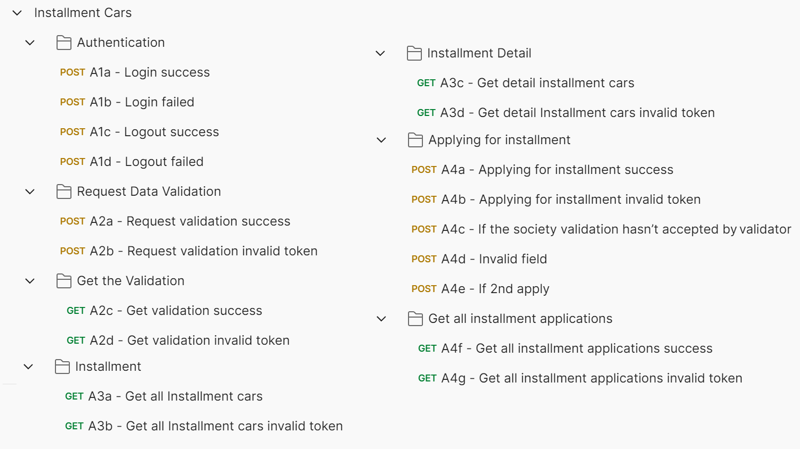

Phase two - Society instalment Cars Platform (Frontend)
In this phase, you can use the gui template provided in the media files to build a society platform. Use the REST API following the REST API you created before.
Implement REST API into the frontend. All response formats must be in JSON form.

Society login and logout
To be able to enter the system, the society must first login using the ID card number and password. When the society has entered the system, the logout button will appear, and the society can exit the system by clicking the logout button
Specifications:
Feature: B1 - Society login and logout: as a visitor, i want to login into society instalment cars platform and logout to exit the system.

Scenario: B1a - Society login success
Given I am on the login page
And I enter correct id_card_number and password
Then I redirected to society dashboard page
Scenario: B1b - Society login fails
Given I am on the login page
And I enter wrong id_card_number or password
Then I stay in the login page and I see error message “ID Card Number or Password incorrect”
Scenario: B1c - Society logout success
Given I am on the any page that has been logged in
And I press logout button
Then I get message “logout success” and redirected to login page
And I cannot reach the previous page by going back

Society Dashboard
In the dashboard page, there are two sections, data validation and instalment cars section. where the society must request a data validation and the data validation is approved by the validator to be able to register for instalment cars application.

Specifications:
Feature: B2 - Society Dashboard: as a society, i want to see data validation info and my instalment applications list in the dashboard page.
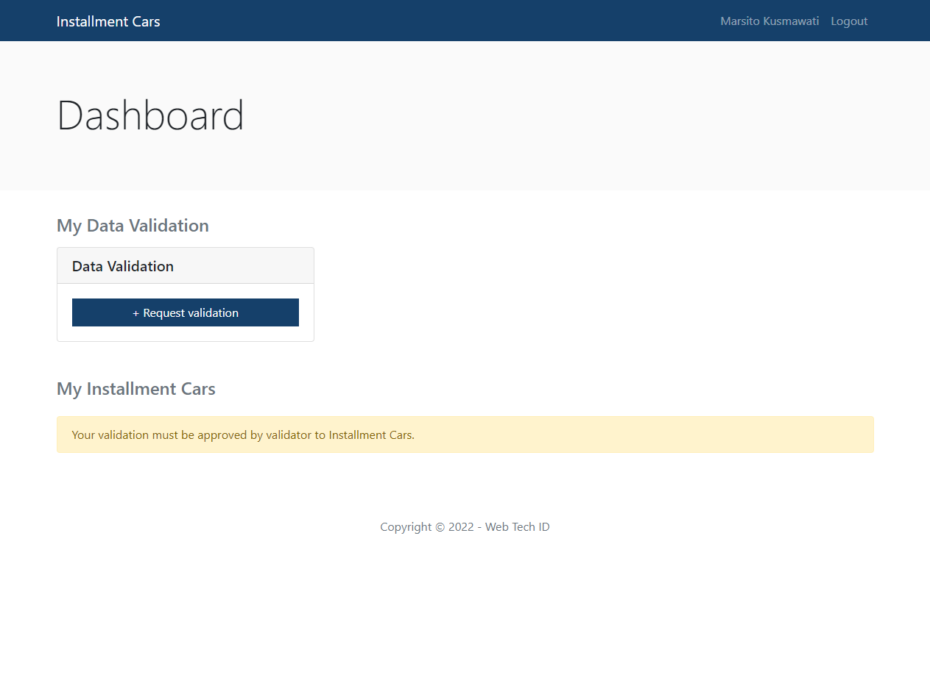
Scenario: B2a – Data validation section is displayed
Given I am on dashboard page
Then I see the data validation section with “My Data validation” title
Scenario: B2b - Link to request data validation appears when society hasn’t data validation before
Given I am on dashboard page
And I haven’t request data validation before
Then I see request data validation link in the data validation section
Scenario: B2c - Show data validation info
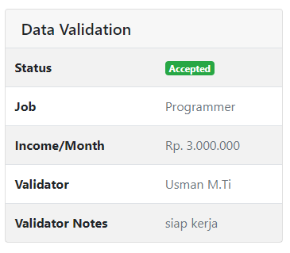
Given I am on dashboard page
And my request data validation is sent or accepted/rejected by validator
Then I see data validation info in the data validation section

Scenario: B2d - instalment cars application list section is displayed
Given I am on dashboard page
Then I see the instalment cars application list section with “instalment applications” title

Scenario: B2e - Show instalment cars application info message
Given I am on dashboard page
And I haven’t request data validation before
Then I see “Your data validation must be approved by validator to get the applying instalment” in the instalment cars application list section

Scenario: B2f - The car instalment application is displayed when society data validation have been accepted by validator
Given I am on dashboard page
And I my request data validation has been accepted by validator
Then I see the instalment cars application with link is displayed in the instalment cars application list section
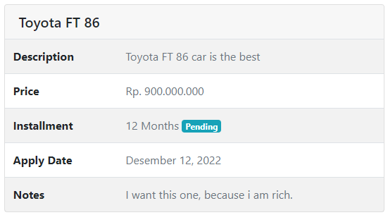
Given I am on dashboard page
And my instalment cars application is finished
Scenario: B2h - The instalment applications show instalment cars application info correctly when instalment cars application is finished
Given I am on dashboard page
Then I see instalment cars application info (cars, total months, apply date, notes) in the instalment cars application box

Request Data validation
In the data validation request page, the society can fill in the job, job description and income if they have by selecting "Yes, I have" in the dropdown. Are you working? question and they can send a request if the reason accepted has been filled.

Specifications :
Feature: B3 - Society Data validation: as a society, I want to request data validation.
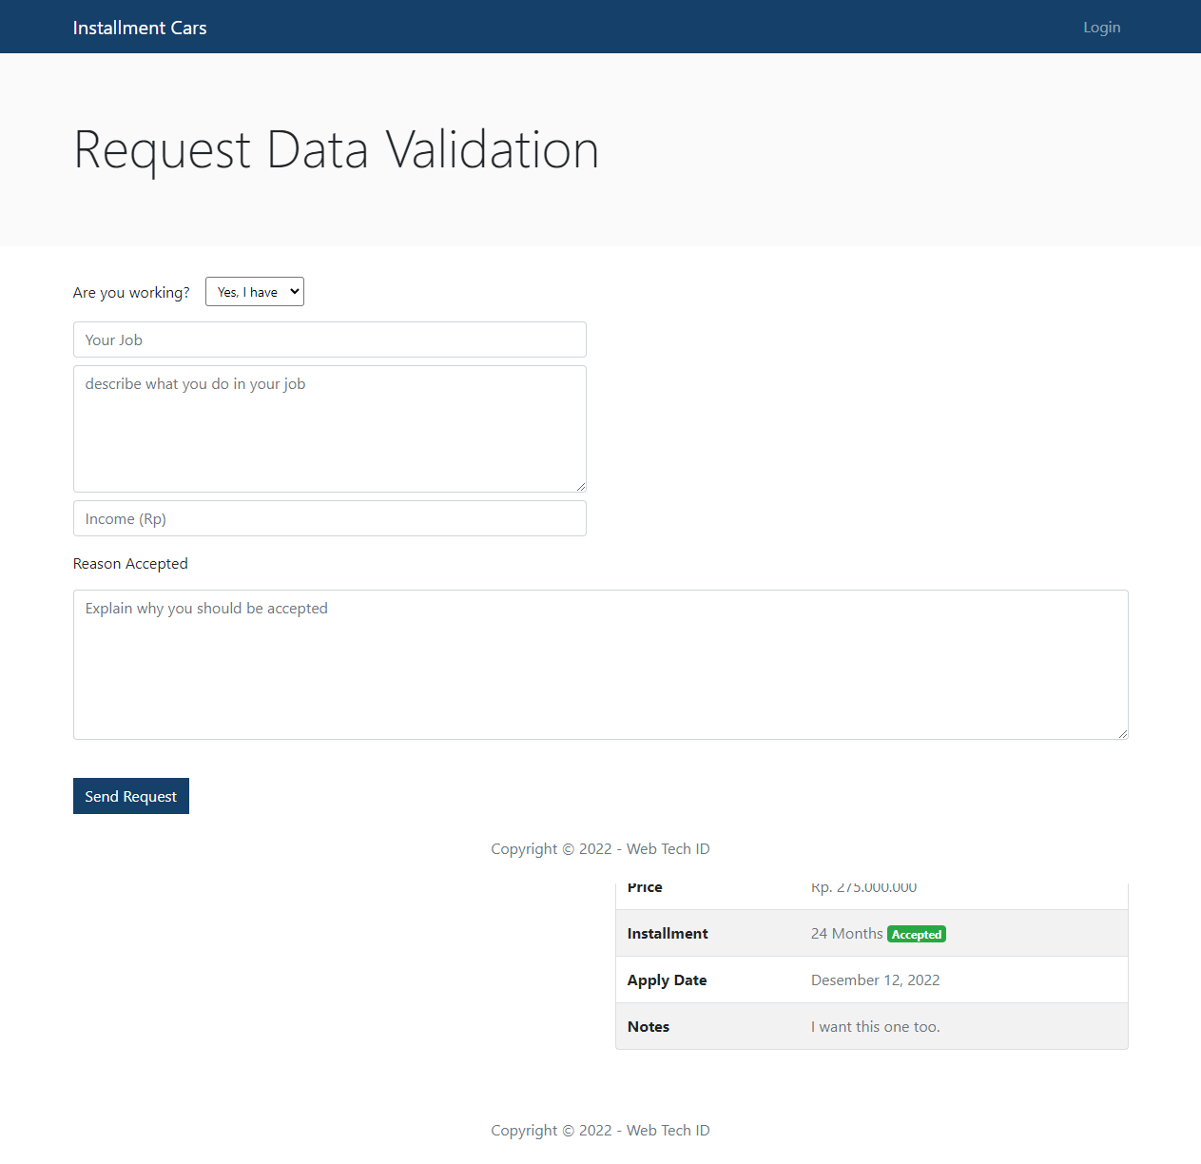
Scenario: B3a - Data validation form is displayed correctly
When I press “Send Request” button in the dashboard page
Then I see the data validation form (job, job description, income, reason accepted) is displayed

Scenario: B3b - Request data validation successful
Given I am on request data validation page
And I press request button
Then the request data validation is sent, the “Request data validation successful” message is appear, and I redirected to dashboard page

instalment Cars List
When the society registers for instalment cars application by pressing the "Add instalment cars application" button on the dashboard page, the society is directed to the list instalment Cars page to select instalment Cars. In the item instalment Cars, display the applying instalment available in those cars correctly.

Specifications :
Feature: B4 - instalment Cars List: as a society, I want to see a list of all instalment Cars.
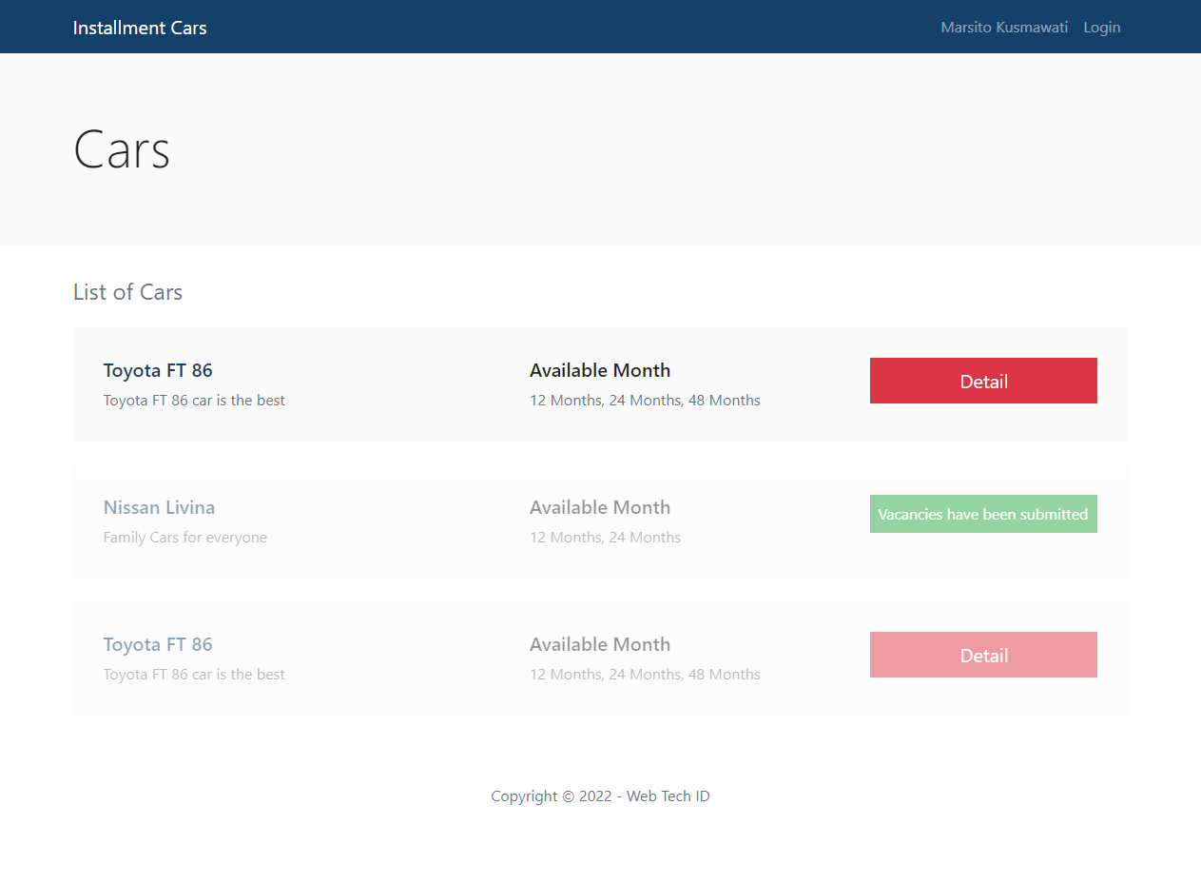

Scenario: B4a - Show list instalment Cars
Given I am on instalment Cars list page
Then I see a list of instalment Cars
Scenario: B4b - Show information for each instalment Cars
Given I am on instalment Cars page
Then I see instalment information (car name, description, available month) in each instalment item.

Scenario: B4c – instalment item unavailable when the instalment has been apply before.

Detail instalment
In the instalment detail page, there are details of instalment shown like car name, address, car description, available months. Society can apply instalment by filling months and notes for application.
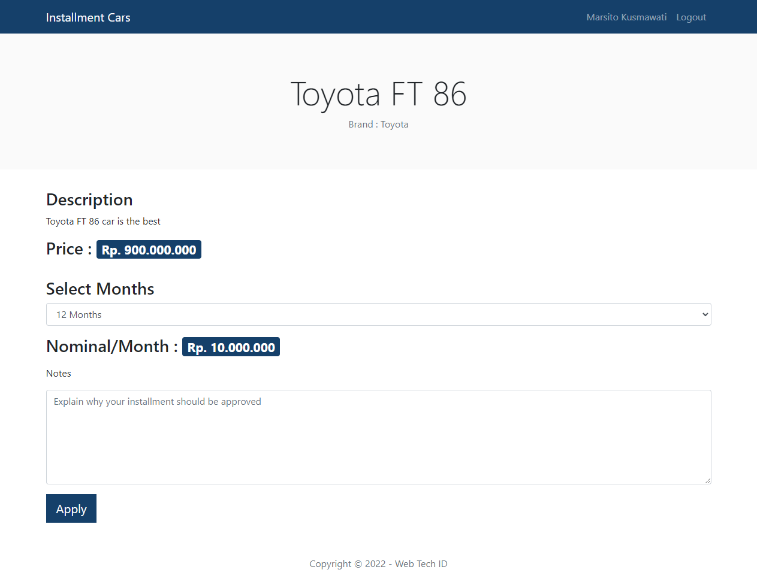

Specifications :
Feature: B5 - Detail Instalment: as a society, I want to see details of Instalment and see available months.

Scenario: B5a - Information displays correctly
Given I am on instalment detail page
Then I see the section with available moths and calculate the price to be paid each month.

Scenario: B5b - Can apply for a instalment if the income equal or exceed the calculation per month
Given I am on instalment detail page
Then I see available months and calculate the price to be paid each month

Scenario: B5c - Register instalment cars application
Given I am on instalment detail page
I choose total months
I fill the Notes for instalment field
And I press “Apply” button
Then the success or error message is appear and I redirected to dashboard page

Notes:
- For each response from the REST API must be displayed.
- Build the frontend into production mode first before your frontend project is pushed and the REST API must be consumed from your API before.

ERD
You can make your own ERD according to your needs. bellow is an example of ERD:
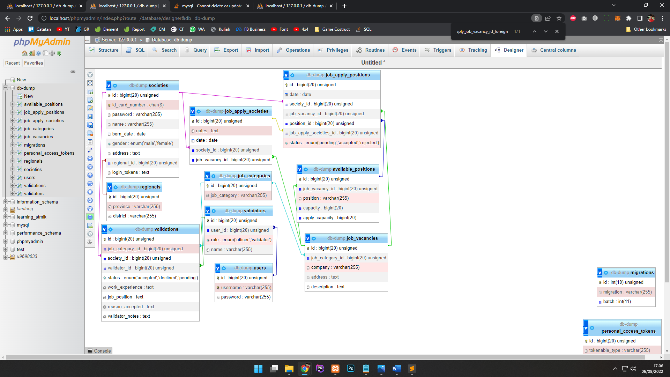

INSTRUCTION FOR COMPETITORS

- You may create additional endpoints if necessary, but you must fulfil all of the requirements listed above.
- You can add additional fields to the response body if needed, but ensure that all required fields are included and the structure is displayed correctly.
- Create a root folder called XX_SERVER_MODULE in your local computer, where XX is your computer number.
- Created Postman Collection, Database (db-dump.sql) and ER diagram (db-diagram.pdf) should be exported and saved under the root folder <host>/XX_SERVER_MODULE
- REST API should be reached on <host>/XX_SERVER_MODULE/BACKEND where xx is PC number. No port and no /public suffix path.
- Frontend app should be reached on <host>/XX_SERVER_MODULE/FRONTEND.
- Zip root folder XX_SERVER_MODULE and submit to the submission page. Make sure to exclude the vendor and node_modules folder when zipping files.

