AI-Powered Customer Support Conversational Assistant

1. Introduction
With the rapid growth of e-commerce platforms, customers expect instant and accurate responses to their queries regarding products, prices, discounts, and availability. Traditional rule-based chatbots are limited and fail to handle follow-up questions or contextual conversations.
This project presents an AI-powered conversational assistant designed for Customer Support, capable of answering domain-specific questions using Natural Language Processing (NLP) techniques and an optional LLM (ChatGPT) interface for enhanced response quality.

2. Problem Statement
Intelligent Conversational Assistant
Develop a chatbot that:
- Answers domain-specific FAQs reliably
- Handles follow-up questions
- Responds politely to unknown or irrelevant queries
- Uses NLP or LLM techniques
- Provides an API-based backend

3. Project Objective
The main objectives of this project are:
- To build a customer support chatbot for e-commerce websites
- To understand and respond to natural language queries
- To handle conversational context and follow-up questions
- To provide accurate, non-hallucinated responses
- To demonstrate practical NLP and conversational AI concepts

4. System Overview
The system works in the following stages:
- Data Collection
Product data is scraped from e-commerce websites (Shopify collections) and stored in CSV format.
- Preprocessing
  - Text cleaning
  - Lemmatization
  - Stopword removal
  - Extractive summarization
- Intent Detection
User queries are classified into intents such as:
  - Price
  - Discount
  - Stock availability
  - Product details
  - General information
- Information Retrieval
TF-IDF vectorization and cosine similarity are used to retrieve the most relevant products.
- Response Generation
  - Rule-based NLP responses for accuracy
  - Optional ChatGPT integration for natural language formatting
- Conversation Handling
Session memory is used to handle follow-up queries.
5. Architecture Diagram (Textual Representation)
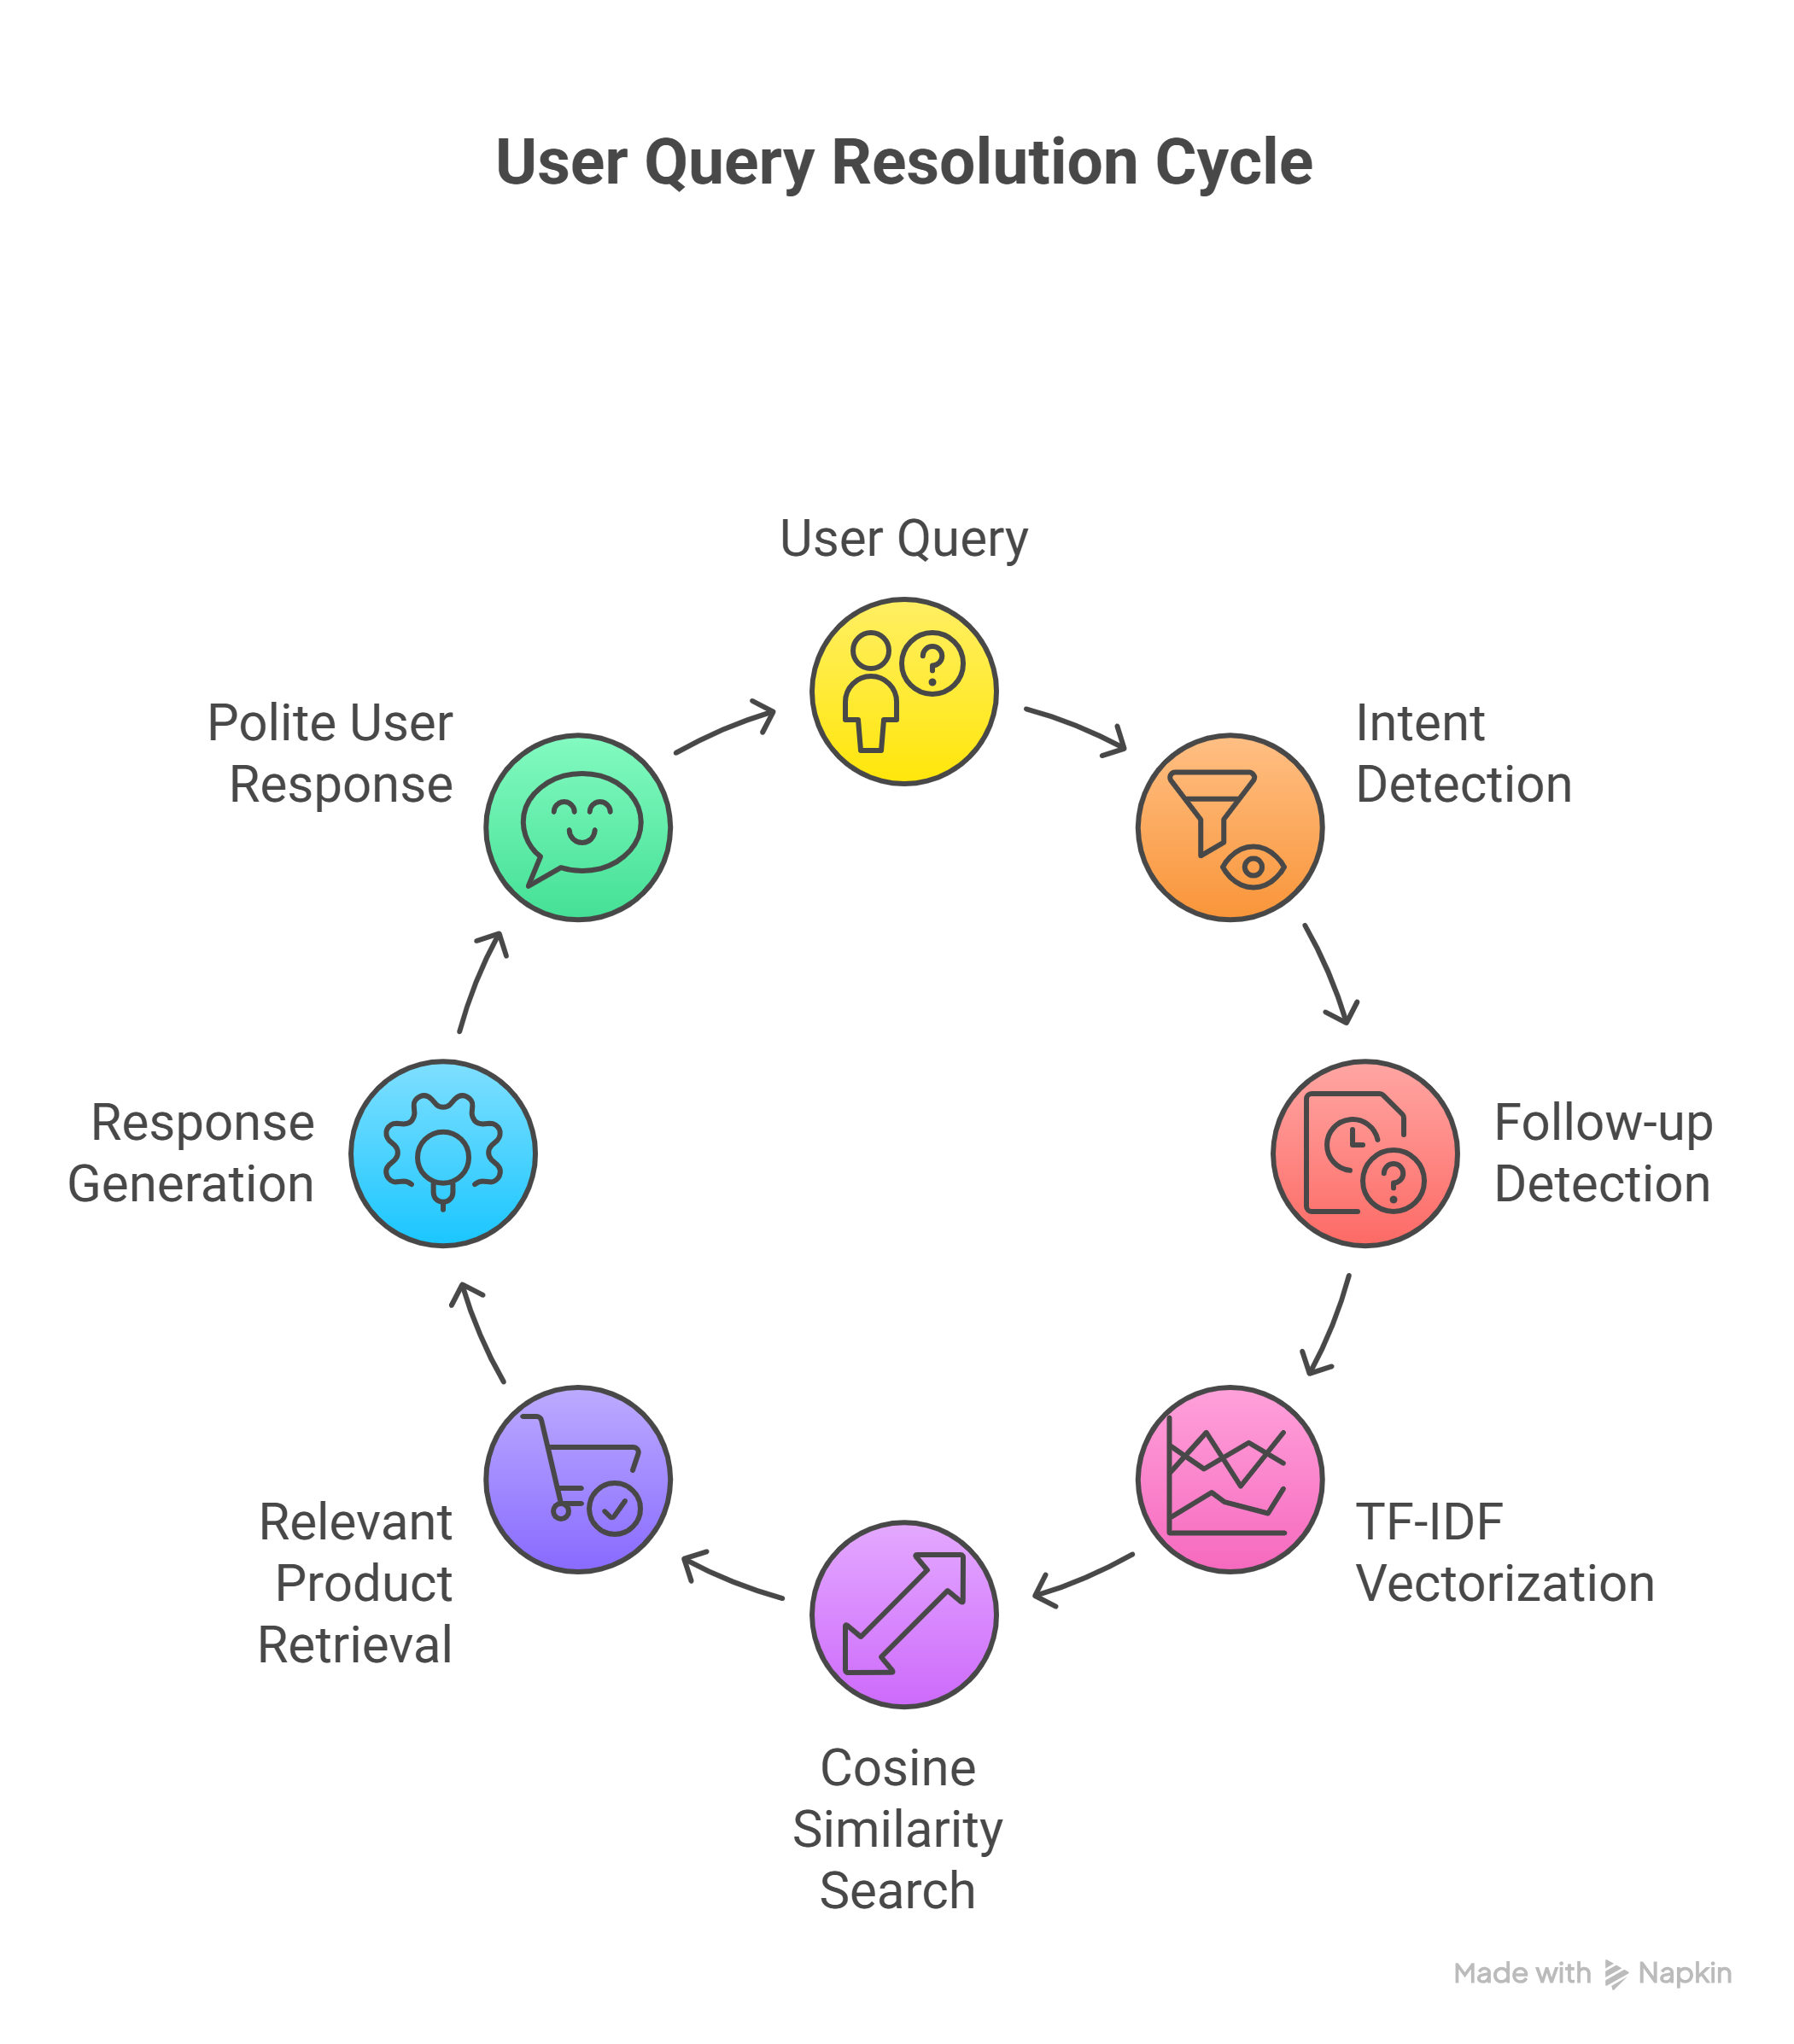
6. Technologies Used
Programming Language
- Python 3.x
Libraries and Frameworks
- Flask (API backend)
- Flask-SocketIO (WebSocket communication)
- NLTK (text preprocessing)
- Scikit-learn (TF-IDF & cosine similarity)
- Pandas & NumPy (data handling)
- BeautifulSoup & Requests (web scraping)
- Schedule & Threading (background jobs)
- OpenAI API (ChatGPT integration – optional)

7. Key Features
7.1 FAQ Answering
The chatbot answers common customer queries such as:
- “What is the price of this product?”
- “Is it in stock?”
- “What discount is available?”
7.2 Follow-Up Question Handling
The chatbot remembers the previously discussed product and can respond to:
- “What about discount?”
- “Is it available?”
- “Tell me more details”
7.3 Polite Fallback Responses
For irrelevant or unknown queries, the chatbot responds politely without crashing.
7.4 Hybrid NLP + LLM Approach
- NLP ensures accuracy and prevents hallucination
- ChatGPT improves response fluency and user experience
8. API Design
WebSocket Events
- run-scrape – Scrape product data
- query_with_inputs – Ask questions
- reset_session – Clear conversation context
- health – Server status check
Backend Type
- API-based backend using Flask and WebSocket
9. Sample Conversation
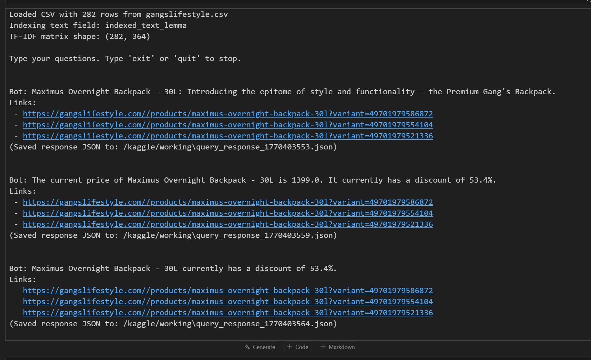
10. Error Handling
- Invalid URLs are safely rejected
- Missing or empty datasets are handled gracefully
- Low similarity queries trigger fallback responses
- Session resets are supported

11. Evaluation Criteria Mapping
Evaluation Focus | Implementation
Conversational Logic | Session memory & follow-ups
Response Quality | Intent-based + LLM responses
Error Handling | Robust fallbacks & validation

12. Limitations
- Voice input/output not implemented (text-based only)
- Performance depends on dataset size
- LLM usage requires internet and API key

13. Future Enhancements
- Voice-based chatbot integration
- Multilingual support
- Deep learning–based intent classification
- Frontend UI (React / Web App)
- Analytics dashboard for queries

14. Conclusion
This project successfully demonstrates the design and implementation of an AI-powered customer support conversational assistant using NLP and modern AI techniques. It satisfies all requirements of the given problem statement and showcases practical applications of conversational AI in real-world scenarios.

