**2.5.2**

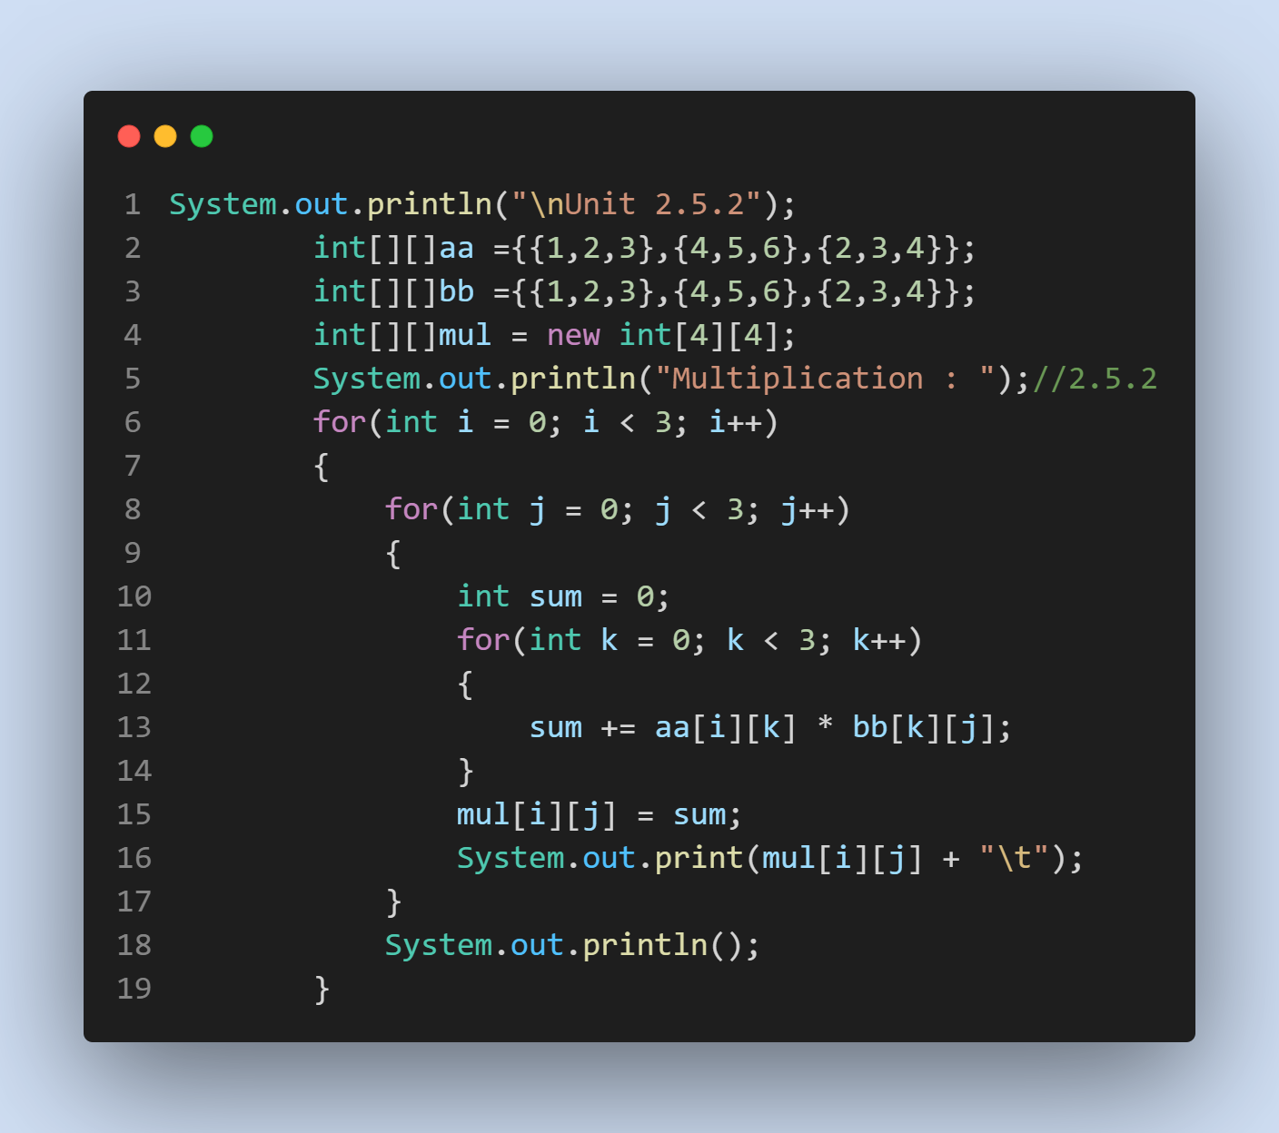**OUTPUT**

