DEVELOPMENT of SEMI-HUMANOID ASSISTANT ROBOT

A Major Project Report
Submitted in partial fulfillment of the requirements for the award of the degree of
BACHELOR OF TECHNOLOGY
in
Electrical and Electronics Engineering by
Aryan Sameer - 22071A0213
Durgamadhaba Panda - 22071A0214
Khushi Sharma - 22071A0226
Under the guidance of
Dr. Rashmi Kapoor
Sr. Assistant Professor


Department of Electrical & Electronics Engineering
VNR VIGNANA JYOTHI INSTITUTE OF ENGINEERING & TECHNOLOGY
AN AUTONOMOUS INSTITUTE
Pragathi Nagar, Nizampet (S.O), Hyderabad September 2025

VNR VIGNANA JYOTHI INSTITUTE OF ENGINEERING & TECHNOLOGY AN AUTONOMOUS INSTITUTE

Pragathi Nagar, Nizampet (S.O), Hyderabad-500090 DEPARTMENT OF ELECTRICAL AND ELECTRONICS ENGINEERING

CERTIFICATE
This is to certify that Aryan Sameer – 22071A0213, Durgamadhaba Panda - 22071A0214,
Khushi Sharma- 22071A0226 have successfully completed their major project work at Electrical and Electronics Engineering Department of VNR VJIET, Hyderabad, titled “Development of SEMI-HUMANOID ASSISTANT ROBOT”, in fulfillment of the requirements for the award of B. Tech degree during the academic year 2024-25.This work is carried out under our supervision and has not been submitted to any other University/Institute for award of any degree/diploma.

Signature of Project Guide Signature of Head of the Department
Dr. Rashmi Kapoor Dr. V. Ramesh Babu
Sr. Assistant Professor Professor & HOD
Department of Electrical and Electronics Department of Electrical and Electronics
Engineering Engineering
VNR VJIET VNR VJIET

VNR VIGNANA JYOTHI INSTITUTE OF ENGINEERING & TECHNOLOGY AN AUTONOMOUS INSTITUTE
Pragathi Nagar, Nizampet (S.O), Hyderabad-500090 DEPARTMENT OF ELECTRICAL AND ELECTRONICS ENGINEERING


DECLARATION

We hereby declare that the major project titled “Development of SEMI-HUMANOID ASSISTANT ROBOT”, submitted in partial fulfillment of the requirements for the award of Bachelor of Technology in Electrical and Electronics Engineering at VNR Vignana Jyothi Institute of Engineering and Technology, An Autonomous Institute Hyderabad, is an authentic work and the same has not been submitted to any other university or organization for the award of any degree/diploma.

 | Aryan Sameer | Durgamadhaba Panda | Khushi Sharma
 | 22071A0213 | 22071A0214 | 22071A0226
 | VNR VJIET | VNR VJIET | VNR VJIET

ACKNOWLEDGEMENT

The development of this major project, though it was a challenging task, has been completed with the cooperation and guidance of experts and eminent persons in this field. We are pleased to express our gratitude to those people whose comments, criticism and Suggestions greatly encouraged us in the betterment of the work. First, we thank our beloved principal Dr. C. D. NAIDU, for permitting us to do this work. We wish to express our thanks & gratitude to our beloved Dr. V. Ramesh Babu, Professor and HOD, Electrical & Electronics Engineering Department, VNRVJIET, Bachupally, Nizampet (S.O), Hyderabad-500090, Telangana, India for this valuable guidance in the successful completion of the Major Project. We all are immensely thankful to our project guide Dr. Rashmi Kapoor, Sr. Assistant Professor, Dept. of EEE, VNRVJIET, for the exhaustive technical help and encouragement during this course of work. We also want to express our heart full thanks to the Faculty of Electrical & Electronics Engineering Department for their cooperation throughout this work. Finally, we sincerely express our thanks to all those who directly or indirectly extended their help for the successful completion of my major project.

Aryan Sameer Durgamadhaba Panda Khushi Sharma
22071A0213 22071A0214 22071A0226

INDEX

Chapters | Content | Page No.
Chapter I | Introduction | 6
Chapter II | Digital Campus Map | 6
Chapter III | AI SMART ASSISTANT (CHAT-BOT) | 11
Chapter IV | ROS Communication and Robot Movement | 17
Chapter V | Conclusion | 24

I Introduction

Project Overview:
Our major project, BRO – Semi-Humanoid Assistant Robot, is designed to assist students, faculty, and visitors on the campus by providing guidance, information, and support. Its core features include Digital Campus Map, Chabot, ROS communication and Distributed Architecture.

II Digital Campus Map

Feature Motivation:
Navigating large campuses can be confusing, especially for new students and visitors. A digital indoor map integrated with BRO will help users find classrooms, labs, seminar halls, exam halls, and administrative offices with ease.

Scope of Navigation Feature:
- Indoor map digitization of our college.
- Pathfinding between key points of interest.
- Easy access via QR codes that link to the navigation system.
- Integration with BRO’s interactive interface for voice-assisted guidance.

2.1 Tools and Technologies Used
QGIS (Geographic Information System Software):
- Used for digitization of the college floor plan.
- Creating vector layers for rooms, corridors, and junctions.
- Conversion of physical maps into usable spatial data.
Python:
- Used for implementing graph-based algorithms.
- Libraries: networkx, matplotlib, geopandas.
A* Algorithm:
- Selected for shortest path calculation due to its balance of optimality and efficiency.
- Uses heuristics (Euclidean/Manhattan distance) to find the optimal path.

2.2 System Architecture of Navigation Feature
- Data Collection:
  - College floor plans/blueprints collected.
  - Imported into QGIS.
- Digitization:
  - Vector layers created for blocks, classrooms, labs, seminar halls, exam halls.
  - Corridors and junctions digitized as line/point features.

- Graph Representation:
  - Nodes: Entry points, rooms, halls, corridors.
  - Edges: Walkable paths, corridors, stairways.
  - Weights: Distances (Euclidean/Manhattan).
- Pathfinding (A* Algorithm):
  - User selects source and destination (or scans QR for destination).
  - Shortest path computed using A*.
  - Path displayed and optionally narrated by BRO.
- QR Code Access:
  - Users scan QR to directly view a digital map and navigation path on mobile.

2.2.1 Multi-Floor Integration Process
To address the challenge of scaling the navigation system across different levels of the college, a robust multi-floor integration process was implemented. This process extended the initial single-floor graph representation into a complete 3D-aware network, ensuring seamless pathfinding across stairways and elevators.
- Individual Floor Digitization: Each distinct floor (e.g., Ground, First, Second) was individually digitized in QGIS. This involved creating separate vector layers for rooms, corridors, and junctions for each level.
- Layered Graph Representation: The digital maps were modelled as a layered graph, where nodes represent locations on a specific floor, and edges represent the walkable paths on that floor.
- Inter-Floor Connectivity Nodes (Stairways & Elevators): Special connection nodes were introduced at the locations of stairways and elevators on each floor. These nodes act as 'portals' between the layered graphs.
- Connecting Edges (Vertical Links): Edges were created to connect the corresponding stairway/elevator nodes between adjacent floors (e.g., the stairway node on the First floor connects to the same stairway node on the Second floor).
- Stairway Weighting: The weight (distance/cost) of these vertical links was calculated based on the distance or time taken to traverse the stairs, adding a slight penalty to discourage unnecessary floor changes unless required
- A Algorithm Adaptation:* The A* algorithm ⁸was seamlessly adapted to search this expanded, multi-layered graph⁹. When searching for a path between two points on different floors, the algorithm naturally identifies the most optimal sequence of horizontal (corridor) and vertical (stairway/elevator) movements by selecting the lowest-cost path $f(n)=g(n)+h(n)$ across the connected graphs

2.3 Working of A* (A-star) Algorithm
The A* algorithm is one of the most widely used pathfinding and graph traversal algorithms. It is preferred in navigation systems because it guarantees the shortest path while also being computationally efficient.

2.31 Concept
- A* finds the shortest path between a start node and a goal node in a weighted graph.
- It uses a best-first search approach, combining actual cost (distance already traveled) with an estimated cost (heuristic distance to goal).

The evaluation function is:
f(n)=g(n)+h(n)
Where:
- g(n) = Actual cost from the start node to current node n.
- h(n) = Estimated cost (heuristic) from node n to the goal node.
- f(n) = Total estimated cost of the cheapest solution through node n.

2.32 Working Steps
- Initialization:
  - Start with the source node and put it in the open list (nodes to be evaluated).
  - Closed list is initially empty (nodes already evaluated).
- Node Expansion:
  - Pick the node from the open list with the lowest f(n).
  - Move it to the closed list.
- Neighbor Evaluation:
  - For each neighbor of the current node:
    - If neighbor is not in open/closed list → calculate f(n) and add to open list.
    - If already in open list but new path is cheaper → update its cost.
- Goal Check:
  - Repeat until the goal node is reached.
  - Reconstruct the path from goal to start by backtracking through parent nodes.

2.33 Heuristic Function (h)
The efficiency of A* depends on the choice of heuristic:
- Euclidean Distance (for continuous maps like your digitized corridors):
​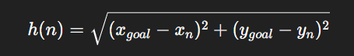

2.34 Why A* for Indoor Navigation?
- Optimal: Always finds the shortest path (if heuristic is admissible).
- Efficient: Explores fewer nodes than algorithms like Dijkstra’s.
- Flexible: Works with real spatial data (coordinates from QGIS).
- Practical: Already used in games, GPS, and robotics — making it suitable for our project.

2.35 Example Flow (Simplified)
- Start: Classroom A → Destination: Seminar Hall.
- A* expands corridor nodes step by step.
- At each step, it evaluates f(n) = g(n) + h(n) and picks the corridor that seems closer to the seminar hall.
- Once it reaches the seminar hall node, it reconstructs the shortest path and outputs it.

2.4 Integration with BRO Robot
- Voice Command Support: Users can ask BRO, “Take me to Seminar Hall” → BRO processes request → Displays/Announces shortest path.
- Interactive Screen/Map: BRO’s screen displays the digitized campus map with highlighted paths.
- Assistance for New Visitors: QR codes + BRO guidance act as a combined navigation aid.

2.5 Results and Output
- Successfully digitized the map of the college using QGIS.
- Successfully implemented Multi Floor mapping for college block.
- Generated a graph network representing the rooms and corridors.
- Implemented A* algorithm to compute shortest paths.
- Output includes:
  - Navigation path highlighted on the map.
  - Distance/steps between locations.
PG_1ST_FLOOR MAP PG_2ND _FLOOR MAP
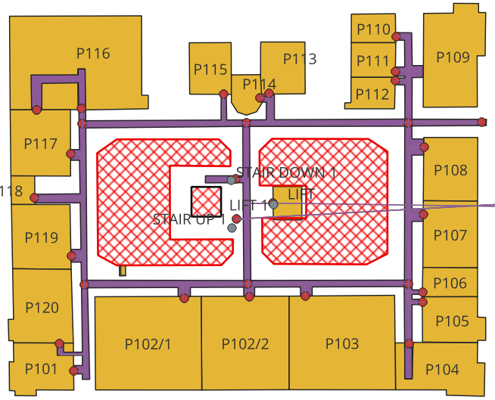 | 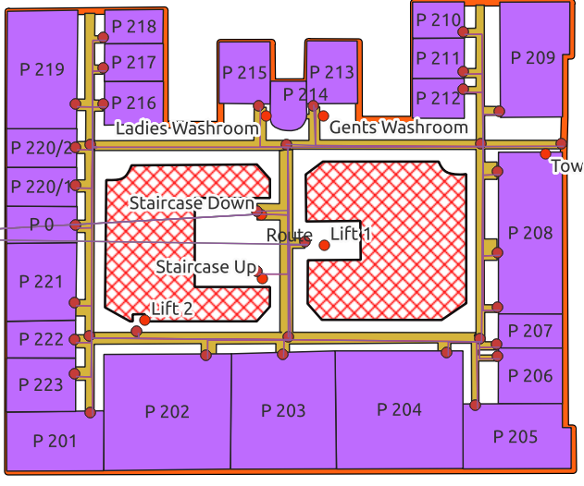
ABC_3RD _FLOOR MAP

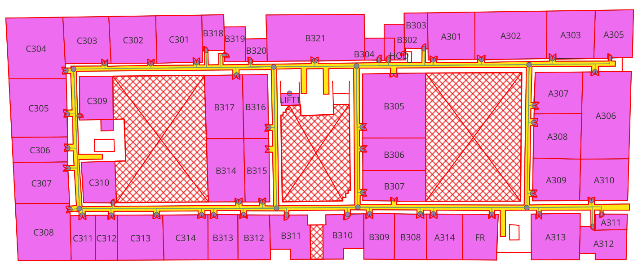
MULTI-FLOOR DEMONSTRATION of PG Block
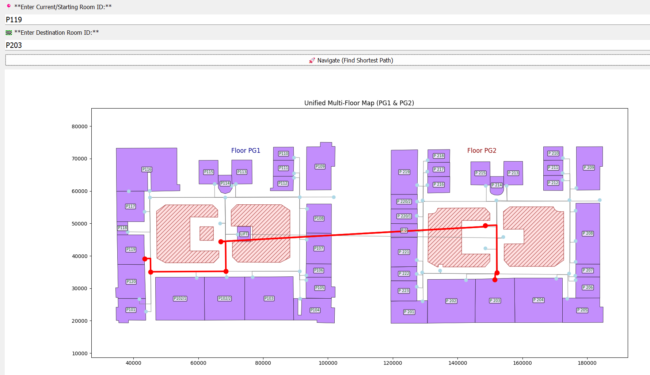

2.6 Applications of Navigation Feature
- Helping freshers and visitors easily locate blocks, classrooms, and offices.
- Helping students quickly find seminar halls, exam halls, labs.
- Emergency guidance during fire drills or evacuations.
- Supporting digital campus initiatives and paperless orientation.

2.7 Challenges Faced
- Maintaining accuracy of digitized maps.
- Scaling system to multiple floors/buildings.
- Handling crowded/narrow corridors in pathfinding.
- Synchronizing QR code access with live navigation updates.

2.8 Conclusion
The Indoor Navigation and Digital Campus Map feature enhances BRO’s functionality as a campus assistant robot. With QGIS-based digitization, graph-based modeling, and A* pathfinding, visitors and students can easily access navigation through QR codes or direct interaction with BRO. This feature demonstrates how robotics and GIS can combine to improve campus accessibility and smart navigation.

III AI SMART ASSISTANT (CHAT-BOT)
3.1 Introduction
The chatbot is designed as a Retrieval-Augmented Generation (RAG) system integrated into BRO’s local hardware (Jetson Orin Nano). It transforms unstructured documents into vectorized semantic knowledge and performs real-time similarity search to answer queries in a deterministic and hallucination-free manner.
The system establishes a document → chunk → embedding → FAISS index → retrieval → LLM pipeline, optimized for both cloud processing and edge deployment.

3.2 Tools and Technologies Used
1. LangChain (Technical Role in RAG)
LangChain orchestrates the entire workflow:
• Document Loading
- Uses libraries: LangchainDoc, PyPDFLoader, UnstructuredPowerPointLoader, pandas
- Extracts raw text + metadata
• Text Splitting
- RecursiveCharacterTextSplitter
- Splitting strategy:
  - Large → paragraphs → sentences → characters
  - Ensures semantic completeness
• Chains
- RetrievalQA chain
- Executes: Embed Query → Vector Search → LLM → Output
• Prompt Templates
- System prompt forces context-only grounding
- Ensures hallucination suppression
2. Hugging Face Embeddings (BAAI/bge-base-en-v1.5)
Why embeddings? (Math Explanation)
Embeddings convert text into a dense vector of dimension 768:
$$f:\text{text}→R^{768}$$

Semantically similar texts end up close in vector space.
Example:
“Exam Cell” ≈ “Examination Section” because
$$cos⁡(θ)→1$$
How the bge-base Model Works Internally
- 12-layer Transformer encoder
- Multi-Head Self Attention
- Positional embeddings
- Final CLS token → pooled representation
- Norm + linear projection → 768-D vector
Optimization Techniques Used
These optimizations allowed running the model efficiently in limited environments:
1. FP16 Precision
- Converts weights from 32-bit → 16-bit floating point
- Reduces memory and improves throughput
2. TensorRT / ONNX Optimization
- Exporting to ONNX reduces framework overhead
- TensorRT engine fuses layers → faster matrix multiplications
3. Dynamic Quantization (INT8)
- Converts key layers to 8-bit when needed
- 30–40% speedup on Jetson
4. CPU/GPU Hybrid
- Jetson executes the LLM on GPU
- Embeddings optionally computed on CPU during sync
3. Semantic Search with FAISS
- FAISS stores all embeddings in a high-dimensional index and allows O(log n)–O(n) search depending on the index type.
- Index Type Used
- Most setups (including yours) use:
- FAISS IndexFlatIP
- Inner Product (dot product) similarity
- Equivalent to cosine similarity when vectors are L2-normalized
- Pros: precise results
- Cons: slower for extremely large datasets → acceptable for < 1000 docs
- Similarity Computation
- FAISS computes:
- $\text{score}=⟨q,d_{i}⟩$
Where:
- $q$= query embedding
- $d_{i}$= document chunk embedding
- Chunks with highest score are the best matches.
Why Vector Search Instead of Keywords?
- Keyword search → lexical
Vector search → semantic
- Example:
User asks: “timings of exam branch”
Document contains: “Examination section working hours”
FAISS retrieves it because embeddings reflect meaning, not exact words.
4. Python Libraries:
- dotenv, os → environment/config management
- langchain_community, langchain_core → for leveraging langchain services
- threading, schedule, time → for multi thread operation
- pyttsx3, speech_recognition → text-to-speech and speech-to-text conversion
5. LLM (Phi-3 Mini)
Phi-3 Mini Internal Architecture
- 3.8B parameters
- Decoder-only Transformer
- Rotary Positional Embeddings (RoPE)
- Multi-Query Attention (efficient on Jetson)
- Quantized to q4_k or q6_k for local inference
Why This Prevents Hallucination
LLM cannot invent answers because:
- Context window contains only official chunks
- Instruction forces context-only generation
- If chunks don’t match → “I don’t know”
6. Streamlit:
- Used to build both User Chat Interface and Admin Panel.
- Provides upload, delete, and database rebuild functionality for documents.
3.3 RAG Workflow
Step 1 — Query Embedding
User query → embedding:
$$q=f(\text{user_query})$$
Step 2 — Vector Similarity Search
For each document chunk embedding $d_{i}$:
$$\text{sim}(q,d_{i})=\frac{q⋅d_{i}}{∣∣q∣∣ ∣∣d_{i}∣∣}$$
FAISS returns top-k highest-scoring chunks.
Step 3 — LLM Context Construction
Chunks + query → fed to LLM.
Step 4 — Contextual Answer
LLM selects and summarizes relevant parts.
3.4 Integration with BRO Robot
Speech-to-Text (STT)
- Uses speech_recognition library
- Converts audio waveform to text
- Preprocessing: MFCC, FFT
Text-to-Speech (TTS)
- pyttsx3
- Outputs via Jetson audio interface
Offline Access: Ollama enables Jetson Orin Nano to run LLM (Phi-3 mini) locally with FAISS database storing the embeddings locally.
3.6 Results and Output
- Successfully built a Streamlit chatbot UI with conversational history.
- Created an Admin Panel for uploading/removing documents.
- Verified that the chatbot correctly answers from institutional documents.
- Syncs the documents with the cloud storage to fetch every 2 hours.
3.7 Applications of Chatbot Feature
- Assisting students with academic queries (exam rules, syllabus, schedules).
- Helping visitors find information about facilities and departments.
- Providing faculty/staff with quick access to circulars and policies.
- Supporting digital campus initiatives by reducing manual inquiries.
- Extensible to integrate with college ERP or library systems.
  - Conclusion
The chatbot implements a fully optimized RAG system with:
✓ Transformer-based embedding generation
✓ High-dimensional vector storage
✓ FAISS-accelerated semantic similarity search
✓ Local LLM inference on Jetson
✓ multi-threaded processing for real-time response
✓ Cloud-to-edge sync for document updates
This results in a reliable, hallucination-resistant, low-latency information assistant embedded within a humanoid robot.

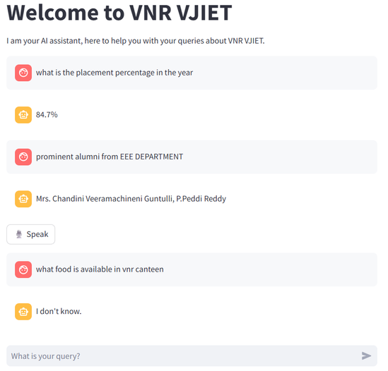

IV ROS Communication and Robot Movement

4.1 Introduction
The robot described in this report uses a differential-drive configuration consisting of two DC brushed motors with quadrature encoders. A Raspberry Pi is employed for motor actuation, PWM generation, and encoder interfacing, while a laptop running ROS2 Humble serves as the high-level controller. Communication between these devices is achieved using ROS2 topics transmitted over Wi-Fi.
The main objectives of the system are:
- To convert high-level velocity commands into PWM signals.
- To reliably measure wheel movement using encoders.
- To compute real-time odometry.
- To ensure smooth and precise motor control suitable for navigation systems such as SLAM and Nav2.
The robot’s mechanical parameters are:
- Wheel radius: 1.25 cm (0.0125 m)
- Wheel diameter: 2.5 cm
- Wheel base: 5.5 cm (0.055 m)
- Encoder resolution: 145 ticks per rotation (TPR)
These parameters form the basis for all calculations and control algorithms presented.
4.2 System Overview
The system consists of interconnected hardware and software modules:
Hardware:
- DC Motors with encoders
- Transistor-based H-bridge motor driver
- Raspberry Pi (motor control and odometry nodes)
- Laptop running ROS2 (e.g., SLAM/Nav2/teleoperation)
- Power supply (battery)

ROS2 Topics:
Topic |  | Description
/cmd_vel |  | Linear & angular velocity commands (Twist)
/motor_direction |  | Direction control signals to driver
/wheel_speed |  | PWM duty or angular speed feedback
/wheel_ticks |  | Encoder tick counter data
/odom |  | Robot odometry (pose + velocity)
/tf |  | Transform frame odom → base_link

The Raspberry Pi acts as the low-level controller, while the laptop handles high-level planning.

4.3 DC Motor Theory
4.3.1 Electrical Model
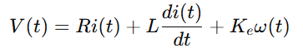
A brushed DC motor follows the differential equation:
Where:
- $V(t)$: Applied voltage
- $R$: Armature resistance
- $L$: Armature inductance
- $i(t)$: Armature current
- $ω(t)$: Angular velocity
- $K_{e}$: Back-EMF constant
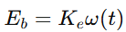
Back-EMF:

Back-EMF opposes the applied voltage and increases with speed, limiting the motor’s maximum RPM.

4.3.2 Mechanical Model
Torque generated:
$$τ(t)=K_{t}i(t)$$
Motor dynamic equation:
$$J_{total}\frac{dω}{dt}+bω(t)=τ(t)-τ_{load}(t)$$
Where:
- $J_{total}$: Combined inertia of motor + load
- $b$: Damping coefficient
- $τ_{load}$: External resistive torque

4.4 PWM Motor Control
4.4.1 Purpose of PWM
PWM modulates the average voltage to the motor:
$$V_{avg}=D⋅V_{supply}$$
Where $D$is the duty cycle.
Higher duty cycle → faster motor speed.

4.4.2 PWM Frequency Selection
Human hearing range: 20 Hz–20 kHz
Thus, PWM < 18 kHz produces audible whining.
Selected PWM frequency: 20 kHz
- Silent operation
- Supported by MOSFET drivers
- Smooth current ripple
L298N (BJT-based) cannot switch cleanly at 20 kHz, hence MOSFET drivers are recommended.
4.5 MOSFET vs BJT Motor Drivers
BJT-Based Driver (e.g., L298N)
- 2V voltage drop → motor receives lower power
- Poor efficiency
- Low switching frequency capability
- Large heat generation
- Considered obsolete
MOSFET-Based Drivers
- Very low Rds(on)
- High efficiency
- High current handling
- Suitable for 20 kHz PWM
- Minimal heat generation
Conclusion:
A MOSFET driver is essential for stable robotics applications.
4.6 Differential Drive Kinematics
Given:
- Wheel radius $r=0.0125\text{ m}$
- Wheel base $L=0.055\text{ m}$
4.6.1 Wheel Velocities
For commanded linear velocity $v$and angular velocity $ω_{robot}$:
$$v_{L}=v-\frac{L}{2}ω_{robot} \\ v_{R}=v+\frac{L}{2}ω_{robot}$$
4.6.2 Angular Wheel Velocities
$$ω_{wL}=\frac{v_{L}}{r},ω_{wR}=\frac{v_{R}}{r}$$
Convert to RPM:
$$RPM=ω⋅\frac{60}{2π}$$
4.7 Encoder Modelling
Encoder ticks-per-rotation: 145 TPR (Tick per Rotation)
Wheel circumference:
$$C=2πr=2π(0.0125)=0.07854\text{ m}$$
Distance per tick:
$$d_{tick}=\frac{C}{TPR}=\frac{0.07854}{145}=0.000541\text{ m/tick}$$
Wheel displacement:
$$d=ticks⋅d_{tick}$$
Wheel linear velocity:
$$v=\frac{d}{Δt}$$
4.8 Odometry Derivation
Let:
- $Δs_{L}$: left wheel displacement
- $Δs_{R}$: right wheel displacement
Robot linear displacement:
$$Δs=\frac{Δs_{L}+Δs_{R}}{2}$$
Change in orientation:
$$Δθ=\frac{Δs_{R}-Δs_{L}}{L}$$
Pose update:
$$x_{new}=x+Δscos⁡(θ+Δθ/2) \\ y_{new}=y+Δssin⁡(θ+Δθ/2) \\ θ_{new}=θ+Δθ$$
This midpoint method improves numerical accuracy.
4.9 ROS2 Communication Architecture
4.9.1 Node Distribution
Laptop
- Navigation (Nav2)
- Teleoperation
- Map server
- SLAM
Publishes: /cmd_vel
Raspberry Pi
- Motor controller node (PWM + direction)
- Encoder node (interrupt-based tick counting)
- Odometry node
Publishes:
- /wheel_ticks
- /odom
- /tf
Consumes:
- /cmd_vel
4.9.2 Topic Rates and QoS
Recommended rates:
- /cmd_vel → 10–50 Hz
- /wheel_ticks → 100–200 Hz
- /odom → 50 Hz
- /tf → 50 Hz
QoS:
- Reliable for /odom and /wheel_ticks
- Best effort acceptable for /wheel_speed
- Queue depth: 10–50
4.10 Hardware Implementation Details
• MOSFET H-bridge selected for efficiency and high-frequency operation
• Quadrature encoder connected to GPIO interrupt pins
• Flyback protection inherent in MOSFET H-bridges
• Power supply sized for stall current × safety factor (2× recommended)
4.11 Hardware Implementation Details
• TPR calibration:
Verified experimentally as 145 ticks/rotation
• Wheel radius verification:
Measured via commanded displacement tests
• Encoder validation:
Tick frequency matches predicted 145 ticks/s at 0.1 m/s
• Odometry validation in RViz:
/tf and /odom confirmed to align with real movement
• Sourcing issue fixed:
Missing /tf resolved by sourcing setup.bash on all terminals
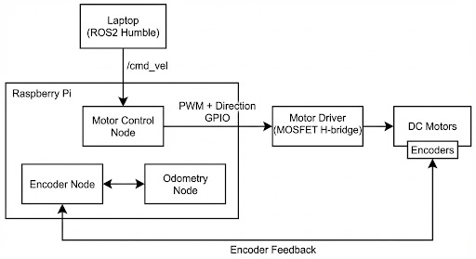
4.12 Complete System Diagram

4.13 Conclusion
This report provides a comprehensive and formal presentation of a ROS2-based motor control system for a differential-drive robot. It includes:
- Electrical and mechanical modelling of DC motors
- PWM theory and motor driver selection
- Encoder-based velocity and displacement computation
- Differential drive odometry equations
- ROS2 topic architecture
- PID control considerations
By integrating accurate motor modelling, encoder feedback, and precise odometry, the system achieves stable, predictable motion suitable for mapping, SLAM, and navigation tasks.

V CONCLUSION

The BRO – Semi-Humanoid Assistant Robot represents a fully integrated blend of robotics, AI, GIS, and distributed computing, engineered to function as a comprehensive digital campus assistant. Each subsystem—Chatbot (AI + RAG), Indoor Digital Campus Map (GIS-based navigation), and ROS2-based Motor Control—contributes to a unified architecture that enhances usability, autonomy, and interaction.
The project successfully demonstrates how different technological domains can work together to solve real-world problems. The AI chatbot improves information accessibility through natural, conversational interaction. The indoor navigation system provides reliable, map-based guidance using graph modelling and A* path planning. The ROS2 subsystem enables stable and predictable robot motion through accurate motor modelling, encoder feedback, and differential-drive odometry.
Together, these components create a scalable and modular robotic platform capable of assisting students, faculty, and visitors across the campus. The robot not only reduces manual workload but also promotes the vision of a smart, connected, and digitally enabled educational environment. This project highlights the potential of combining robotics, AI, and GIS to build intelligent service systems that can be expanded further for future applications such as autonomous delivery, security monitoring, and multi-robot collaboration.

