Project-:Village Database
Name-:Pawan Kumar Mishra
En.NO-:161B141
Batch-:BY/B5
Submitted to-:Dr. Mahesh Kumar
Subject-:Advanced Programming Lab(PYTHON)

AIM-: To make a interactive for a village sarpanch and other members so as to store and retreive data easily.
Steps to follow-:
1)Run the python file named pawan1.py from the list given below as it is the main window file

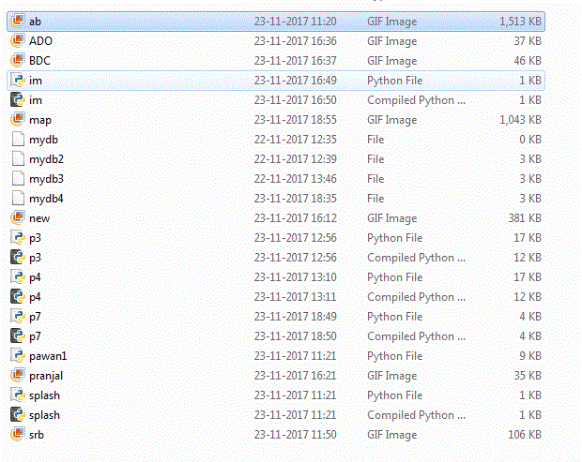
    - Now a 5 second splash screen will appear. After that a login window will appear as shown below:

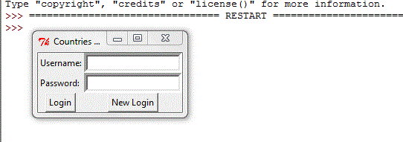
    - You can either login with your username and password one which
is already saved is (Username:pawanpg ||Password:1234) and click on Login button to login or one can create a login id and password by clicking on New Login
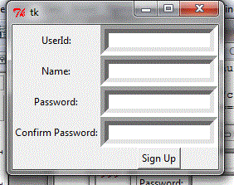
    - If you press on New Login than following window appears in which
UserId :varchar/String
Name:varchar/String
Password:varchar/String
Confirm Password:varchar/String
after filling each entry click on Sign Up button
      - After Logging in GUI following window appears
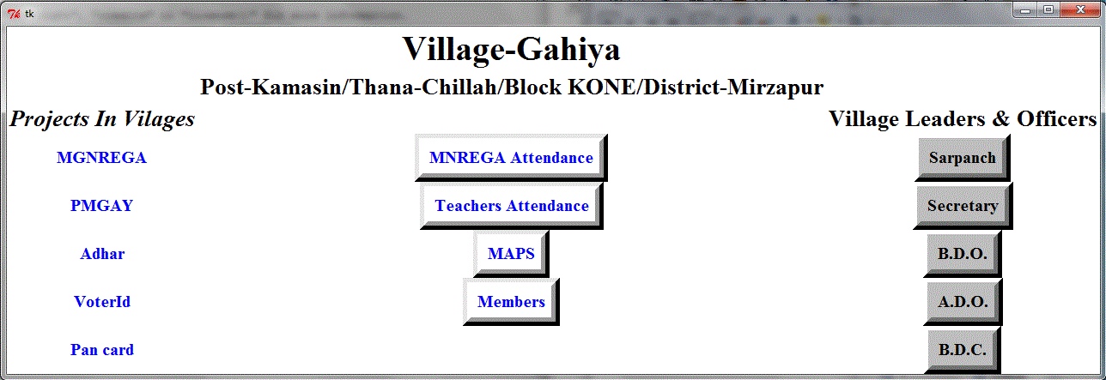

    - On rightmost column there is Hyperlinks related to projects going on in our villages like MNREGA,Adhhar Card , VoterID etc.
Click on them and a tab in chrome appears like below
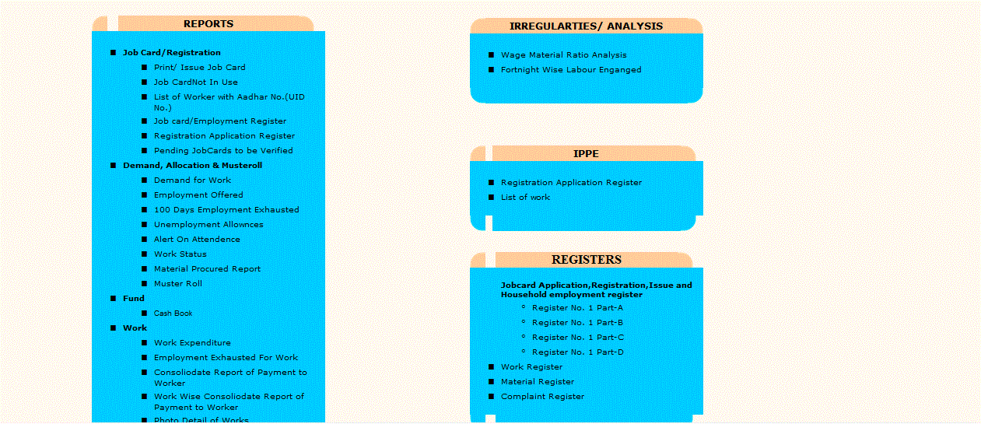
    - In the Center there is a attendance system for MNREGA workers, Teachers in the village school, Google map of my village, Database of members of my village.
    - Images for Attendance for MNREGA are like-:
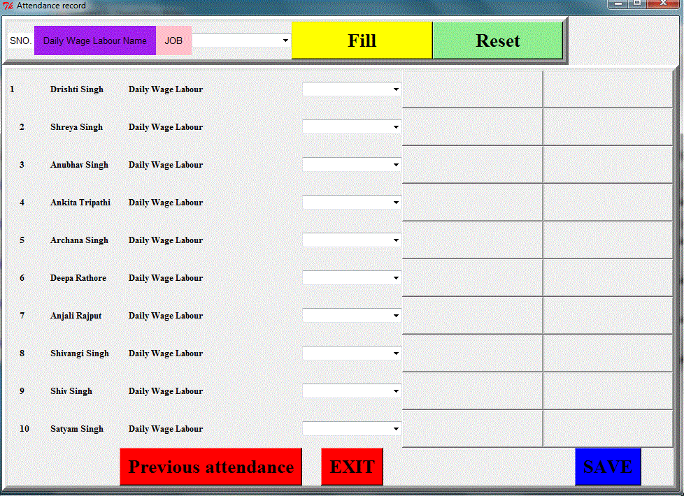
    - You can save attendance by clicking on save. Also one can see the attendance for the previous three days by clicking on previous attendance

      - Similarly is for attendance of Teachers
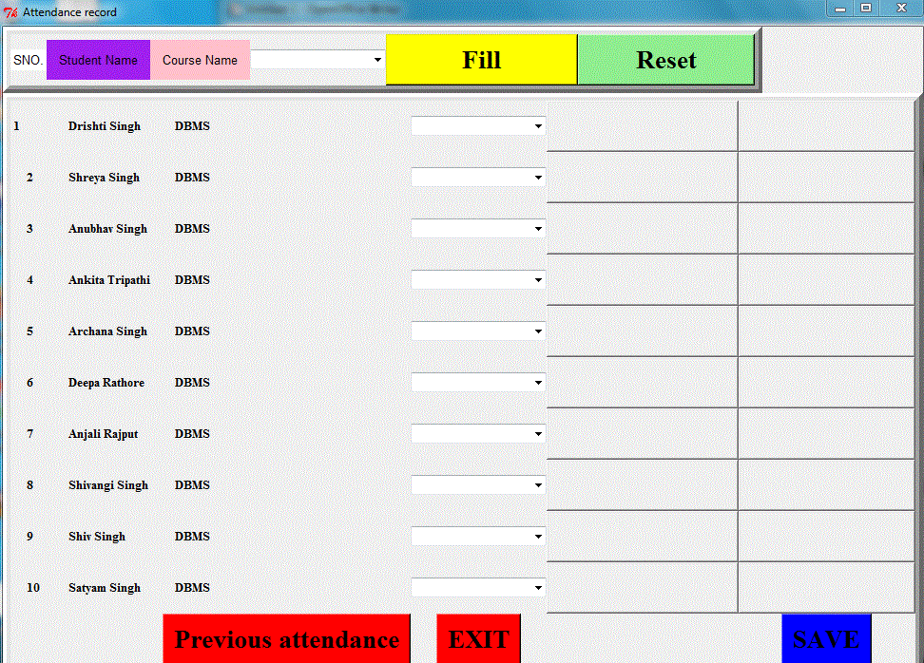
11)Google map for my village is

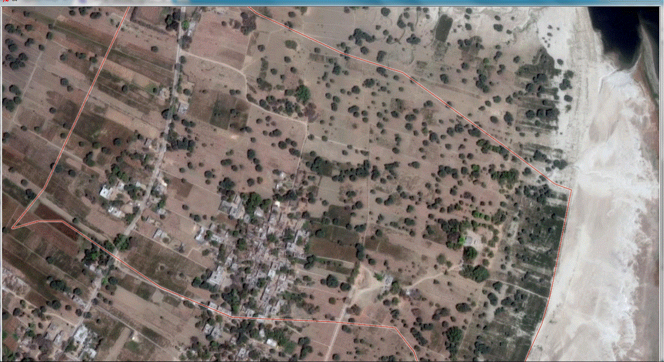

12)Also you can see the members of village and and also add
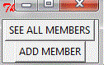
members by clicking on Members button

13)Click on SEE ALL MEMBERS to see all the members in
database
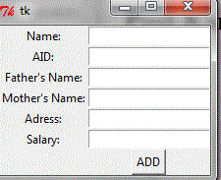
14)Click on ADD MEMBER to add members in village database
Here,
Name-:String
AID:Integer(aadharcard Number)
Father's Name:String
Mother's Name:String
Adress:String
Salary:Integer
15)Click on ADD to add member
16)In the Rightmost corner there is contact details of village leaders
like Sarpanch, BDO, Secretary, ADO, BDC

SARPANCH

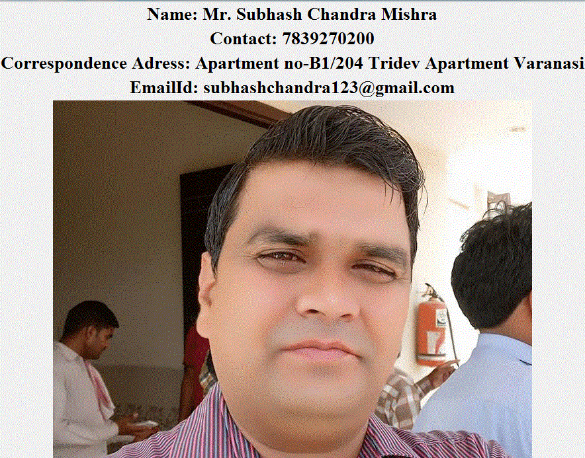
SECRETARY:
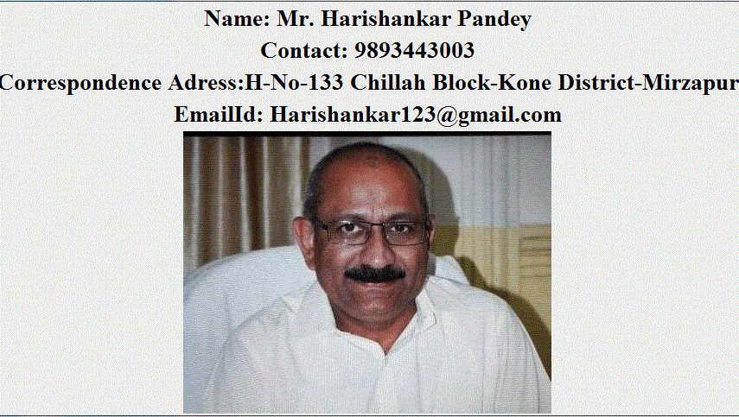
B.D.O.-:
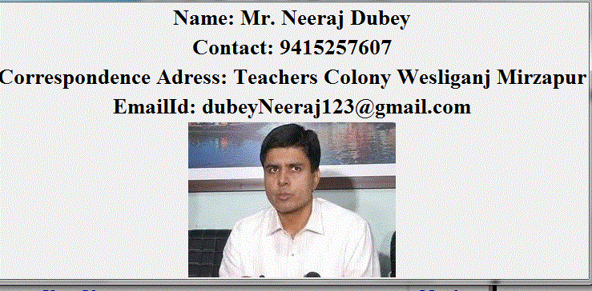
A.D.O.-:
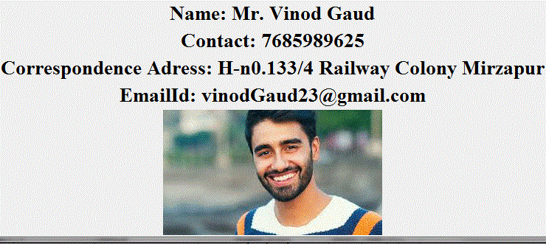

B.D.C.-:

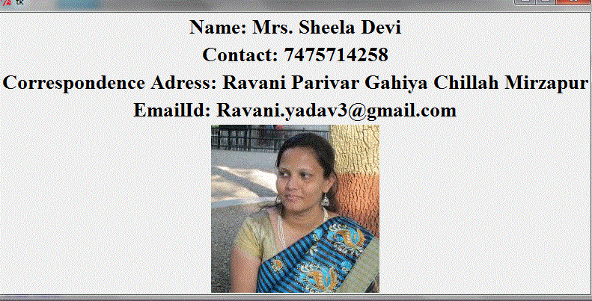
Benefits-:This GUI is very much easy to interact even for a villager who little knowledge about computer, also very helpful to store, retrieve data and maintain it

THANK YOU

