**1. Demonstrate the use of HTML and Web Server Controls.**

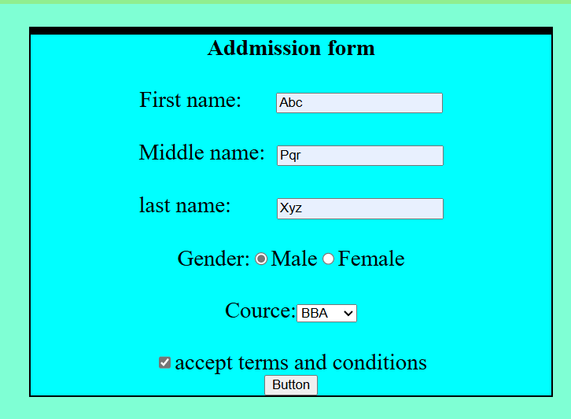

**2.Write an ASP.NET program that demonstrates use of web controls.**

using System;

using System.Collections.Generic;

using System.Linq;

using System.Web;

using System.Web.UI;

using System.Web.UI.WebControls;

public partial class _Default : System.Web.UI.Page

{

protected void Page_Load(object sender, EventArgs e)

{

}

protected void Button1_Click(object sender, EventArgs e)

{

Label1.Text = "your username is : " + TextBox1.Text;

Label2.Text = " your password is : " + TextBox2.Text;

}

}

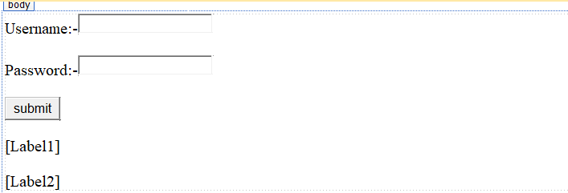

**OUTPUT:-**

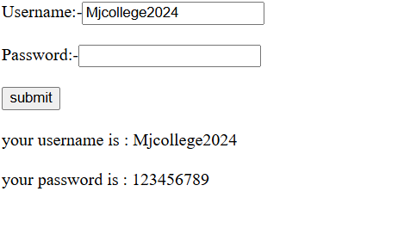

**3.Write an ASP.NET that returns the windows name of your computer and URL of the page that you are visiting.**

using System;

using System.Collections.Generic;

using System.Linq;

using System.Web;

using System.Web.UI;

using System.Web.UI.WebControls;

public partial class Default2 : System.Web.UI.Page

{

protected void Page_Load(object sender, EventArgs e)

{

Response.Write("your ip address : " + Request.UserHostAddress + "<br>");

Response.Write("your computer name : " + System.Net.Dns.GetHostEntry(Request.UserHostAddress).HostName + "<br>");

Response.Write("current url:" + Request.Url.AbsoluteUri);

}

}

**Output:-**

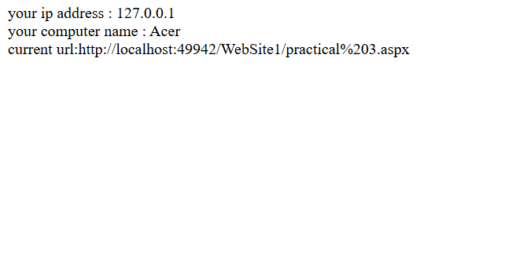

**4.Demonstrate DropDown List box,CheckButton,RadioButton controls.**

using System;

using System.Collections.Generic;

using System.Linq;

using System.Web;

using System.Web.UI;

using System.Web.UI.WebControls;

public partial class Default3 : System.Web.UI.Page

{

protected void Page_Load(object sender, EventArgs e)

{

}

protected void Button1_Click(object sender, EventArgs e)

{

if (DropDownList1.SelectedValue == null)

{

}

else

{

Label1.Text = "your class is " + DropDownList1.SelectedValue;

}

if (CheckBox1.Checked)

{

Label2.Text = CheckBox1.Text;

if (CheckBox2.Checked)

{

Label2.Text = CheckBox1.Text + " " + CheckBox2.Text;

if (CheckBox3.Checked)

{

Label2.Text = CheckBox1.Text + " " + CheckBox2.Text + " " + CheckBox3.Text;

}

}

}

if(RadioButton1.Checked){

Label3.Text = RadioButton1.Text + "";

}

if (RadioButton2.Checked)

{

Label3.Text = RadioButton2.Text + "";

}

}

}

**Output:-**

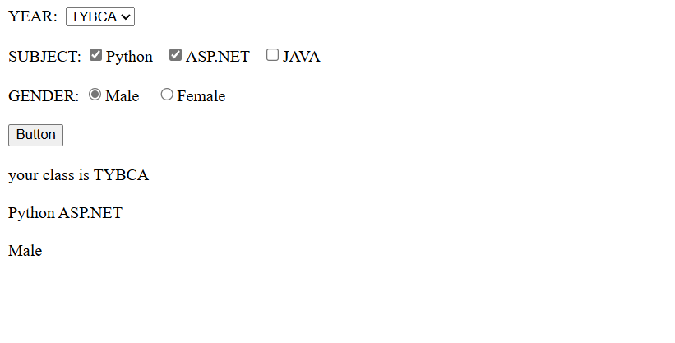

**5. Demonstrate the use of Calender and Adrotator Control**

<?xml version="1.0" encoding="utf-8" ?>

<Advertisements>

<Ad>

<ImageUrl>http://localhost:49942/WebSite1/cs.jpg</ImageUrl>

<AlternateText>

Eagle

</AlternateText>

<Impressions>20</Impressions>

</Ad>

</Advertisements>

**Output:-**



using System;

using System.Collections.Generic;

using System.Linq;

using System.Web;

using System.Web.UI;

using System.Web.UI.WebControls;

public partial class _Default : System.Web.UI.Page

{

protected void Page_Load(object sender, EventArgs e)

{

}

protected void Calendar1_SelectionChanged(object sender, EventArgs e)

{

Label1.Text = "you are selected : " + Calendar1.SelectedDate.ToString("D");

}

}

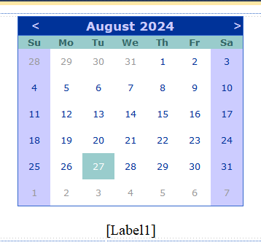

**Output:-**

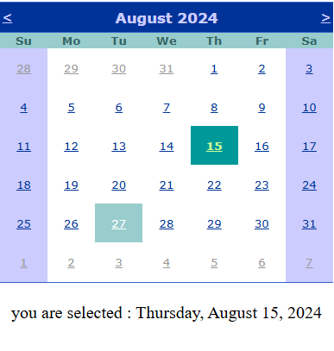

**6. Create a Registration form to demonstrate the use of various validation controls.**

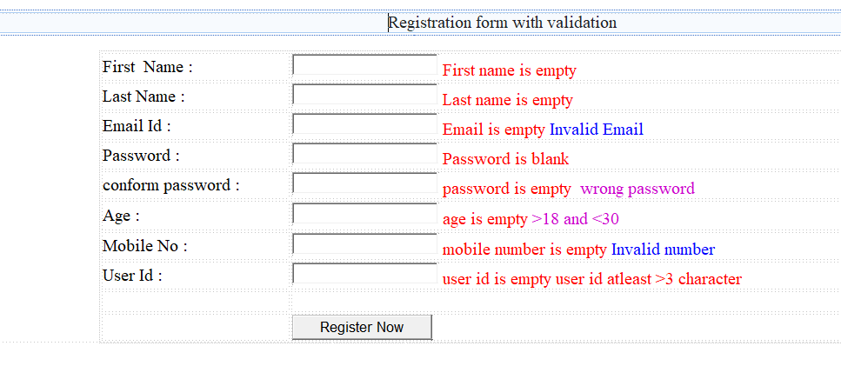

**Output:-**

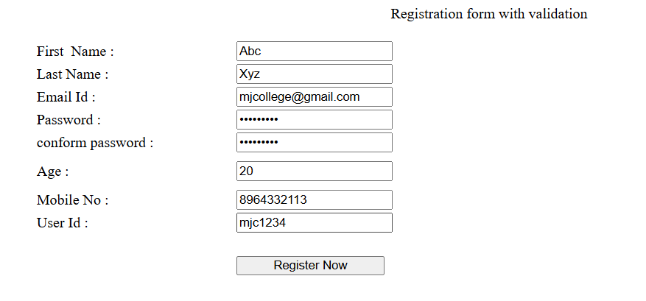

**7. Demonstrate use of Master Pages with applying Themes**

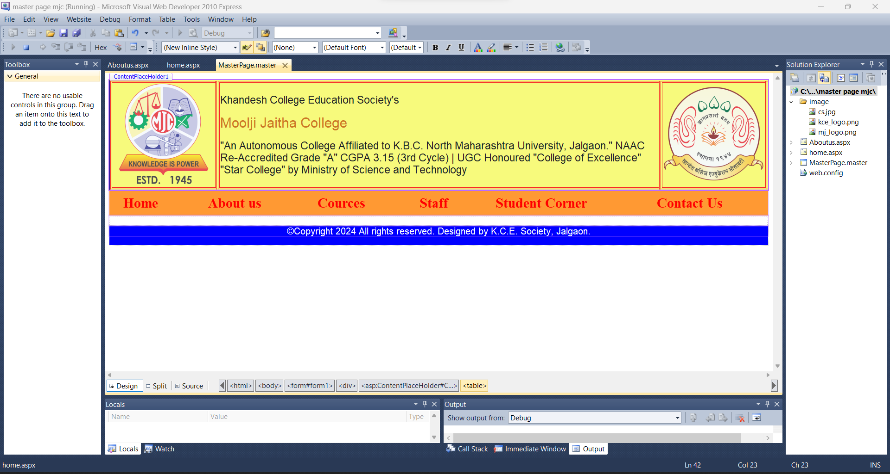

**Output:** -

