**ME-180 HW5: Logbook for myRIO Project**

**Shang Wang**

Connecting the DIGILENT bread board with myRIO, wiring the motor with the H-bridge motor driver.

Note: the direction of the encoder and the rotation of the motor might be different.

**Create the two directional motor control:**

Wiring: The PWM signal flows in the AIN1 and a digital outputs signal is injected in AIN2 of the H-Bridge. The motor direction is determined by the signal of AIN2 is HIGH or LOW.

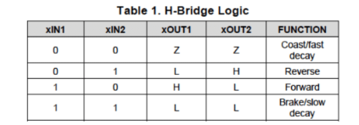

Coding: a sub-vi for the dual directional PWM controlled motor.

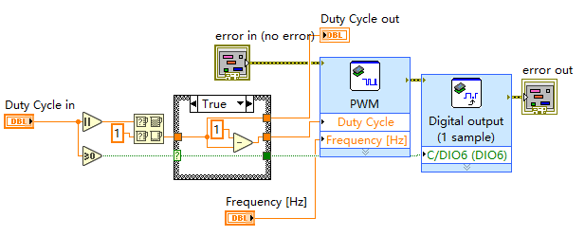

Note: Any duty cycle outside of the range (-1,1) will be truncated. And the actual INPUT/OUTPUT relationship of the H-Bridge looks like:

|  |  |  |  |
| --- | --- | --- | --- |
| AIN1(Digital Output) | AIN2(PWM, DUTYCYCLE) | DIRECTION | VELOCITY |
| HIGH | 0.1 | P | HIGH |
| HIGH | 0.9 | P | LOW |
| LOW | 0.1 | N | LOW |
| LOW | 0.9 | N | HIGH |

Thus, to make sure the consistency of the effort flows into the motor and the value of the duty cycle. Some preprocess is introduced to make sure a) duty cycle 0.9 stands for the maximum positive velocity of the motor, and b) duty cycle -0.9 stands for the maximum negative velocity of the motor.

**Create the controller using subsystem for the Control Simulation**

Select all the blocks and wires inside the Control & Simulation Loop, then select Edit > Create Simulation Subsystem to build a controller that could contain integrator/Derivative blocks.

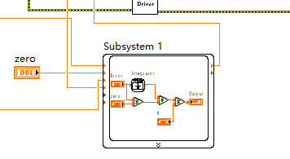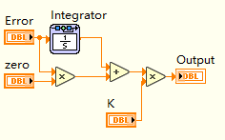

The controller here has a transfer function:

$$C\left(s\right)=K(\frac{1}{s}+z)$$

**Building the VI**

Using the shift register to record the previous velocity, calculate the difference between it and the current velocity as the error and send the error to the controller. The controller will send a duty cycle value to the motor driver sub-vi. 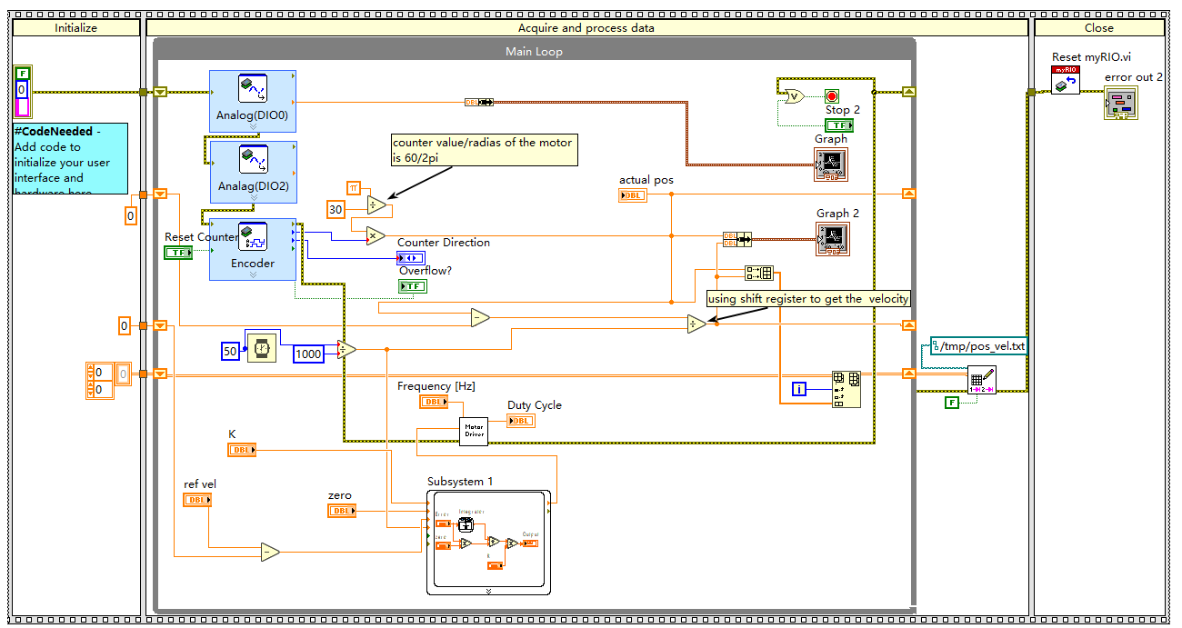

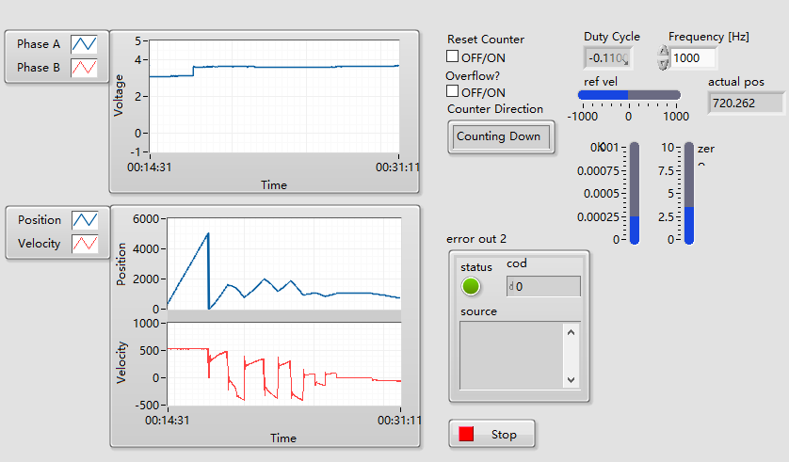

**Compare different controller responses**

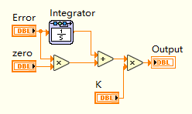

**Fig.1 Response of** **pure integrator(zero = 0) controller system**

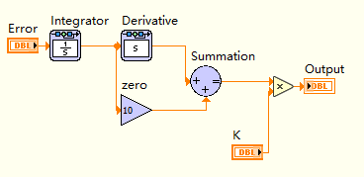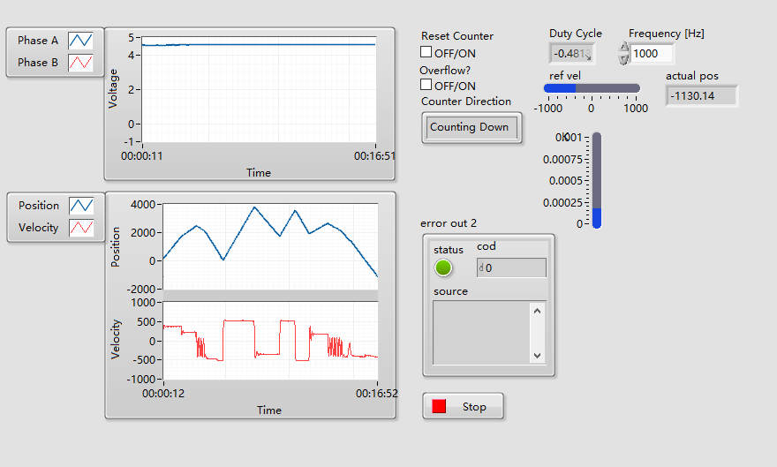

**Fig.2 Response of the PI controlled system**

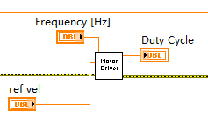 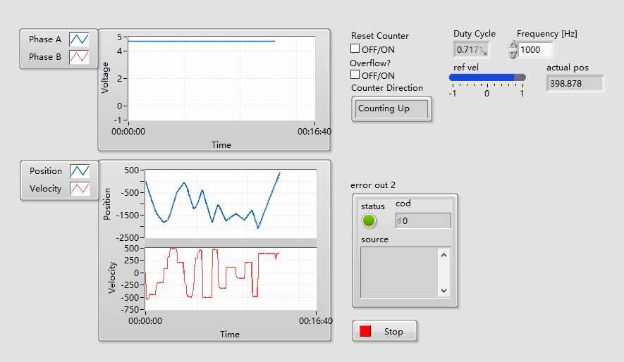

**Fig.3 Response of the open loop system**

**Transfer Function for the system:**

$$τ=I\ddot{θ}+B\dot{θ} \\ τ=I\dot{ω}+Bω$$

Thus, the transfer function for velocity is

$$G\left(s\right)=\frac{ω}{τ}=\frac{1}{Is+B}$$

the actual transfer function with the duty cycle as input looks like: $$\frac{X\left(s\right)}{D(s)}=\frac{A}{Is+B}$$

where the duty cycle $d$ is proportional to the torque $τ$ with coefficient $A$.

**For a pure integrator control system:**

$$C\left(s\right)G\left(s\right)=\frac{K}{s}G\left(s\right)=\frac{K}{s\left(Is+B\right)}$$

**For an PI controller:**

$$C\left(s\right)G(s)=K\frac{\left(s+z\right)}{s}G\left(s\right)=\frac{K\left(s+z\right)}{s\left(Is+B\right)}$$

**For the open-loop system:**

$$C\left(s\right)G\left(s\right)=G\left(s\right)=\frac{1}{Is+B}$$