**ME-180 HW6: Logbook for myRIO Project**

**Shang Wang**

Designing a controller using state space approach.

**1. Equation of Motion for the System.**

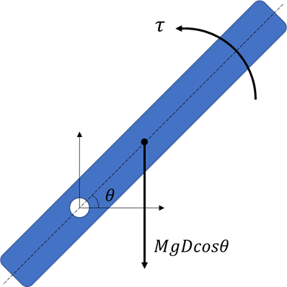

**Fig.1 Load of the Motor**

Due to the nonlinear nature of the inverted pendulum, the control design must go through the linearization process.

$$I\ddot{θ}=τ-B\dot{θ}-k(θ_{0})$$

$k$ is related to the $θ_{0}$, so the system is nonlinear, thus the compensation has to be considered to make guarantee the same response at any working point.

**Inertia:** The inertia is calculated by assuming the mass is evenly distributed in the entire linkage

$I=I_{left}+I_{right}$

$$M=M_{left}+M_{right}=\frac{L_{1}}{L_{1}+L_{2}}M+\frac{L_{2}}{L_{1}+L_{2}}M$$

Formula for Moment of inertia according to the axis at one end $I=ML^{2}/3$

$$I=I_{left}+I_{right}=\frac{L_{1}}{L_{1}+L_{2}}M{L_{1}}^{2}+\frac{L_{2}}{L_{1}+L_{2}}M{L_{2}}^{2}=1.9149×{10}^{-5}Kg∙m^{2}$$

Also, we will neglect the motor inertia, since the motor inertia is two order of magnitude smaller.

**Damping:**

The damping $B$ is already calculated from previous logbook by a step response of the motor, add a linkage do not affect the damping, so the damping is:

$$B=2.7945×{10}^{-6}$$

**Gravity:**

The Gravity can be calculated easily from the figure on the right,

$$F_{g}=MgDcosθ_{0}$$

**Linearize the model:**

First, write out The Equation of Motion for the Fig.1

$$I\ddot{θ}=τ-B\dot{θ}-MgDcosθ_{0}$$

Assume

$$θ=θ_{0}+δθ$$

Then

$$\dot{θ}=δ\dot{θ}, \ddot{θ}=δ\ddot{θ}$$

Linearized by:

$$f\left(θ\right)-f\left(θ_{0}\right)={\left.\frac{∂f}{∂θ}\right|}_{θ_{0}}\left(θ-θ_{0}\right)$$

So

$$MgDcos\left(θ\right)≈-MgDsin\left(θ_{0}\right)δθ+MgDcosθ_{0}$$

Substitute back to the Equation, then the linearized equation is:

$$I\ddot{θ}+B\dot{θ}-MgDsin\left(θ_{0}\right)δθ=τ-MgDcos\left(θ_{0}\right)$$

Let

$$\tilde{τ}=τ-MgDcos\left(θ_{0}\right)$$

Then the Transfer Function for position is:

$$G_{0}\left(s\right)=\frac{δθ}{\tilde{τ}}=\frac{1}{Is^{2}+Bs-MgDsin\left(θ_{0}\right)}$$

From the previous Logbook we know the Torque $τ$ is proportional to the Duty cycle $D$,

$$τ=AD$$

Where $A$ is calculated from the Motor’s instruction menu.

Assume:

$$\tilde{D}=D-\frac{MgDcos\left(θ_{0}\right)}{A}$$

So the Transfer Function for the Duty cycle and position is:

$$G\left(s\right)=\frac{δθ}{\tilde{D}}=\frac{A}{Is^{2}+Bs-MgDsin\left(θ_{0}\right)}$$

**4. Design via State Space.**

$$G\left(s\right)=\frac{A}{Is^{2}+Bs-MgDsin\left(θ_{0}\right)}=\frac{A/I}{s^{2}+\frac{B}{I}s-\frac{MgDsin\left(θ_{0}\right)}{I}}$$

Phase variables:

$$x_{1}=δθ \\ x_{2}=δ\dot{θ}$$

Write in state space representation:

$$\dot{x}=\left[\begin{matrix}0 & 1 \\ \frac{MgDsin\left(θ_{0}\right)}{I} & -\frac{B}{I}\end{matrix}\right]x+\left[\begin{matrix}0 \\ A/I\end{matrix}\right]u$$

$$y=\left[\begin{matrix}1 & 0\end{matrix}\right]x$$

Desired state space representation:

$$\dot{x}=\left[\begin{matrix}0 & 1 \\ -\left(-\frac{MgDsin\left(θ_{0}\right)}{I}+K_{1}\right) & -\left(\frac{B}{I}+K_{2}\right)\end{matrix}\right]x+\left[\begin{matrix}0 \\ A/I\end{matrix}\right]r$$

$$sI-A+BK=\left[\begin{matrix}s & 0 \\ 0 & s\end{matrix}\right]-\left[\begin{matrix}0 & 1 \\ -\left(-\frac{MgDsin\left(θ_{0}\right)}{I}+K_{1}\right) & -\left(\frac{B}{I}+K_{2}\right)\end{matrix}\right]$$

$$\det\left(sI-A+BK\right)=s^{2}+ \left(\frac{B}{I}+K_{2}\right)s+\left(-\frac{MgDsin\left(θ_{0}\right)}{I}+K_{1}\right)$$

Desired Transfer Function 1:

Which has 20% over shoot

$$G\left(s\right)=\frac{A/I}{s^{2}+4s+64}$$

Desired Transfer Function 2:

Which has no over shoot

$$G\left(s\right)=\frac{A/I}{s^{2}+8s+15}$$

**5.Analysis of Error and Time Response:**

The transfer function for position is

$$G\left(s\right)=\frac{A}{Is^{2}+Bs-MgDsin\left(θ_{0}\right)}=\frac{A/I}{s^{2}+\frac{B}{I}s-\frac{MgDsin\left(θ_{0}\right)}{I}}$$

So, for a step input to the system, the steady state error is:

$$e\left(∞\right)=\frac{1}{1+\lim_{s→0}{G\left(s\right)}}=\lim_{s→0}{\frac{s^{2}+\frac{B}{I}s-\frac{MgDsin\left(θ_{0}\right)}{I}}{{A/I+s}^{2}+\frac{B}{I}s-\frac{MgDsin\left(θ_{0}\right)}{I}}}=\frac{-\frac{MgDsin\left(θ_{0}\right)}{I}}{A/I-\frac{MgDsin\left(θ_{0}\right)}{I}}$$

**Measuring the Inertia, Damping, Gravity and Center of Mass.**

And use the Formula for Moment of inertia

$$I=1.9149×{10}^{-5}Kg∙m^{2}$$

**Damping:**

The Damping $B$ is already calculated from previous log book buy a step response of the motor, add a linkage do not affect the Damping, so the damping is:

$$B=2.7945×{10}^{-6}$$

**6.Start building VI:**

Create a SubVI to compensate for the gravity term in order to calculate the torque.

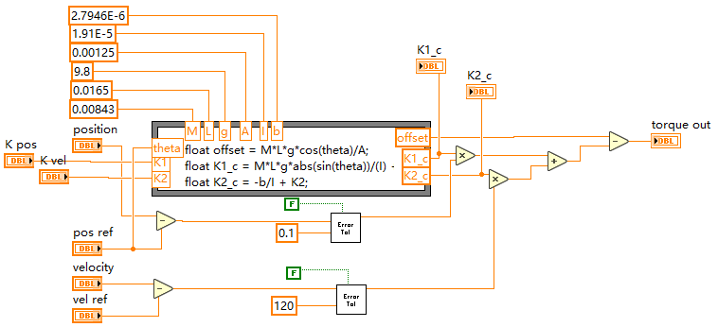

**Fig.2.1 Gravity Term Compensate**

Then, make a FIFO filter to filter out the velocity in order to get a better

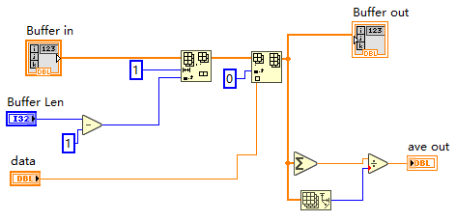

**Fig.3 Filter SubVI**

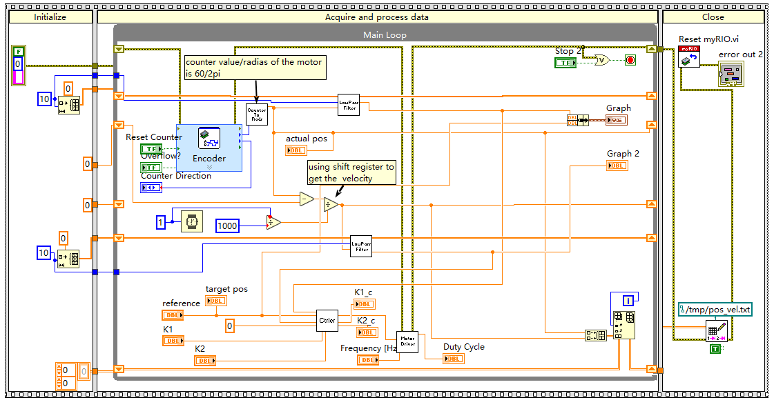

**Fig. Main Vi System diagram**.

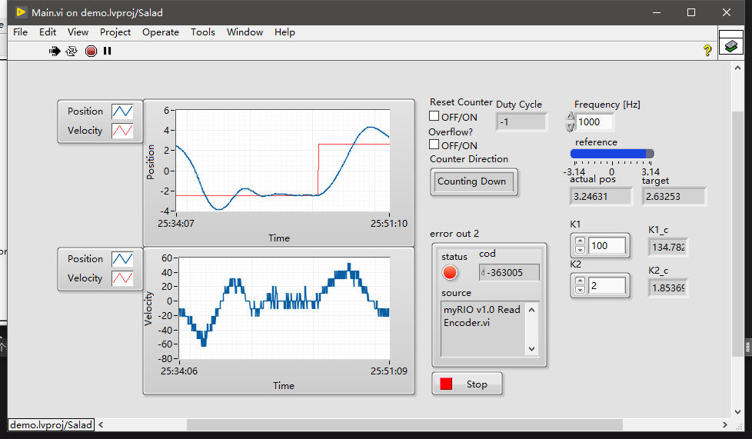



**Fig. The Response of the System for Two Given Step input . (the lower plot is velocity)**