**ME-180 HW7: Logbook for the MyRIO Project**

**Shang Wang**

**1.** **Paperer the second motor.z**

Soldering the encoder chip to the second motor and connect the jump wire. Connect the second motor with the DIGELENT board as shown in previous Logbook.

**2. Wire for the second motor.**

Create another encoder block as the first motor does.

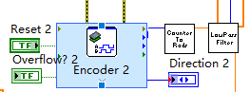

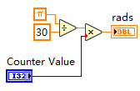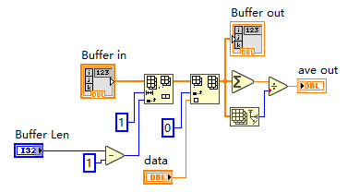**Sub VI of counter value to rad converter (left figure):**

the encoder resolution is $π/30$ form this block. Thus, the error of the position of the encode is around 0.1.

**FIFO shifting Filter Sub VI (right figure):**

The filter which has the smallest lag also could perform a good noise averaging capability.

**3. Measuring the Inertia, Damping, Mass, and the Center of Mass.**

From the HW6 Logbook:

Find the position on the linkage when it’s balance on the pen, mark the center of mass is found.

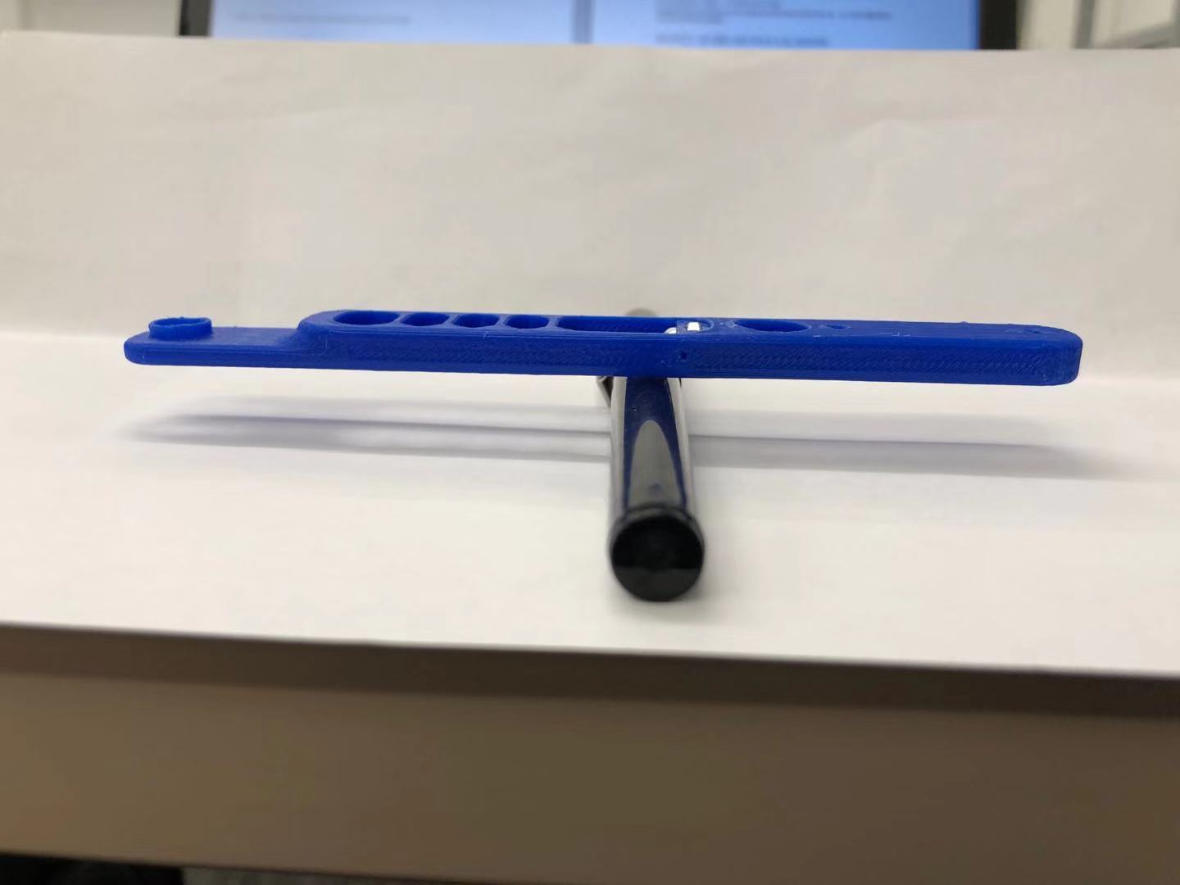

Then, us a caliper to measure the length between Shaft hole and each side( $L_{1}, L_{2}$), Also, calculate the distance $D$ between the center of mass and shaft hole.

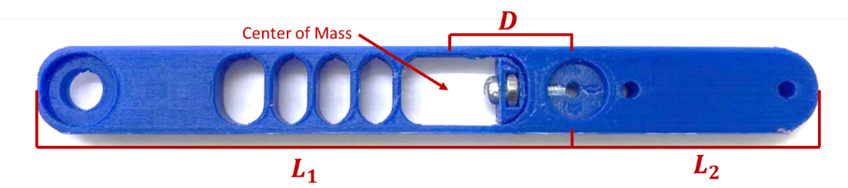

Where $L_{1}={3.75}^{''}=0.0953 m$; $L_{2}=1.75''=0.0444 m$ $D={0.65}^{''}=0.0165 m$

**Mass:** Weight the linkage, the weight of the linkage is: $M=0.00843 kg.$

**Inertia:** The inertia is calculated by assume the linkage is an “ideal linkage”, then the mass is evenly distributed in the entire linkage. So, the we can consider the Inertia on left side of the shaft hole and on right side separately. By assume:

$I=I_{left}+I_{right}$

$$M=M_{left}+M_{right}=\frac{L_{1}}{L_{1}+L_{2}}M+\frac{L_{2}}{L_{1}+L_{2}}M$$

And use the Formula for Moment of inertia $I=ML^{2}/3$

$$I=I_{left}+I_{right}=\frac{L_{1}}{L_{1}+L_{2}}M{L_{1}}^{2}+\frac{L_{2}}{L_{1}+L_{2}}M{L_{2}}^{2}=1.9149×{10}^{-5}Kg∙m^{2}$$

**Damping:**

The Damping $B$ is already calculated from previous log book buy a step response of the motor, add a linkage do not affect the Damping, so the damping is:

$$B=2.7945×{10}^{-6}$$

**4. Level System:**

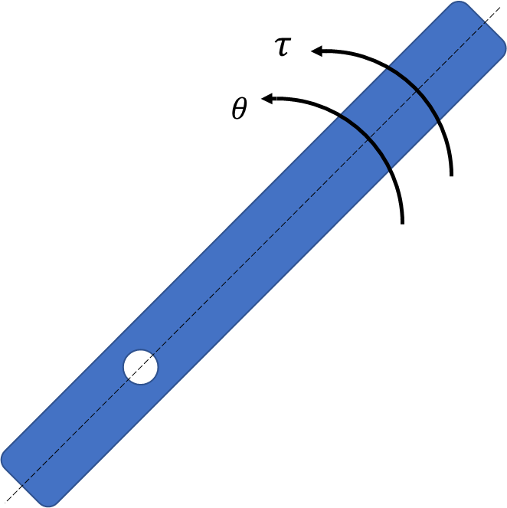**1). Write out the transfer function for the Level system:**

Dynamic system function without any gravity.

$$I\ddot{θ}=τ-B\dot{θ}$$

Transfer function of the system is:

$$G_{0}\left(s\right)=\frac{θ}{τ}=\frac{1}{Is^{2}+Bs}$$

From the previous Logbook we know the Torque $τ$ is roughly proportional to the Duty cycle $D$:

$$τ=AD$$

In fact, the linearity of the ratio $A(D)$ will lose its accuracy while

the duty cycle is smaller than approximately 0.3. But for the project, $A(D)$ is treated as a constant $A$.

$A=0.003865$ is calculated from the Motor’s instruction menu.

Therefore, the Transfer Function for the position in terms of the duty cycle is: $$G\left(s\right)=\frac{Θ(s)}{D(s)}=\frac{A}{Is^{2}+Bs}$$

**2). Design VI via State Space pole placement.**

$$G\left(s\right)=\frac{A}{Is^{2}+Bs}=\frac{A/I}{s^{2}+\frac{B}{I}s}$$

Phase variables:

$$x_{1}=θ \\ x_{2}=\dot{θ}$$

Write in state space representation:

$$\dot{x}=\left[\begin{matrix}0 & 1 \\ 0 & -\frac{B}{I}\end{matrix}\right]x+\left[\begin{matrix}0 \\ A/I\end{matrix}\right]u$$

$$y=\left[\begin{matrix}1 & 0\end{matrix}\right]x$$

Desired state space representation:

Desired Transfer Function with duty cycle as the input, the position is the output:

$$G_{d}\left(s\right)=\frac{64}{s^{2}+4s+64}$$

Which has 20% overshoot and 1 second settling time, So:

$$K_{1}=k=64 \\ K_{2}=b-\frac{B}{I}=4-\frac{B}{I}$$

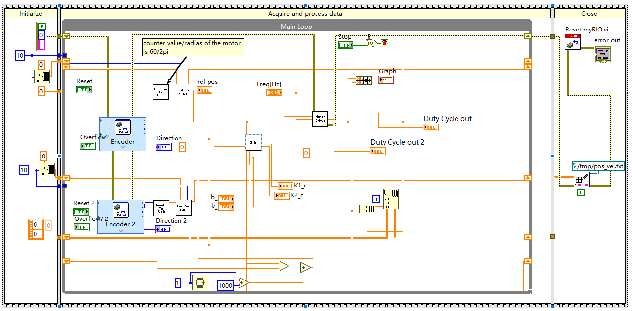

**Fig. VI Code for the level system (without any gravity compensation)**

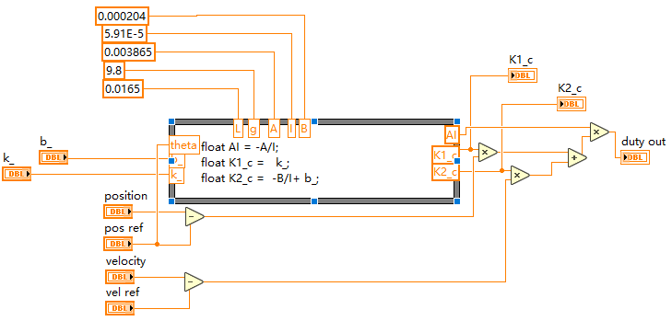

**Fig. Controller Sub VI (without any gravity compensation)**

**6) the results:**

Connect the myRIO with DIGILENT board and wiring the motor as mentioned in pervious Logbook**.**

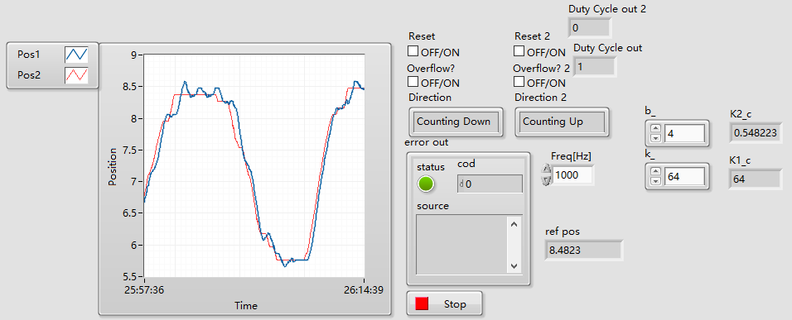

**Fig. The Response of the level system while the position of the second motor as the reference input.**

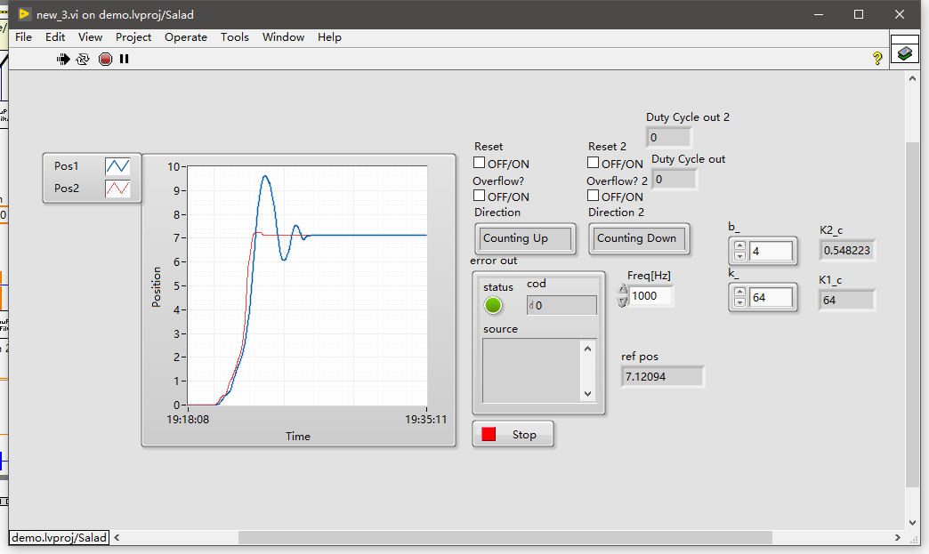

**Fig. The Step Response of the level system while the position of the second motor as the reference input.**

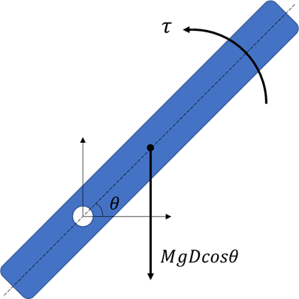**5. Vertical System.**

write out the equation of motion for the system:

$$I\ddot{θ}=τ-B\dot{θ}-k(m)$$

$k(m)$ is the gravitational term which describes how the gravity affects the dynamics of the system.

**Gravity:**

The Gravity is:

$$F_{g}=MgDcosθ$$

**1) Linearize the model:**

First, write out The Equation of Motion for the Fig.1

$$I\ddot{θ}=τ-B\dot{θ}-MgDcosθ$$

Assume

$$θ=θ_{0}+δθ$$

Then

$$\dot{θ}=δ\dot{θ}$$

$$\ddot{θ}=δ\ddot{θ}$$

First order linearization the nonlinear gravitational term $MgDcosθ$:

$$f\left(θ\right)-f\left(θ_{0}\right)={\left.\frac{∂f}{∂θ}\right|}_{θ_{0}}\left(θ-θ_{0}\right)$$

Therefore:

$$MgDcos\left(θ\right)≈-MgDsin\left(θ_{0}\right)δθ+MgDcos\left(θ_{0}\right)$$

Substitute it back to the Equation, then the linearized equation is:

$$I\ddot{δθ}+B\dot{δθ}-MgDsin\left(θ_{0}\right)δθ=τ-MgDcos\left(θ_{0}\right)$$

Let

$$\tilde{τ}=τ-MgDcos\left(θ_{0}\right)$$

Then the Transfer Function for position is:

$$G_{0}\left(s\right)=\frac{ΔΘ(s)}{\tilde{T}(s)}=\frac{1}{Is^{2}+Bs-MgDsin\left(θ_{0}\right)}$$

$$τ=AD$$

$$\tilde{D}=D-\frac{MgDcos\left(θ_{0}\right)}{A}$$

So, the Transfer Function for the Duty cycle and position is: $$G\left(s\right)=\frac{ΔΘ}{\tilde{D}}=\frac{A}{Is^{2}+Bs-MgDsin\left(θ_{0}\right)}$$

**3). Design via State Space pole placement.**

$$G\left(s\right)=\frac{A}{Is^{2}+Bs-MgDsin\left(θ_{0}\right)}=\frac{A/I}{s^{2}+\frac{B}{I}s-\frac{MgDsin\left(θ_{0}\right)}{I}}$$

Phase variables:

$$x_{1}=δθ \\ x_{2}=δ\dot{θ}$$

Write in state space representation:

$$\dot{x}=\left[\begin{matrix}0 & 1 \\ \frac{MgDsin\left(θ_{0}\right)}{I} & -\frac{B}{I}\end{matrix}\right]x+\left[\begin{matrix}0 \\ A/I\end{matrix}\right]u$$

$$y=\left[\begin{matrix}1 & 0\end{matrix}\right]x$$

Desired state space representation:

Desired Transfer Function with duty cycle as the input, the position is the output:

$$G_{d}\left(s\right)=\frac{64}{s^{2}+4s+64}$$

Which has 20% overshoot and 1 second settling time.

**5). Start building VI:**

Create a SubVI to compensate for the gravity term in order to calculate the torque.

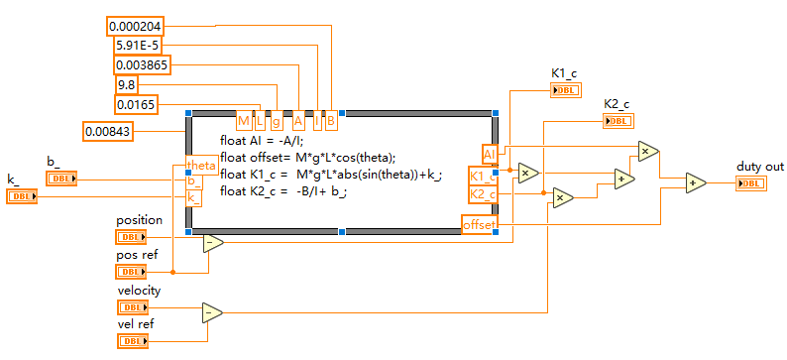

**Fig. Gravity Compensation controller**

The compensation is according the reference position, not the real time position of the system.

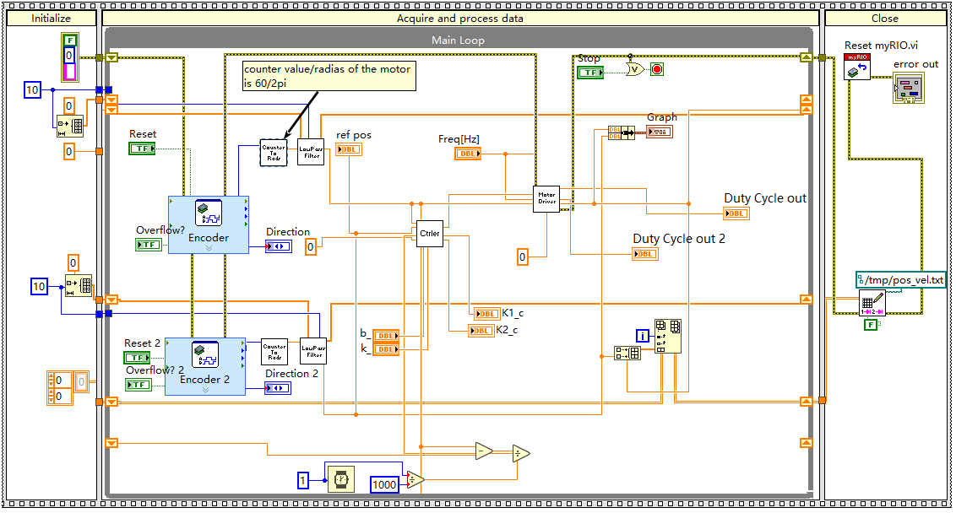

**Fig. VI Code for the system with gravity compensation**

**6) the results:**

Connect the myRIO with DIGILENT board and wiring the motor as mentioned in pervious Logbook**.**

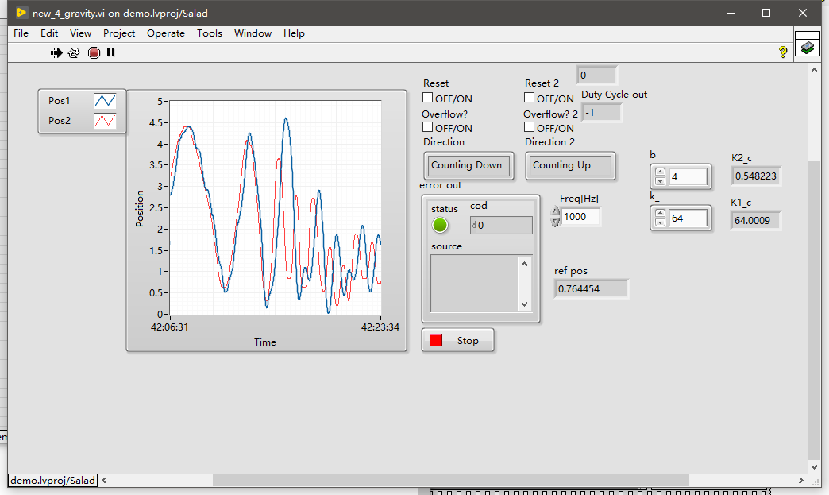

**Fig. The Response of the system while the position of the second motor as the reference input.**

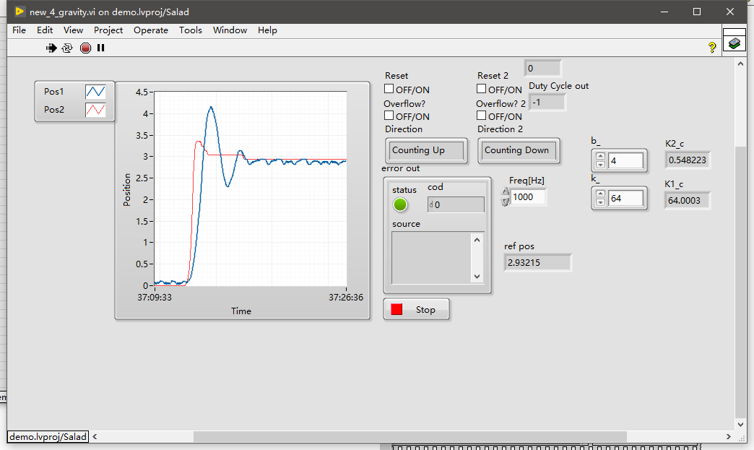

**Fig. The Step Response of while the position of the second motor as the reference input**