**ME-180 HW9: Logbook for MyRIO Project**

Shang Wang

This project is closely related to the last project.

**1.** **Build the VI.**

$$G\left(s\right)=\frac{A}{Is^{2}+Bs}=\frac{A/I}{s^{2}+\frac{B}{I}s}$$

Phase variables:

$$x_{1}=θ ; x_{2}=\dot{θ}$$

Write in phase variable form:

$\dot{x}=\left[\begin{matrix}0 & 1 \\ 0 & -\frac{B}{I}\end{matrix}\right]x+\left[\begin{matrix}0 \\ A/I\end{matrix}\right]u$; $y=\left[\begin{matrix}1 & 0\end{matrix}\right]x$

In order to get the force-motion behavior, we set:

$$u=\left[\begin{matrix}k_{1} \\ k_{2}\end{matrix}\right](x-r)$$

Using the encoder reading $y_{k}$ to generate the states estimate form observer ${\hat{x}}_{k}$ at time step $t=kT$. Then input ${\hat{x}}_{k}$ as well as the reference $r_{k+1}$ to form a torque (Duty Cycle) input signal to the motor at $t=(k+1)T$. Target characteristic equations of the observer and the system are:

$$ϕ_{OBS}\left(s\right)=s^{2}+B_{OBS}s+K_{OBS}$$

$$ϕ_{M}\left(s\right)=s^{2}+B_{TAR}s+K_{TAR}$$

We set the $K_{OBS}=64$, $B_{OBS}=12$ for now.

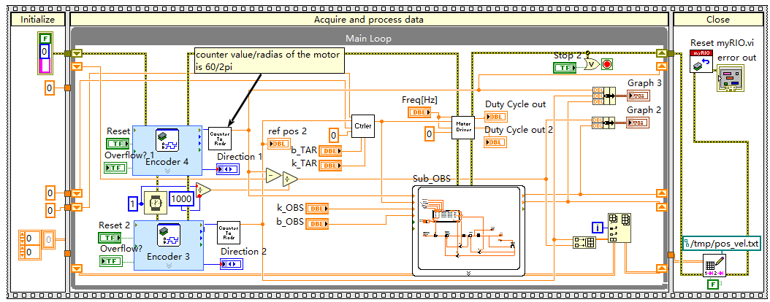

**Fig.1 VI for Observer Control**

**2. Run the VI:**

The reference signal is left to 0 in the testing scenario. The linkage is hit by hand to simulate a step input. As shown in the figure2, the energy of the system is gradually dissipated by the damping term. The small overshoot might be the consequences of the latency response of the observer.

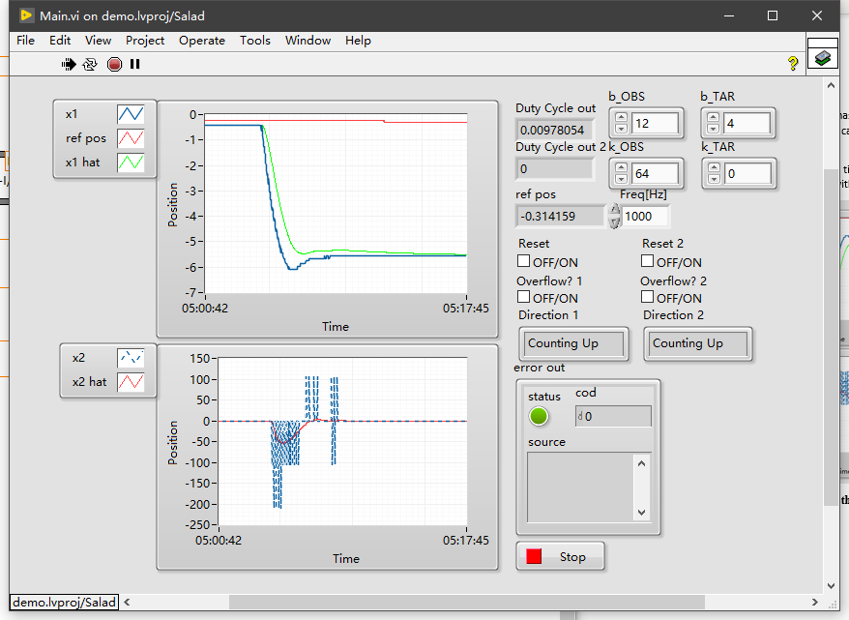

**Fig.2 Response of the system with an impulse (positive viscosity).**

From Fig.3, the negative viscosity will put an RHP pole into the system, which results in the instability of the system.

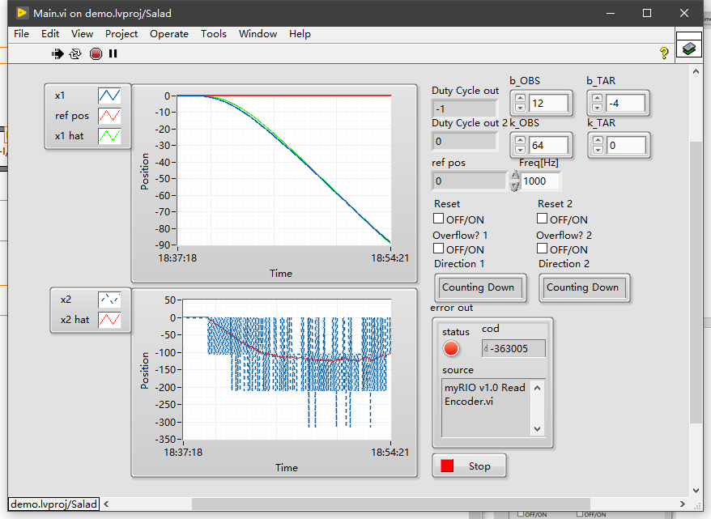

**Fig.3 Response of the system with an impulse (negative viscosity).**