Tufts University

EE105 Feedback Control Systems, Fall 2018  
Prof. Brian Aull

Homework #3 Due Monday, October 1

1. **Cruise control**.

Delve into our in-class example of a cruise control system of a car with mass m (in kg) and friction proportional to speed with a coefficient b (in N/m/s). The car behaves as a simple first-order mass and friction system. In this problem, you will compare the open loop system of Figure 1 below with the closed loop system of Figure 2.

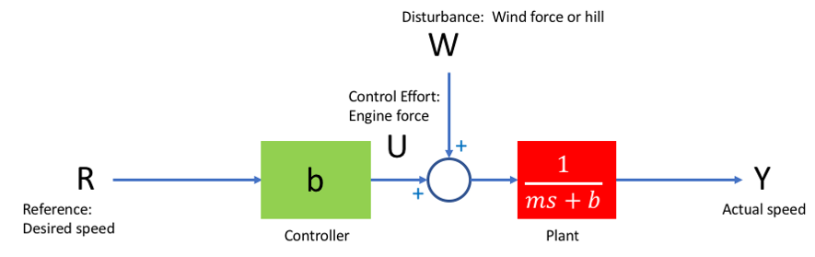

Figure 1: Open loop system. Controller just commands the engine force U = bR that would cancel friction at the desired speed R under ideal conditions (no disturbance)

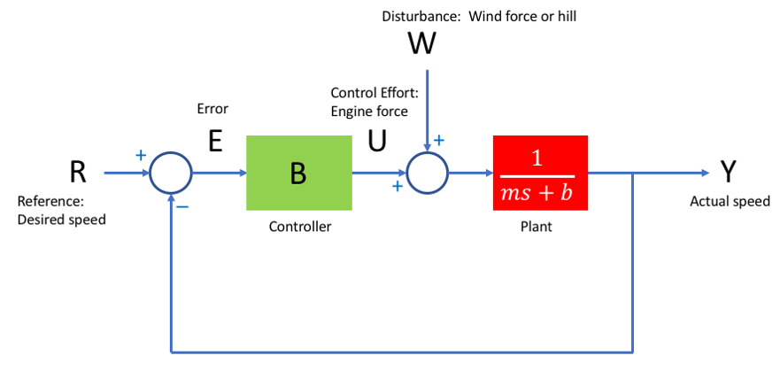

Figure 2: Closed-loop system. Controller commands engine force U = B(R-Y) based on measuring the speed Y. B is just a constant with no frequency dependence.

(a) Write the transfer function Y(s)/R(s) for the open-loop system (W=0)

(b) Write the transfer function Y(s)/R(s) for the closed-loop system (W=0)

(c) Write an expression for the response y(t) of the open-loop system to a 1 m/s step at the reference input R

(d) Write an expression for the response y(t) of the closed-loop system to a 1 m/s step at the reference input R

(e) Using m = 1000 kg, b = 50 N/m/s, and a controller gain of B = 500 N/m/s, plot the step responses from parts (c) and (d) for 0 < t < 100s on a common graph (using Matlab, Mathematica, or your favorite tool)

(f) Note that the closed-loop system responds faster, but does not settle to the right value. Show that the steady state error 1-y(∞) = 1/(1+B/b).

(g) (a) Write the transfer function for the controller effort, U(s)/R(s) for the open-loop system (W=0)

(h) Write the transfer function for the controller effort, U(s)/R(s) for the closed-loop system (W=0)

(i) Write an expression for the controller effort response u(t) of the open-loop system to a 1 m/s step at the reference input R

(j) Write an expression for the controller effort response u(t) of the closed-loop system to a 1 m/s step at the reference input R

(k) Using m = 1000 kg, b = 50 N/m/s, and a controller gain of B = 500 N/m/s, plot the step responses from parts (i) and (j) for 0 < t < 50s on a common graph (using Matlab, Mathematica, or your favorite tool).

(l) Write the transfer function Y(s)/W(s), describing the response of the system to a disturbance for the open-loop system (R=0)

(m) Write the transfer function Y(s)/W(s) describing the response of the system to a disturbance for the closed-loop system (R=0)

(n) Using m = 1000 kg, b = 50 N/m/s, and a controller gain of B = 500 N/m/s, plot the step responses from parts (l) and (m) for 0 < t < 50s on a common graph (using Matlab, Mathematica, or your favorite tool).