USE CASE DIAGRAM

Actors:

* Customer: The customer can be generalized as the new customer and other is registered customer.

Use Cases:

* Log In User: It is used for checking the user information for user database safety.
* Dashboard: The system has three dashboard :-

1. Find Room dashboard: Here the user can search his/her room in different Areas, Cities etc.
2. Upload Room Details Dashboard: Here user can upload a room details on database for rent.
3. Profile dashboard: Here user can view his personal information like name, email, phone number etc.

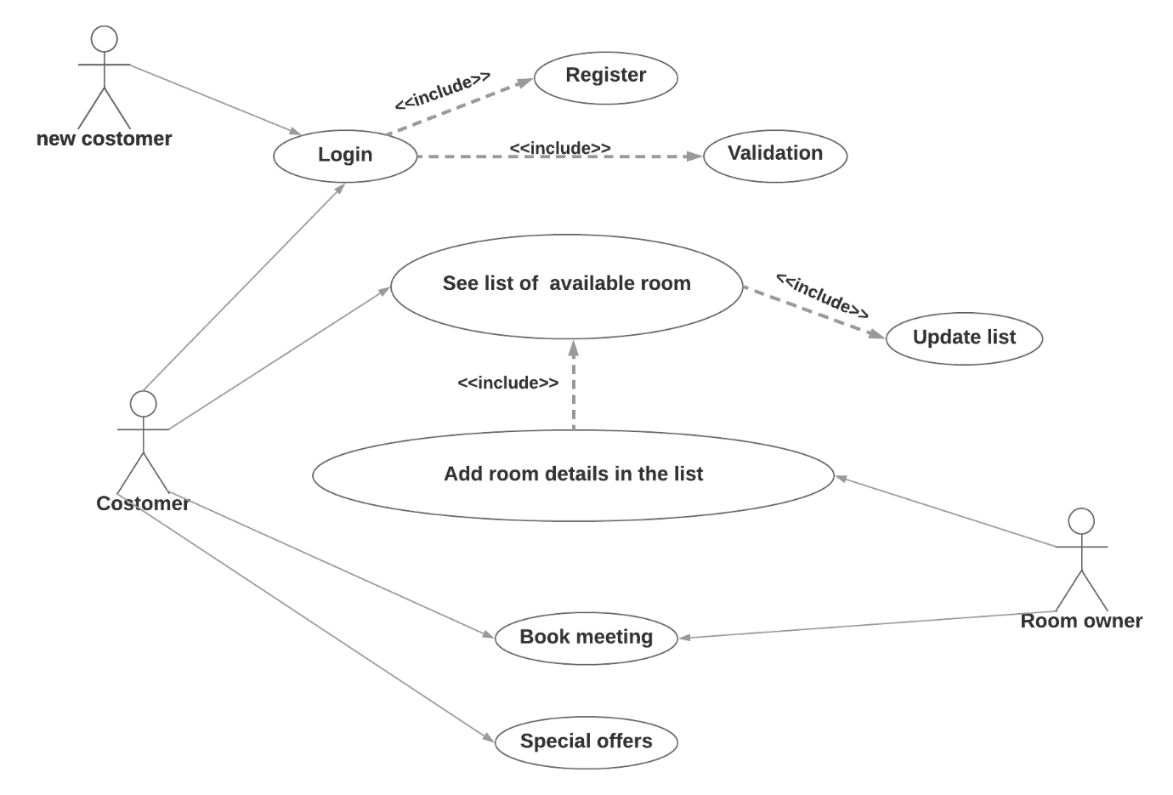

Data Flow Diagram

In Data flow diagram, there are some external and internal entities as follows:-

**External Entity:**

* Customer : Registered/unregistered customers
* System : Who is maintaining the system
* Admin(rental) : Who upload Room data for rent

**Internal Entity:**

* Dashboard:
* Find Room Dashboard
* Upload Room Details Dashboard
* Profile Dashboard

DFD LEVEL 0

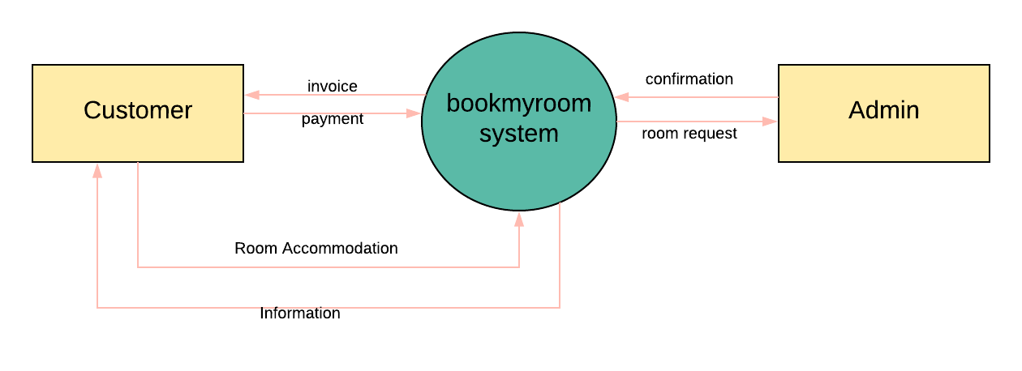

DFD LEVEL 1

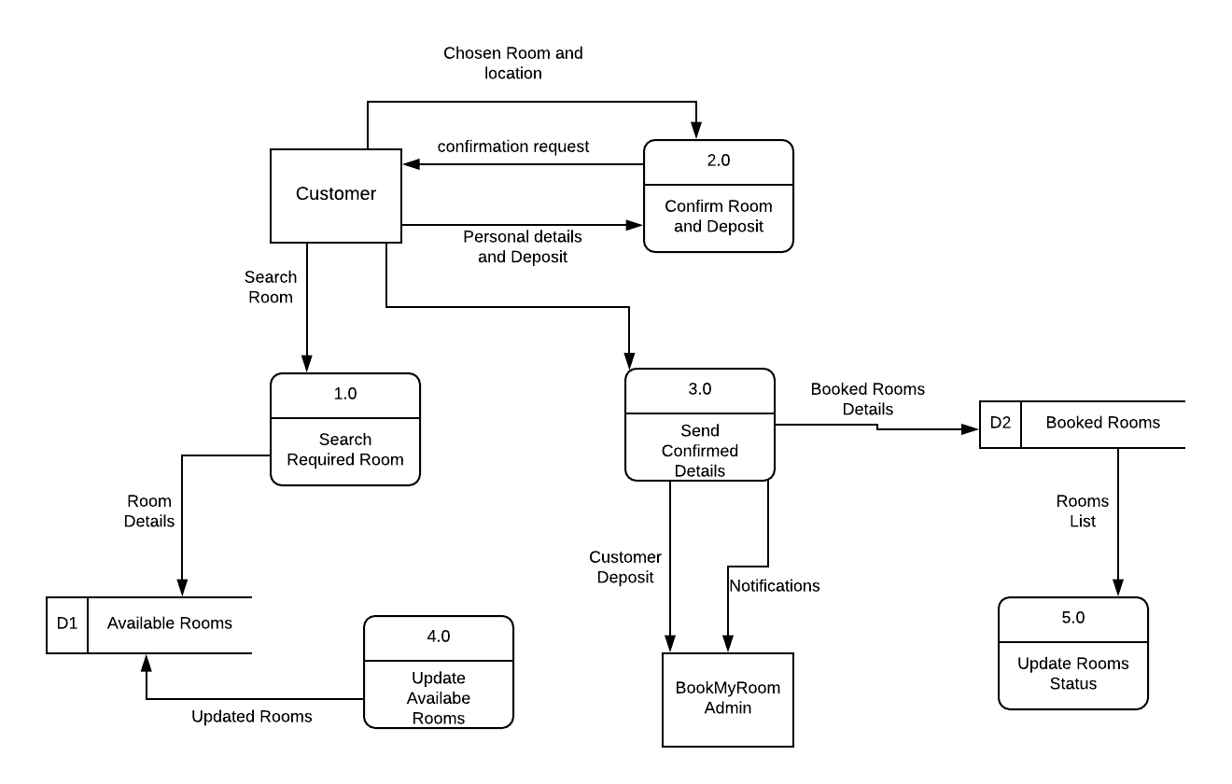

DFD LEVEL 2

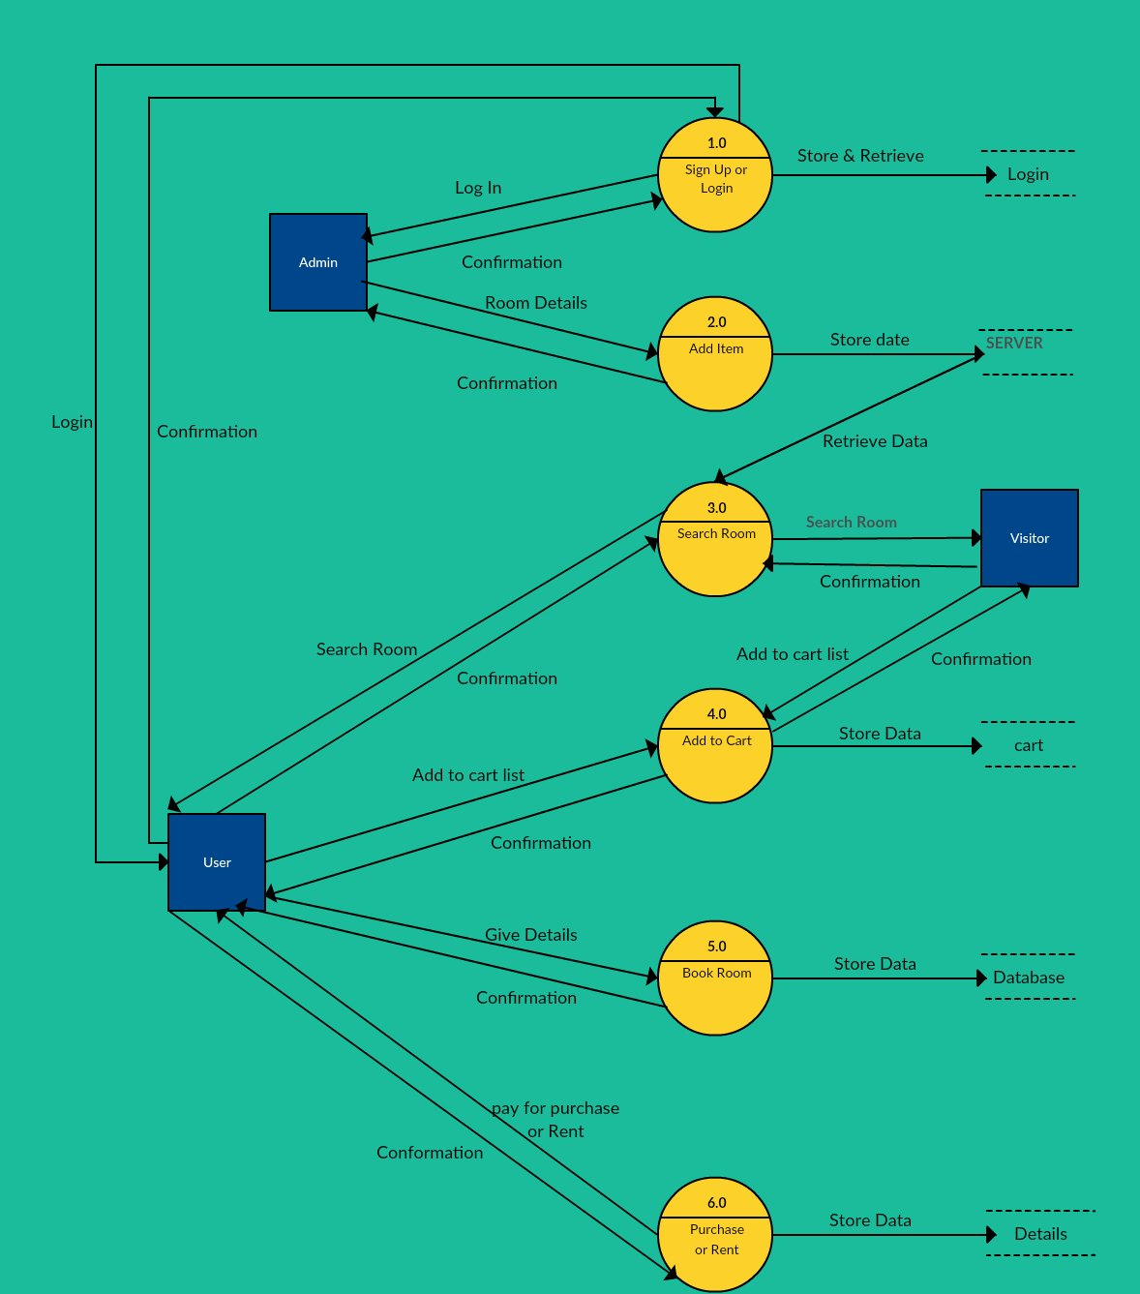

CLASS DIAGRAM

There are many classes classified and attributes in class diagram

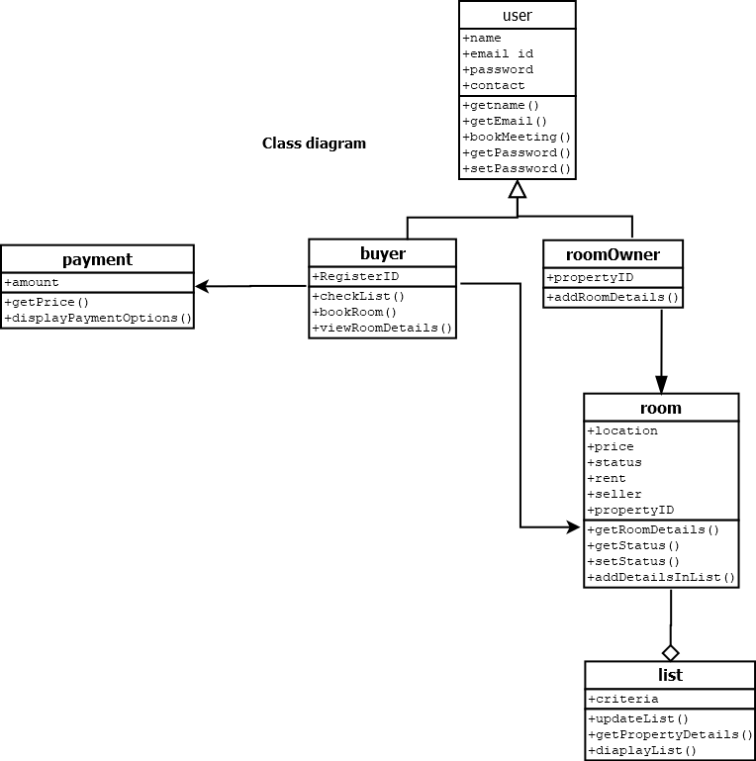

E-R DIAGRAM

