Python导论第二次作业
姓名：陶熔墅
学号：201718013727073
- 编程实现
本作业操作系统为Linux Deepin, 代码编辑器为Vim，Python版本为Anaconda3中的Python3.6.4，通过在Terminal中调用Python命令来运行本次作业的代码文件homework02.py完成前四大题的编程实现；并且通过在Terminal中直接调用iPython来打开其交互界面，输入命令来实现第五大题的编程实现。代码运行结果如下图所示：

前四题代码运行结果如下图所示：
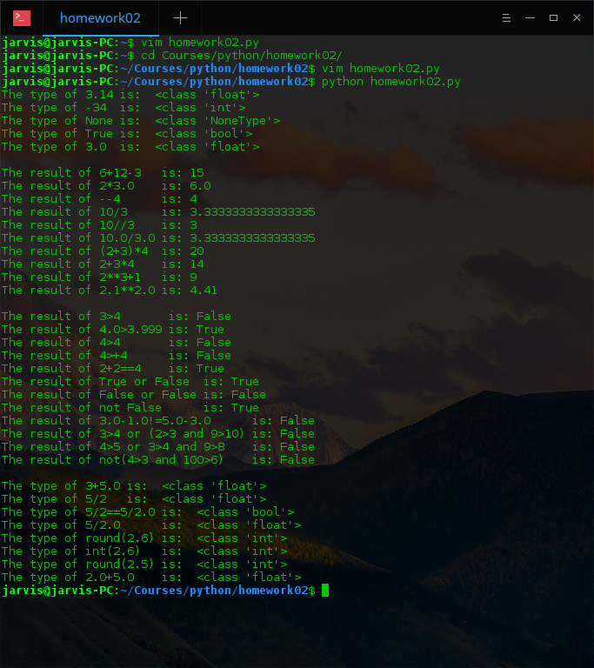

第五题代码运行结果如下：
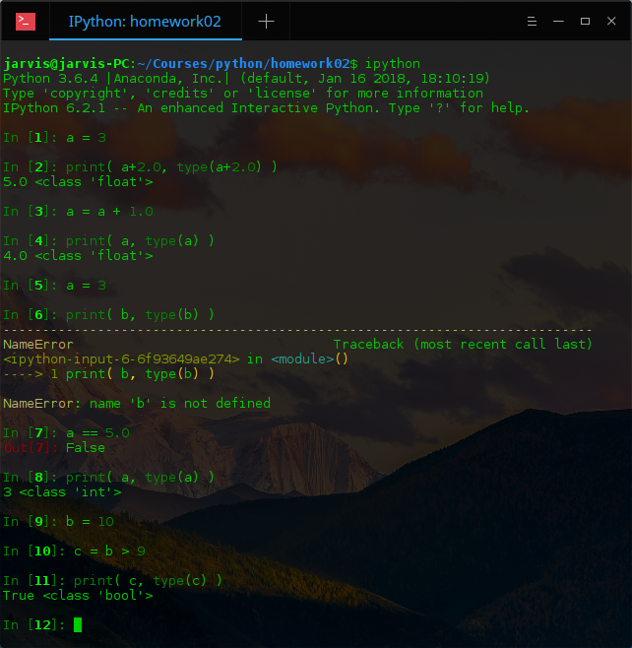

2. 代码附录
Homework02.py：
#*******************************************
print("The type of 3.14 is: ",type(3.14))
print("The type of -34 is: ",type(-34))
print("The type of None is: ",type(None))
print("The type of True is: ",type(True))
print("The type of 3.0 is: ",type(3.0))
print()
#*******************************************
print("The result of 6+12-3 is:", 6+12-3 )
print("The result of 2*3.0 is:", 2*3.0 )
print("The result of --4 is:", --4 )
print("The result of 10/3 is:", 10/3 )
print("The result of 10//3 is:", 10//3 )
print("The result of 10.0/3.0 is:", 10.0/3.0)
print("The result of (2+3)*4 is:", (2+3)*4 )
print("The result of 2+3*4 is:", 3+3*4 )
print("The result of 2**3+1 is:", 2**3+1 )
print("The result of 2.1**2.0 is:", 2.1**2.0)
print()
#*******************************************
print("The result of 3>4 is:", 3>4 )
print("The result of 4.0>3.999 is:", 4.0>3.999)
print("The result of 4>4 is:", 4>4 )
print("The result of 4>+4 is:", 4>+4 )
print("The result of 2+2==4 is:", 2+2==4 )
print("The result of True or False is:", True or False )
print("The result of False or False is:", False or False)
print("The result of not False is:", not False )
print("The result of 3.0-1.0!=5.0-3.0 is:", 3.0-1.0!=5.0-3.0 )
print("The result of 3>4 or (2>3 and 9>10) is:", 3>4 or (2>3 and 9>10))
print("The result of 4>5 or 3>4 and 9>8 is:", 4>5 or 3>4 and 9>8 )
print("The result of not(4>3 and 100>6) is:", not(4>3 and 100>6) )
print()
#*******************************************
print("The type of 3+5.0 is: ",type(3+5.0))
print("The type of 5/2 is: ",type(5/2 ))
print("The type of 5/2==5/2.0 is: ",type(5/2==5/2.0))
print("The type of 5/2.0 is: ",type(5/2.0 ))
print("The type of round(2.6) is: ",type(round(2.6)))
print("The type of int(2.6) is: ",type(int(2.6) ))
print("The type of round(2.5) is: ",type(round(2.5)))
print("The type of 2.0+5.0 is: ",type(2.0+5.0 ))
print("The type of 5*2==5.0*2.0 is: ",type(5*2==5.0*2.0))

