Lab Practical #08:
Study Packet capture and header analysis by Wireshark (HTTP, TCP, UDP, IP, etc.)
Practical Assignment #08:
- Give details about usage of Wireshark tool.
Wireshark is a network protocol analyzer used to capture and analyze network packets. It helps in understanding network communication and troubleshooting network problems.
Uses of Wireshark:
- Captures live network traffic.
- Analyzes protocols such as HTTP, HTTPS, TCP, UDP, IP, DNS and ICMP.
- Inspects packet headers and source/destination addresses.
- Analyzes TCP 3-way handshake (SYN, SYN-ACK, ACK).
- Observes DNS requests and responses.
- Analyzes ICMP packets generated by ping.
- Helps in network troubleshooting and security analysis.
Thus, Wireshark is an important tool for studying and analyzing network communication.
- Packet capture and header analysis by Wireshark (HTTP, TCP, UDP, IP, etc.)
- Study Packet capture and header analysis by wire-shark.
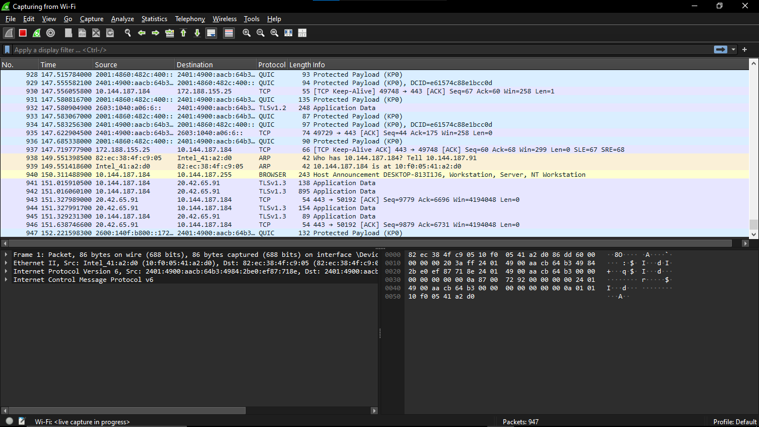
  - Capturing and observe Live Traffic – Use any website.

- Applying Capture Filters:
  - HTTP traffic: http
    - For HTTP - Inspect request and response headers, URLs, and status codes.
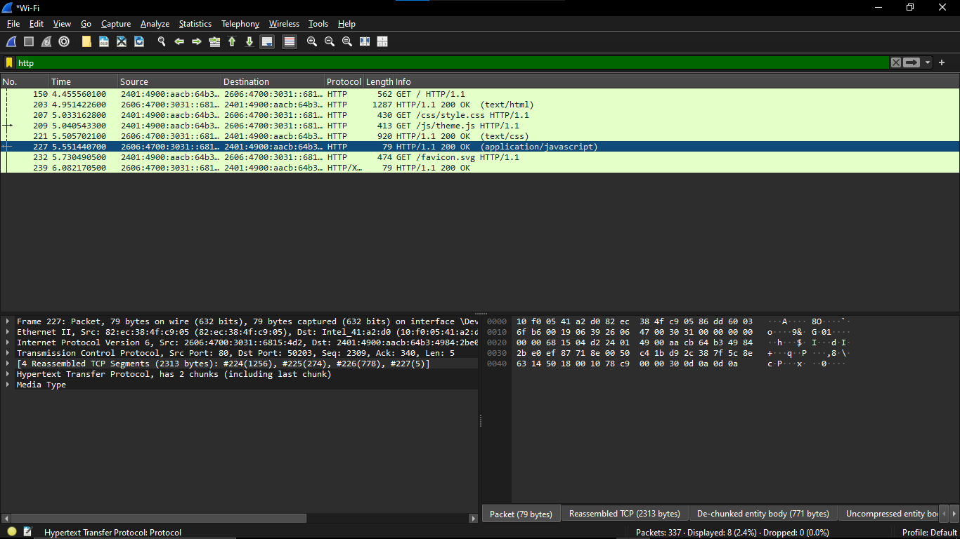
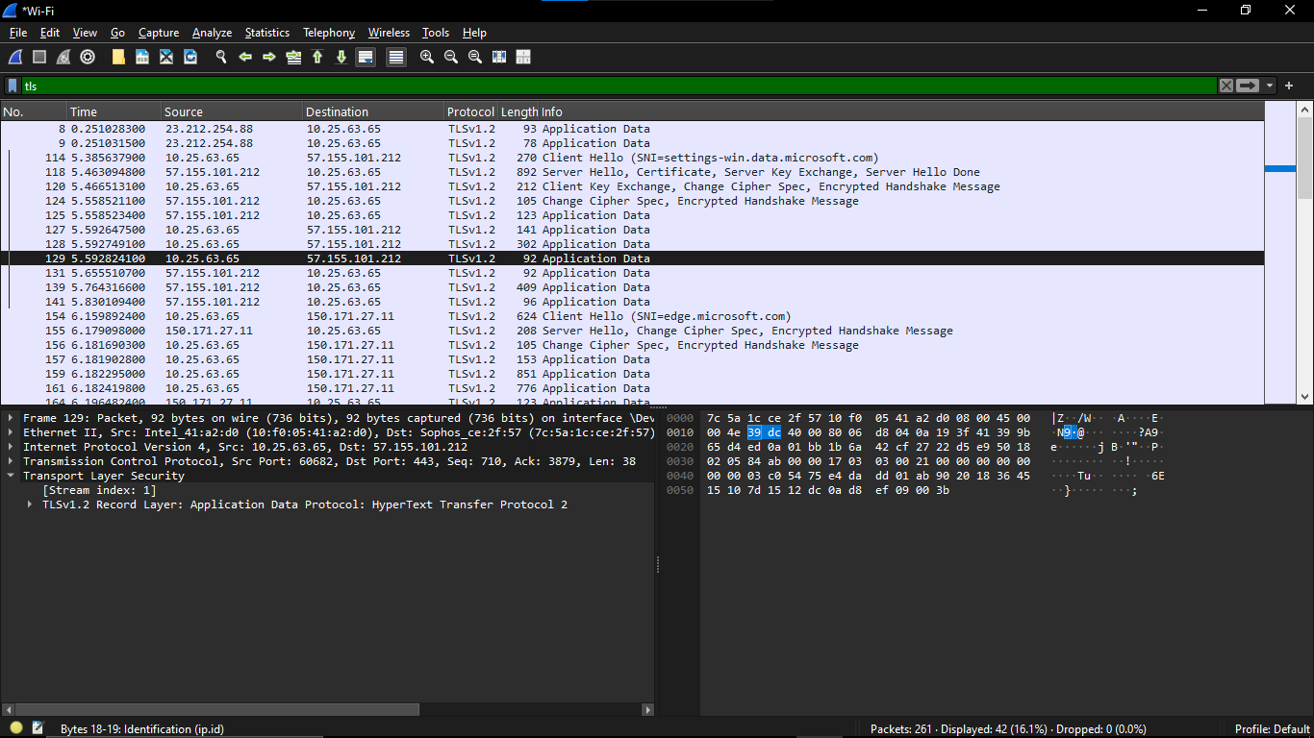
    - For HTTPS, observe the handshake process (TLS).

  - DNS requests: dns
    - Observe how domain names are translated into IP addresses.
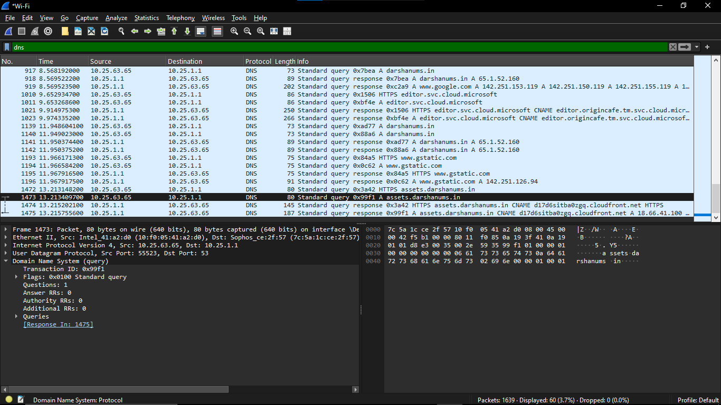
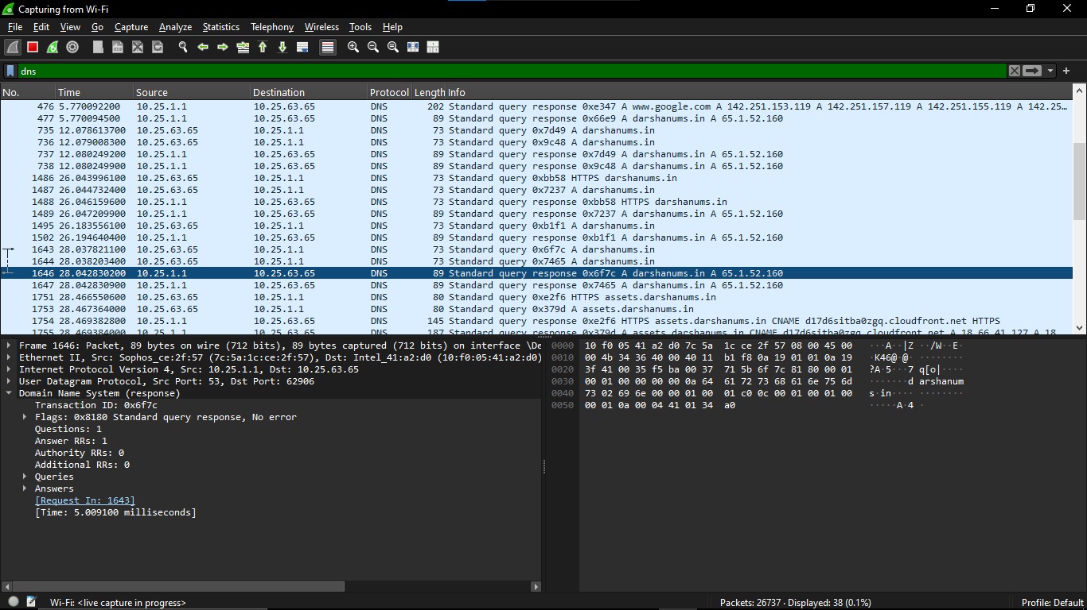
    - Identify DNS request and response packets.

  - TCP packets: tcp
    - Observe the 3-way handshake (SYN, SYN-ACK, ACK).

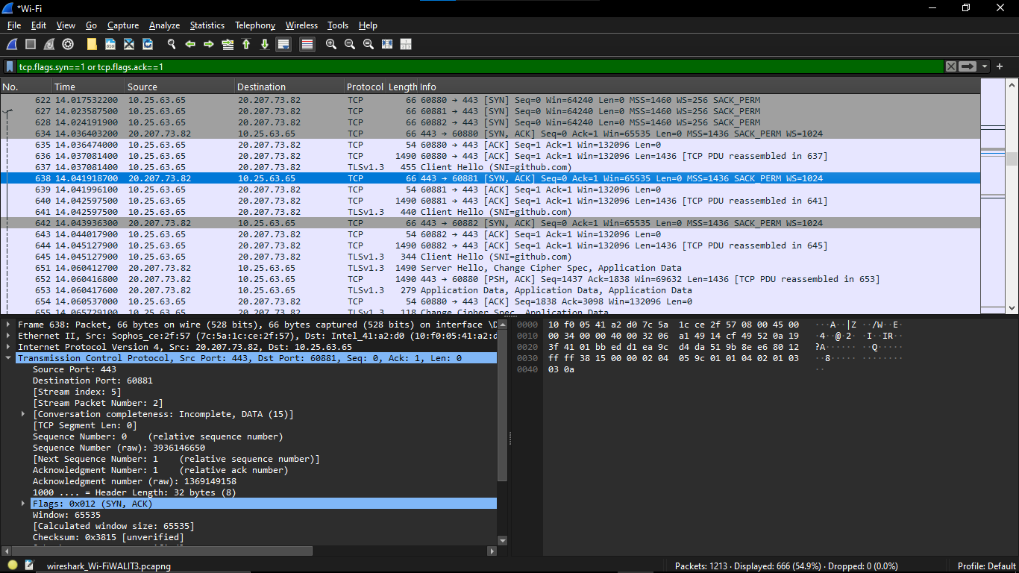
    - Identify sequence numbers and acknowledgment numbers.
  - ICMP (ping): icmp
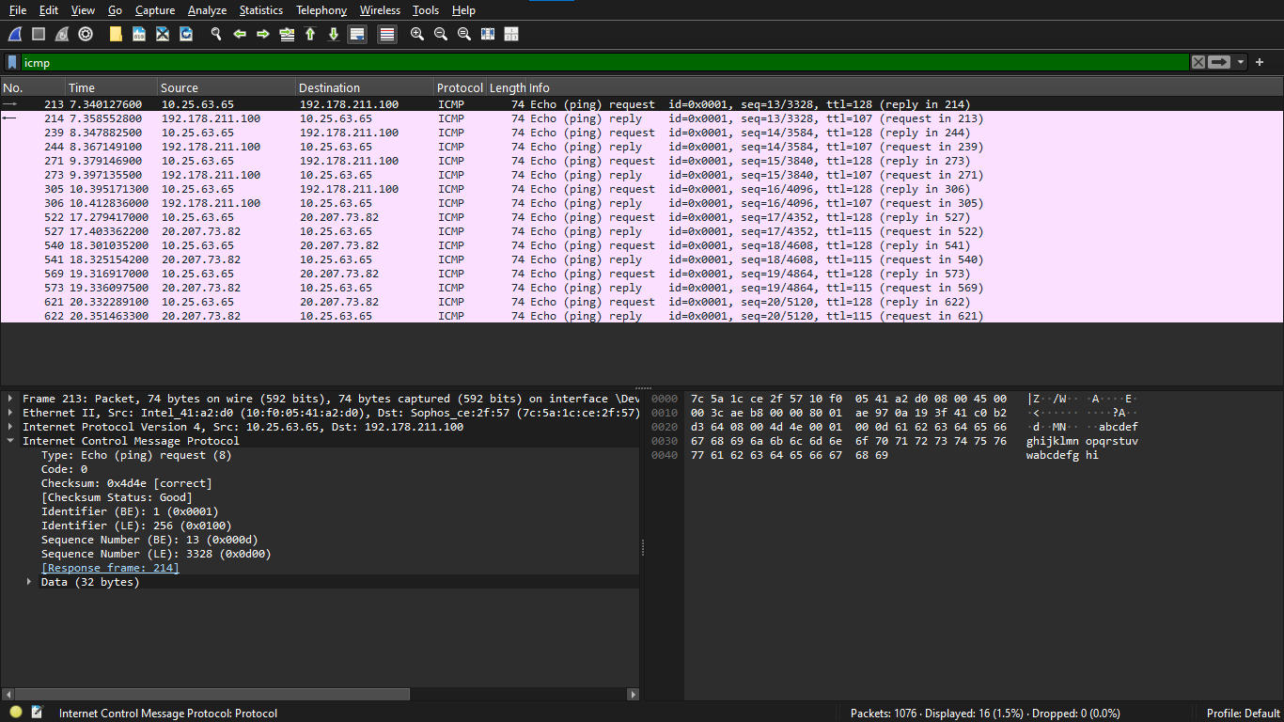
    - Send ping requests (ping google.com) and observe request/reply packets.

