Lab Practical #03:
Study of different types of network cables & connectors and crimping a LAN.
Practical Assignment #02:
- List various networks cable. Also, write short details and usage.
- Difference between guided and unguided media.
- Give cross-wired cable and straight through cable diagram (Color Code wise).

List various networks cable and connectors. Also, write short description.
- Twisted Pair Cables:
  - Description: It is physical media made up of pair of cables twisted with each other. The frequency range for cable is from 0 to 3.5KHz. Widely used in different kinds of data and voice infrastructure. The use of two wires twisted together helps to reduce crosstalk and electromagnetic induction.
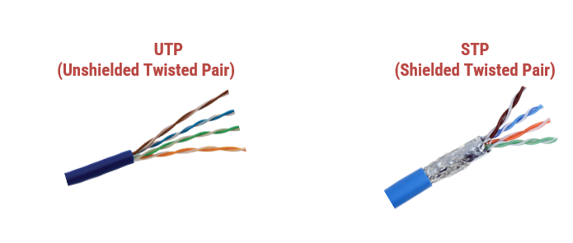
  - Diagram:

- Coaxial Cables:
  - Description: It is outer conductor is braided shield and Inner conductor is solid metal. The middle core responsible for the data transferring whereas the copper mesh prevents from the EMI (Electromagnetic interference). It used in television and long distance telephone transmission.it has excellent noise immunity and higher frequency as compared to Twisted pair cable.
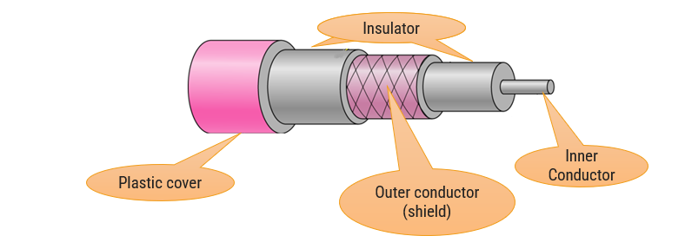
  - Diagram:
- Fiber Optic Cables:
  - Description: It is made of glass or plastic which is called “core” and transmits signals in the form of light. Core is surrounded by a cladding of less dense glass or plastic. It uses reflection to guide light through a channel. It provides faster data transmission, and carries data at a longer distance as compared to copper wire. It is used in high bandwidth network.
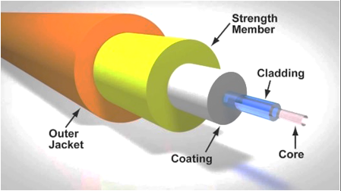
  - Diagram:

- Difference between guided and unguided media.
Guided media | Unguided media
The guided media is also called wired communication or bounded transmission media. | The unguided media is also called wireless communication or unbounded transmission media.
Used to perform point-to-point communication. | Unguided media is generally suited for radio broadcasting in all directions.
Discrete network topologies are formed by the guided media. | Continuous network topologies are formed by the unguided media.
Signals are in the form of voltage, current, or photons in the guided media. | Signals are in the form of electromagnetic waves in unguided media.
For a shorter distance, this is the best option. | For longer distances, this method is used.

Give cross-wired cable and straight through cable diagram & usage (Color Code wise).
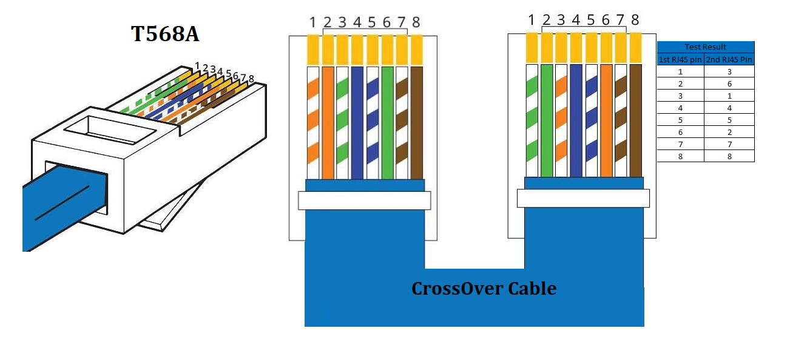
- Cross-wired Cable Diagram (Color Code)
Source: Ethernet Cable Color Coding and Crimping Guide - SwitchFirewall

Purpose: Crossover cables are found primarily on connections between similar devices like two computers or two switches. A difference between straight-through and crossover cables is that the order of the wires differs at each end of the cable. This will allow communication of devices indicating if they are transmitting or receiving by crossovering' the 'Tx' and 'Rx' so that data can be obtained by both similar devices.
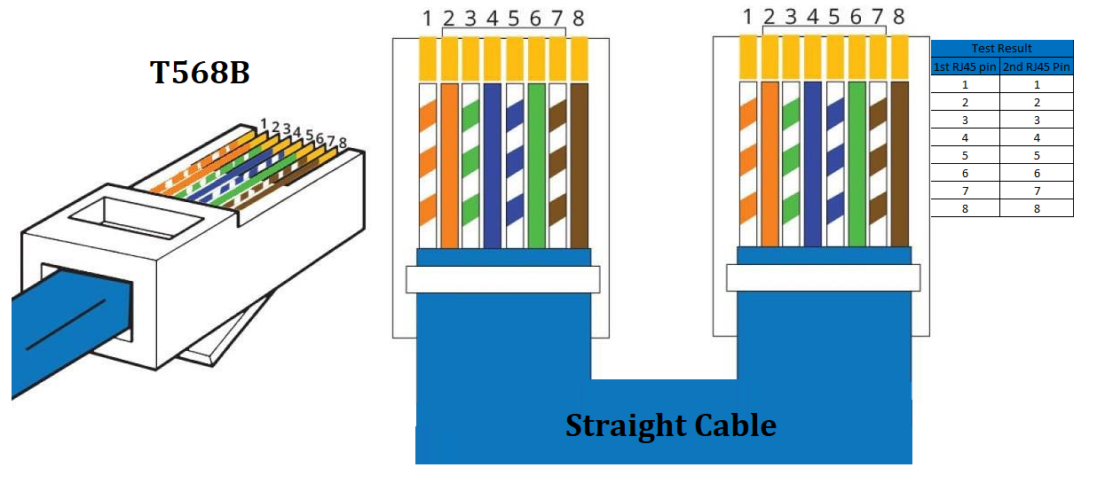
- Straight Through Cable Diagram (Color Code)
Source: Ethernet Cable Color Coding and Crimping Guide - SwitchFirewall
Purpose: It is used in connecting between two different devices, for example, from the computer to the router, a straight-through cable will be needed. There are no left or right constrictions on the straight-through cable, as both ends have the same wiring signals, so the wires correspond to the same pins at the other end, too. In such a way, the transceiver protocol can be set up in such a manner that the information is transmitted from one device to another without any need for manual configuration.

