Lab Practical #12:
Study the concept of routing using packet tracer. (Dynamic Routing)
Practical Assignment #12:
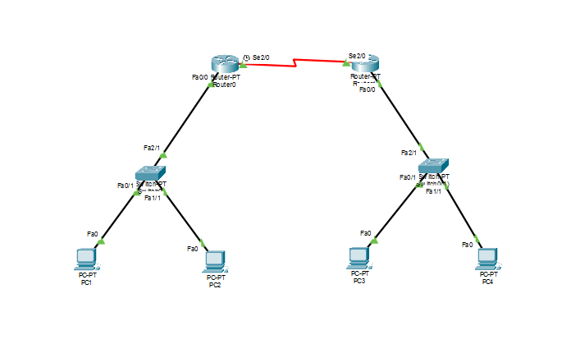
- Connect the two different routers based on the calculated IP addresses and subnet using a packet tracer.

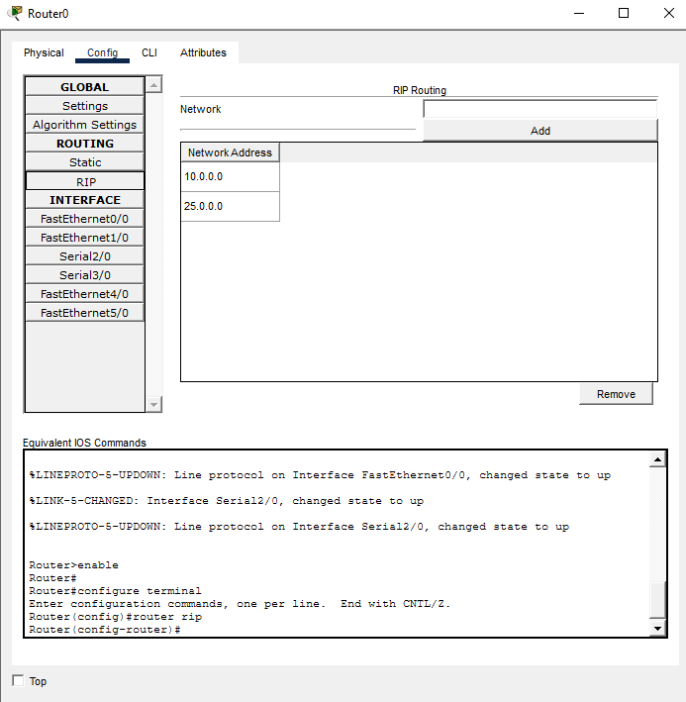
IP address | Network ID
10.0.0.2 | 10.0.0.1
10.0.0.3 | 10.0.0.1
192.168.0.2 | 192.168.0.1
192.168.0.3 | 192.168.0.1
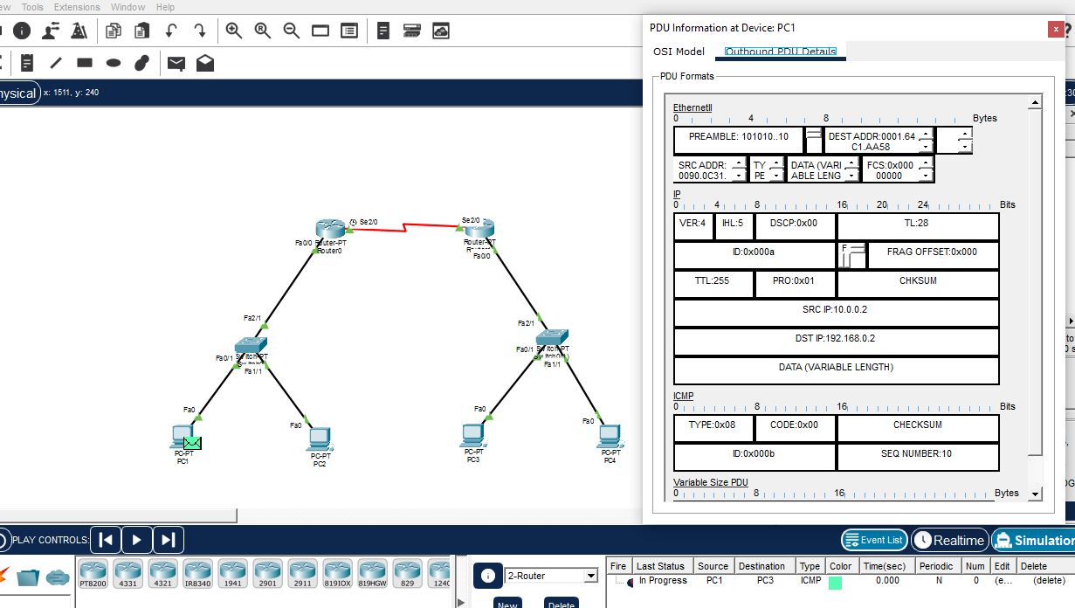

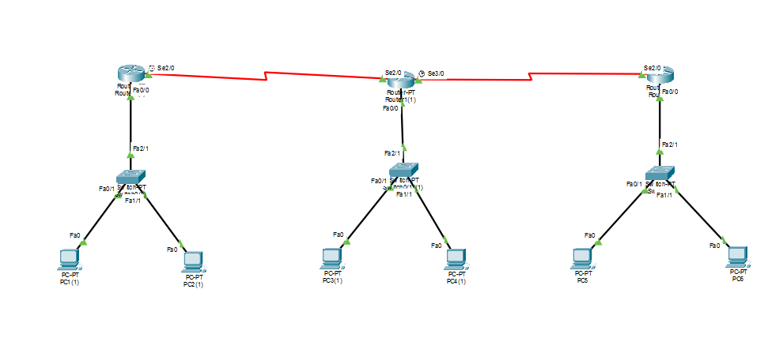
- Connect the three different routers based on the calculated IP addresses and subnet using a packet tracer.
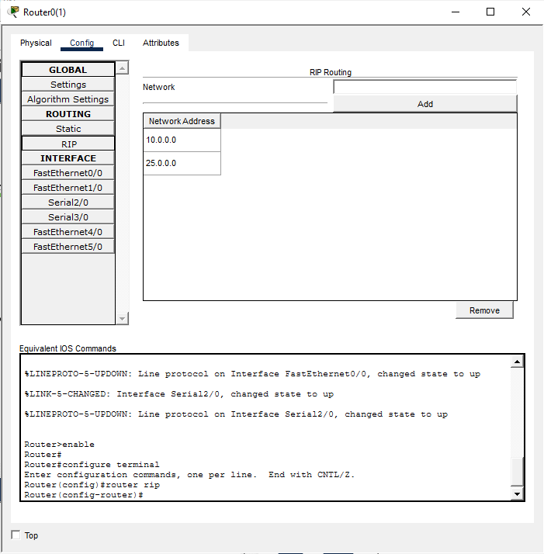
IP address | Network ID
10.0.0.2 | 10.0.0.1
10.0.0.3 | 10.0.0.1
192.168.0.2 | 192.168.0.1
192.168.0.3 | 192.168.0.1
123.0.0.2 | 123.0.0.1
123.0.0.3 | 123.0.0.1
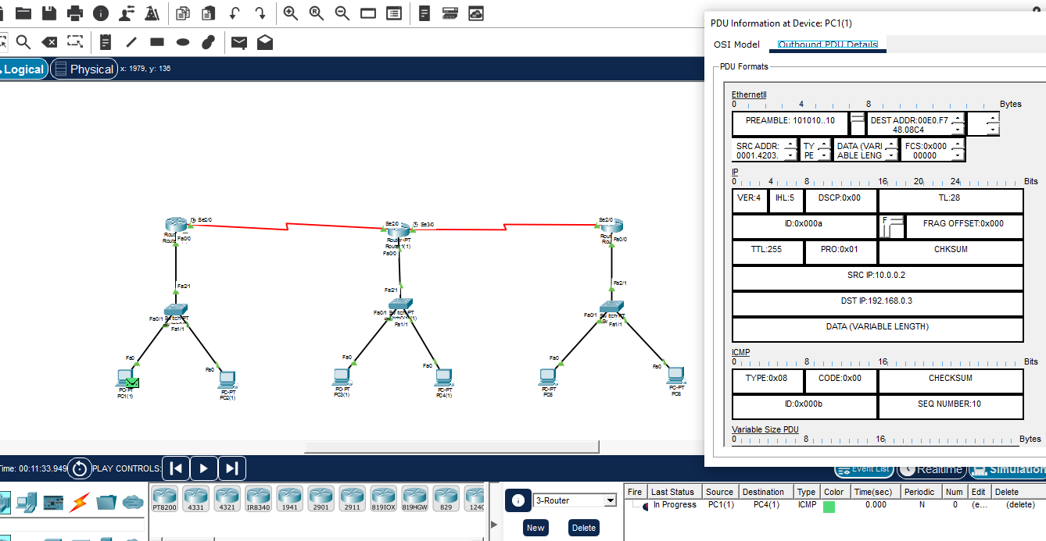

- Connect the five different routers based on the calculated IP addresses and subnet using a packet tracer.
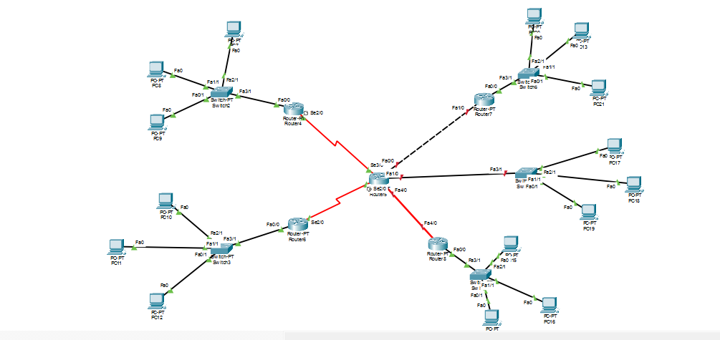
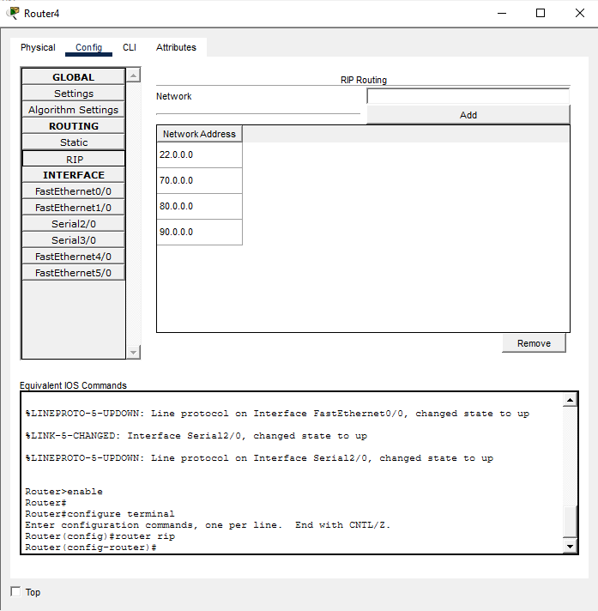

IP address | Network ID
22.0.0.2 | 22.0.0.1
22.0.0.3 | 22.0.0.1
22.0.0.4 | 22.0.0.1
33.0.0.2 | 33.0.0.1
33.0.0.3 | 33.0.0.1
33.0.0.4 | 33.0.0.1
44.0.0.2 | 44.0.0.1
44.0.0.3 | 44.0.0.1
44.0.0.4 | 44.0.0.1
55.0.0.2 | 55.0.0.1
55.0.0.3 | 55.0.0.1
55.0.0.4 | 55.0.0.1
66.0.0.2 | 66.0.0.1
66.0.0.3 | 66.0.0.1
66.0.0.4 | 66.0.0.1

To do Instructions:
- RIP routing screenshot with routing table.
- Mention IP address table of each node and network ID of each network.
- Ping command / Packet (PDU) transfer screenshot between two different network nodes.
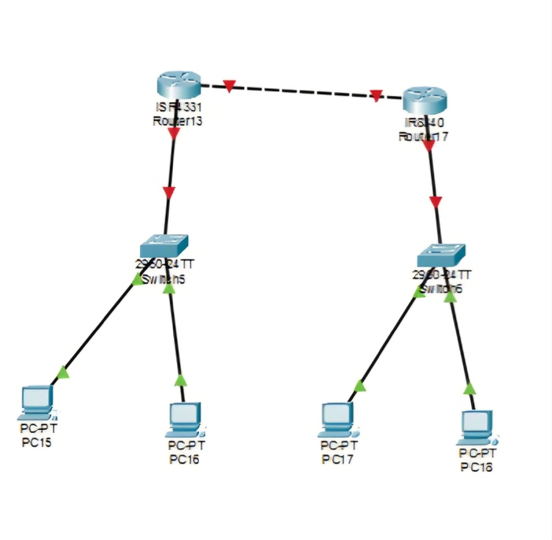 | 