Lab Practical #11:
Study the concept of routing using packet tracer. (Static Routing)
Practical Assignment #11:
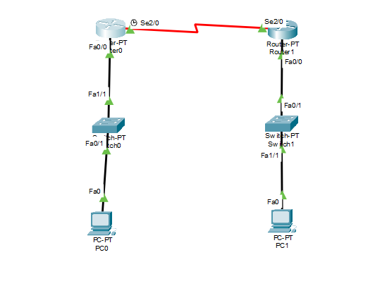
- Connect the two different routers based on the calculated IP addresses and subnet using a packet tracer.
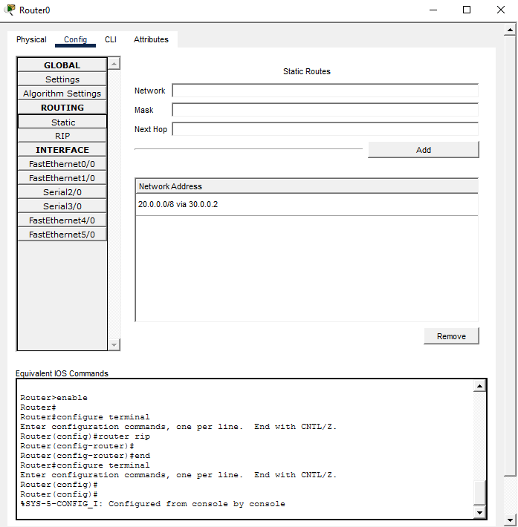

IP address | Network ID
10.0.0.2 | 10.0.0.1
20.0.0.2 | 20.0.0.1

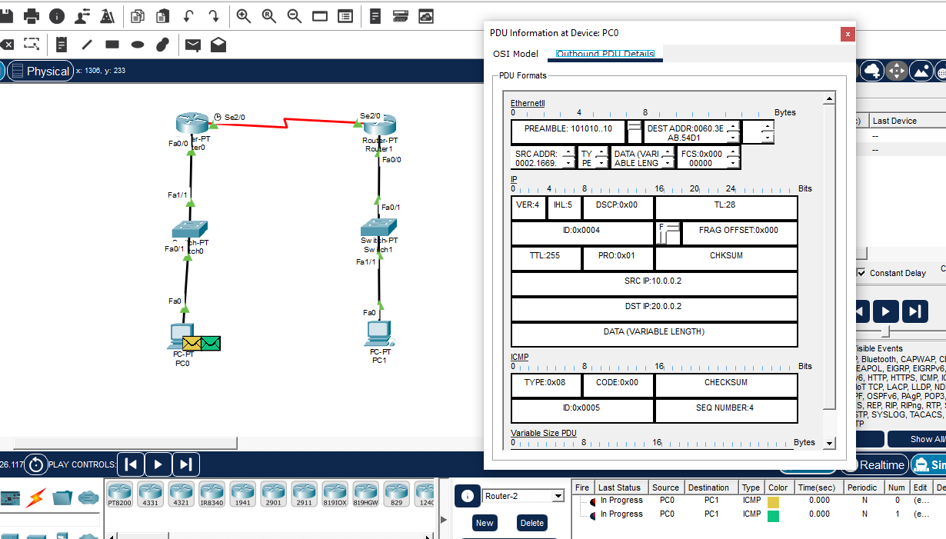
- Connect the three different routers based on the calculated IP addresses and subnet using a packet tracer.
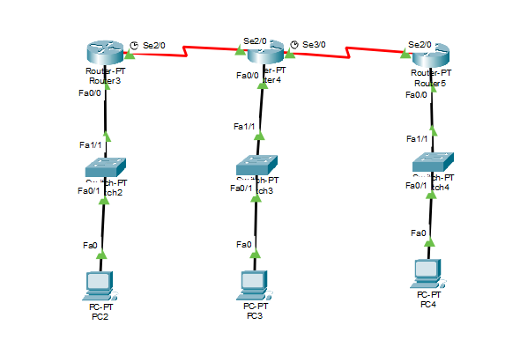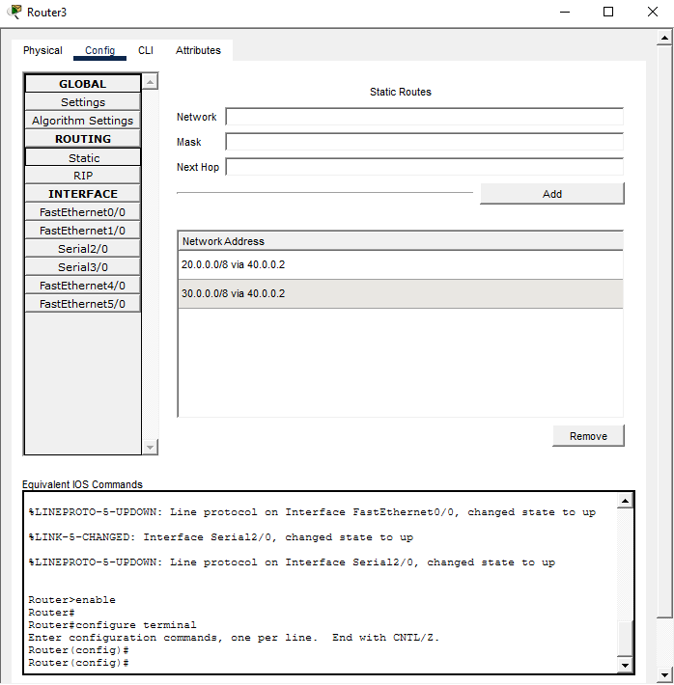

IP address | Network ID
10.0.0.2 | 10.0.0.1
20.0.0.2 | 20.0.0.1
30.0.0.2 | 30.0.0.1

To do Instructions:
- RIP routing screenshot with routing table.
- Mention IP address table of each node and network ID of each network.
- Ping command / Packet (PDU) transfer screenshot between two different network nodes.
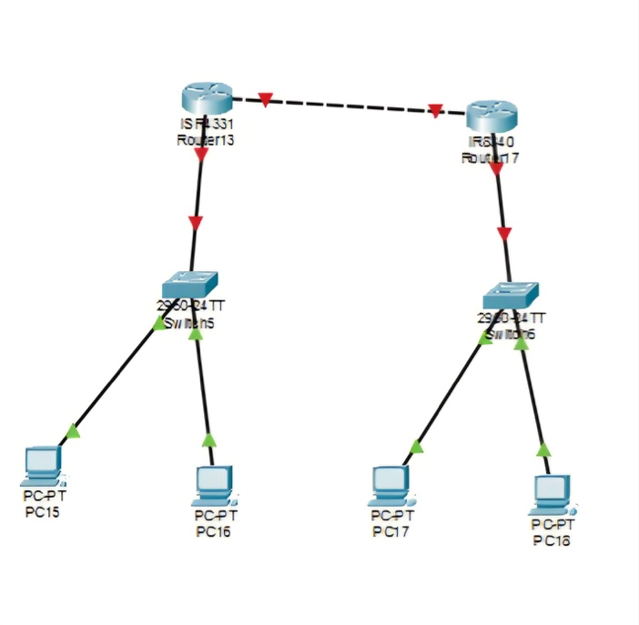 | 