Lab Practical #07:
To configure Telnet & SSH for remote connection.
Practical Assignment #07:
- To configure Telnet and SSH services on a network topology, perform remote login operations, and capture network packets to analyze security differences (plain text vs. encryption).
Instructions:
- Screenshots & Steps of:
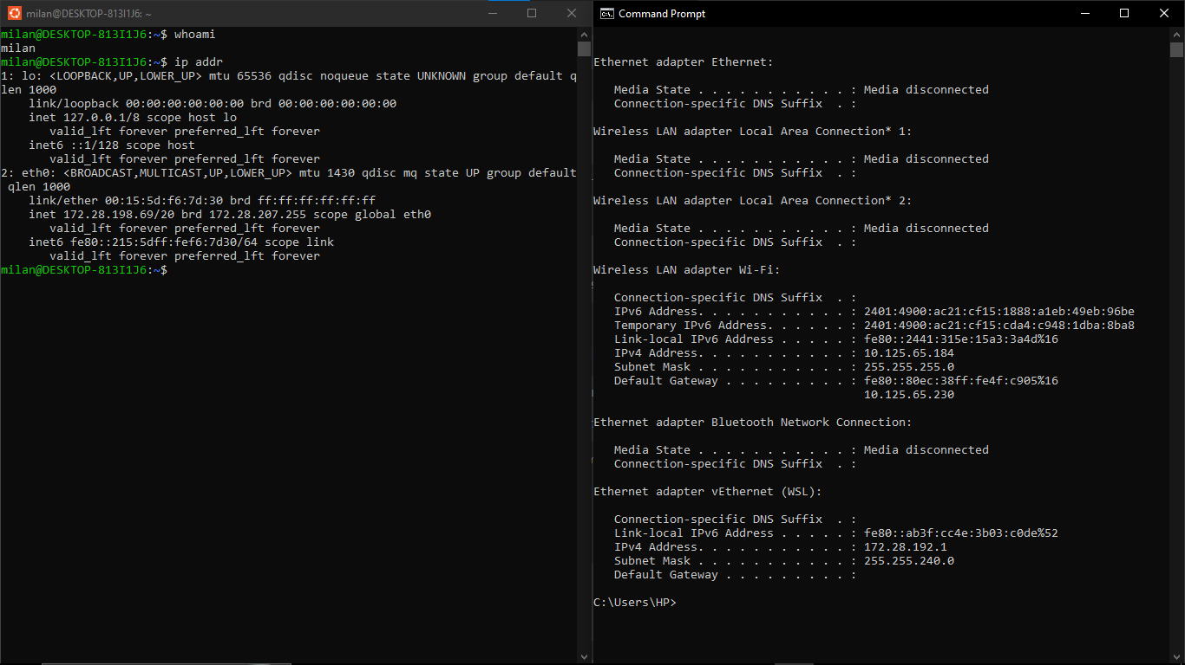
  - Your PC IP Address & Linux VM IP address

  - Successful SSH login using PuTTY
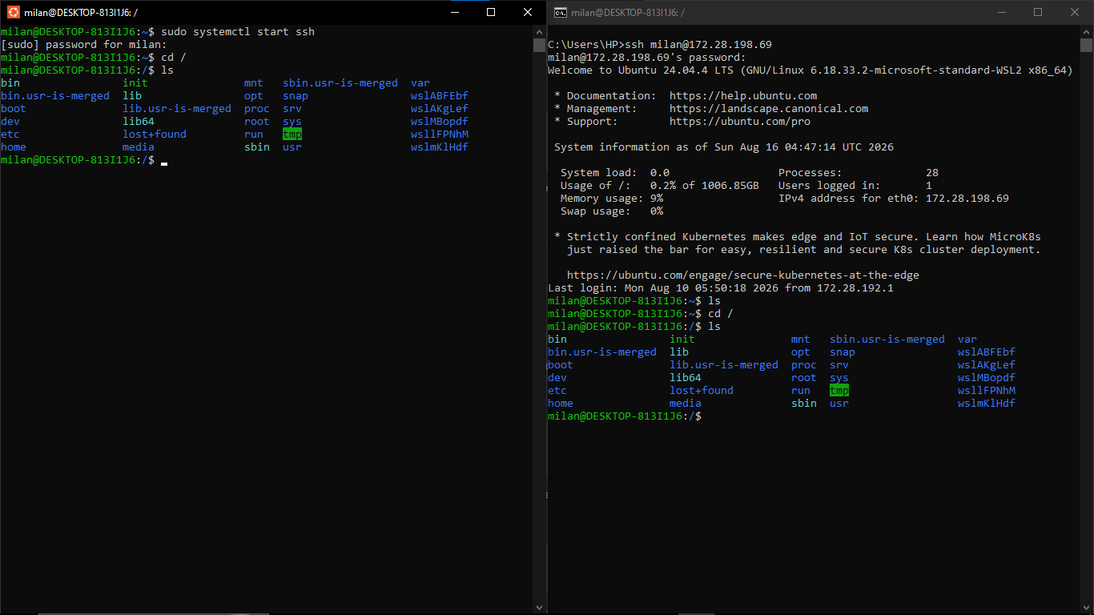
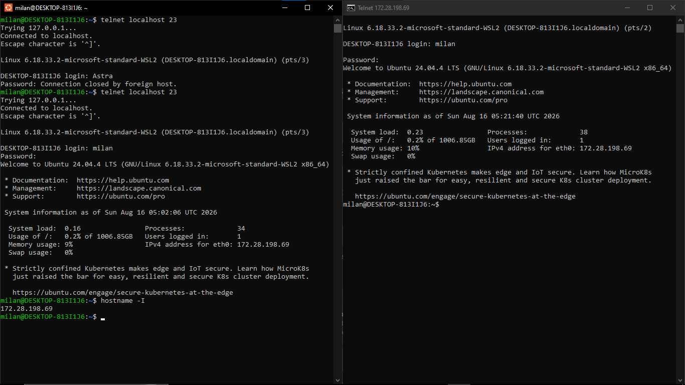
  - Successful Telnet login using PuTTY

  - Execution of Linux commands

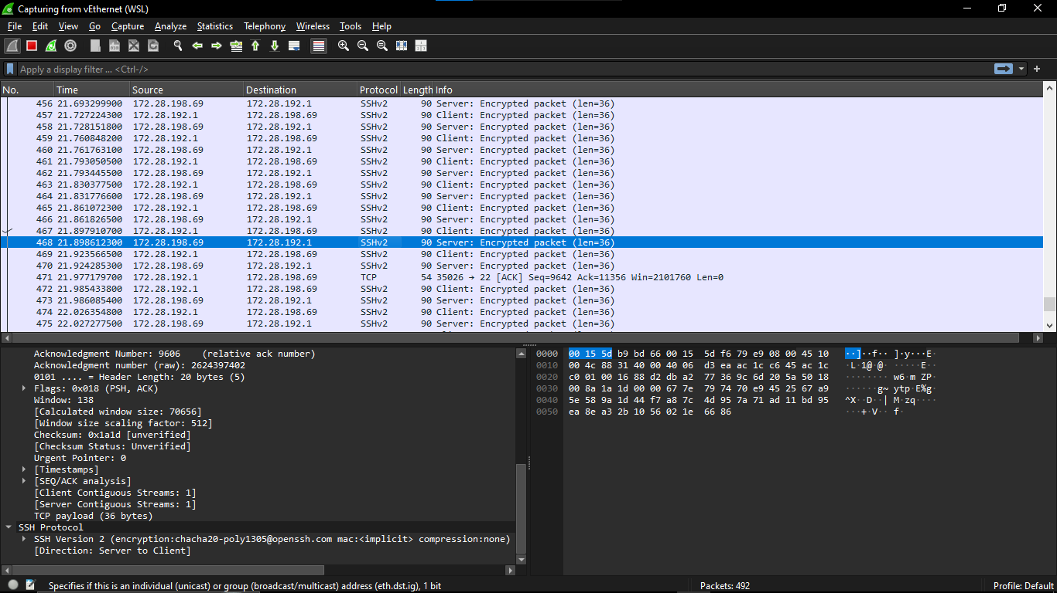
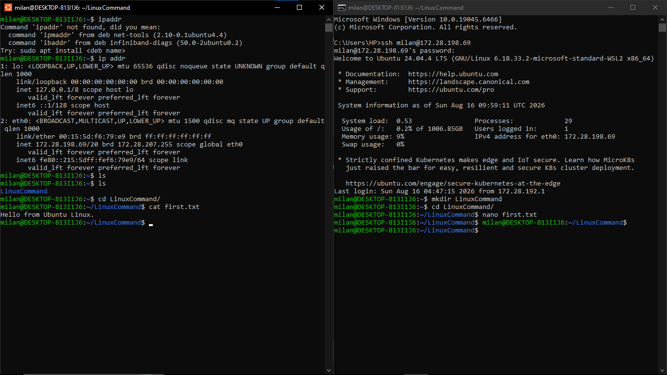
  - Capture network packets to analyze security differences between both protocols. (plain text vs. encryption).

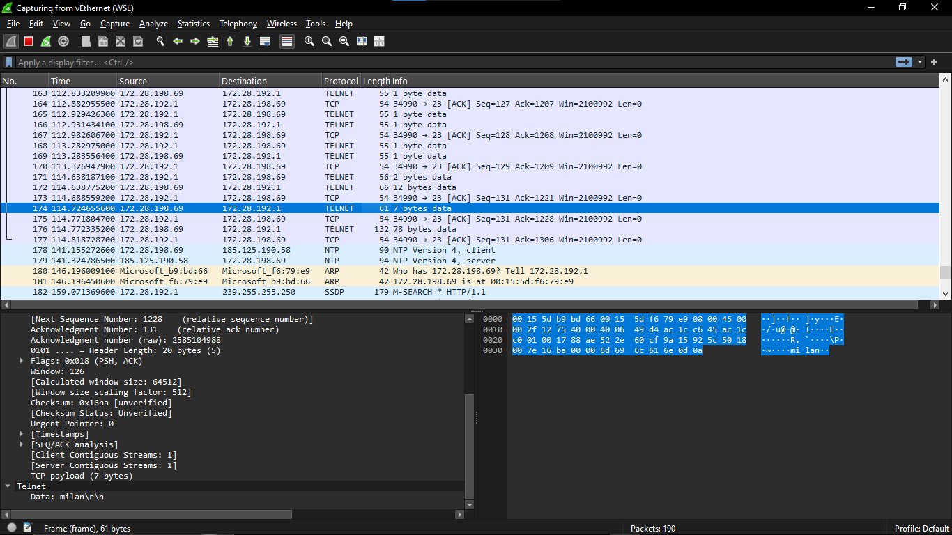

- Assignment Questions
  - Explain the difference between Telnet and SSH.
Telnet and SSH are protocols used for remote login. Telnet uses TCP port 23 and transmits data in plain text, making it insecure. SSH uses TCP port 22 and encrypts the communication between the client and server. Therefore, SSH provides better security and is preferred for remote administration.

  - Why is SSH considered more secure?
SSH is more secure because it encrypts the communication between the client and server. It protects usernames, passwords, commands, and other data from being easily viewed during network packet capture. In our practical, Telnet data was readable in Wireshark, while SSH traffic was encrypted.

  - List the Linux commands executed during the practical and write their purpose.
The Linux commands used were:
- whoami – Displays the current logged-in user.
- hostname – Displays the system hostname.
- pwd – Displays the current working directory.
- ls – Lists files and directories.
- ip addr – Displays network interfaces and IP addresses.
- uname -a – Displays system and kernel information.

  - Explain the role of PuTTY in remote administration.
PuTTY is a remote-access application used to connect to remote computers using protocols such as SSH and Telnet. It provides a terminal through which users can log in and execute commands on a remote system. In our practical, Ubuntu terminal and Windows CMD were used instead of PuTTY.

  - Mention three real-world applications of SSH.
    - Remote server administration – Managing servers from a remote computer.
    - Secure file transfer – Transferring files securely using SFTP.
    - Cloud server management – Accessing and managing cloud-based servers remotely.

