Lab Practical #01:
Study of basic networking commands and IP configuration.
Practical Assignment #01:
- Perform and explain various networking commands listed below:
  - ipconfig
  - ping
  - getmac
  - systeminfo
  - traceroute / tracert
  - netstat
  - nslookup
  - hostname
  - pathping
  - arp
  - dig

ipconfig

Description:
These commands show your computer's complete network identity — its IP address, subnet mask, default gateway, DNS servers, and MAC address. Think of it as your computer's network ID card.
No. | Option | Description
1 | ipconfig /all | Display full configuration information.
2 | ipconfig /release | Release the IPv4 address for the specified adapter.
3 | ipconfig /renew | Renew the IPv4 address for the specified adapter.
4 | ipconfig /displaydns | Display the contents of the DNS Resolver Cache.
5 | ipconfig / allcompartments | Displays all the information about all compartments.

Implementation:

1. ipconfig /all
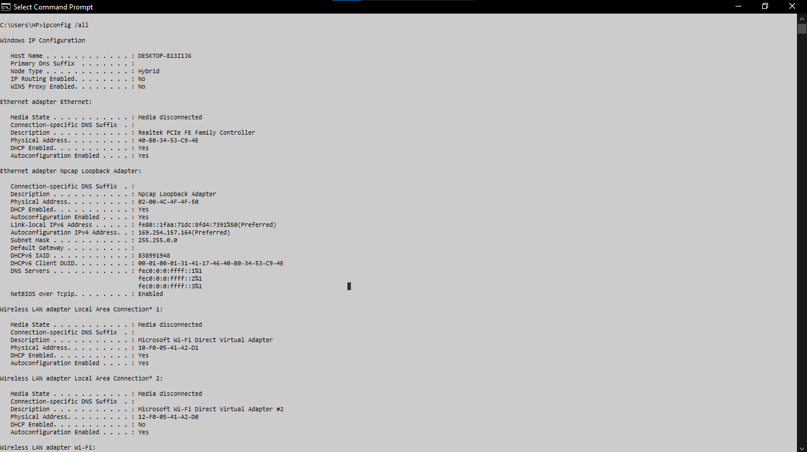

2. ipconfig /release
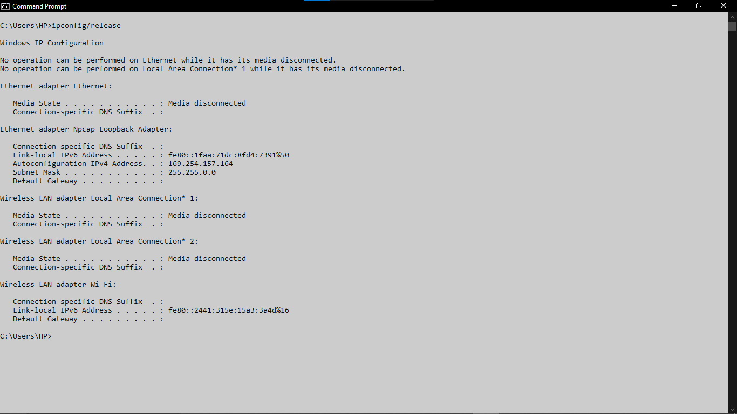

3. ipconfig /renew
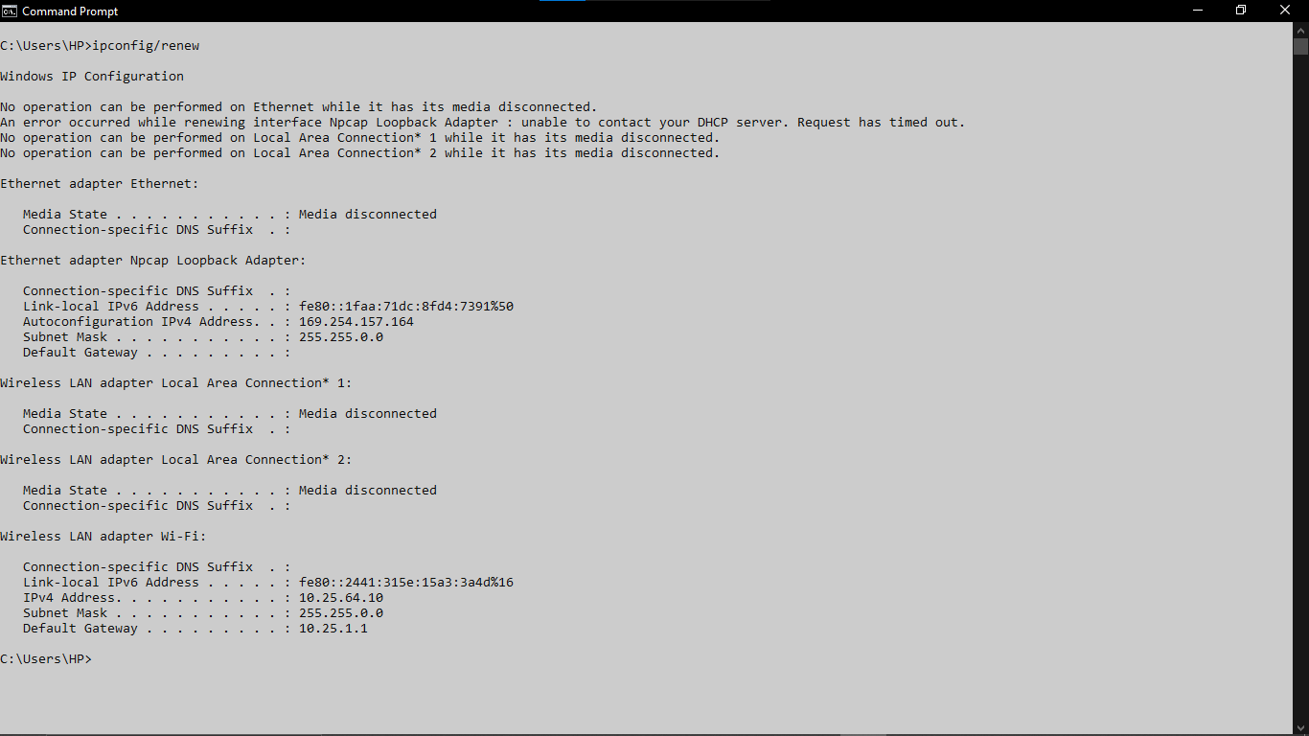

4. ipconfig /displaydns
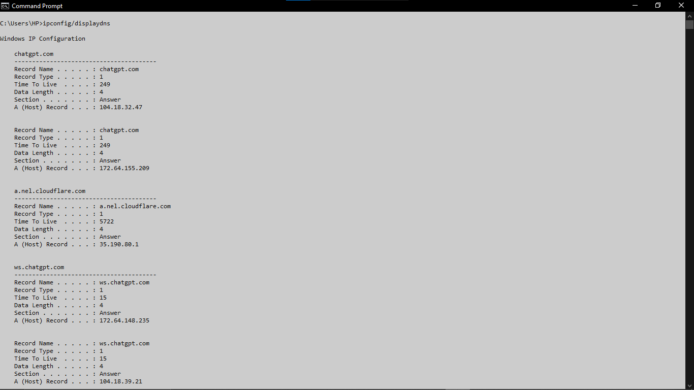

5. ipconfig /allcompartments
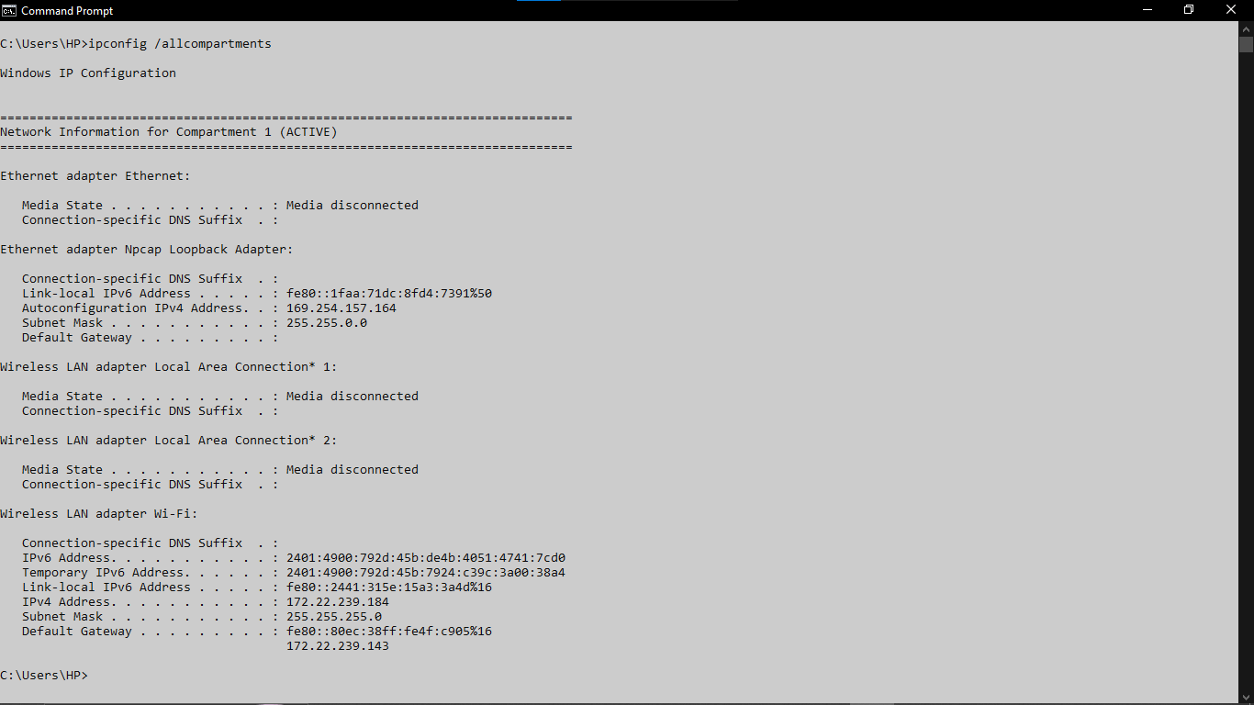

ping

Description:
ping sends small data packets to a target and waits for a reply. It checks if a device is reachable and measures how long the round-trip takes — this delay is called latency, measured in milliseconds (ms).
No. | Option | Description
1 | ping google.com -n 7 | Number of echo requests to send.(ex:7)(by default: 5)
2 | ping google.com -l 64 | Define buffer data size in bytes to send(ex: 64)(by default: 32)
3 | ping google.com -i 50 | Define TTL for data transmition to final server.
4 | ping google.com -4 | Force using IPv4
5 | ping google.com -6 | Force using IPv6

Implementation:

1. ping google.com -n 7
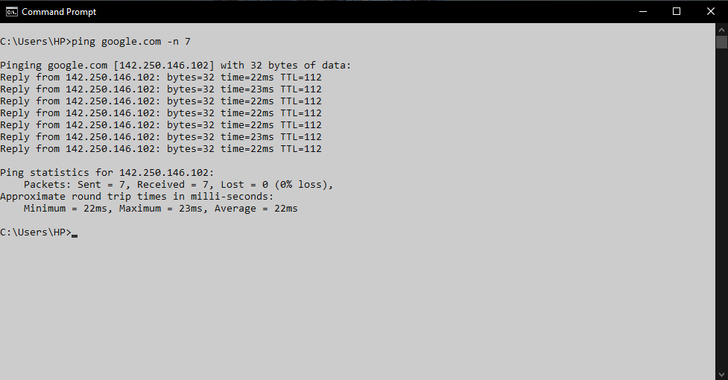

2. ping google.com -l 64
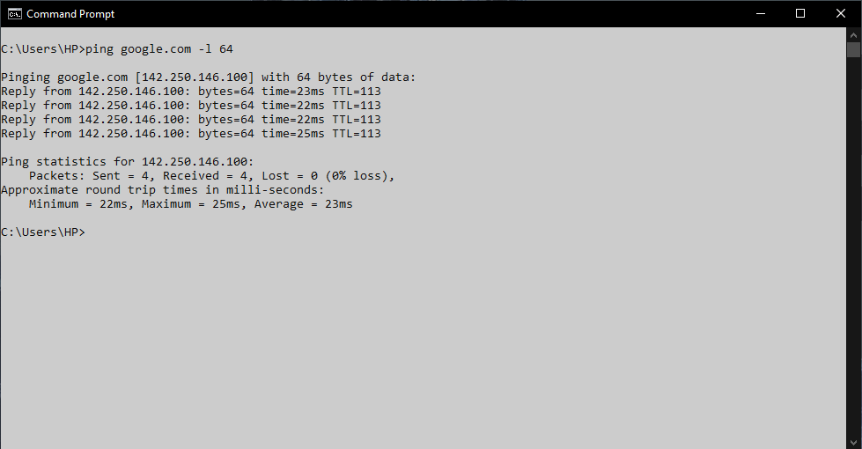

3. ping google.com -i 50
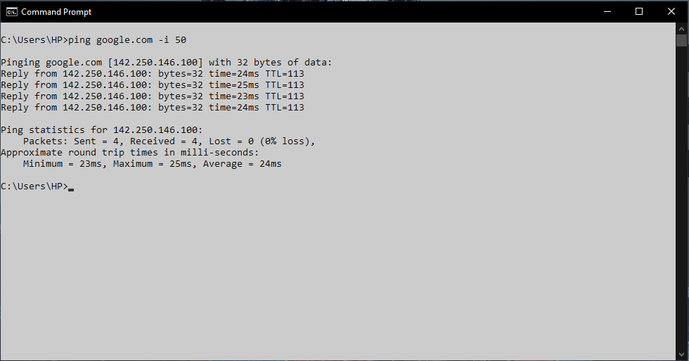

4. ping google.com -4
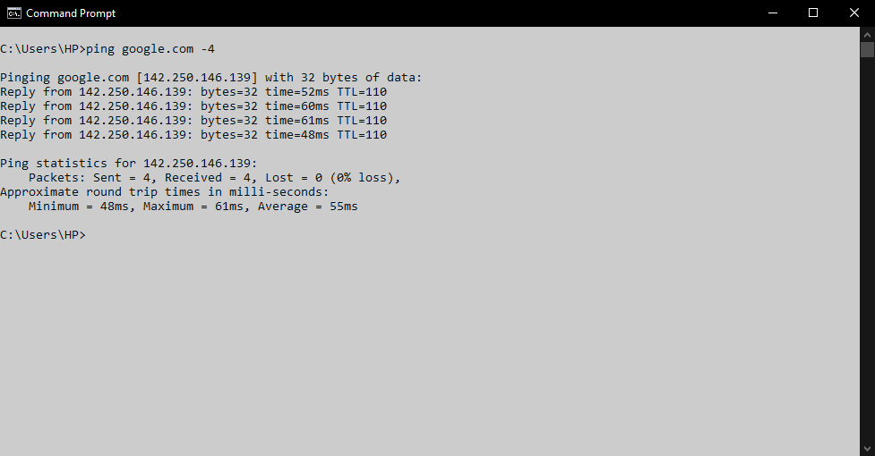

5. ping google.com -6
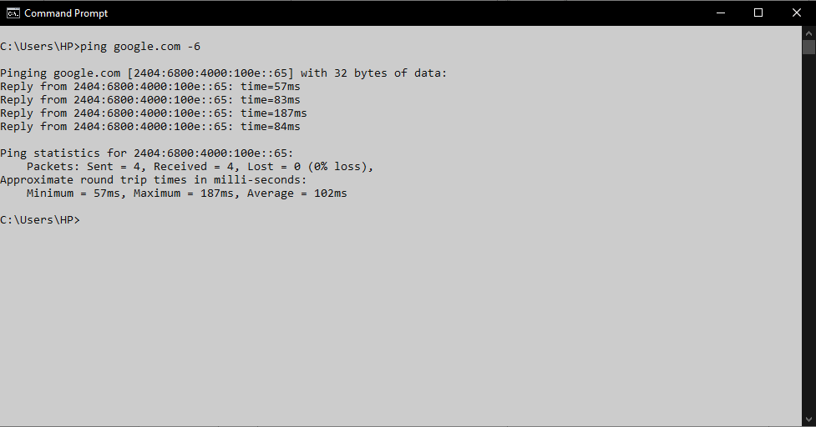

getmac

Description:
Getmac shows the MAC (Media Access Control) address of every network adapter on your system. It is the unique hardware identifier of the network card.
No. | Option | Description
1 | getmac | Displays MAC Address
2 | getmac /v | Verbose information
3 | getmac /fo list | List format
4 | getmac /fo table | Table format
5 | getmac /? | Help

Implementation:

1. getmac
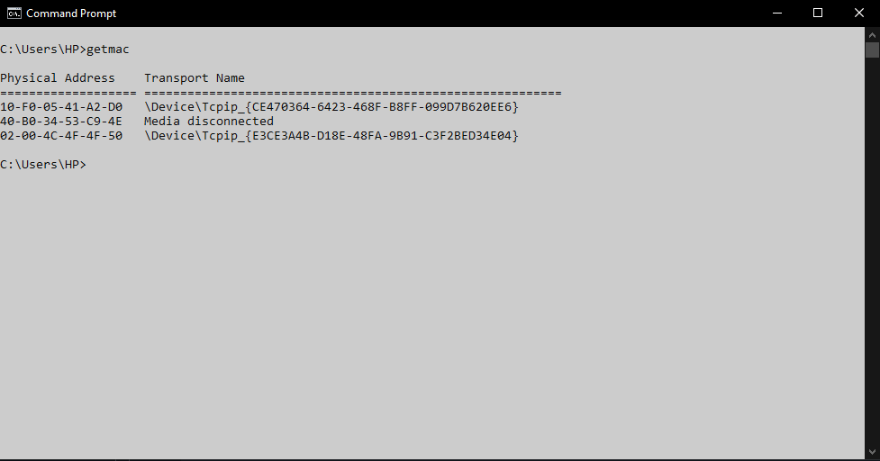

2. getmac /v
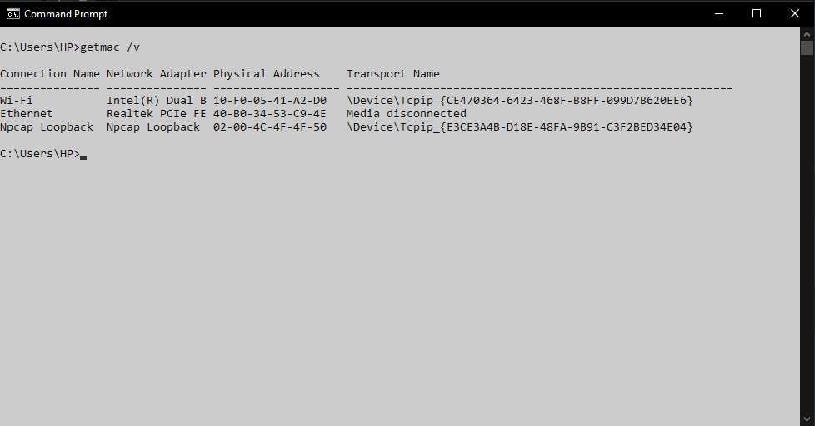

3. getmac /fo list
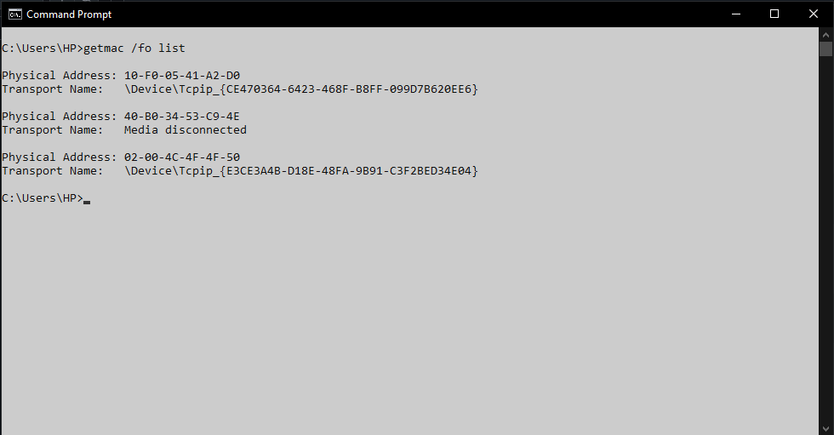

4. getemac /fo table
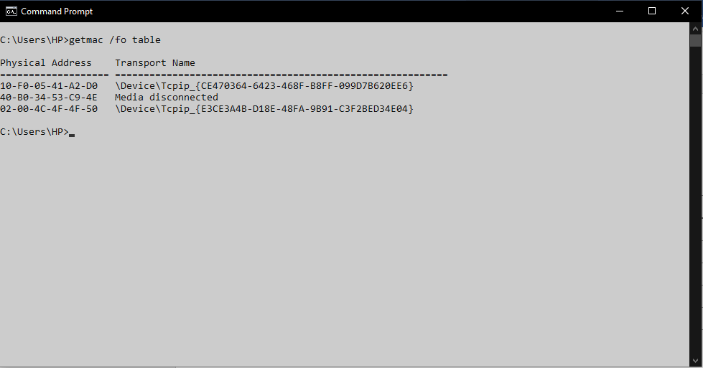

5. getmac /?
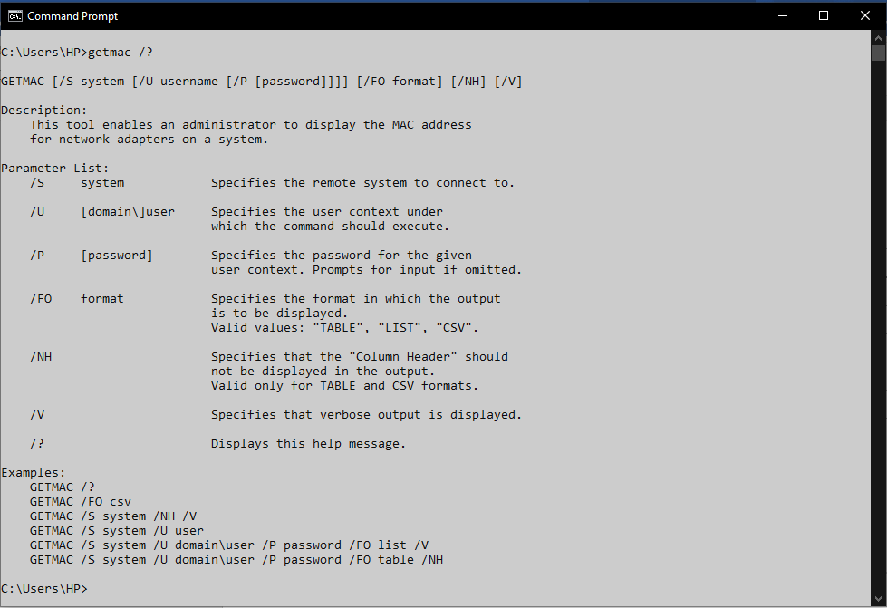

systeminfo

Description:
systeminfo gives a complete profile of the system — OS version, RAM, CPU, installed patches, and network card details. Useful for diagnosing compatibility or configuration issues.
No. | Option | Description
1 | systeminfo | Displays complete system information.
2 | systeminfo /fo list | Display information in list form.
3 | systeminfo /fo csv | Display information in CSV formate.
4 | systeminfo /s system /u user | Specifies the user context under which the command should execute.

Implementation:

1. systeminfo
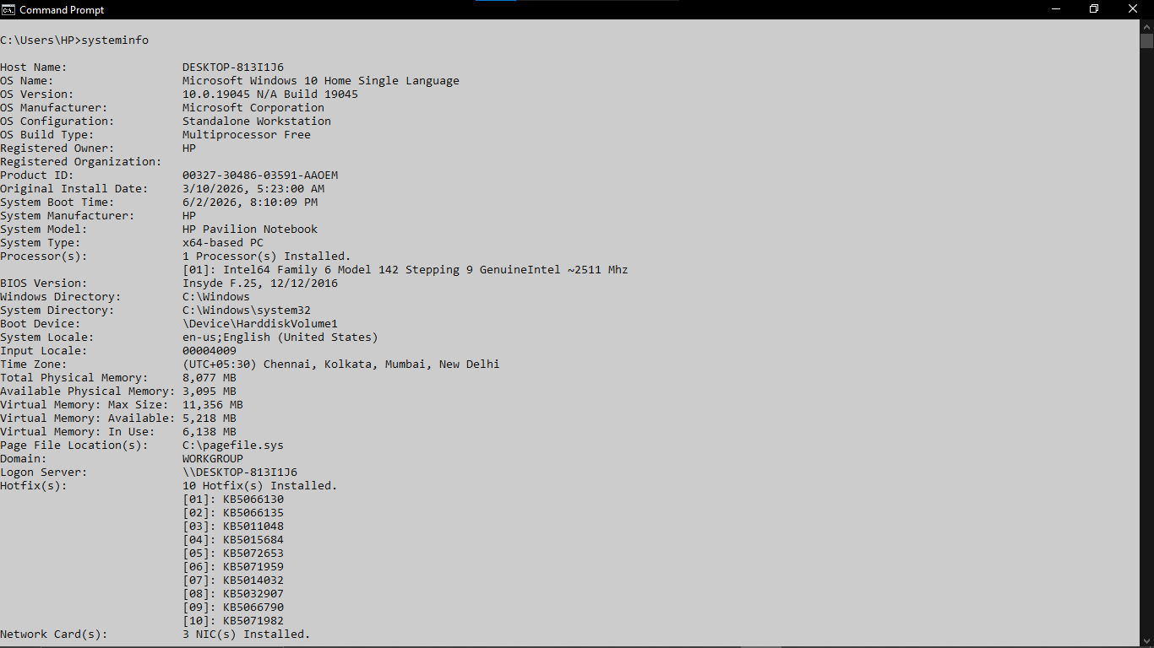

2. systeminfo /fo list
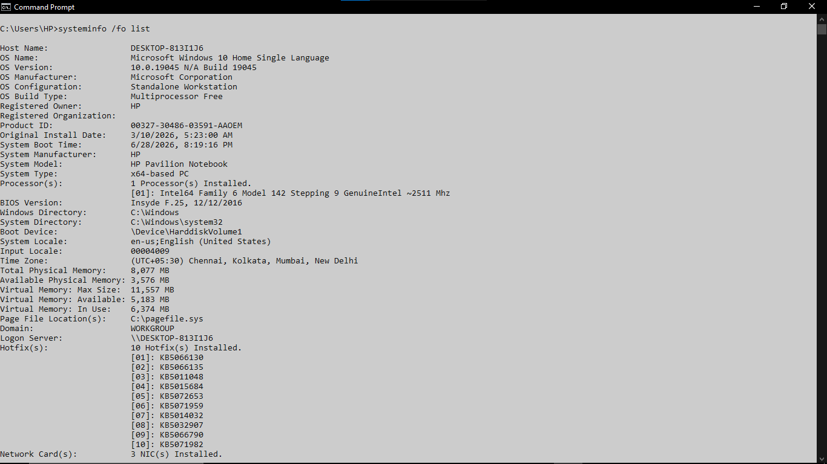

3. systeminfo /fo csv
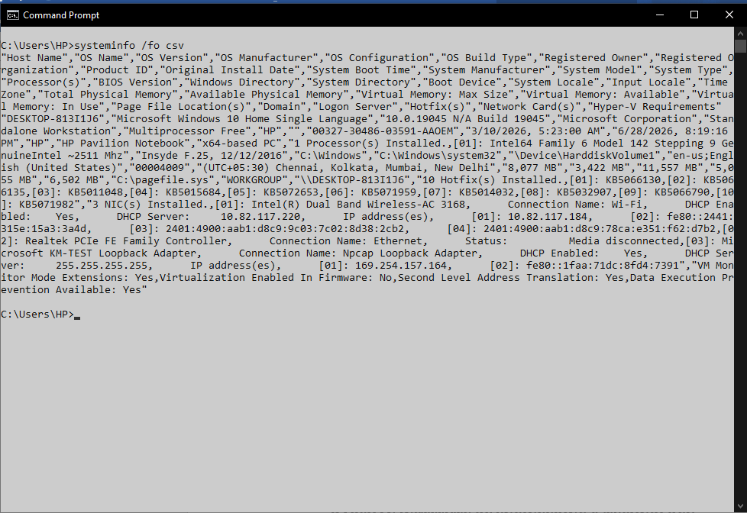

traceroute/tracert

Description:
tracert shows every router (called a hop) your data passes through on its way to a destination. It is like getting a receipt of every city your package passed through during delivery.
No. | Option | Description
1 | tracert google.com | Shows route to Google.
2 | tracert github.com | Shows route to GitHub.
3 | tracert 8.8.8.8 | Shows route to Google's DNS.
4 | tracert -d google.com | Traces route without DNS lookup.
5 | tracert -h 10 google.com | Limits route to 10 hops.

Implementation:

1. tracert google.com
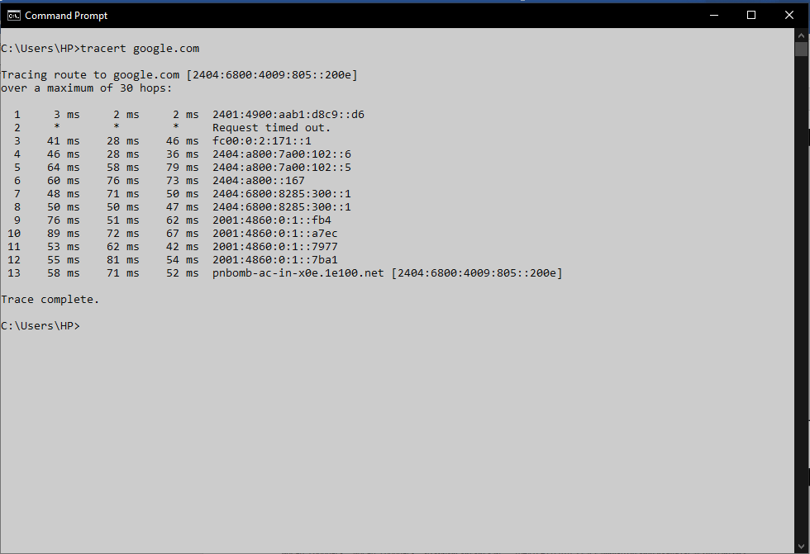

2. tracert -d google.com
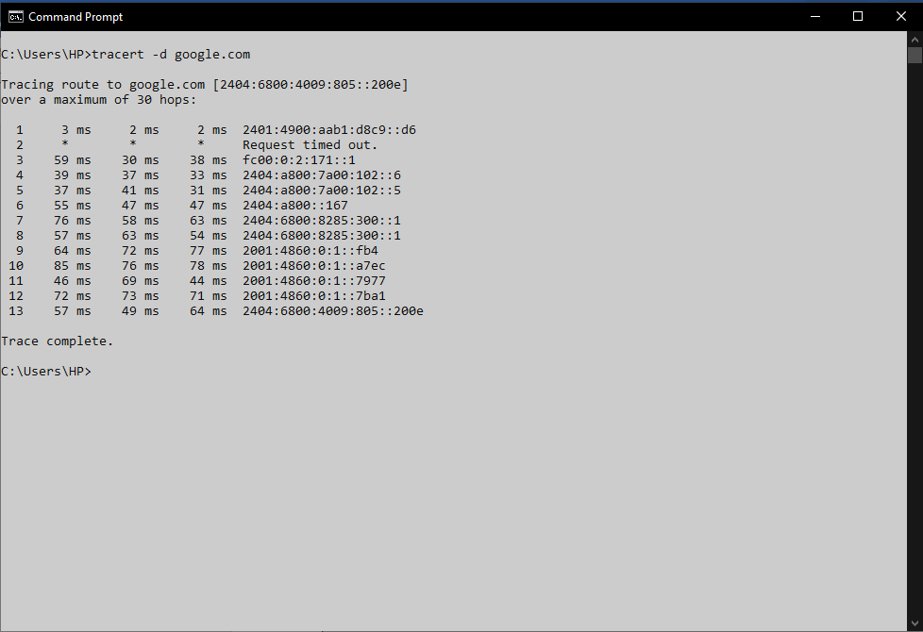

3. tracert -h 10 google.com
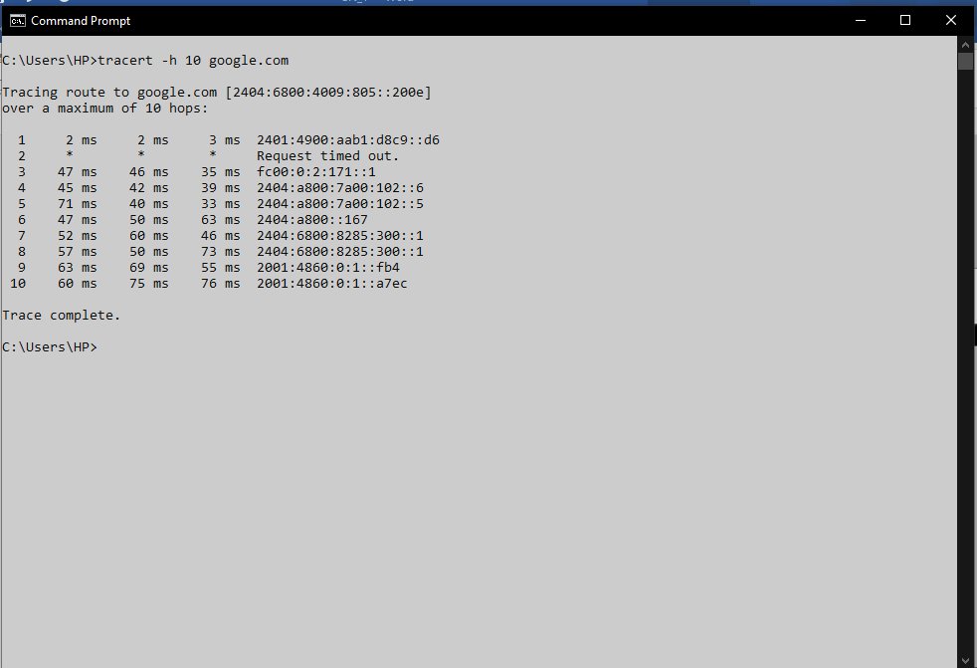

netstat

Description:
netstat shows all active network connections on your machine — which ports are open, which remote servers you are connected to, and which process owns each connection. Very useful for security analysis.
No. | Option | Description
1 | netstat | Shows active network connections.
2 | netstat -ano | Shows connections, ports, and process IDs.
3 | netstat -r | Displays the routing table.
4 | netstat -e | Shows Ethernet statistics.
5 | netstat -s | Shows network protocol statistics.

Implementation:

1. netstat
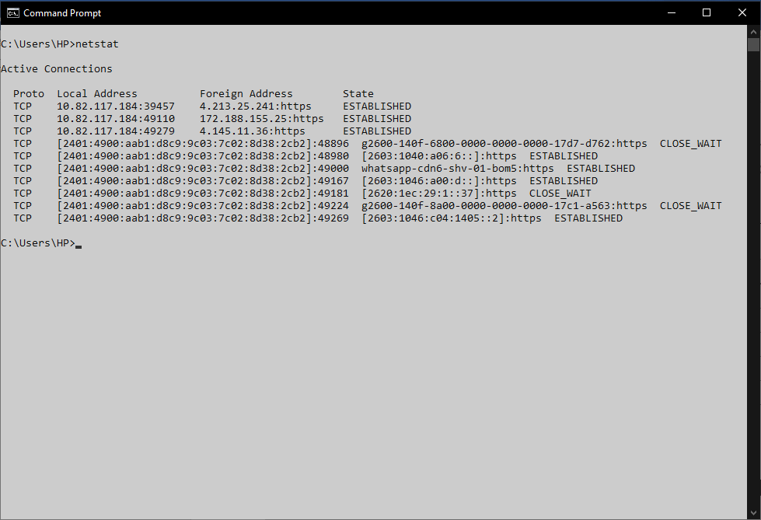

2. netstat -ano
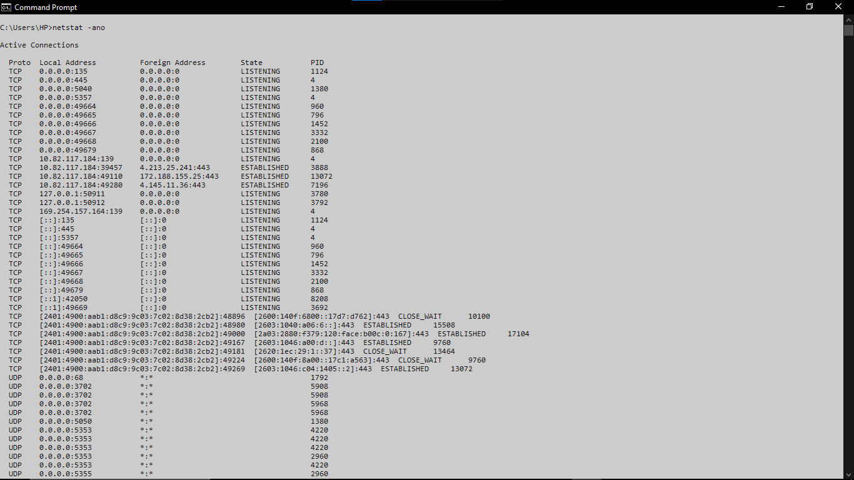

3. netstat -s
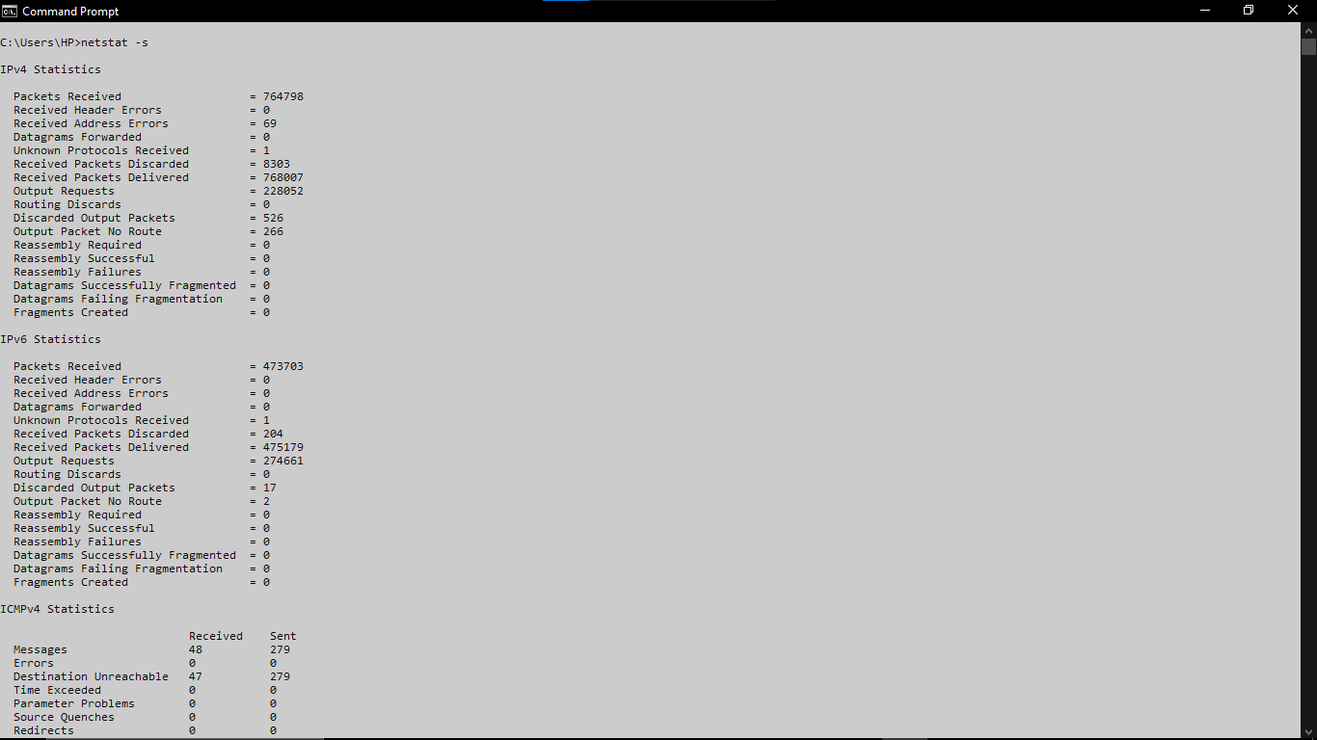

nslookup

Description:
nslookup queries DNS servers to convert domain names into IP addresses. Think of DNS like a phone book — you give a name, it gives back the number (IP address).
No. | Option | Description
1 | nslookup google.com | Google IPFinds Google's IP address.
2 | nslookup darshan.ac.in | Finds Darshan website's IP address.
3 | nslookup github.com | Finds GitHub's IP address.
4 | nslookup -type=mx google.com | Shows Google's mail (MX) servers.
5 | nslookup -type=ns google.com | Shows Google's name (NS) servers.

Implementation:

1. nslookup
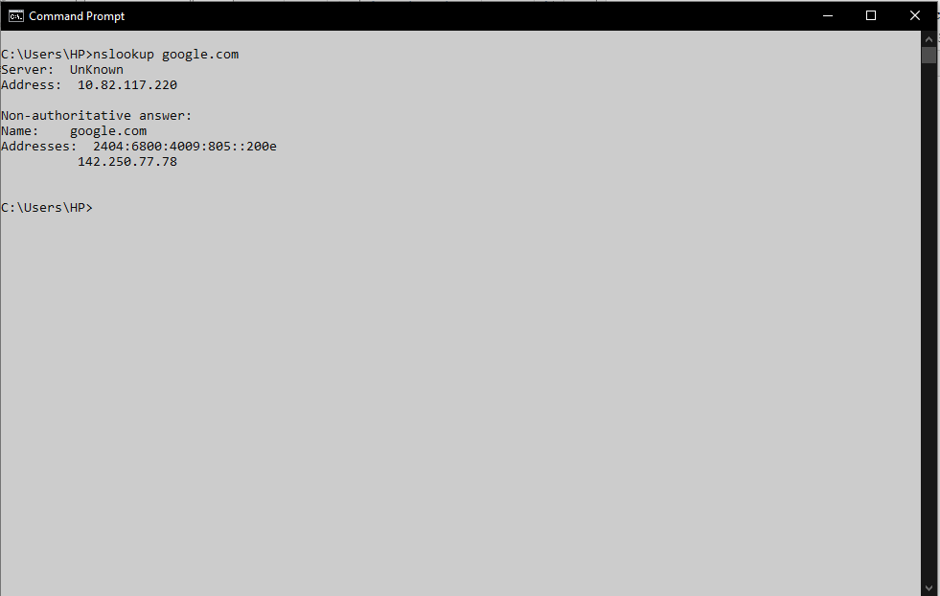

2. nslookup -type=mx google.com
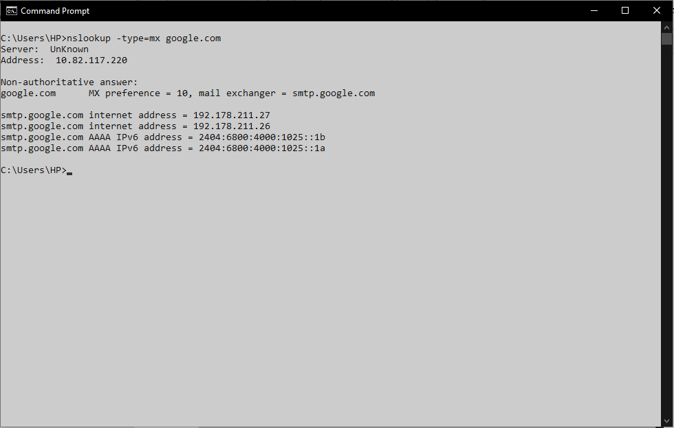

hostname

Description:
hostname prints the name given to your computer on the network. Instead of remembering an IP address, other computers on the same network can use this name to identify your machine.
No. | Option | Description
1 | hostname | Computer name
2 | hostname > host.txt | Saves the computer name to a file.
3 | hostname && ipconfig | Shows the hostname, then the IP configuration.
4 | echo %COMPUTERNAME% | Displays the computer name using an environment variable.
5 | ping %COMPUTERNAME% | Pings the local computer using its hostname.

Implementation:

1. hostname


2. hostname && ipconfig
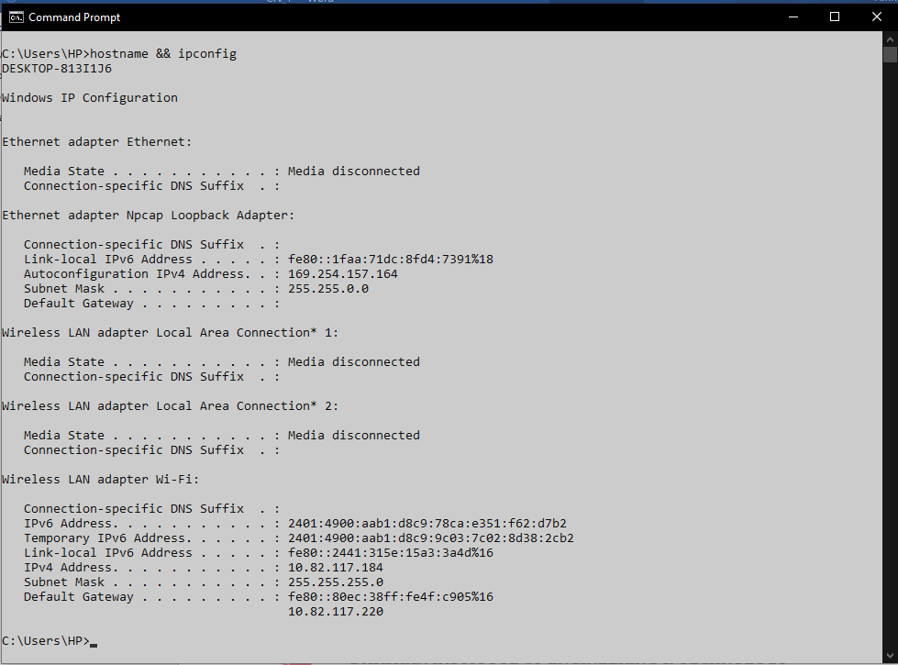

pathping

Description:
pathping combines ping and tracert. It first maps all hops like tracert, then sends 100 packets to each hop and calculates the exact packet loss at every point in the path. It is the most detailed built-in network diagnostic tool on Windows.
No. | Option | Description
1 | pathping google.com | Analyze Google path
2 | pathping github.com | Analyze Google path
3 | pathping 8.8.8.8 | Analyze DNS path
4 | pathping -n google.com | Numeric IP only
5 | pathping -h 5 google.com | Limits to 5 hops

Implementation:

1. pathping google.com
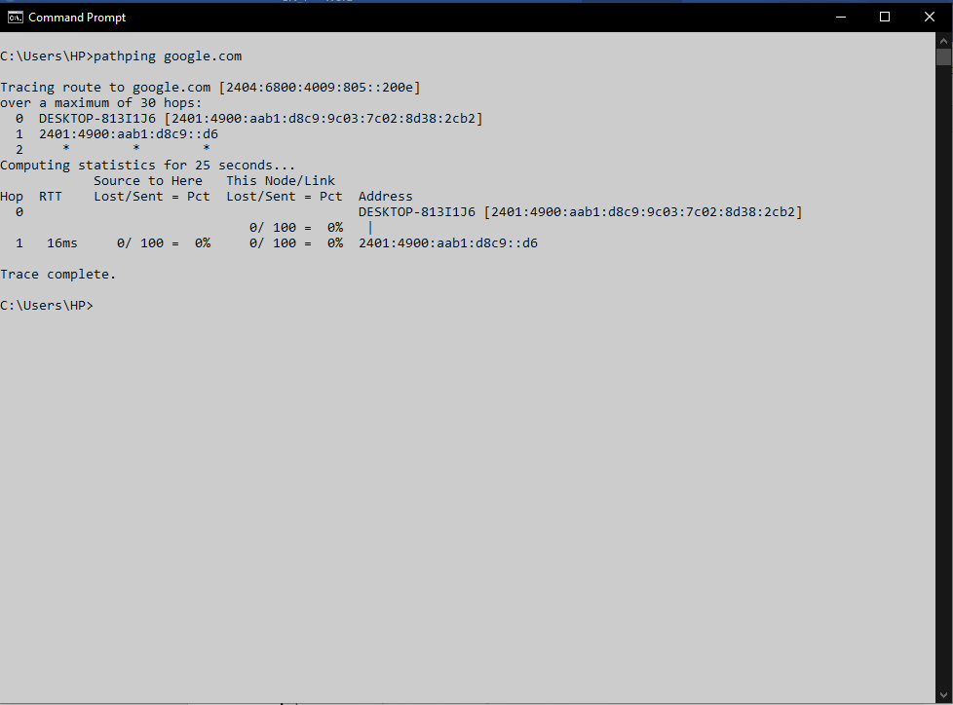

2. pathping -h 5 google.com
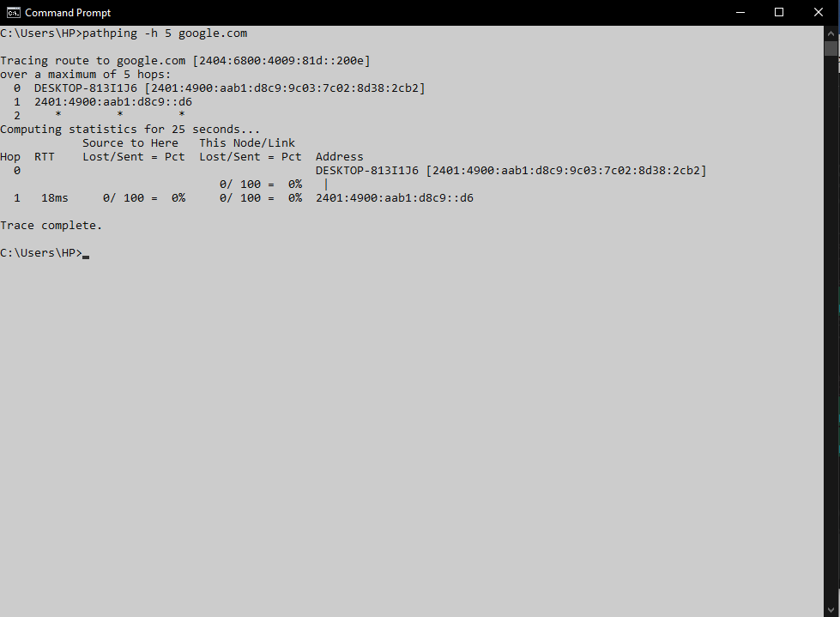

arp

Description:
ARP (Address Resolution Protocol) translates IP addresses into MAC addresses within a local network. Before your computer can send data to 192.168.1.1 (your router), it needs to know its MAC address — ARP handles this automatically.
No. | Option | Description
1 | arp -a | Show current ARP table
2 | arp -d * | Clear ARP cache (Windows)

Implementation:

1. arp -a
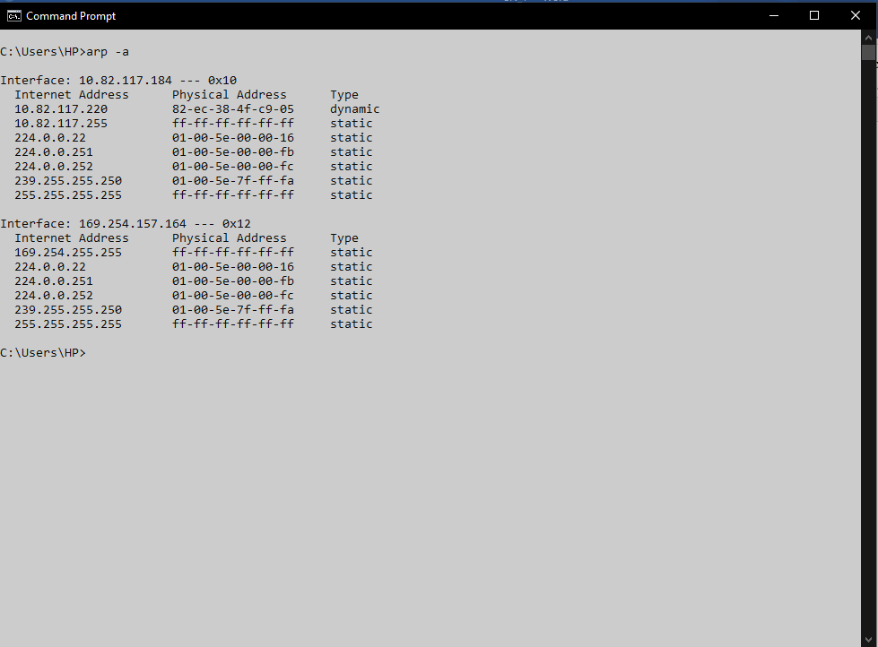

dig

Description:
dig (Domain Information Groper) is a detailed DNS lookup tool. It shows the full DNS response including TTL, query time, and which DNS server answered. More informative than nslookup and preferred by network professionals.
No. | Option | Description
1 | dig google.com
2 | dig google.com A | Find IPv4 address
3 | dig google.com MX | Find mail server
4 | dig google.com NS | Find name servers
5 | dig google.com TXT | Find text records
6 | dig google.com +short | Short output (just the answer)
7 | dig @8.8.8.8 google.com | Use a specific DNS resolver
8 | dig @1.1.1.1 google.com | Use a specific DNS resolver

Implementation:

1. dig google.com
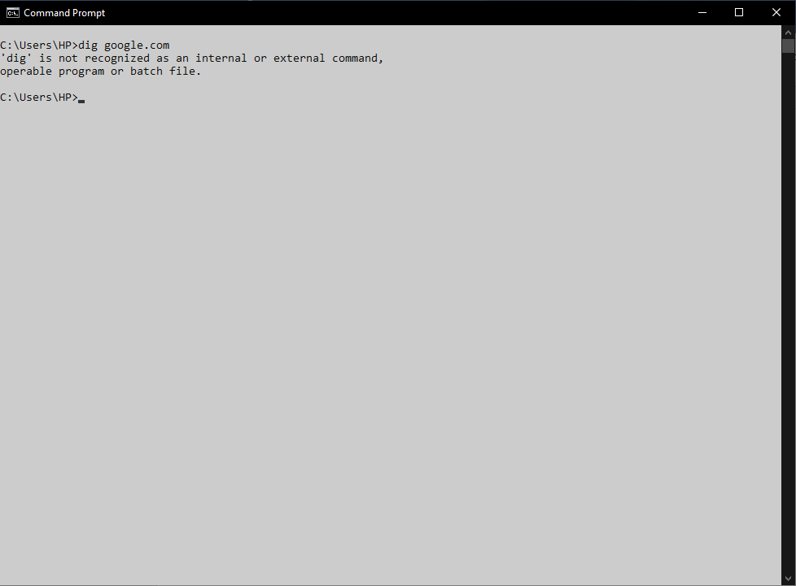
Dig command not built in window.

