Lab Practical #01:
Study of basic networking commands and IP configuration.
Practical Assignment #01:
- Perform and explain various networking commands listed below:
  - ipconfig
  - ping
  - getmac
  - systeminfo
  - traceroute / tracert
  - netstat
  - nslookup
  - hostname
  - pathping
  - arp
  - dig

ipconfig

Description:
This command shows computer's complete network identity. It’s IP address, subnet mask, default gateway, DNS servers, and MAC address.
No. | Option | Description
1 | ipconfig /all | Display full configuration information.
2 | ipconfig /release | Release the IPv4 address for the specified adapter.
3 | ipconfig /renew | Renew the IPv4 address for the specified adapter.
4 | ipconfig /displaydns | Display the contents of the DNS Resolver Cache.
5 | ipconfig /allcompartments | Displays all the information about all compartments.

Implementation:

1. ipconfig /all
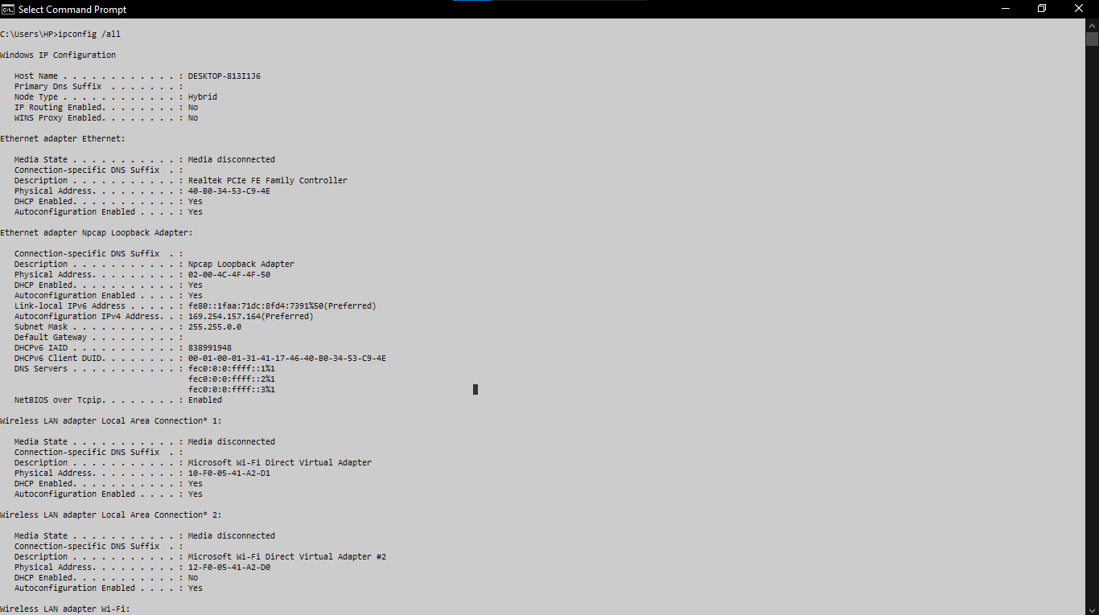

2. ipconfig /release
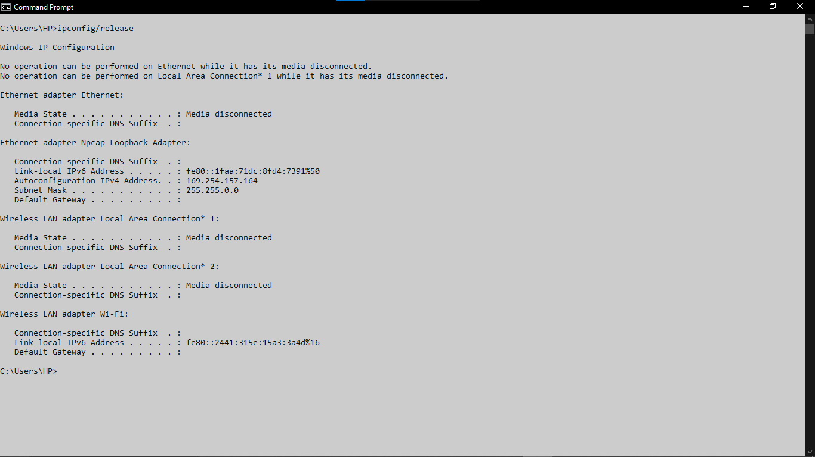

3. ipconfig /renew
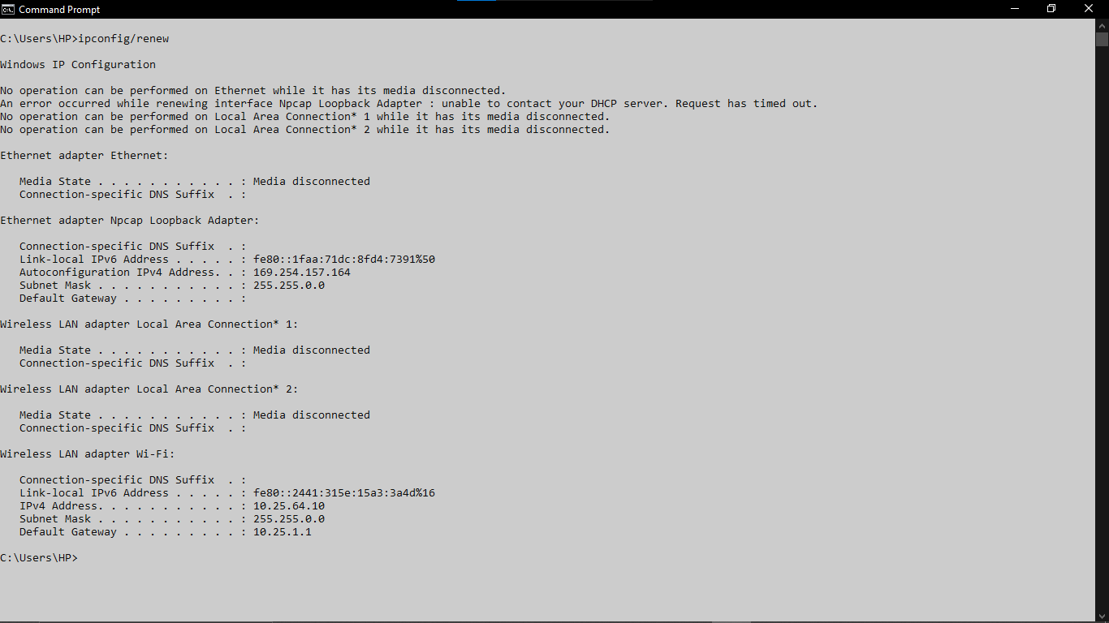

4. ipconfig /displaydns
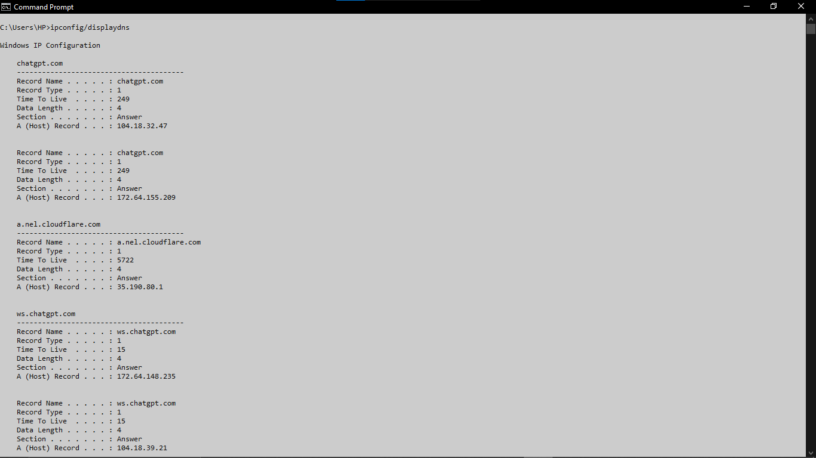

5. ipconfig /allcompartments
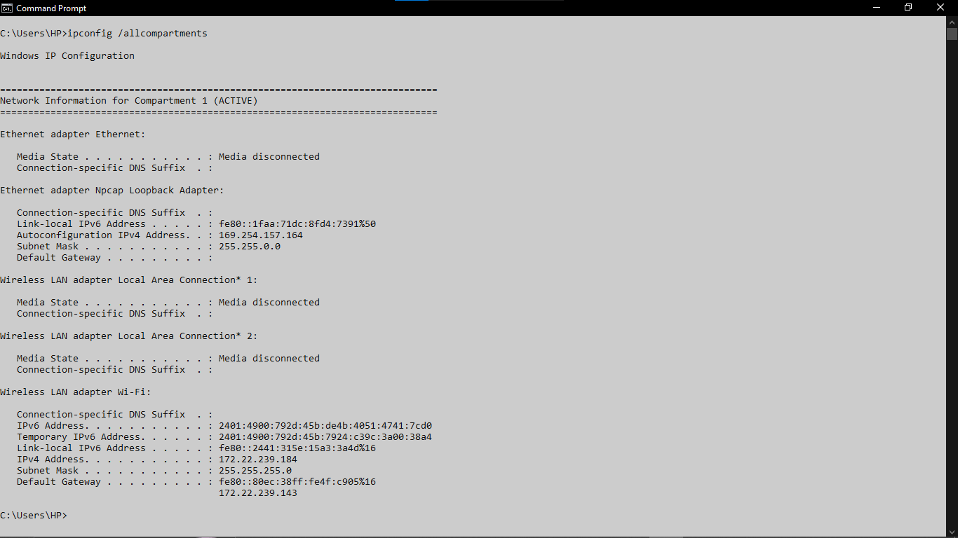

ping

Description:
ping sends small data packets to a target and waits for a reply. It checks if a device is reachable and measures how long the round-trip takes. This delay is called latency, measured in milliseconds (ms).
No. | Option | Description
1 | ping google.com -n 7 | Number of echo requests to send.(ex:7)(by default: 5)
2 | ping google.com -l 64 | Define buffer data size in bytes to send(ex: 64)(by default: 32)
3 | ping google.com -i 50 | Define TTL for data transmition to final server.
4 | ping google.com -4 | Force using IPv4
5 | ping google.com -6 | Force using IPv6

Implementation:

1. ping google.com -n 7
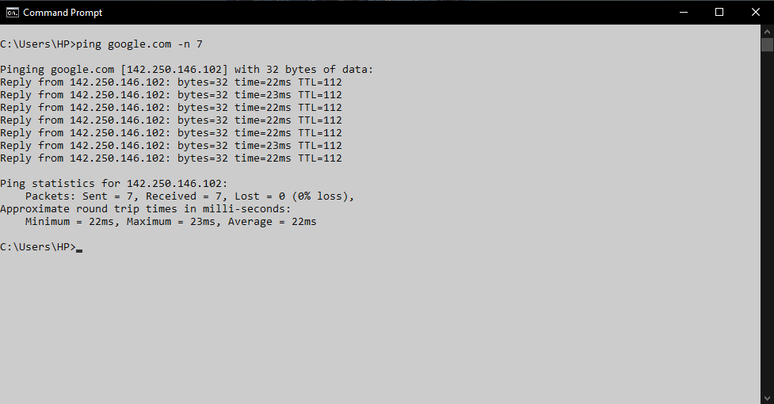

2. ping google.com -l 64
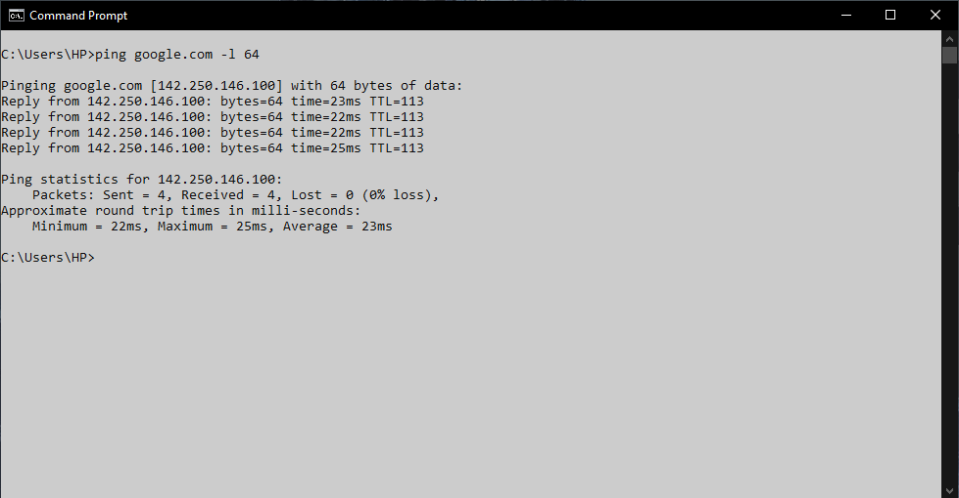

3. ping google.com -i 50
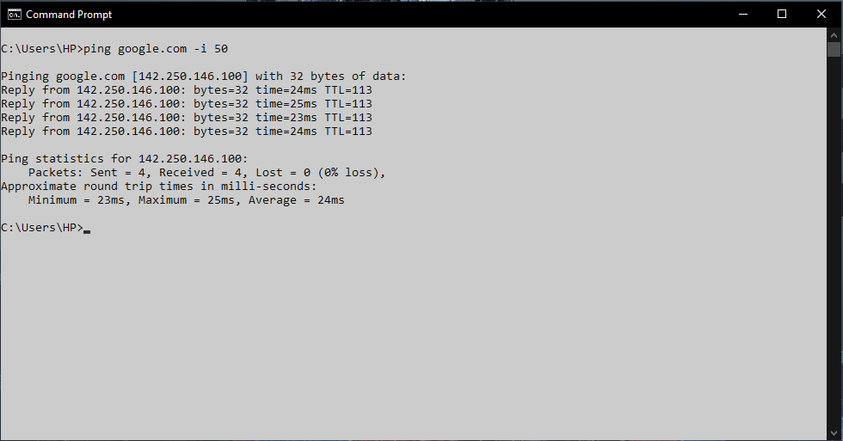

4. ping google.com -4
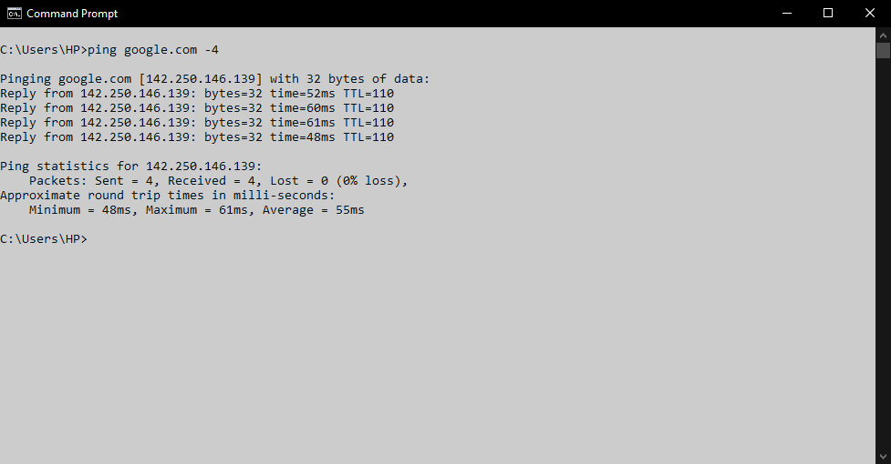

5. ping google.com -6
