Lab Practical #05:
Study the concept of VLAN using packet tracer.
Practical Assignment #05:
- Implement the different network structures in VLAN and VLAN trunking. Also check connectivity between them using ping command or PDU utility.
Instructions:
- Different VLANs configuration setup screenshot. (VLAN example given in ppt)
- Write steps to create VLANs in packet tracer.
- Create a IP address table & Mention IP address of each PC as label.
- Ping command or PDU screenshot between two VLANs.
- Usage of VLAN, Justify your answer with real life example.

Steps to create VLANs in packet tracer
- Open Cisco Packet Tracer and place the required switches and PCs on the workspace, then connect them using copper straight-through cables.
- Click on a switch to open its configuration window, go to the Config tab, and select VLAN Database under the Switching section.
- Enter a VLAN Number (e.g., 10) and a VLAN Name (e.g., VLAN10), then click Add. Repeat for each additional VLAN required (e.g., 20, 30).
- Alternatively, use the CLI tab and enter global configuration mode, then create VLANs using the commands: vlan <number> followed by name <vlan-name>.
- Assign each access port to its VLAN using the interface and switchport access vlan <number> commands (or via the Config tab → FastEthernet interface → VLAN Membership).
- Configure the link between switches as a trunk port so that traffic for all VLANs can pass between switches: interface <port>, switchport mode trunk, and switchport trunk allowed vlan add <vlan-list>.
- Assign static IP addresses to each PC (Desktop → IP Configuration) according to the IP address table.
- Verify the configuration using show vlan brief on the switch CLI.
- Test connectivity using the ping command from a PC's command prompt, or by using the PDU (Add Simple PDU) utility between two PCs, and observe the results in Simulation mode.

Network Structure 1: 2 Switches, 2 VLANs (4 PCs)
Two switches are connected via a trunk link. Each switch hosts one VLAN with two PCs — VLAN10 (192.168.1.1, 192.168.1.2) and VLAN20 (192.168.1.3, 192.168.1.4).
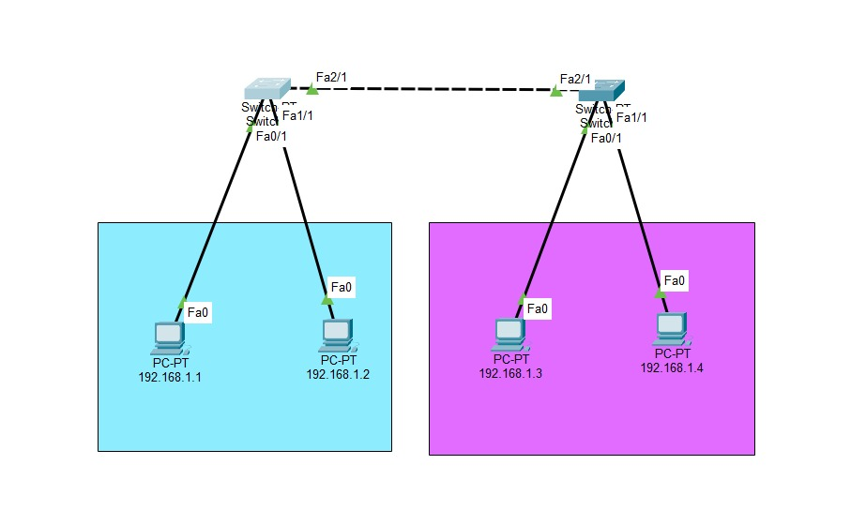
Fig 1.1 — Network topology: 2 switches / 2 VLANs / 4 PCs

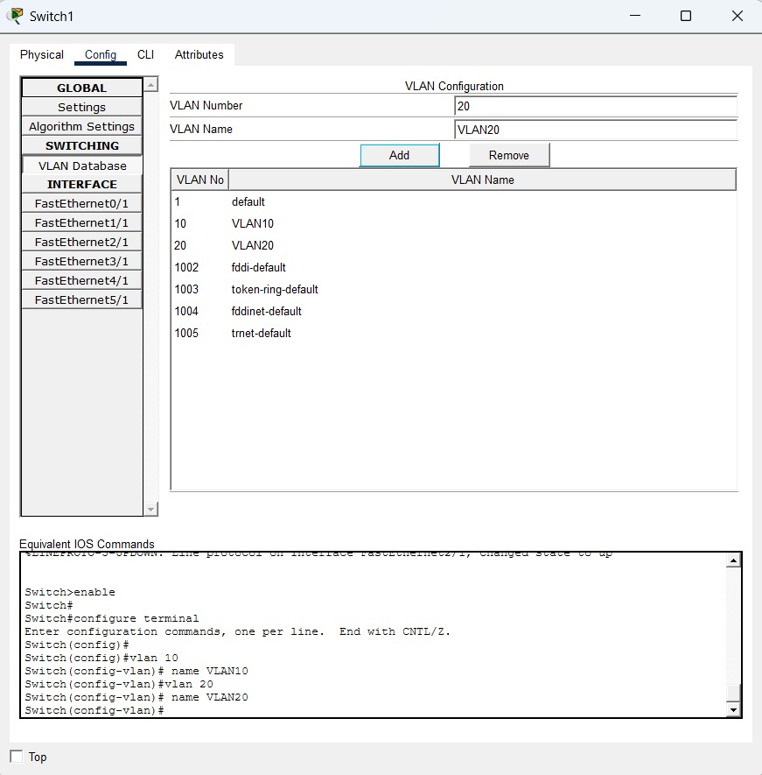Fig 1.1 —
Fig 1.2 — Creating VLAN10 and VLAN20 on Switch1 (VLAN Database)
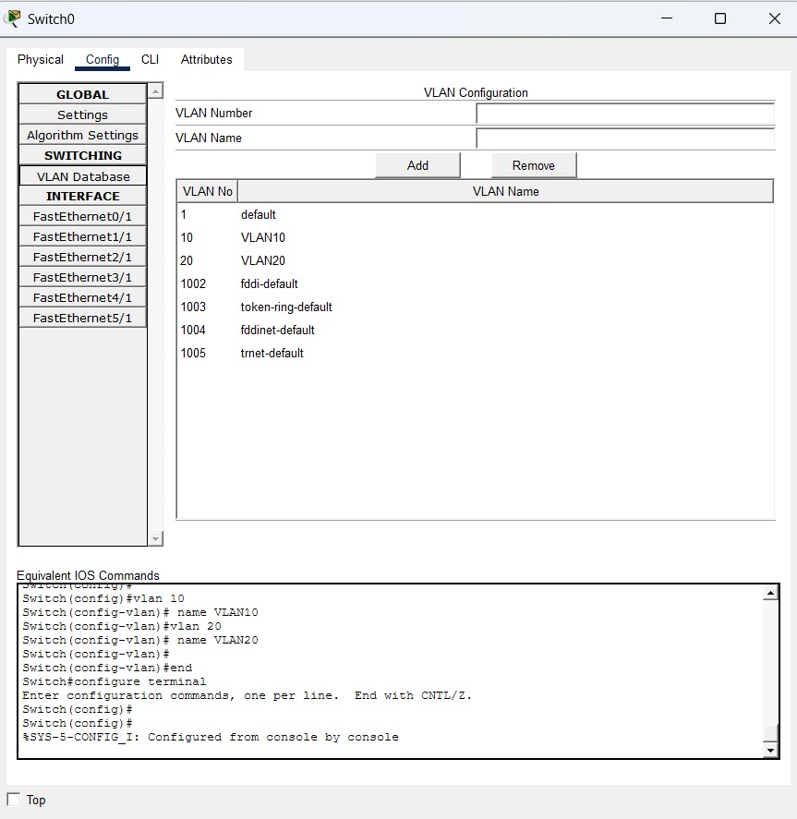
Fig 1.3 — VLAN10 and VLAN20 created on Switch0; equivalent IOS commands
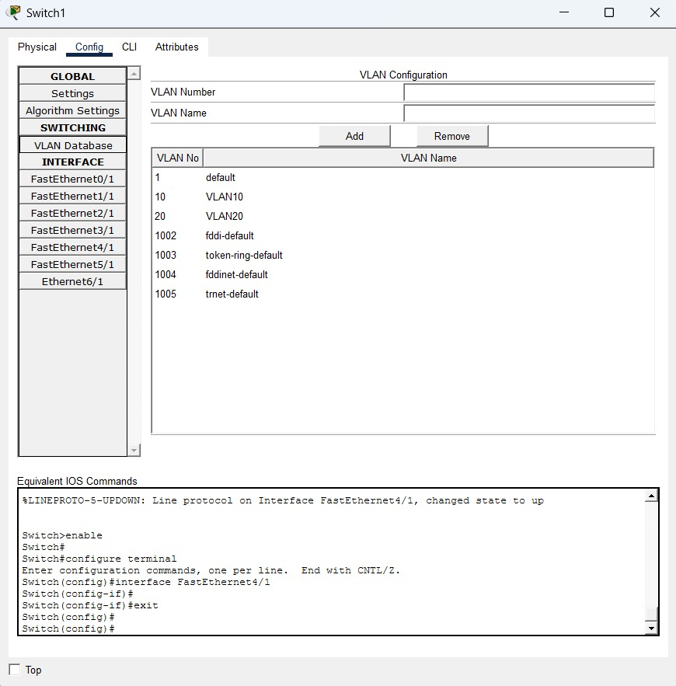
Fig 1.4 — Final VLAN database on Switch1 confirming VLAN10 and VLAN20
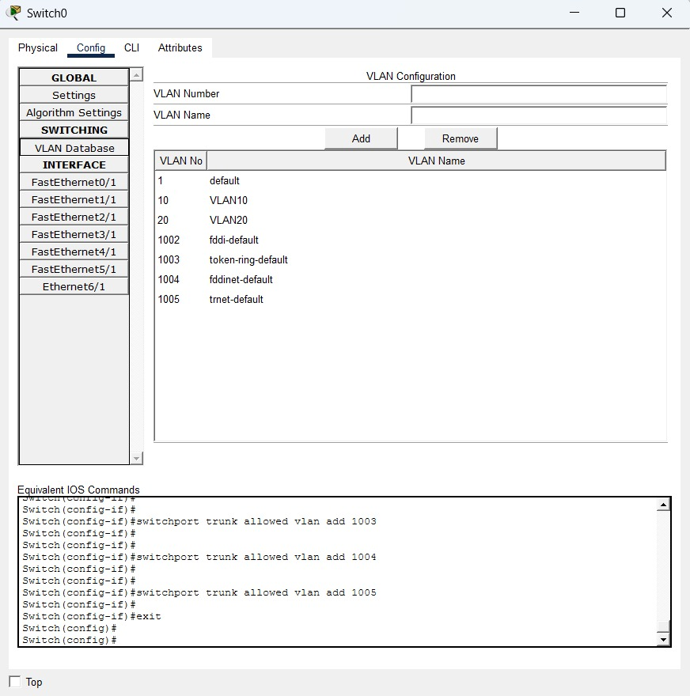
Fig 1.5 — Trunk configuration on Switch0 — allowed VLAN list on the trunk port
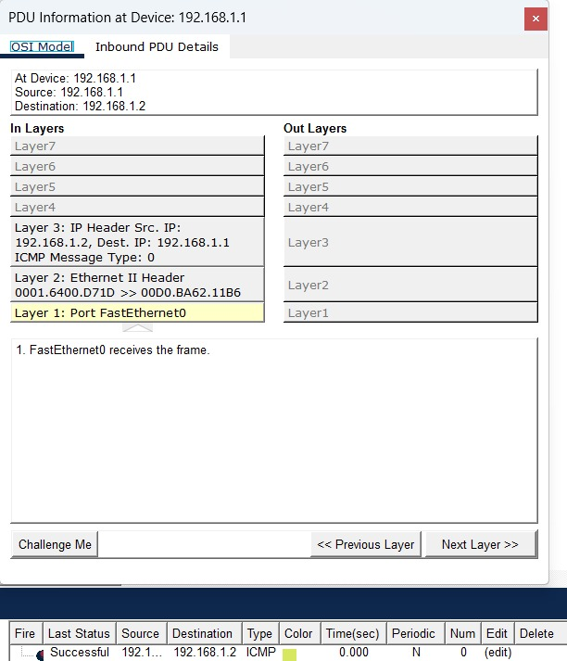
Fig 1.6 — Successful ping (PDU) from 192.168.1.1 to 192.168.1.2, OSI Model view

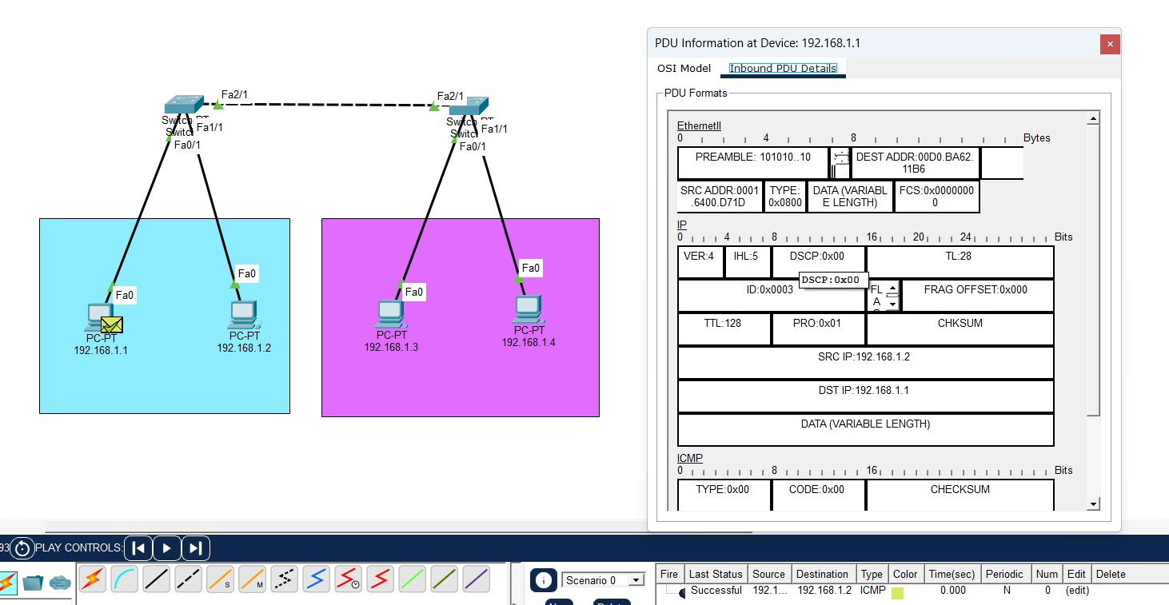
Fig 1.7 — Simulation mode showing the ICMP packet traversing the topology with PDU details

Network Structure 2: 2 Switches, 2 VLANs (8 PCs)
A larger version of the same two-VLAN design, with each VLAN spread across both switches (4 PCs per VLAN, 8 PCs total), connected by a trunk link between Switch0 and Switch1.
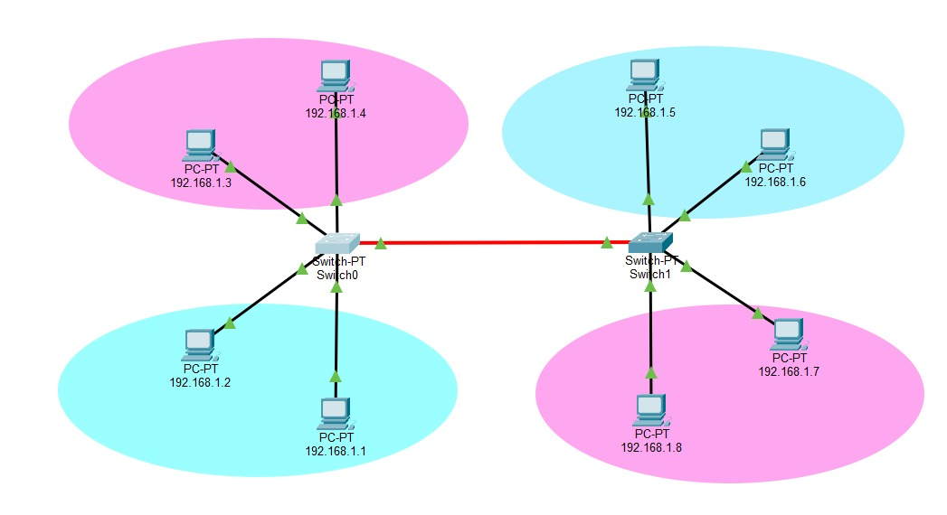
Fig 2.1 — Network topology: 2 switches / 2 VLANs / 8 PCs
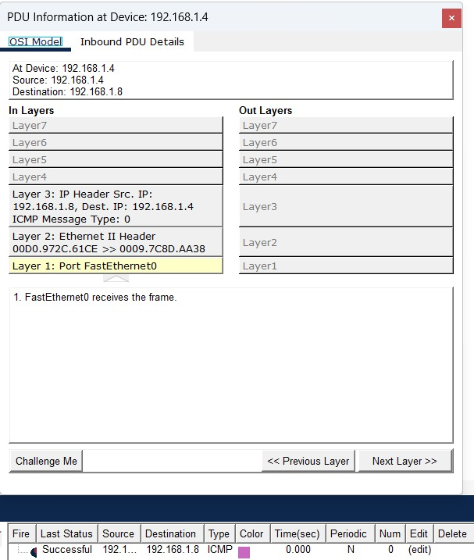
Fig 2.2 — Successful ping (PDU) from 192.168.1.4 to 192.168.1.8, OSI Model view
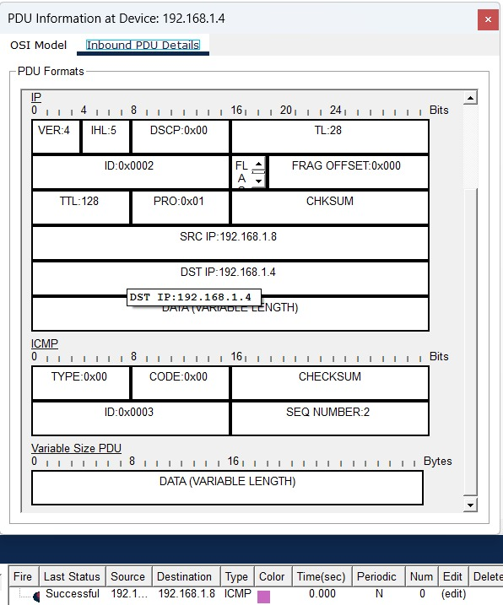
Fig 2.3 — Inbound PDU details showing IP/ICMP header for the 192.168.1.4 → 192.168.1.8 ping

Network Structure 3: 3 Switches, 3 VLANs (9 PCs)
Three switches are connected in series (Switch0 – Switch1 – Switch2), each carrying three VLANs (VLAN10, VLAN20, VLAN30) with one PC per VLAN per switch, for a total of 9 PCs. Trunk links between switches carry all three VLANs.

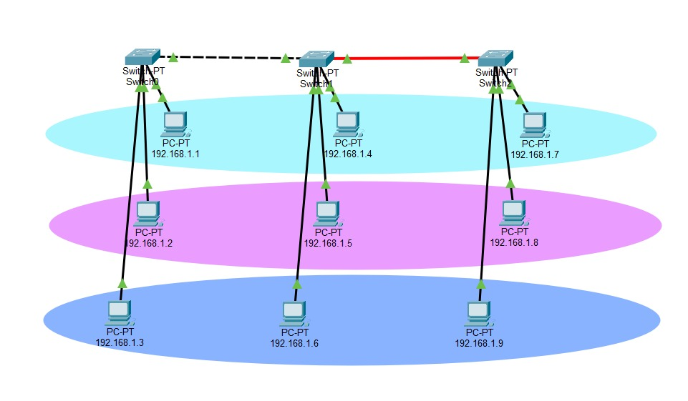
Fig 3.1 — Network topology: 3 switches / 3 VLANs / 9 PCs
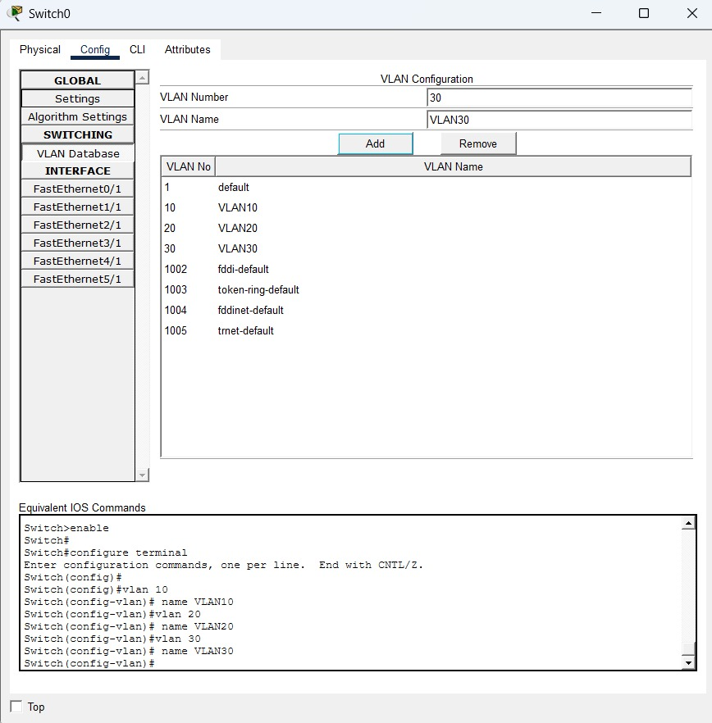
Fig 3.2 — VLAN10, VLAN20 and VLAN30 created on Switch0
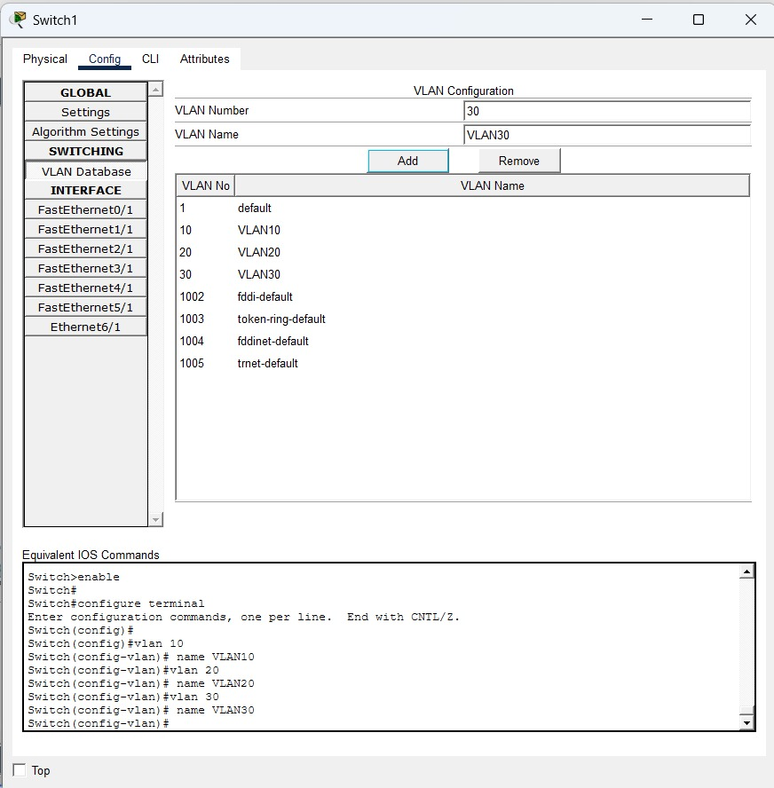
Fig 3.3 — VLAN10, VLAN20 and VLAN30 created on Switch1

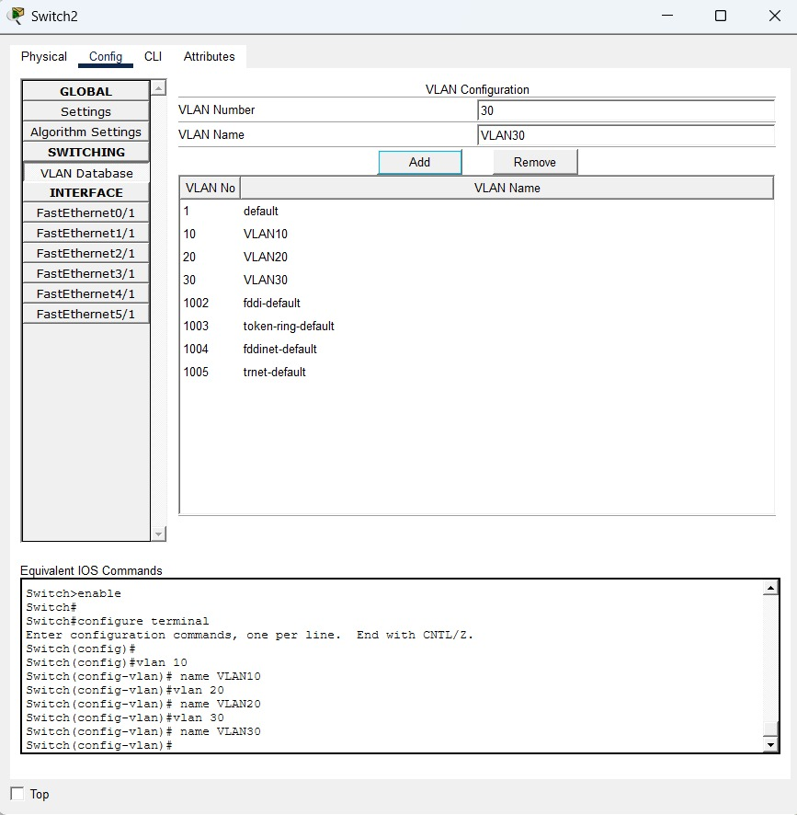
Fig 3.4 — VLAN10, VLAN20 and VLAN30 created on Switch2
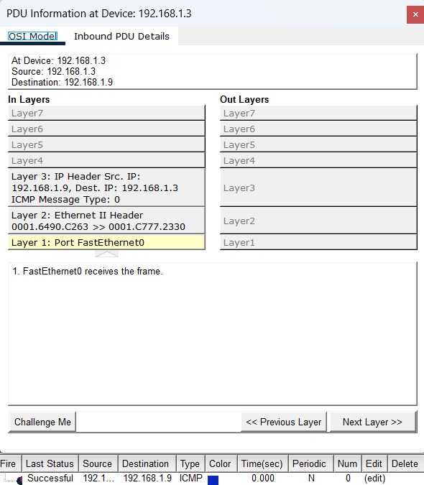
Fig 3.5 — Successful ping (PDU) from 192.168.1.3 to 192.168.1.9, OSI Model view
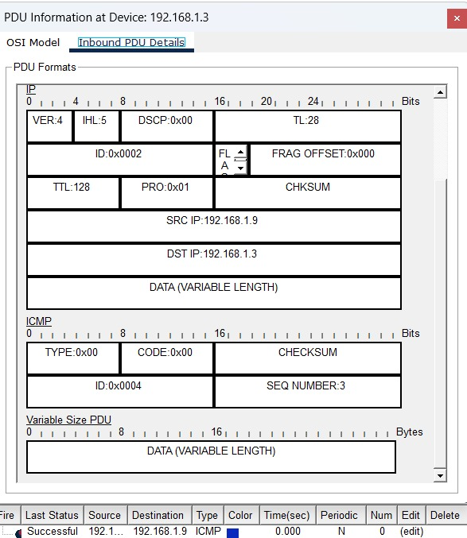
Fig 3.6 — Inbound PDU details showing IP/ICMP header for the 192.168.1.3 → 192.168.1.9 ping

Usage of VLAN –- Real-Life Justification
A VLAN (Virtual Local Area Network) logically segments a single physical switched network into multiple broadcast domains, without requiring separate physical switches for each group. This improves security, performance, and manageability.
Real-life example: In a college campus network, a single switch stack may connect the Administration office, the Faculty staff room, and the Student computer lab. Placing each of these groups in its own VLAN (e.g., VLAN10 = Admin, VLAN20 = Faculty, VLAN30 = Students) ensures that:
- Broadcast traffic from the Student lab does not flood the Admin or Faculty segments, improving overall network performance.
- Students cannot directly access Admin or Faculty systems (e.g., exam servers, payroll systems) unless explicitly routed and permitted, improving security.
- New PCs can be added to the appropriate department simply by assigning the correct VLAN to a switch port — no additional cabling or switches are needed, improving scalability and manageability.
- Trunk links between switches allow traffic from all VLANs to travel over a single physical connection between buildings/floors, reducing cabling cost.
This mirrors exactly what was implemented in the network structures above: separate VLANs for separate PC groups, trunk links carrying multiple VLANs between switches, and verified connectivity using ping/PDU tests.

