Lab Practical #06:
Study the application layer protocol DNS, DHCP, FTP.
Practical Assignment #06:
- Implement the application layer protocol DNS, DHCP, and FTP. Also check connectivity between them using ping command or PDU utility.
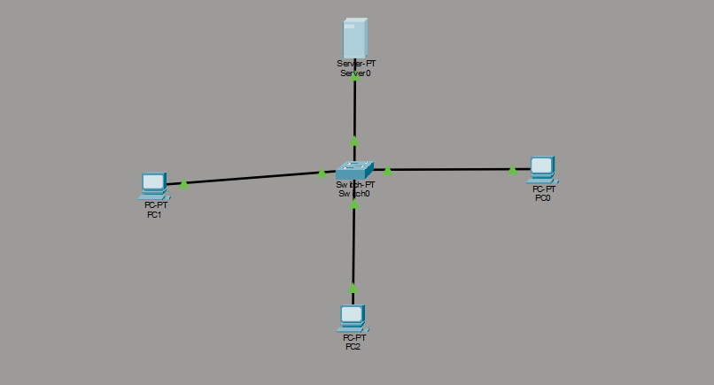
  - DHCP

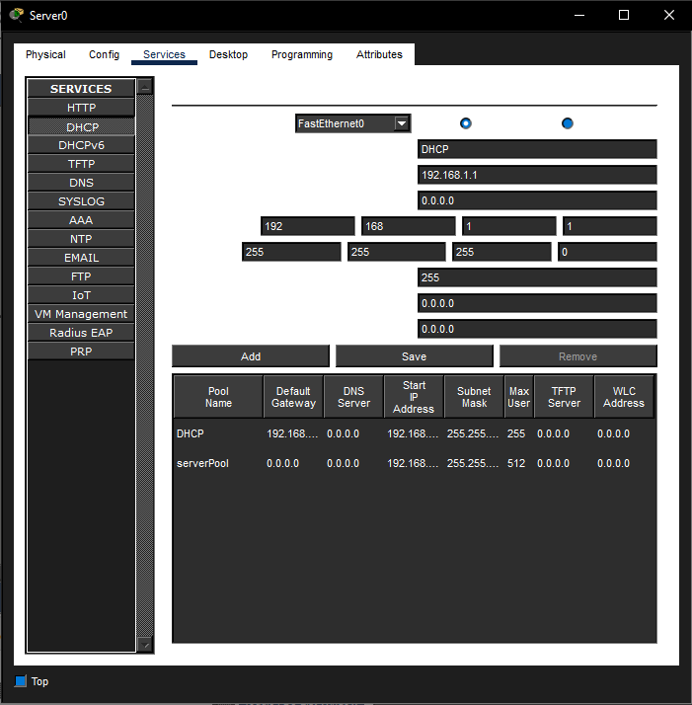
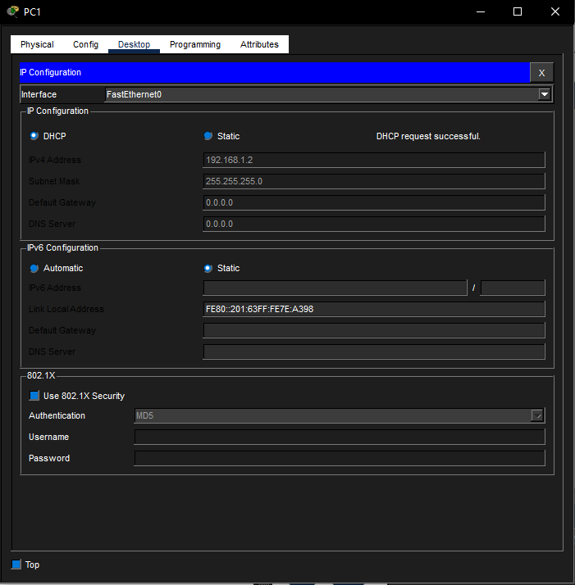

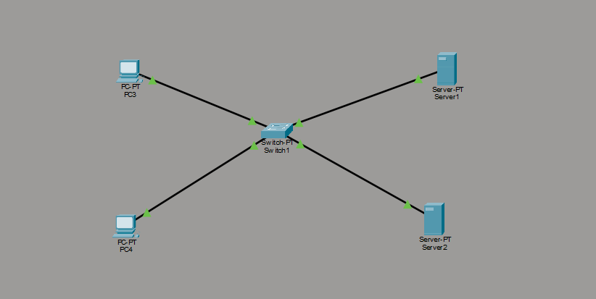
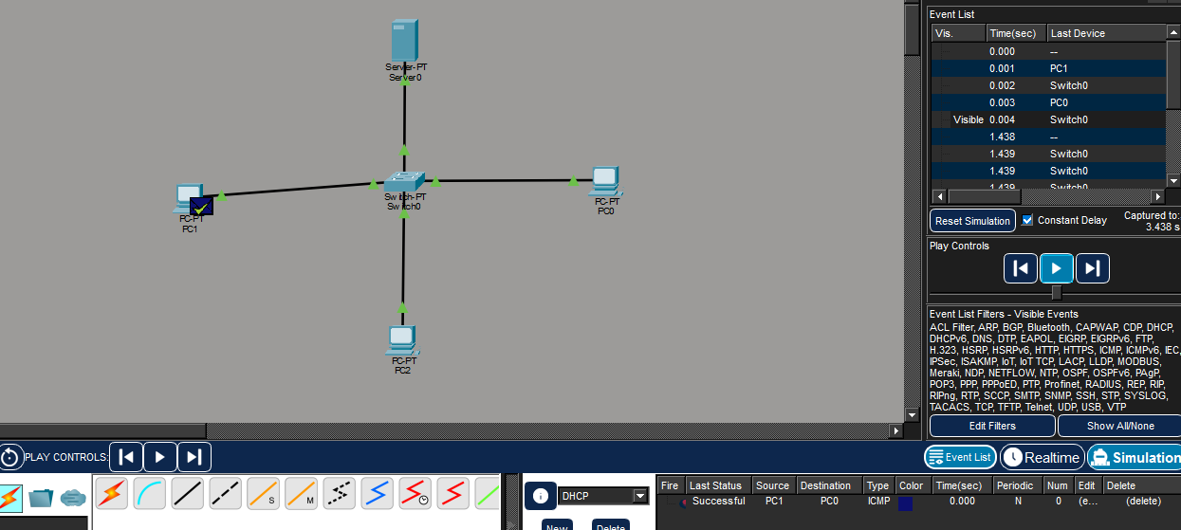
b. DNS
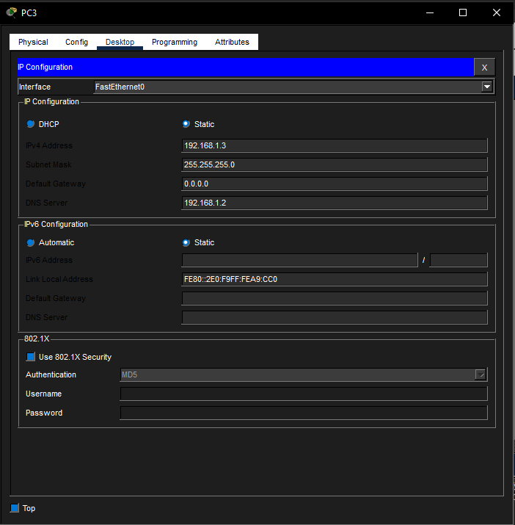

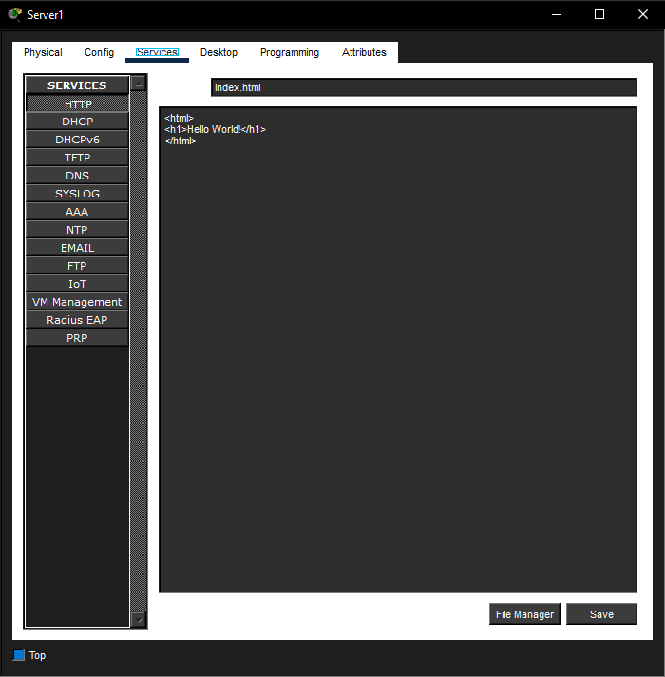
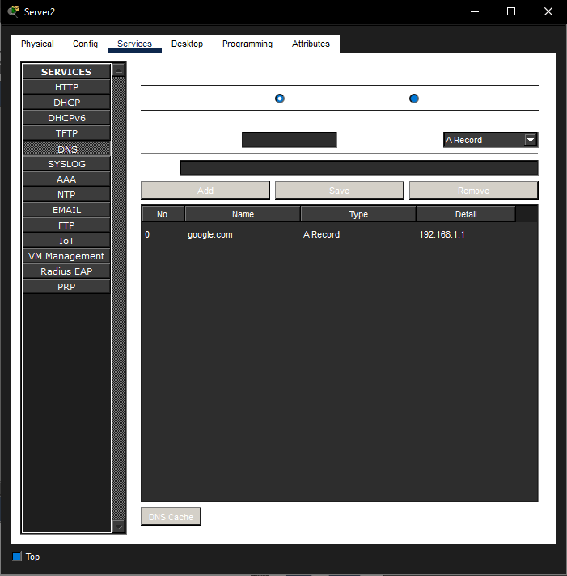
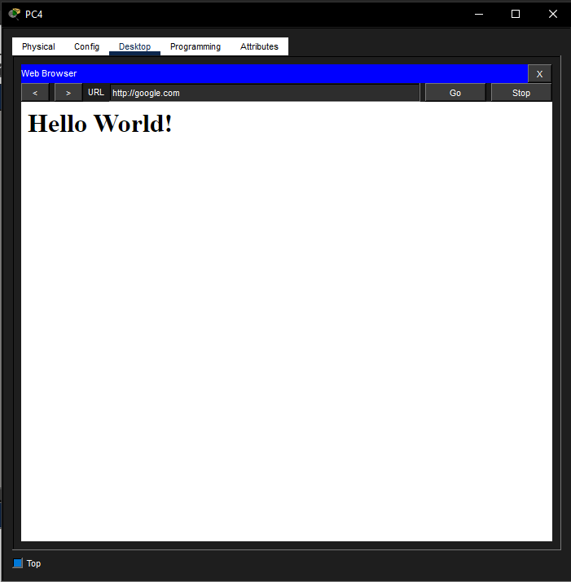

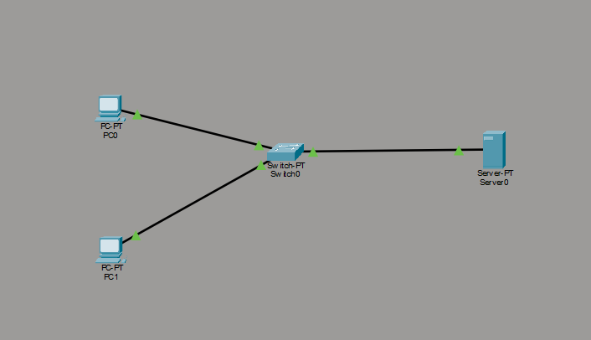
c. FTP

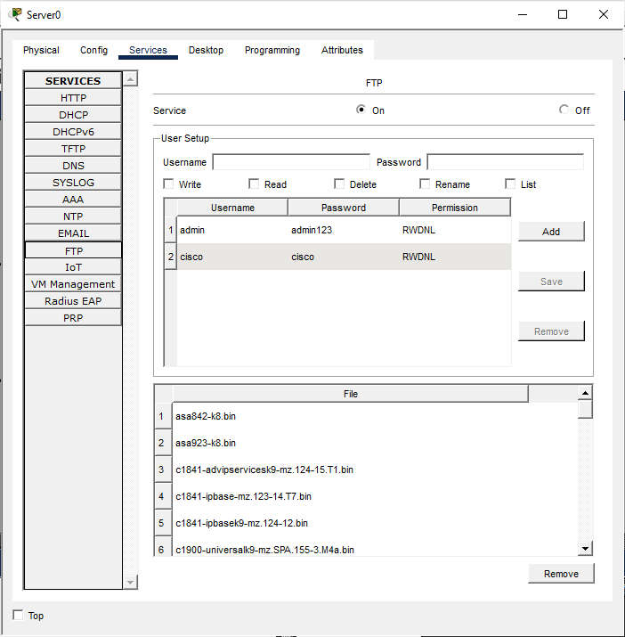
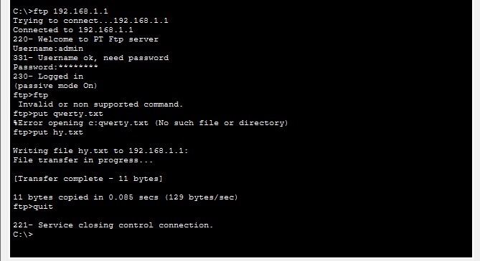

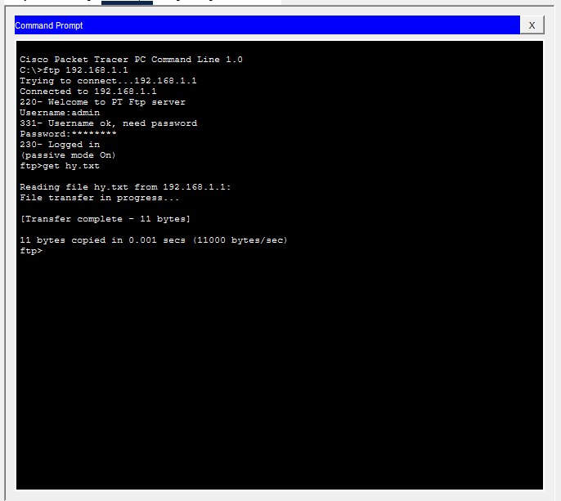

Use of DNS, DHCP, FTP

1. DNS (Domain Name System)
- Use:
DNS translates a domain name (such as google.com) into an IP address that computers use for communication.
- Real-Life Example:
When you type www.google.com in a web browser, DNS finds Google's IP address and connects you to the website. Without DNS, users would need to remember IP addresses like 142.250.xxx.xxx instead of easy-to-remember names.

2. DHCP (Dynamic Host Configuration Protocol)
- Use:
DHCP automatically assigns IP addresses and other network settings (subnet mask, gateway, DNS server) to devices on a network.
- Real-Life Example:
When you connect your phone or laptop to a Wi-Fi network, it automatically receives an IP address from the router's DHCP service. You do not need to configure the IP address manually.

3. FTP (File Transfer Protocol)
- Use:
FTP is used to transfer files between a client and a server over a network.
- Real-Life Example:
A web developer uploads website files from their computer to a web hosting server using FTP. Companies also use FTP servers to share large files among employees.

Instructions:
- Each protocol-wise configuration setup screenshot.
- Create IP address table & mention IP address of each pc as label.
- Ping command or PDU screenshot between two pcs.
- Use of DNS, DHCP & FTP. Justify your answer in real life with example.

