INVENTORY MANAGEMENT SYSTEM
CS23531-WEB PROGRAMMING
Submitted by
JASHWANTH J – 2116241001092
OF
BACHELOR OF INFORMATION TECHNOLOGY
RAJALAKSHMI ENGINEERING COLLEGE, THANDALAM
(An Autonomous Institution)


RAJALAKSHMI ENGINEERING COLLEGE
BONAFIDE CERTIFICATE
Certified that this project titled "Inventory Management System" is the bonafide work of "JASHWANTH J (241001092)" who carried out the project work under my supervision.
SIGNATURE  Dr.P.Neelaveni  HEAD OF THE DEPARTMENT  Information Technology  Rajalakshmi Engineering College,  Rajalakshmi Nagar, Thandalam  Chennai - 602105 | SIGNATURE  N.Satheesh Kumar  COURSE INCHARGE  Information Technology  Rajalakshmi Engineering College,  Rajalakshmi Nagar, Thandalam  Chennai - 602105

This project is submitted for CS23531-WEB PROGRAMMING held on ____________.
INTERNAL EXAMINER | EXTERNAL EXAMINER

TABLE OF CONTENTS
S.NO | TOPIC | PAGE NO
1 | Abstract | 4
2 | Introduction | 4
3 | Purpose | 4
4 | Scope of the project | 5
5 | Software requirement specification | 5
6 | Use case diagram | 6
7 | Entity relationship diagram | 7
8 | Data flow diagram | 8
9 | Module description | 8
10 | Project functionality | 9
11 | Implementation | 9
12 | Conclusion | 14
 | References | 14

INVENTORY MANAGEMENT SYSTEM

1. ABSTRACT
The Inventory Management System is a responsive, single-page web application that helps a small store or warehouse keep track of its products, stock quantities and stock value. The application is built with HTML5, CSS3, JavaScript and React.js, using React Hooks (useState and useEffect) for state management and the browser's LocalStorage for persistence. No backend server or database is used in this version.
Users can add, edit and delete products, update stock quantities, search and filter the product list, and view a dashboard that summarises total products, total stock, low-stock items and inventory value. Each product is compared against its minimum stock level so that low-stock and out-of-stock items are flagged automatically.

2. INTRODUCTION
Keeping inventory records on paper or in spreadsheets is slow and error-prone. Quantities go out of date, low-stock items are noticed late, and it is hard to see the overall value of stock on hand. An inventory system solves these problems by keeping every product record in one place and calculating summaries automatically.
This project provides a simple browser-based inventory tool. It runs without installation: the user opens the page, works with the products, and the data is saved in the browser so that it is still available the next time the application is opened.

3. PURPOSE
- Develop a web application for managing products and stock digitally.
- Reduce manual errors through form validation and duplicate-ID checks.
- Warn the user early when a product reaches or falls below its minimum stock level.
- Provide a clear dashboard with summary figures for quick decision making.
- Demonstrate component-based front-end development with React.js and browser storage.

4. SCOPE OF THE PROJECT
- Manage product records: product ID, name, category, price, quantity, supplier and minimum stock level.
- Create, read, update and delete products, with confirmation before deletion.
- Update stock quantities and display In Stock, Low Stock and Out of Stock statuses.
- Search products by ID or name, filter by category and status, and sort by name, price or quantity.
- Show a dashboard with summary cards and a table of recently added products.
- Save all data in LocalStorage and load it on start-up, with sample data for first use.
- Out of scope: user login, multiple users, a server or database, and order or sales processing.

5. SOFTWARE REQUIREMENT SPECIFICATION

5.1 Functional Requirements
- Add a product with a unique product ID, name, category, price, quantity, supplier and minimum stock level.
- Validate all required fields; price and quantity must be valid non-negative numbers.
- Edit existing product details and delete a product after confirmation.
- Update the quantity of a product and show its new status.
- Search, filter and sort the product list.
- Display dashboard totals: number of products, total stock quantity, low-stock count and total inventory value.
- Store data in LocalStorage and update it on every change.

5.2 Non-Functional Requirements
- Responsive layout for desktop, tablet and mobile screens.
- Clear success messages, validation errors and empty-state messages.
- Fast response: all actions run in the browser without page reloads.
- Easy to read and maintain, using small reusable React components.

5.3 Hardware Requirements
- Any computer, tablet or smartphone with 4 GB RAM or more.

5.4 Software Requirements
- Modern web browser (Chrome, Edge or Firefox).
- Node.js (LTS version) and npm, to install dependencies and run the development server.
- React.js with Vite as the build tool; React Icons for dashboard icons.

6. USE CASE DIAGRAM
The diagram below shows the main actor, the store staff member, and the actions they can perform in the system. Adding, editing, deleting and stock updates all include the step that saves data to LocalStorage.
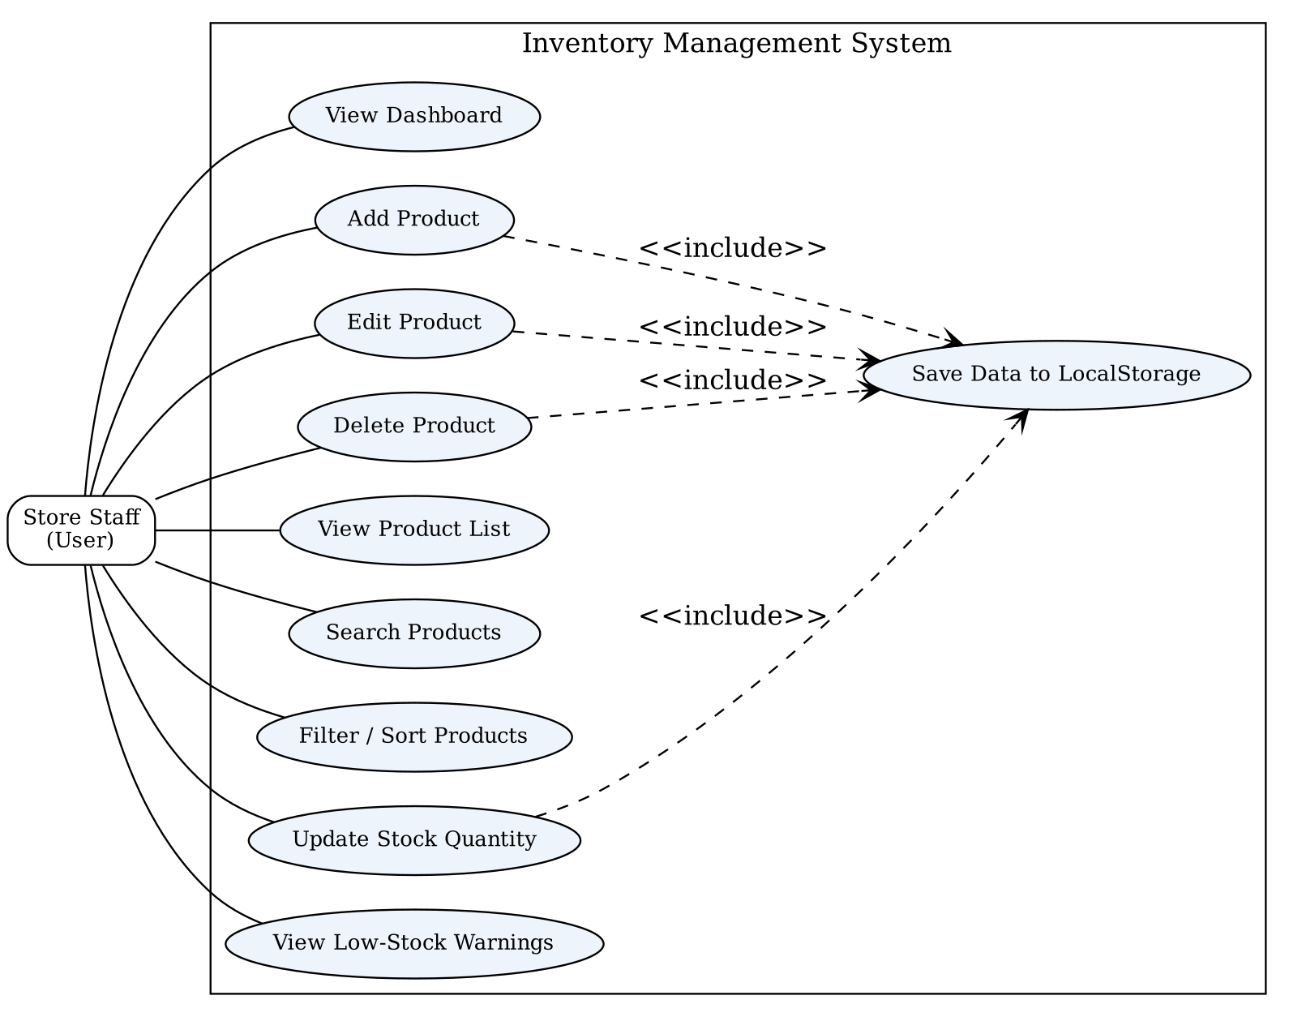
Figure 1: Use case diagram of the Inventory Management System

7. ENTITY RELATIONSHIP DIAGRAM
The system stores each product as one record. Category and supplier are shown as separate entities so that the relationships are clear, although in this version they are saved as fields inside the product record.
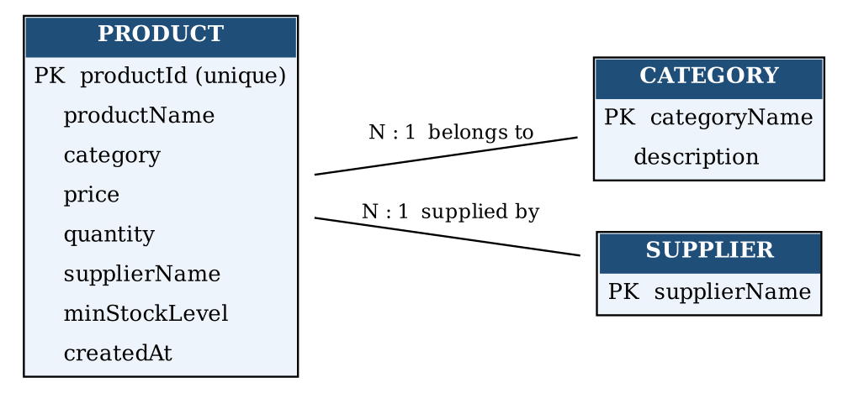
Figure 2: Entity relationship diagram

8. DATA FLOW DIAGRAM
The level-0 data flow diagram shows how user input moves through the four processes and how they read from and write to the product store in LocalStorage.
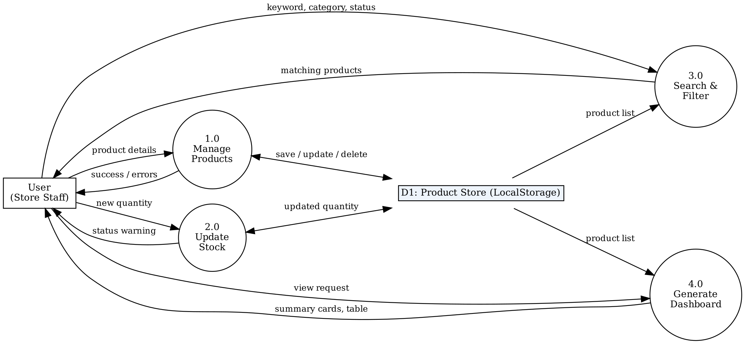
Figure 3: Data flow diagram (level 0)

9. MODULE DESCRIPTION
Module | Responsibility | Main Component(s)
Product module | Add, edit, delete and list products; validation and duplicate-ID check | ProductForm, ProductList
Stock module | Update quantities and show stock status and low-stock warnings | StockManagement
Search module | Search by ID or name; filter by category and status; sort | SearchFilter
Dashboard module | Summary cards and table of recently added products | Dashboard, SummaryCard
Storage module | Load data on start-up and save on every change | App (useEffect with LocalStorage)
Layout module | Sidebar navigation, top navigation bar, About page, dialogs | Sidebar, Navbar, ConfirmationDialog

10. PROJECT FUNCTIONALITY
- Dashboard: total products, total stock, low-stock count, total inventory value (price × quantity) and recent products.
- Product management: add, edit and delete products with confirmation; duplicate IDs are rejected.
- Stock management: update quantities; statuses are In Stock, Low Stock (quantity at or below minimum) and Out of Stock (quantity 0).
- Search and filter: search by ID or name, filter by category and status, sort by name, price or quantity.
- Persistence: data is saved to LocalStorage after every change and reloaded when the application opens.
- Sample data: six products across Electronics, Stationery, Furniture and Accessories are loaded when no saved data exists.

11. IMPLEMENTATION

11.1 Architecture
The application follows a component-based front-end architecture. The App component owns the product list and passes data and handler functions to child components. Product data is read from LocalStorage when the application starts and written back whenever the list changes.

11.2 Project Structure
File / Folder | Purpose
src/components/Sidebar.jsx | Side navigation for Dashboard, Products, Stock Management and About
src/components/Navbar.jsx | Top bar with page title and menu toggle for small screens
src/components/Dashboard.jsx | Summary cards and recently added products table
src/components/ProductList.jsx | Product table with search, filter, sort, edit and delete actions
src/components/ProductForm.jsx | Add/edit form with validation and error messages
src/components/StockManagement.jsx | Quantity update form and stock status table
src/components/SummaryCard.jsx | Reusable card showing an icon, label and value
src/components/SearchFilter.jsx | Reusable search box, category and status filters, sort options
src/components/ConfirmationDialog.jsx | Reusable confirm/cancel dialog used before deleting
src/App.jsx, src/main.jsx | Root component, routing between sections, start-up of the React app
src/App.css, src/index.css | Layout and component styles; global styles and CSS variables
package.json, README.md | Dependencies and scripts (npm install, npm run dev); project guide

11.3 Key Logic
- Duplicate ID check: before saving a new product, the form compares the entered ID with existing IDs (case-insensitive).
- Validation: name, ID, category and supplier must not be empty; price must be a number ≥ 0; quantity and minimum stock must be whole numbers ≥ 0.
- Stock status: quantity 0 → Out of Stock; quantity ≤ minimum stock level → Low Stock; otherwise In Stock.
- Inventory value: the sum of price × quantity over all products, shown in the dashboard.
- Persistence: useEffect saves the product array to LocalStorage on every change; the initial state reads from LocalStorage, or loads sample data if nothing is saved.

11.4 Responsive Design
CSS grid and flexible widths are used for the summary cards and tables. The sidebar collapses into a menu button on tablet and mobile screens, and tables scroll horizontally on small devices so that no content is hidden.
FRONT END CODE
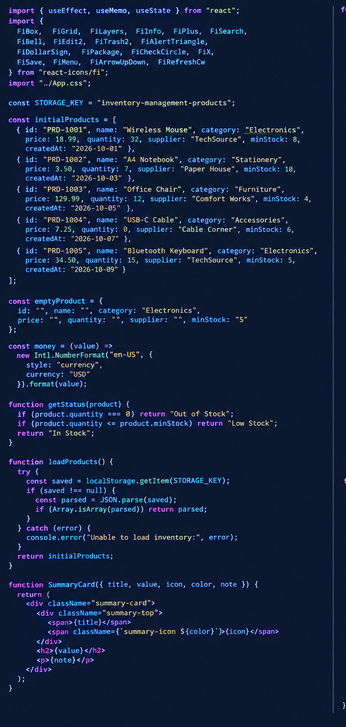
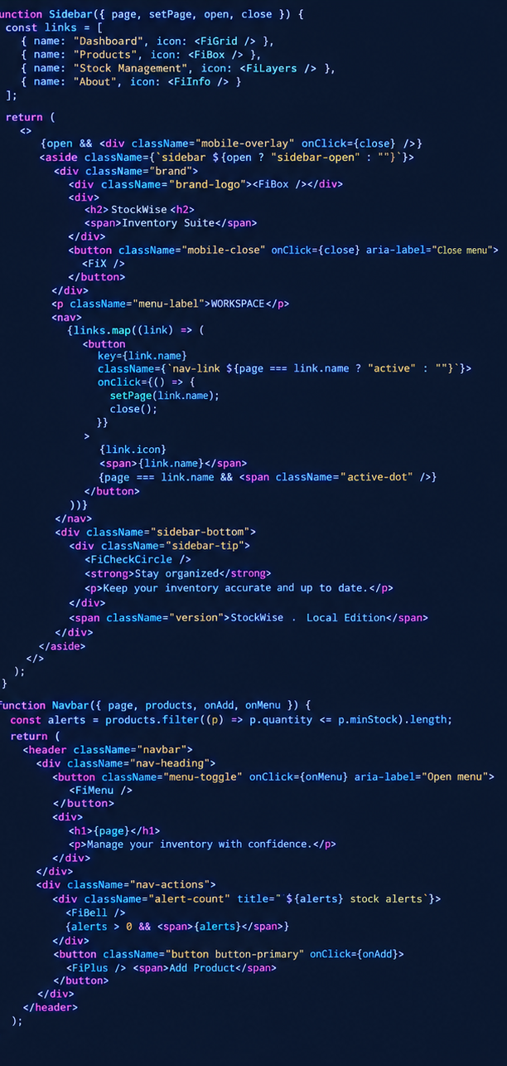
BACK END CODE
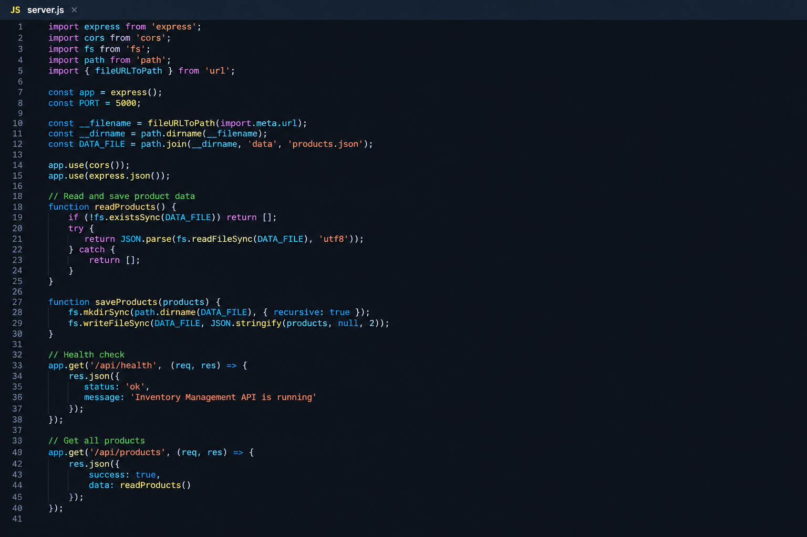
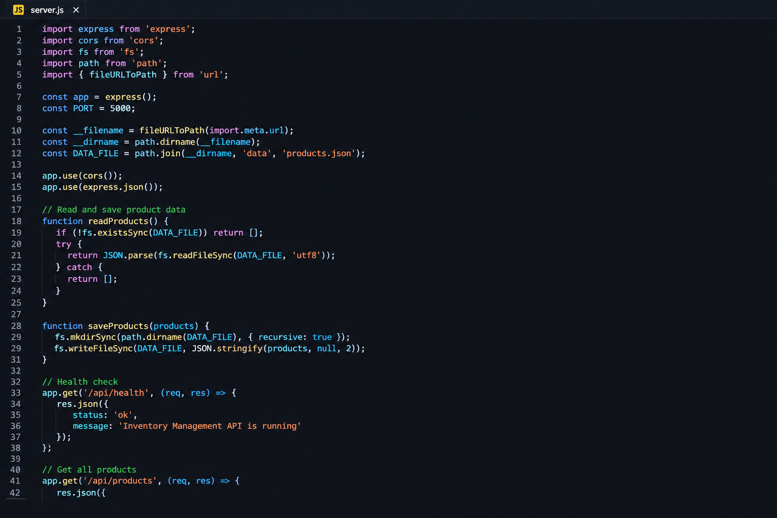
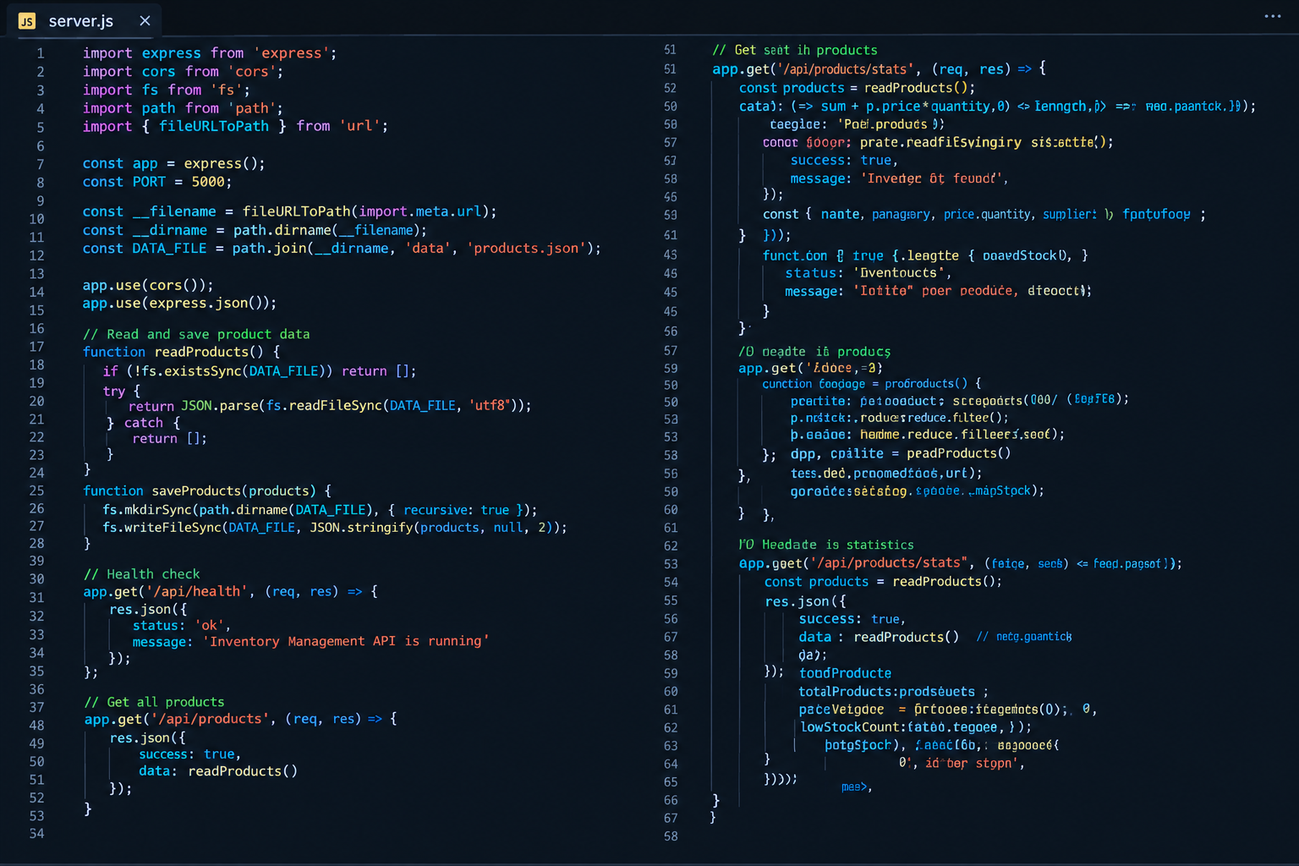
OUTPUT
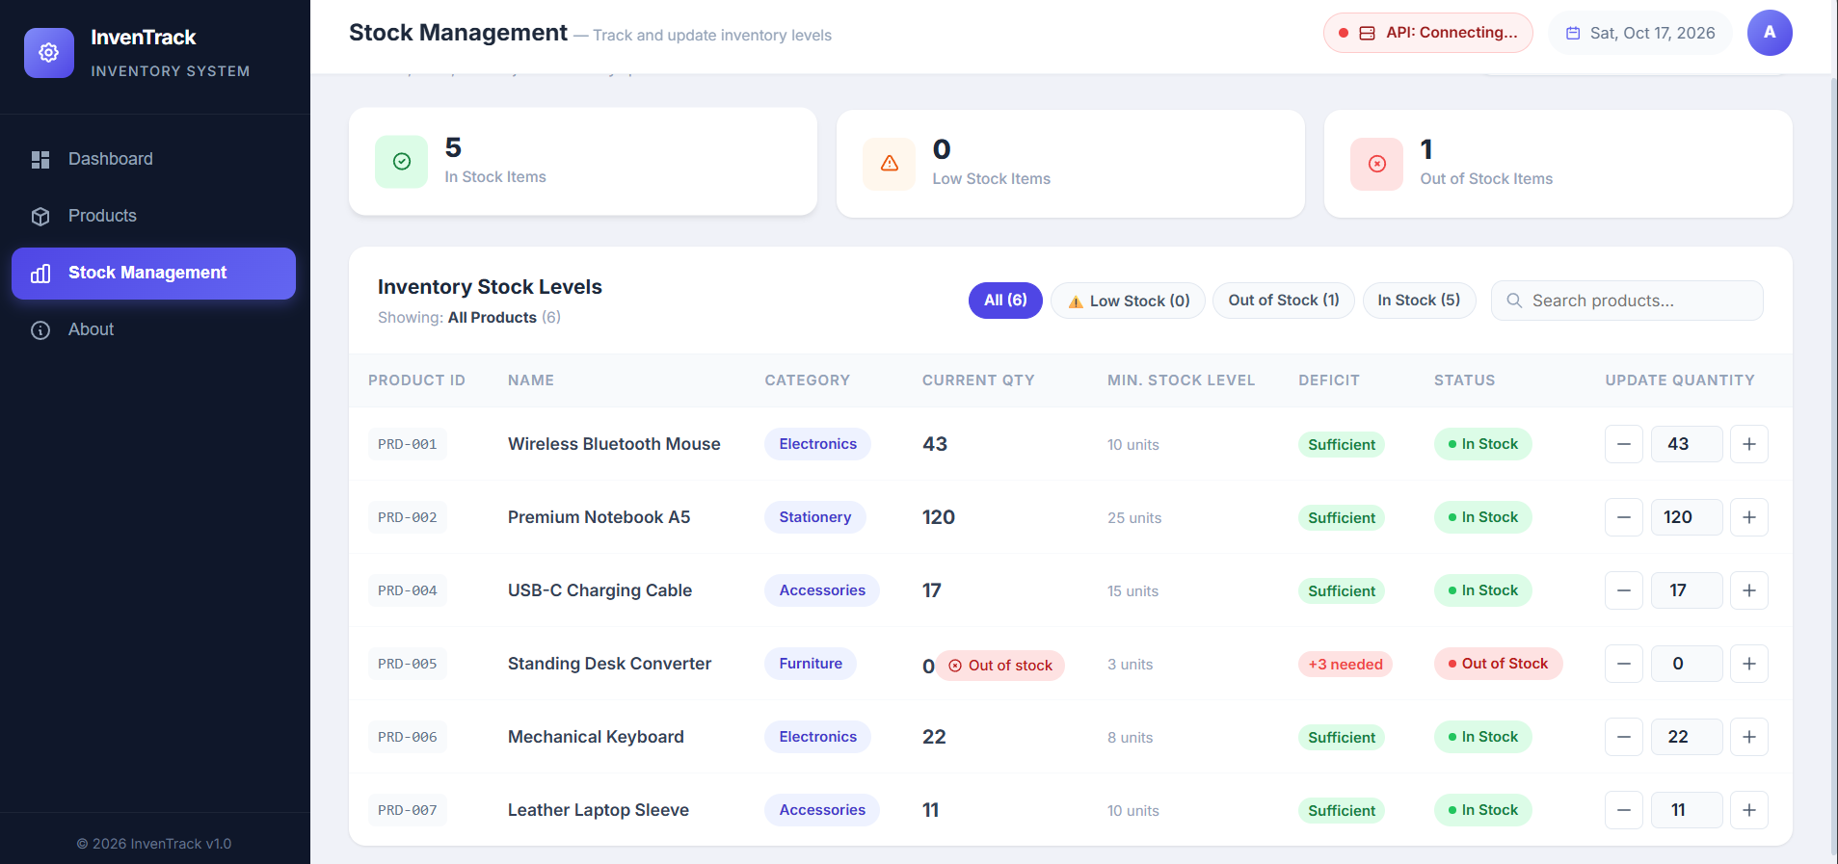
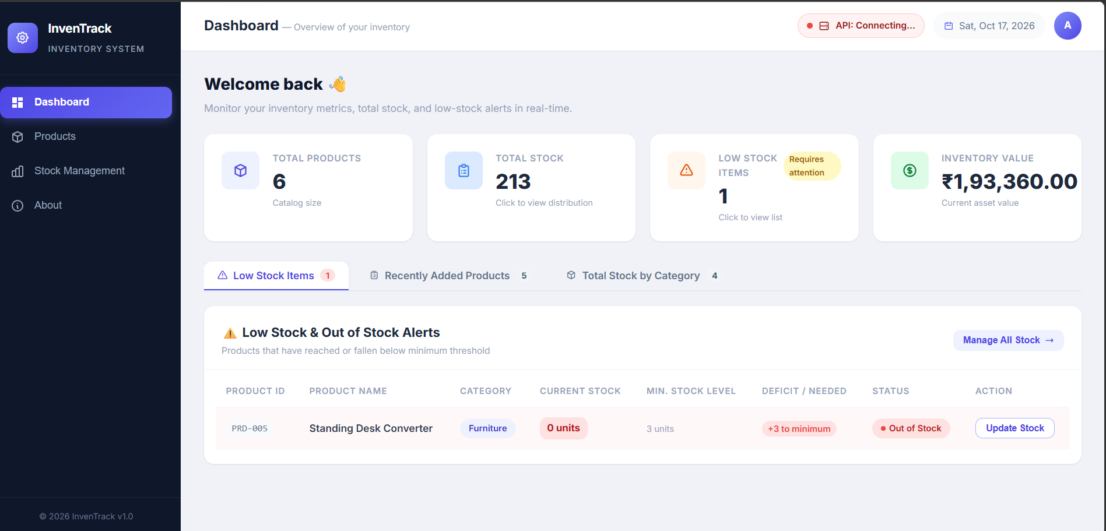

12. CONCLUSION
The Inventory Management System meets the objectives of the Web Programming course. It combines HTML, CSS and JavaScript with React.js components and Hooks to provide product CRUD operations, stock monitoring, search and filtering, dashboard summaries, form validation and LocalStorage persistence, all without a backend. The project shows how a small React application can be organised into reusable components and how browser storage keeps data between sessions. Future versions could add user login, a server database and export to Excel or PDF.

REFERENCES
- React.js Documentation — https://react.dev
- MDN Web Docs (HTML, CSS, JavaScript, Web Storage API) — https://developer.mozilla.org
- Vite Documentation — https://vite.dev
- React Icons — https://react-icons.github.io/react-icons
- W3Schools — https://www.w3schools.com

