Below is a well-structured, realistic set of Playwright interview questions tailored for someone with ~2 years of Playwright experience and 14 years overall testing experience.
I’ve grouped them into categories and included expected answers/hints so you can practice.

✅ Playwright Interview Questions (2 Years Experience)
(Designed for mid-senior QA with strong testing fundamentals)

📌 1. Playwright Basics
1. What is Playwright and why is it preferred over Selenium?
Expected points:
- Supports multiple browsers (Chromium, WebKit, Firefox).
- Auto-waiting for elements and network stability.
- Faster execution, designed for modern web apps.
- Supports multiple languages (JS/TS, Python, Java, .NET).
- Built-in parallel execution with Playwright Test Runner.
- Better shadow-DOM, iframe, network mocking, and tracing capabilities.

2. How do you launch a browser and open a page in Playwright?
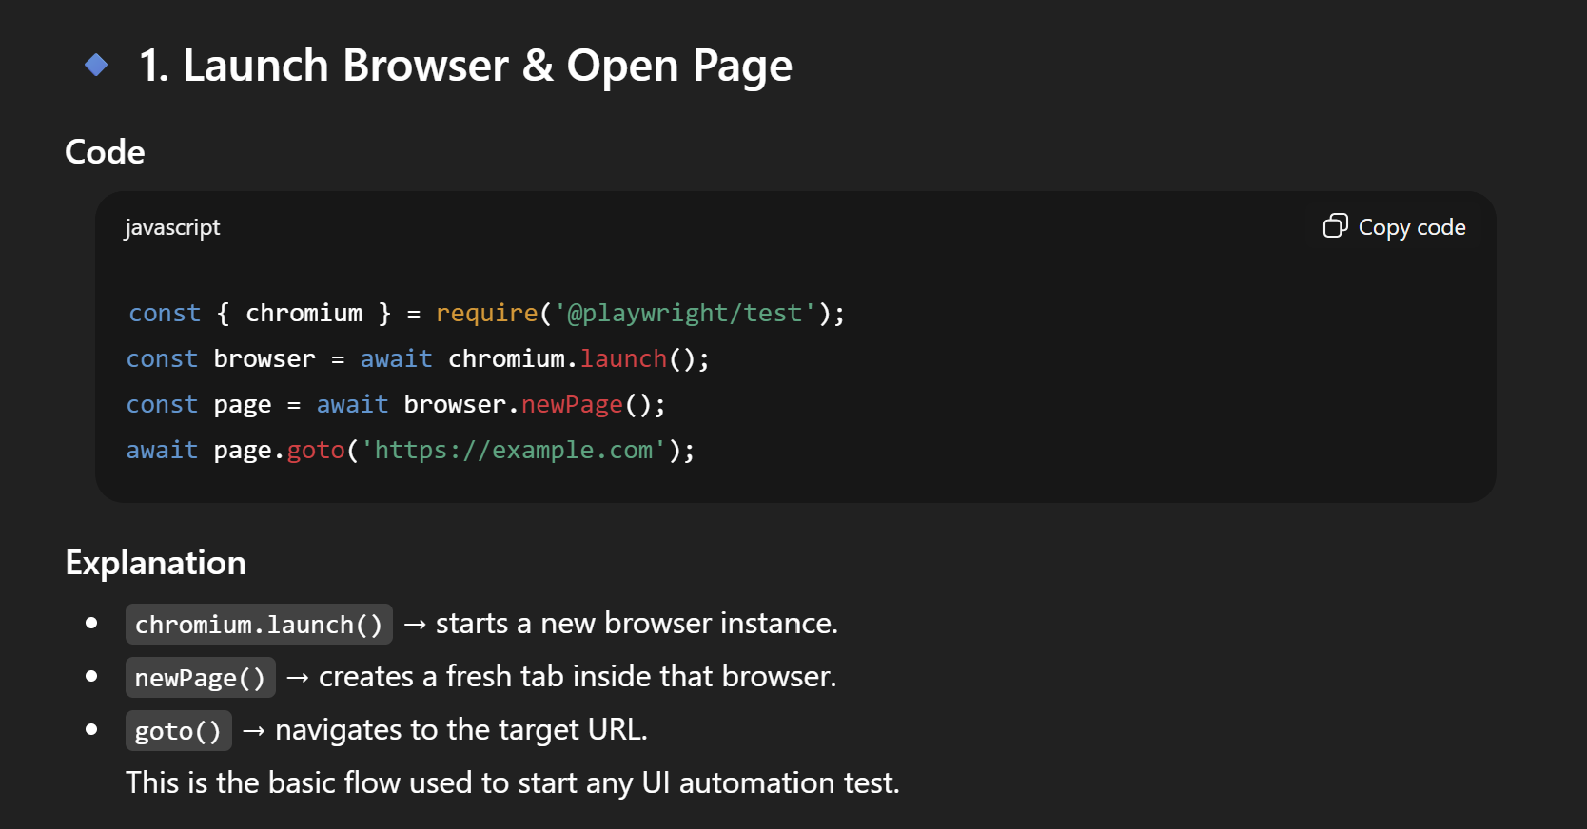
3. What is auto-waiting in Playwright?
Expected points:
- Playwright waits for the element to be:
  - Attached to DOM - ??
  - Visible
  - Stable
  - Not detached
- Eliminates need for Thread.sleep() / manual waits.

📌 2. Locators & Element Handling
4. What is the difference between locator, page.$ and page.$$?
Method | Description
locator() | Lazy; auto-waits; recommended for tests.
page.$() | Returns first matching element handle (no auto waiting).
page.$$() | Returns array of element handles.

5. How do you handle dropdowns in Playwright?
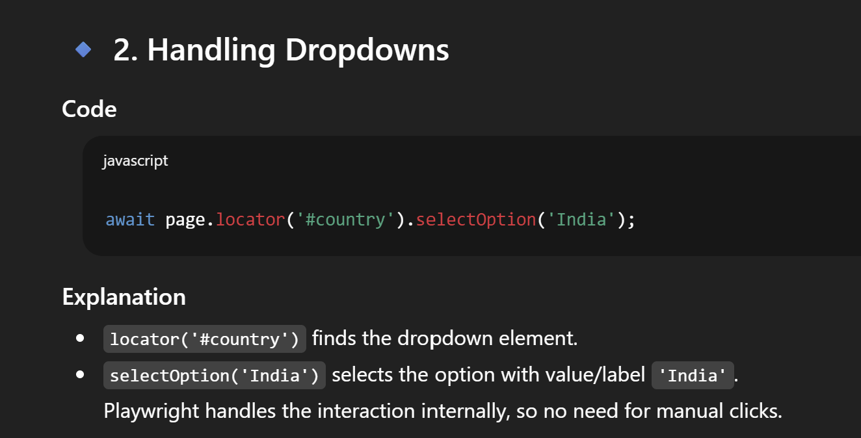
6. How do you handle iframes in Playwright?
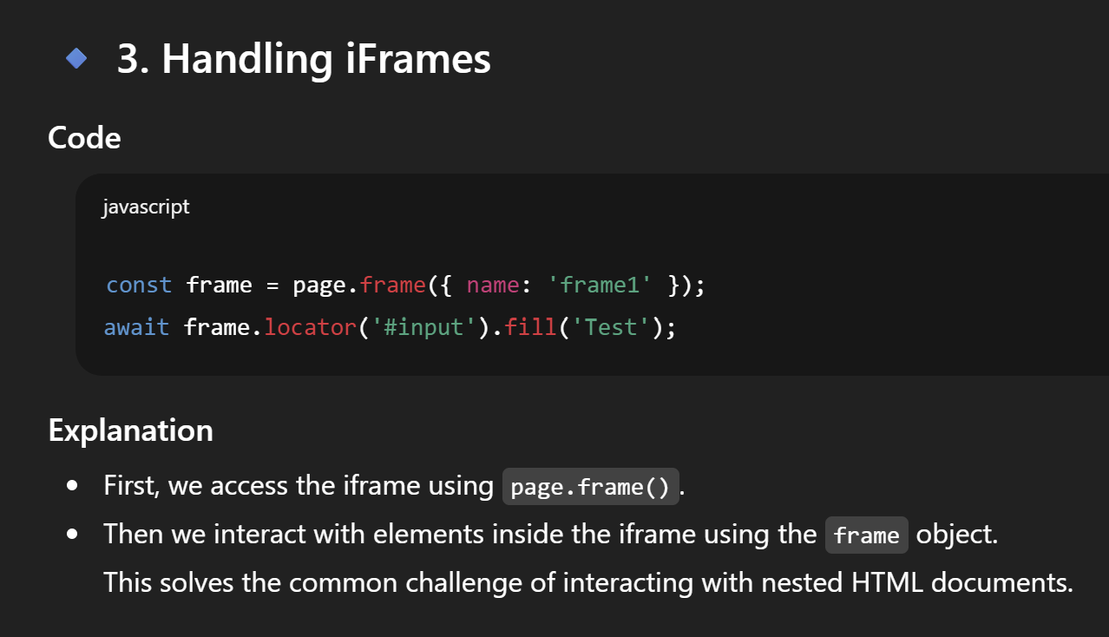
7. How do you handle shadow DOM elements?
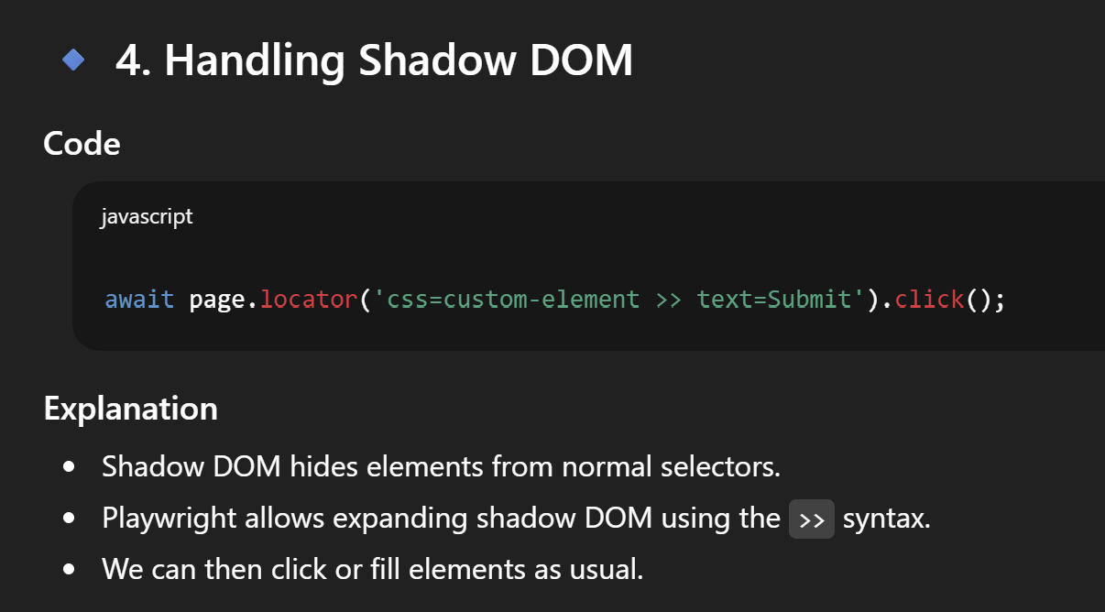
📌 3. Assertions & Test Runner
8. What is Playwright Test Runner and why is it useful?
- Built-in test framework
- Parallel execution
- Retry mechanism
- Video, screenshot, trace options
- Fixtures support

9. How do you configure retries in Playwright?
In playwright.config.js:
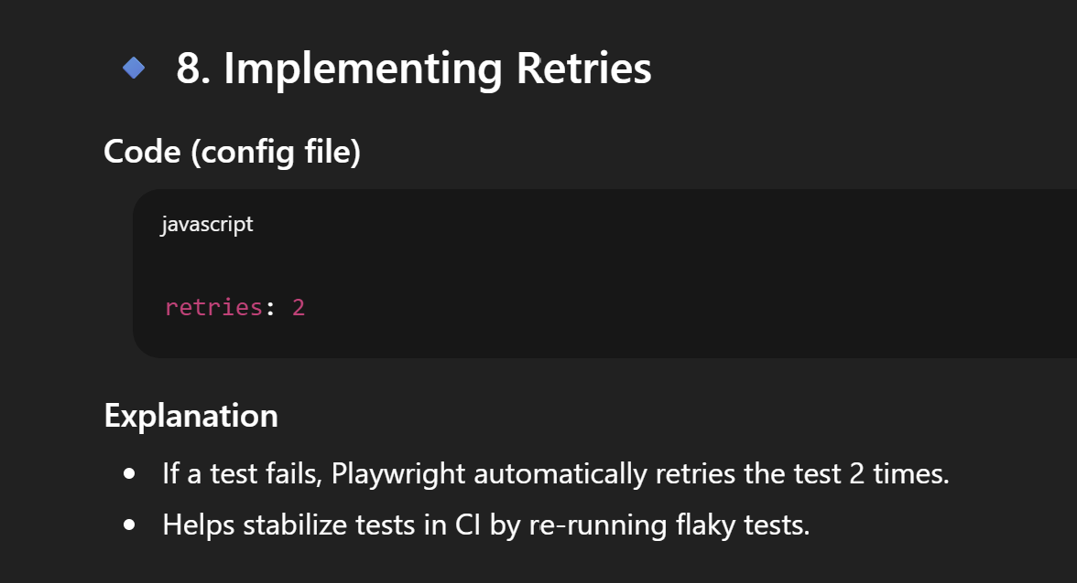
10. What is the difference between expect.toHaveText() and expect.textContent()?
Method | Purpose
toHaveText | Auto-waits and asserts text directly
textContent | Retrieves raw text; must assert manually

📌 4. Network, API & Mocking
11. How do you intercept and mock network requests in Playwright?
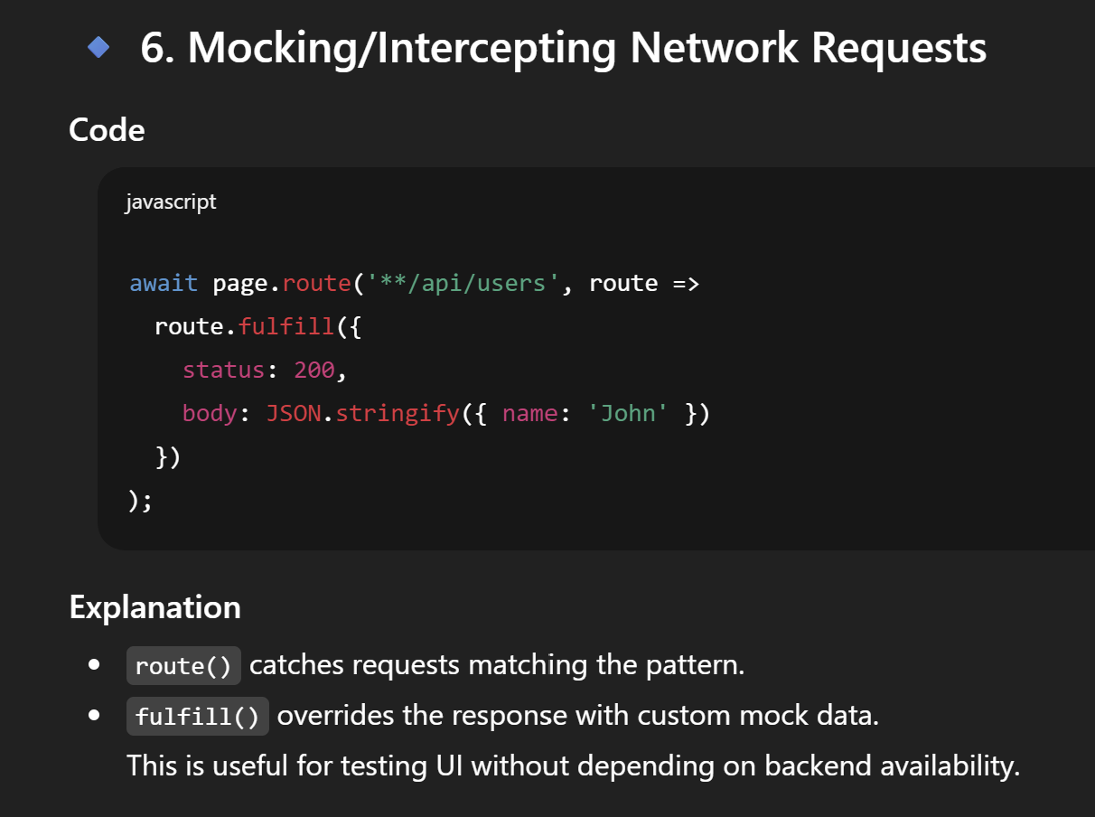
12. Can Playwright test APIs?
Yes, using APIRequestContext.
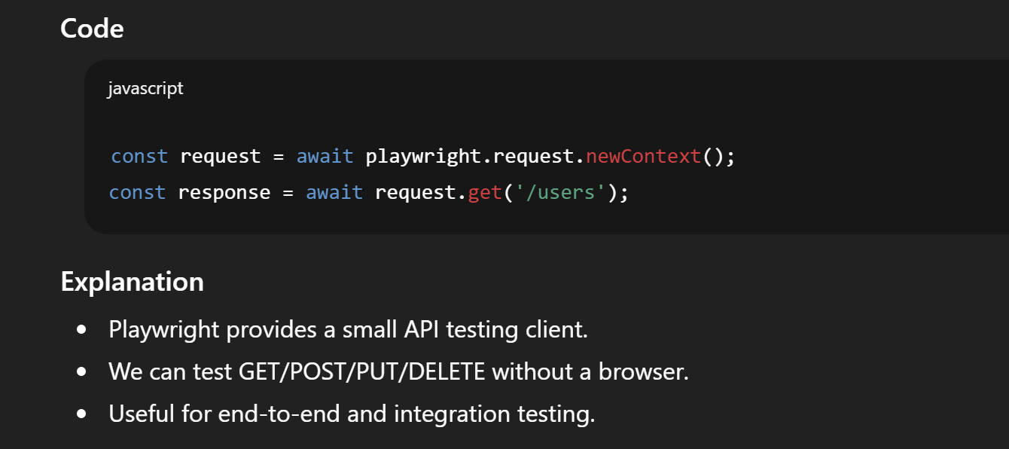
📌 5. Test Organization & Fixtures
13. What are Fixtures in Playwright?
- Reusable setup/teardown logic.
- Example: browser, page, test data, DB connection.

14. How do you run tests in parallel?
Parallel by default, or:
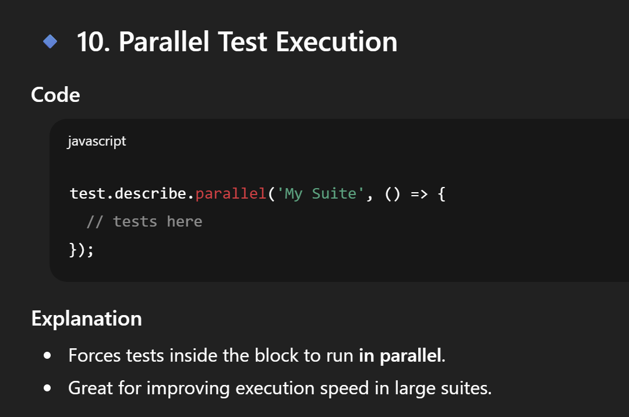
15. How do you create a custom fixture?
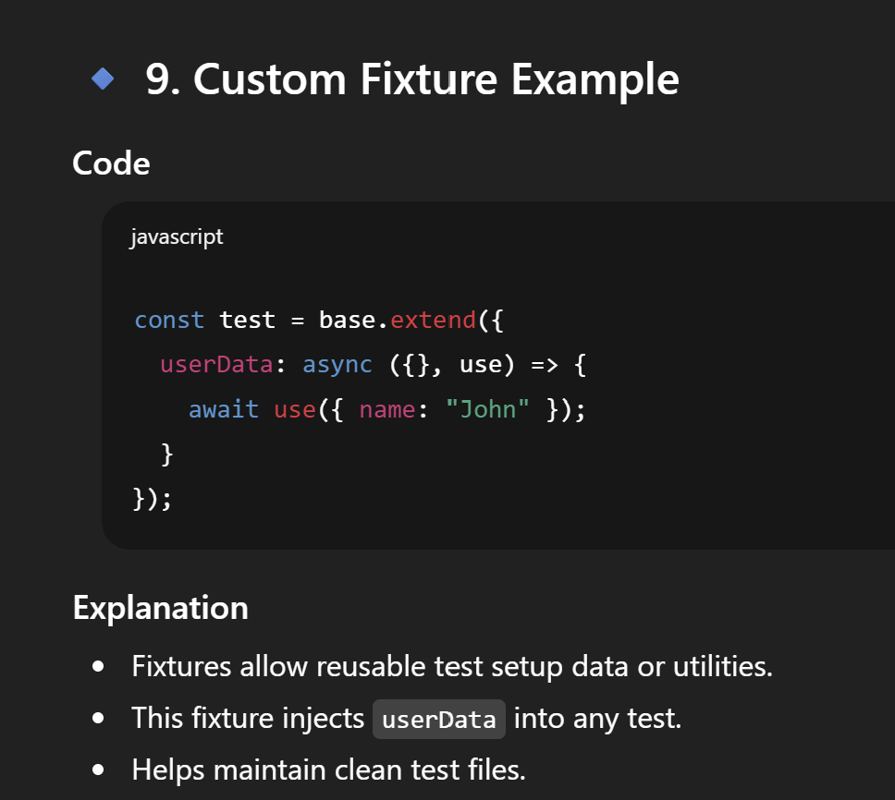
📌 6. Reporting, Tracing & Debugging
16. How do you enable trace / video / screenshot?
In config:
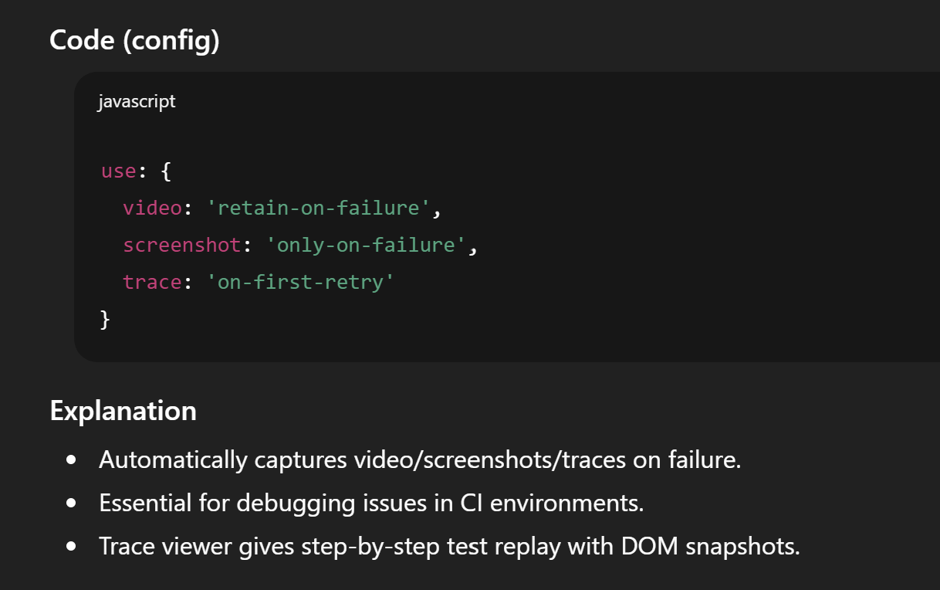
17. What is Playwright Trace Viewer?
- Debug tool that records:
  - DOM snapshots
  - Network logs
  - Console logs
  - Screenshots of each action
- Useful for CI debugging.

18. How do you run tests in debug mode?
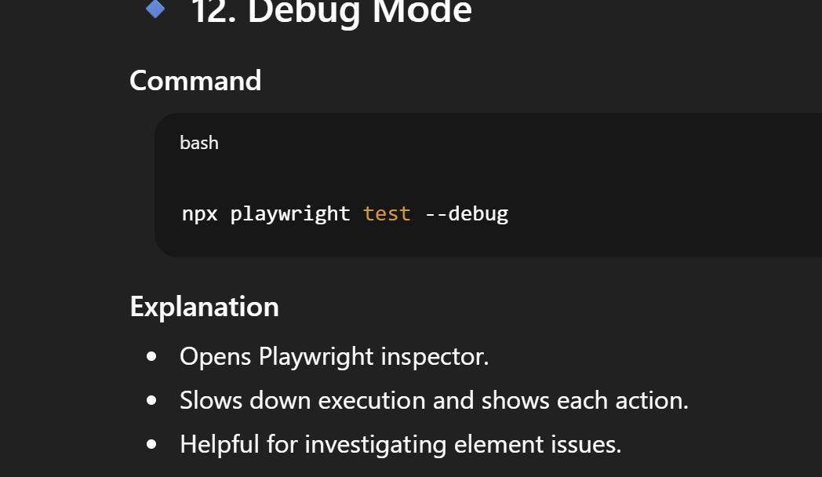
📌 7. Practical / Scenario-Based Questions
19. Your test is failing intermittently on CI but not locally. How do you debug?
Expected answers:
- Use trace viewer
- Add slowMo
- Add retry
- Check network stubbing
- Run in headed mode
- Validate test data / environment issues

20. How do you test file upload and download in Playwright?
Upload:
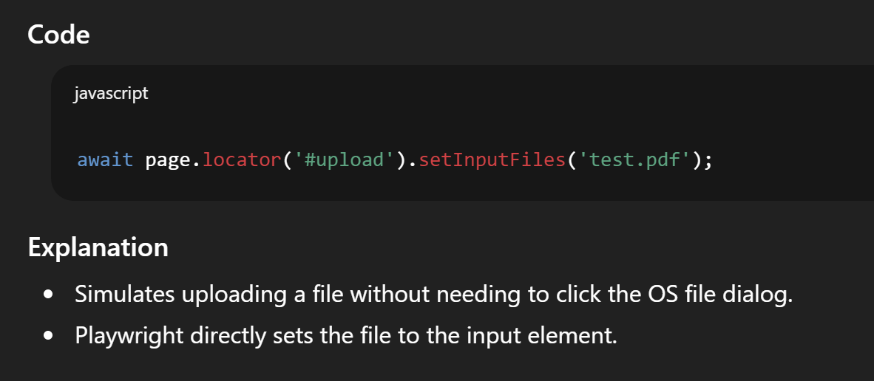
Download:
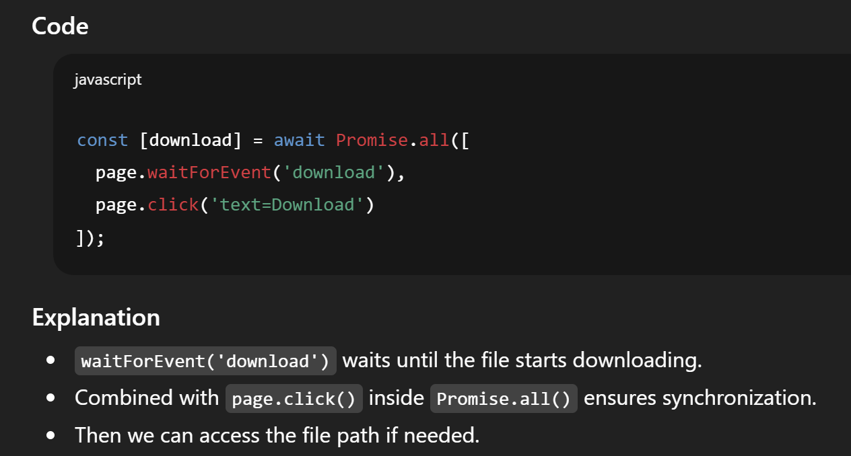
21. How do you handle dynamic elements whose IDs change each refresh?
- Use text locators
- Use role-based locators
- Use XPath with contains
- Use data-testid

📌 8. Advanced Concepts
22. What are BrowserContext and why are they important?

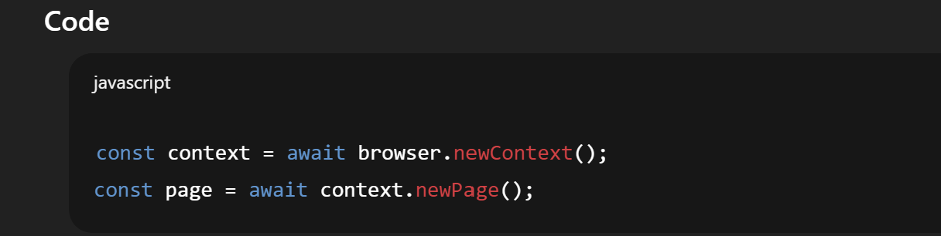
- Equivalent to a new incognito browser
- Used for test isolation
- Separate cookies/session/cache

23. Difference between headless: false and slowMo.
Option | Meaning
headless:false | Shows UI
slowMo | Slows down actions for debugging

24. How do you run a single test file or single test?
npx playwright test tests/login.spec.ts
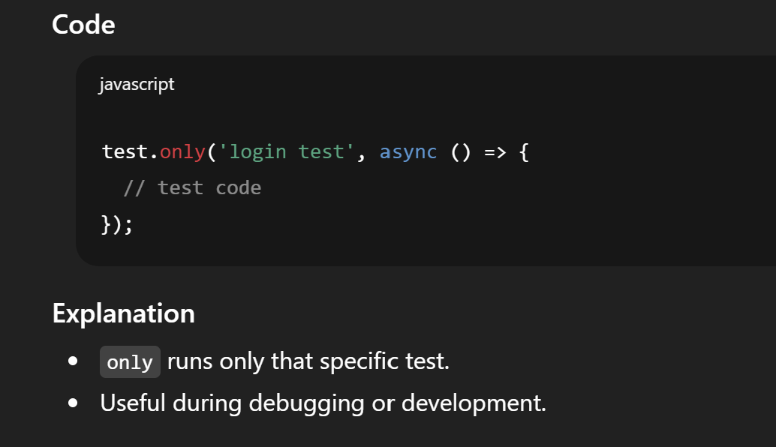
25. What CI/CD tools have you integrated Playwright with?
Expected direction:
- Jenkins
- GitHub Actions
- GitLab CI
- Azure DevOps
- Command used: npx playwright install --with-deps

📌 Would you like me to prepare these for you in any of the following formats?
✔ A PDF-ready document
✔ A mock interview practice session
✔ Q&A flashcards
✔ A shortened cheat sheet
✔ A resume section highlighting Playwright skills
Just tell me!

