PROJECT

Project Management System

**INDEX**

1. Abstract
2. Analysis
3. Hardware/ Software Requirements
4. Software Requirement Specifications
5. Schedule Matrix
6. Modules
7. Output Screens

**Abstract**

This system is designed to provide the services for Manager to manage project contracts

PMS System belongs to the class of application software intended for storage and management of information of contracts, project, and tasks. The systems are used to control data entry to contracts, task orders, projects, tasks.

**Analysis**

1. **Existing System :**

Project Management System setup currently uses a manual system for the management and maintenance of critical information. The current system requires numerous paper forms, with data stores spread throughout infrastructure. Often information (on forms) is incomplete, or does not follow management standards. Forms are often lost in transit between departments requiring a comprehensive auditing process to ensure that no vital information is lost. Multiple copies of the same information exist and may lead to inconsistencies in data.

1. **Proposed System:**

The project is designed for any exhibition to replace their existing manual, paper based system. The new system is to control the following information user information, stalls & huts information. These services are to be provided in an efficient, cost effective manner, with the goal of reducing the time and resources currently required for such tasks.

**Hardware/Software Requirements**

**System Specifications Minimum Hardware Requirements:-**

* 4 GB Ram
* Hard disk 500 GB
* Microsoft Compatible 101 or more Key Board Software Requirements: -

**Operating System** :

* Windows 10
* Programming language: .NET
* Web-Technology: ASP.NET 4.5
* Front-End: ASP.NET MVC
* Back-End: SQL SERVER
* Web Server: IIS

If system, which is going to be developed, is complex in nature the goals of the entire system could not be easily comprehended. Hence the need for a more rigorous system analysis phase arose.

**Feasibility Study**

Feasibility study is conducted once the problem is clearly understood. Feasibility study is a high level capsule version of the entire system analysis and design process. The objective is to determine quickly at a minimum expense how to solve a problem. The purpose of feasibility is not to solve the problem but to determine if the problem is worth solving. The system has been tested for feasibility in the following points.

1. Technical Feasibility

2. Economical Feasibility

3. Operational Feasibility.

1. **Technical Feasibility:** The project is technically feasibility because of the below mentioned feature. The project was developed in Asp.net MVC which is depending upon Model View Controller. It provides the high level of reliability, availability and compatibility. All these make Asp.net MVC an appropriate language for this project. Thus the existing software Asp.net MVC is a powerful and secure language.
2. **Economical Feasibility:** The computerized system will help in automate the selection leading the profits and details of the organization. The costs incurred of not creating the system are set to be great, because precious time can be wanted by manually.
3. **Operational Feasibility:** In this project, the management will know the details of each project where he may be presented and the data will be maintained as decentralized and if any inquires for that particular contract can be known as per their requirements and necessaries.
4. **Resource Feasibility:** In this project management will decide how many resource will be available to complete the projet and in given time.

**Software Requirement Specifications**

A software requirements specification (SRS) is a comprehensive description of the intended purpose and environment for  under development. The SRS fully describes what the software will do and how it will be expected to perform.

**The Software includes:-**

1. Maintaining Contracts Details
2. Maintaining Task Order against Contract
3. Maintaing Projects against Task Orders.
4. Maining Tasks against Projects.
5. Maining Labor Categories
6. Maintaing Option Years

**Schedule Matrix of 20 Days**

|  |  |
| --- | --- |
| Study | 02 |
| Requirement Gathering | 06 |
| Designing | 02 |
| Development | 8 |
| Testing and Implementation | 4 |

**MODULES**

1. Contracts
2. Contract Categories
3. Task Orders
4. Projects
5. Project Tasks
6. Labor Categories
7. Option Years

**Controllers**

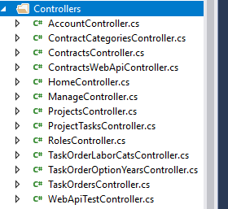

**Models**

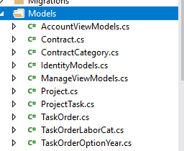

**Views**

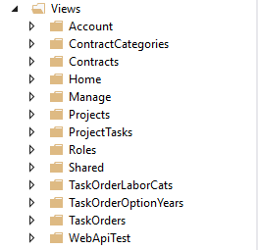

**Screenshots**

Login Page

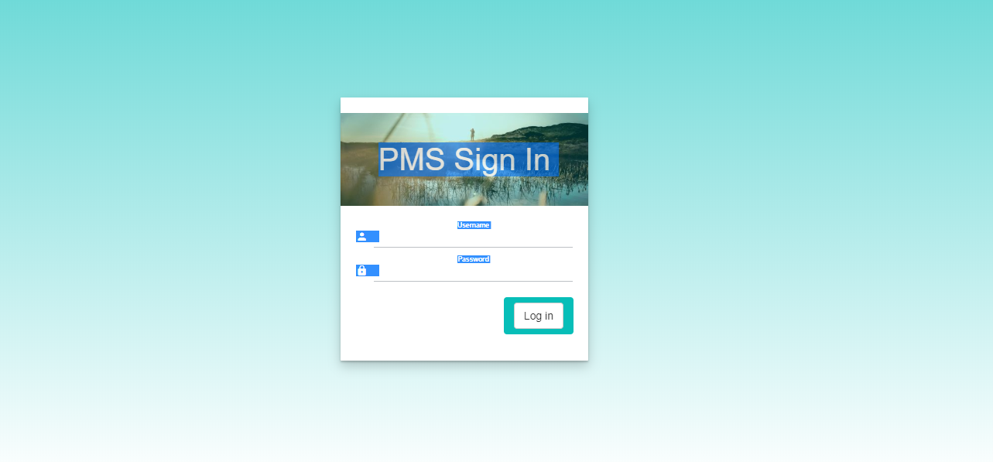

Dashboard Landing Page

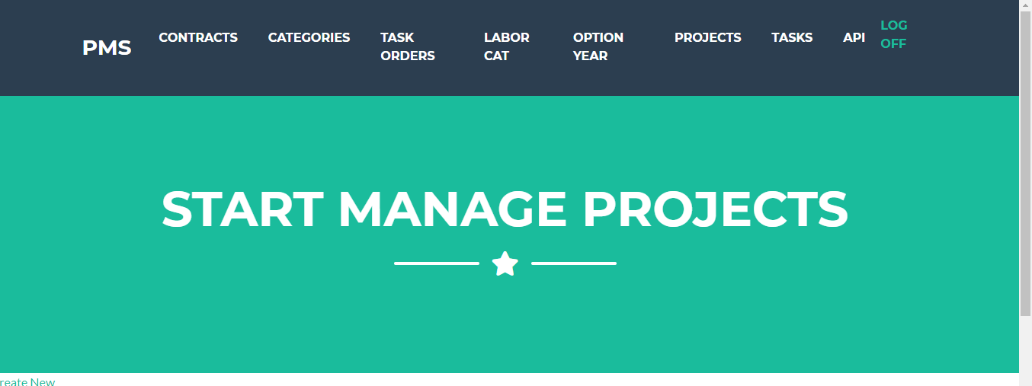

Contracts List

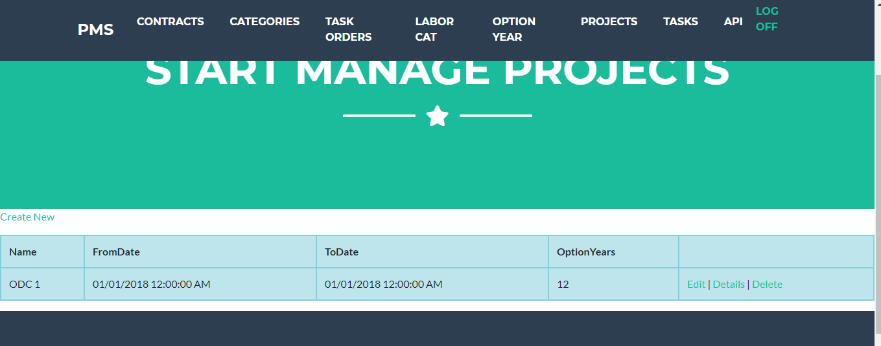

Create Contact

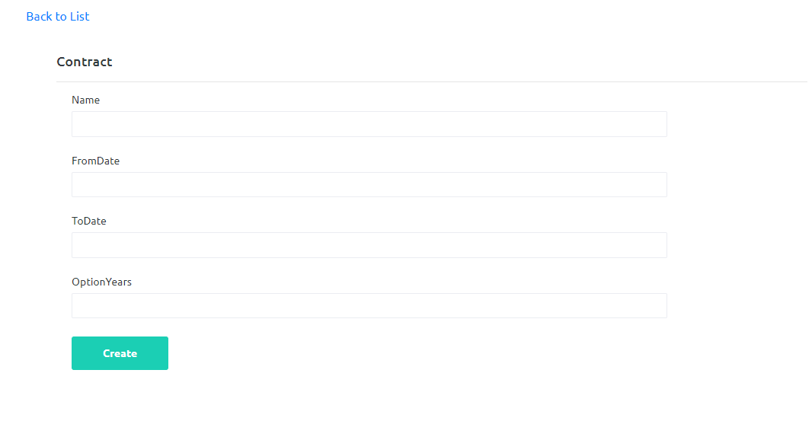

Contract Category

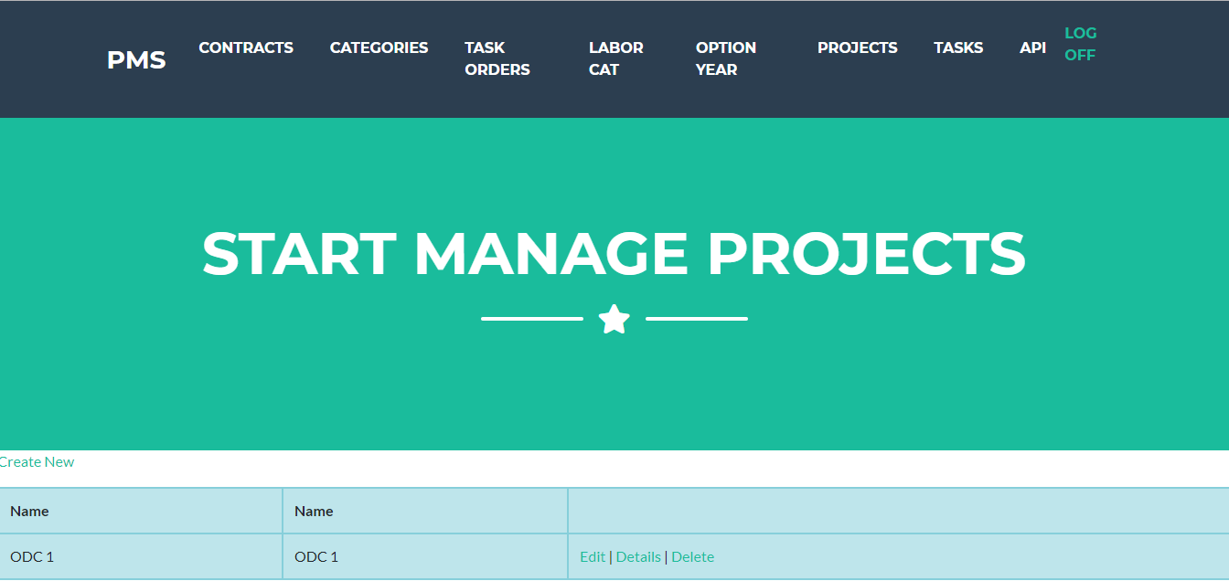

Create Contract Category

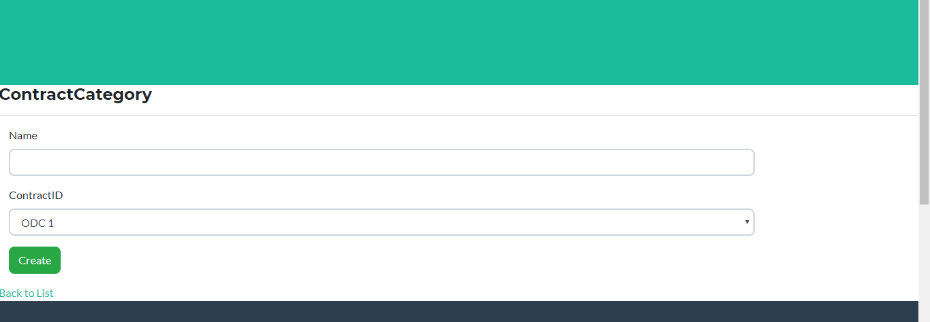

Task Order List

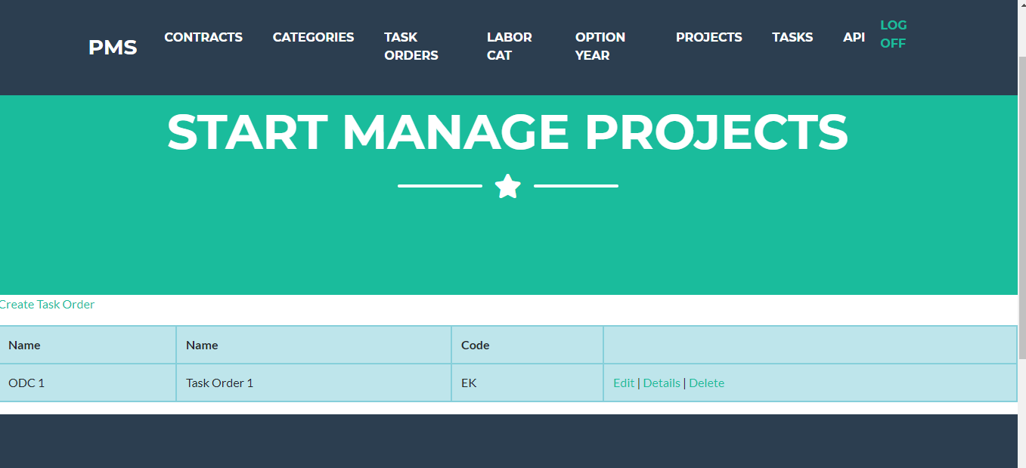

Create Task Order

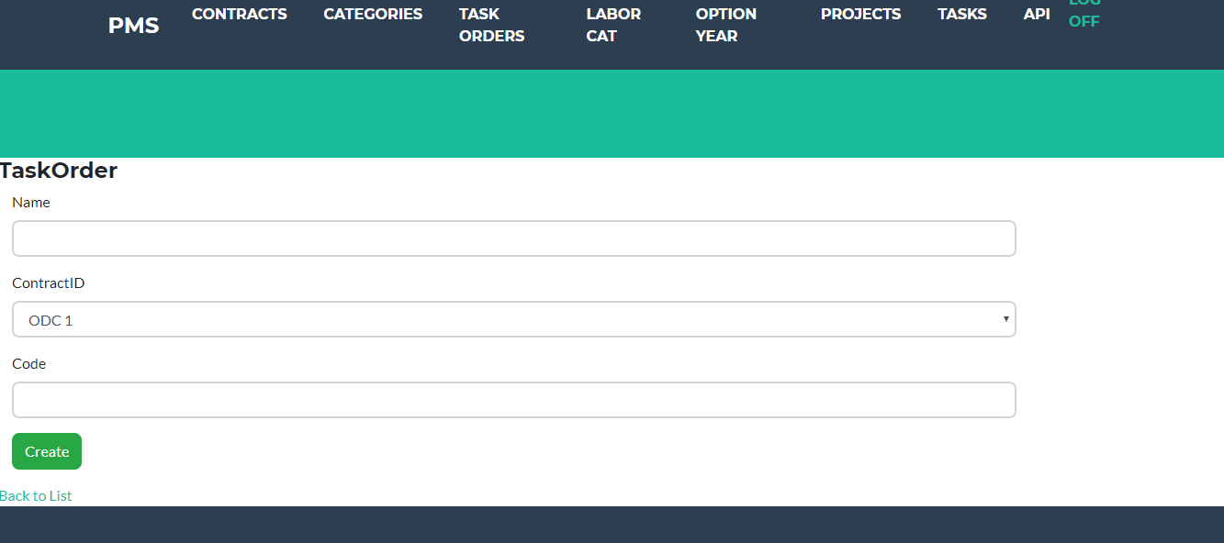

Labor Category Screen List

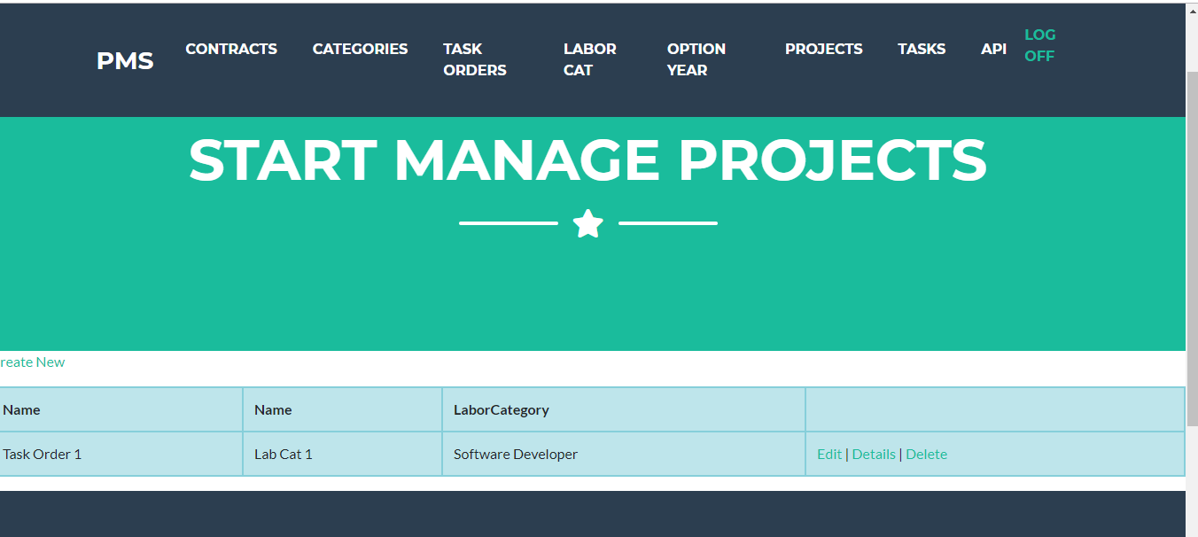

Add Labor Category

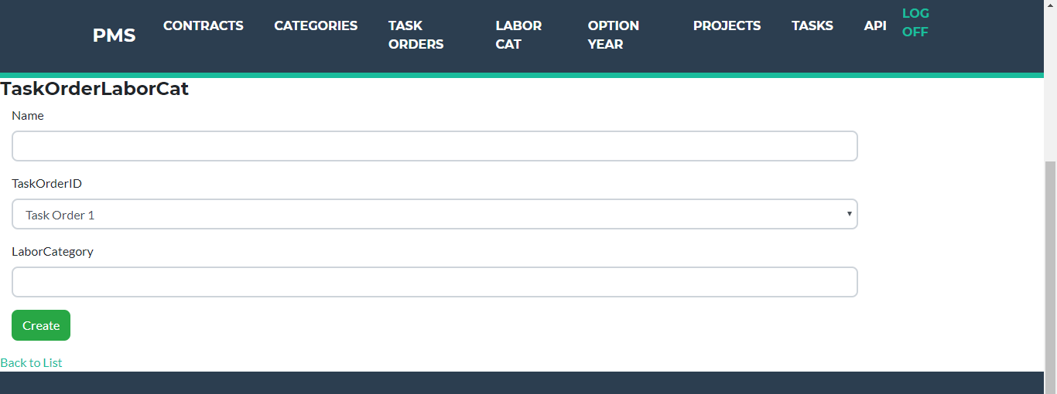

Option Year List

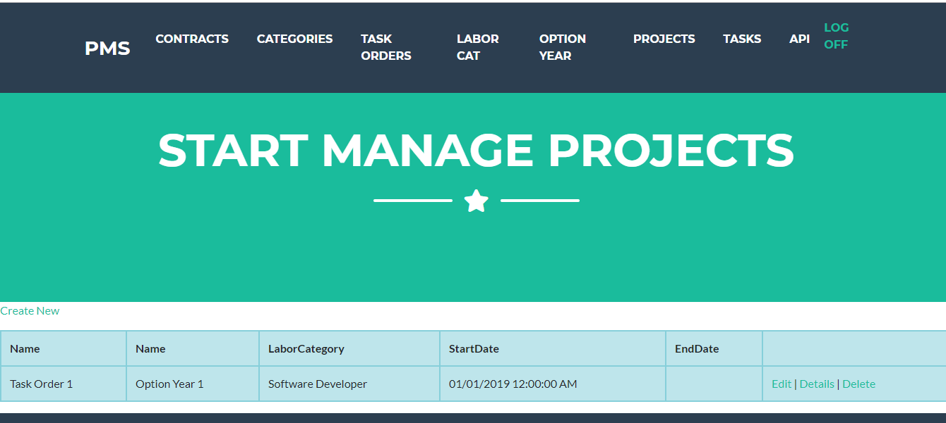

Create Option Year

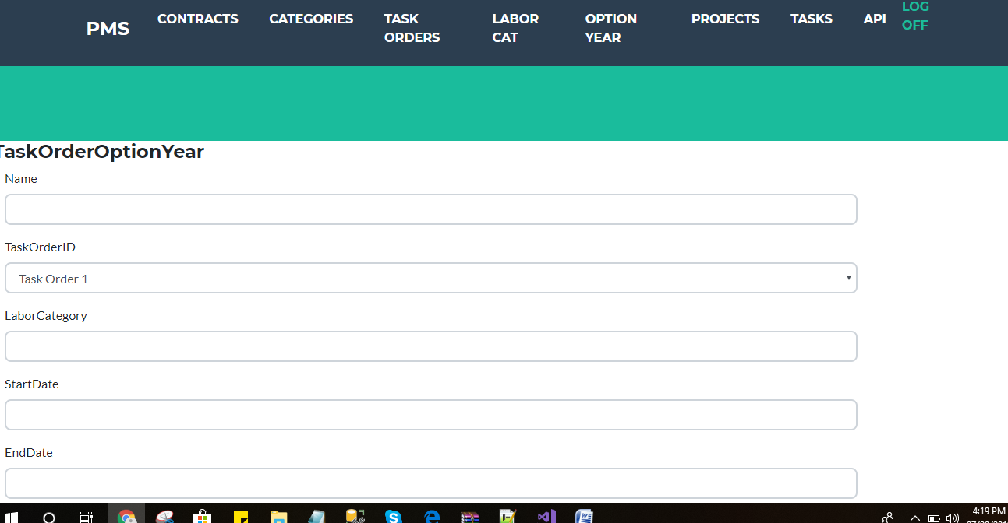

Show Project List

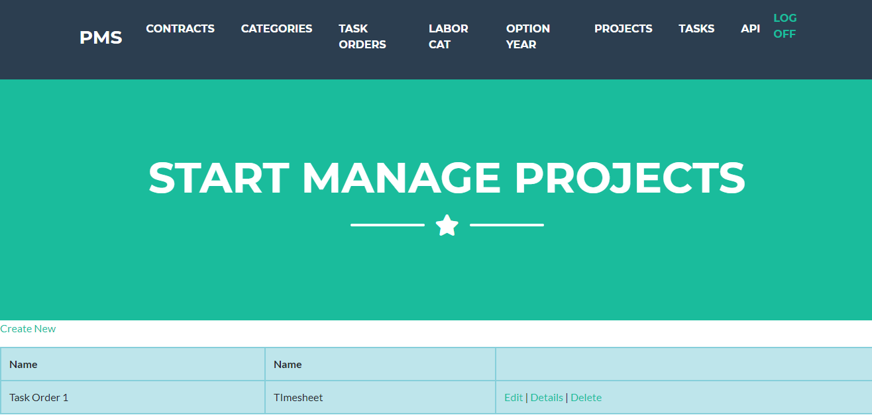

Create Project

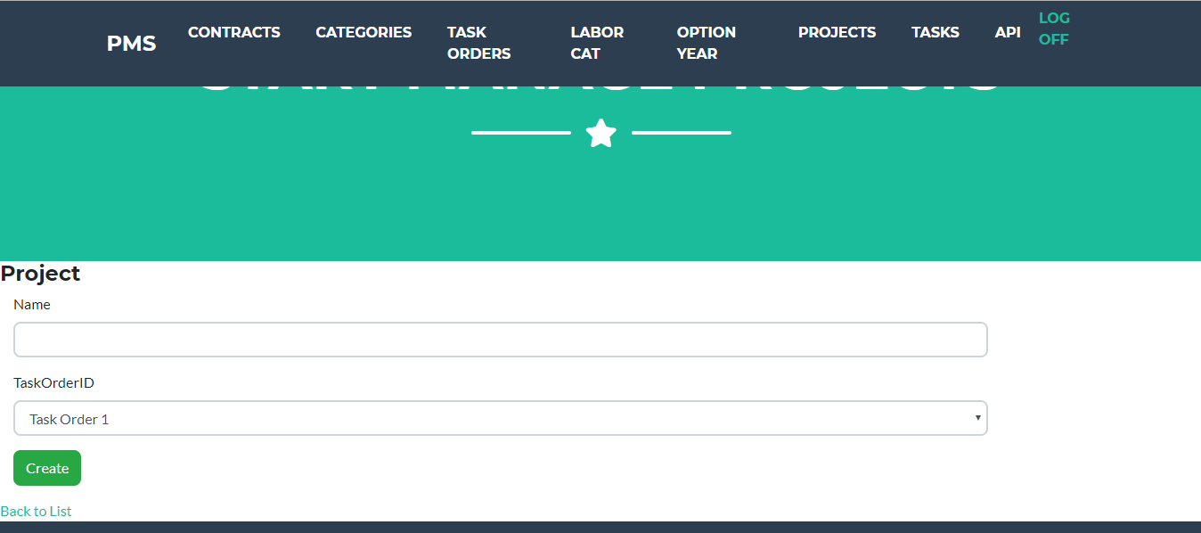

Show Tasks List

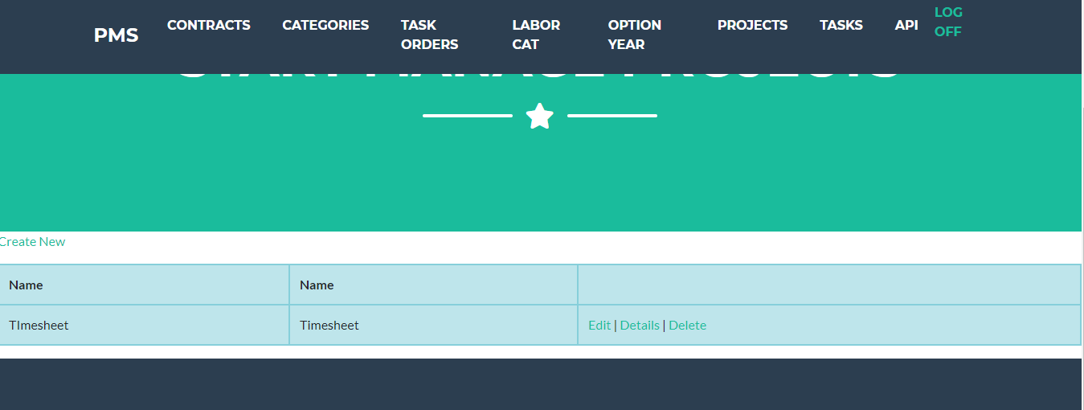

Create Tasks

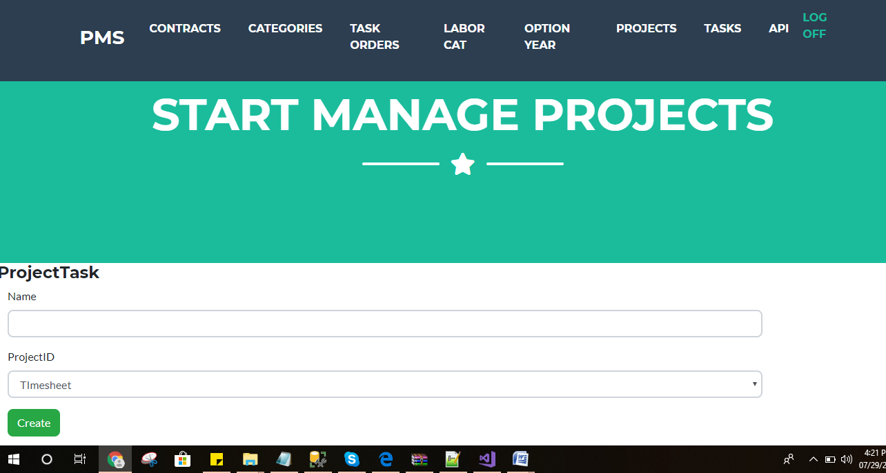

Create/Edit/Delete/Read via Web Api

