# ASSIGNMENT

Implement below section before next class

Reviews Section

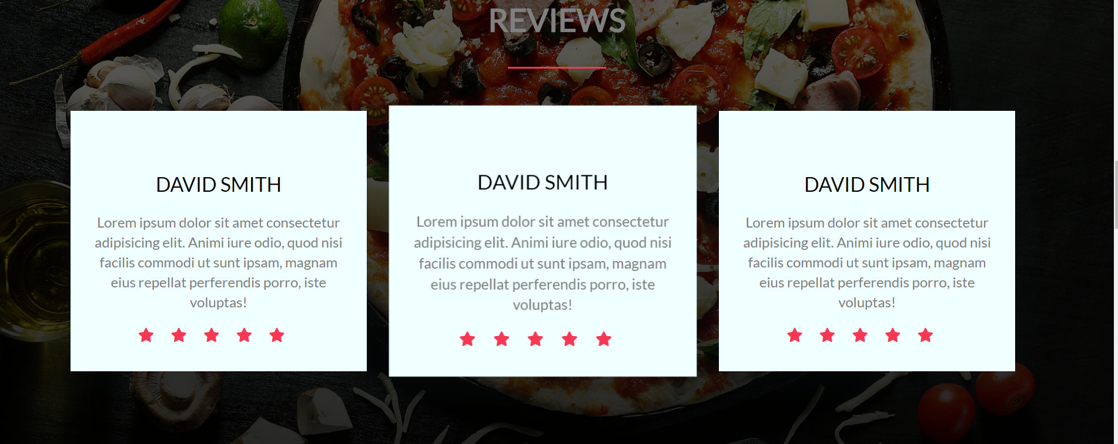

Plans Section

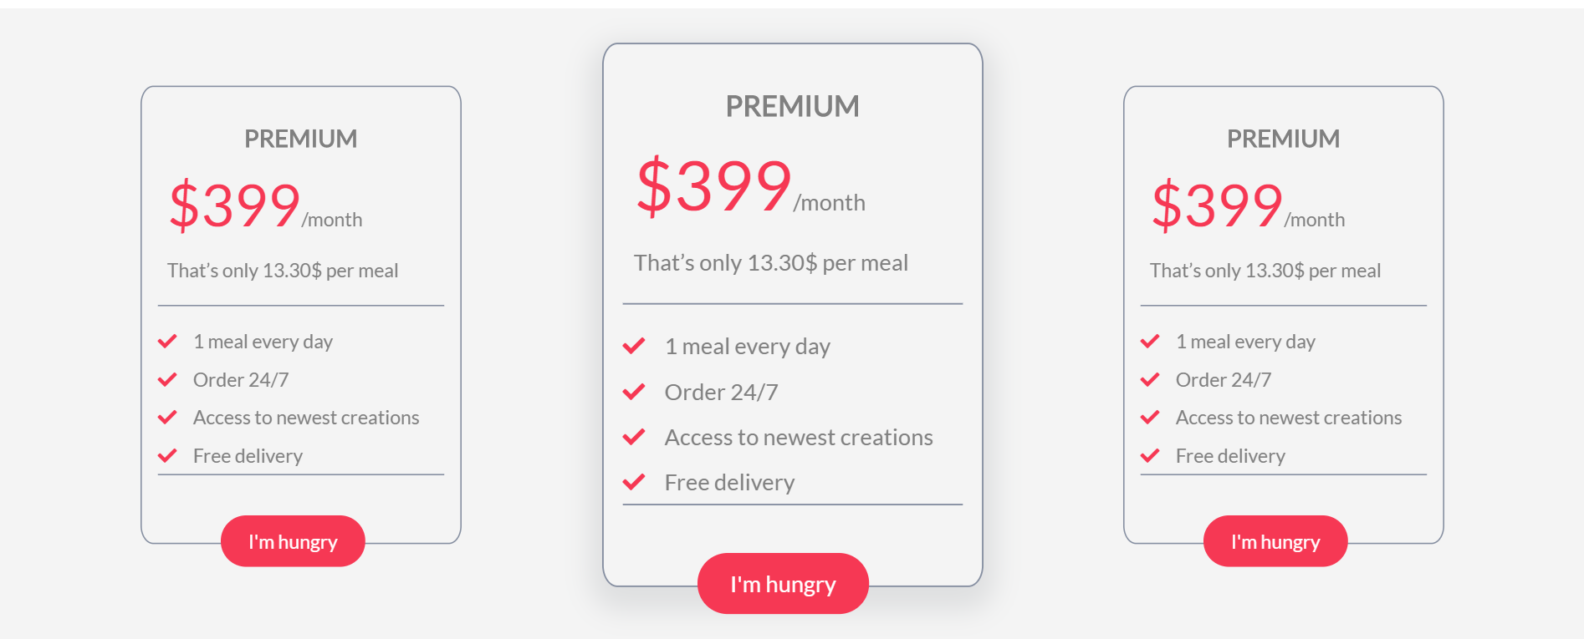

Footer Section



**Pages**

**You need to implements following UIs**

1. **Login ,Singup**
2. **Forget Password,reset password**

## Articles to refer

* <https://developer.mozilla.org/en-US/docs/Learn/CSS/First_steps/How_CSS_works>
* <https://developer.mozilla.org/en-US/docs/Learn/CSS/Building_blocks/Cascade_and_inheritance>
* <https://developer.mozilla.org/en-US/docs/Learn/CSS/Building_blocks/The_box_model>
* <https://developer.mozilla.org/en-US/docs/Learn/CSS/Building_blocks/Backgrounds_and_borders>
* <https://developer.mozilla.org/en-US/docs/Learn/CSS/Building_blocks/Sizing_items_in_CSS>