# CS 601

**Lecture 2: Try it out**

Create a basic web page containing the essential document tags/elements and some text, save it as a web page, and look at it in a web browser.

Notes: These instructions are written for Windows users. Mac and Linux users should be able to follow along using a different text editor such as TextEdit or Vim.

1. From the Start Menu, launch Notepad (usually in the Accessories group).
2. Add the <!DOCTYPE html>, <html>, <head>, and <title> tags/elements.
3. Add some text of your choice for the document title.
4. Close the Title and Head using </title> and </head> tags/elements.
5. Add the <body> tag.
6. Add the text "Hello World" to your document, after the opening body tag.
7. Close the Body and HTML using </body> and </html>.
8. Save the file to a convenient location by selecting File > Save As, choosing a directory to save to, and naming your file -> practice.html.

This is what you should see after saving:

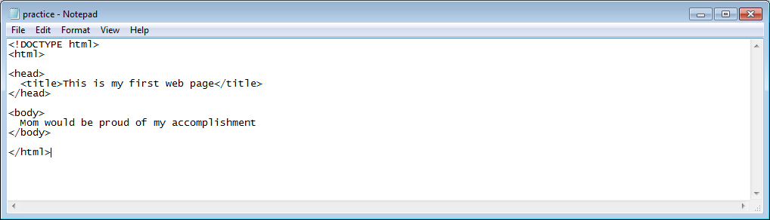

1. Preview your page in a web browser by double clicking on the practice.html file icon, or by using your browsers File > Open File … menu option.

This is what you should see in your web browser:

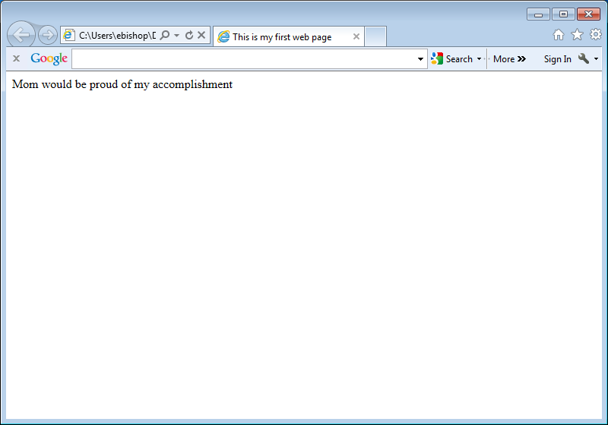

***That’s it. Good job, you have successfully created and viewed your first web page!***